NAME-B.SIRI SAHITHI

REG NO-192121102

EXPERIMENT-10- E-Book Management System.

CLASS DIAGRAM:

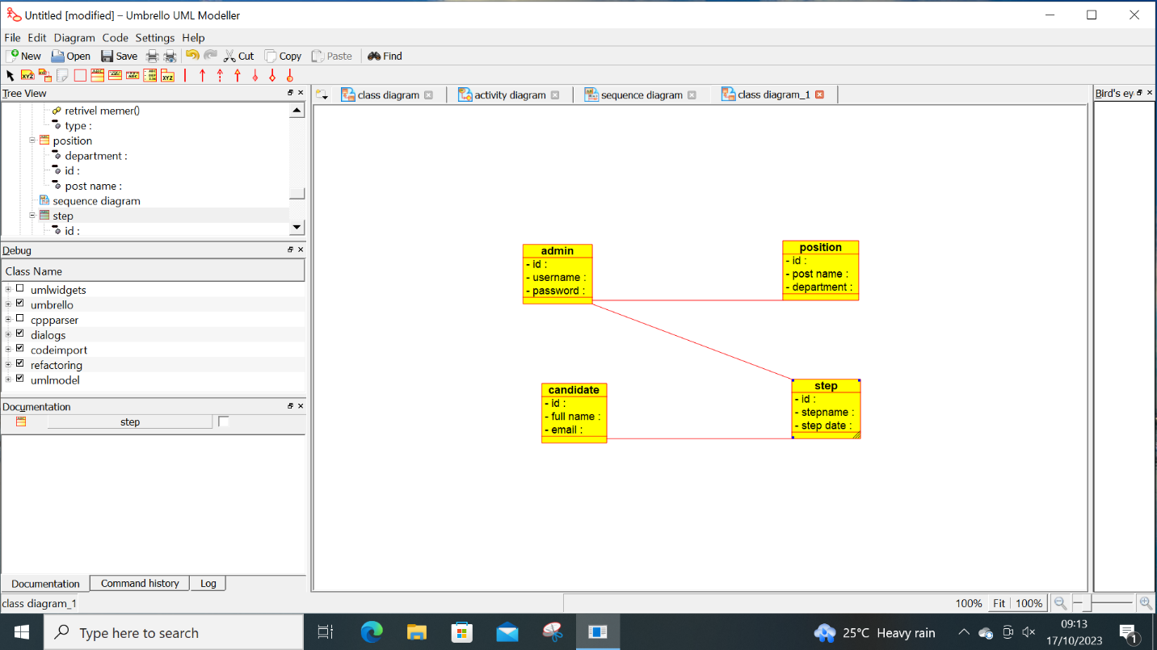

ACTIVITY DIAGRAM:

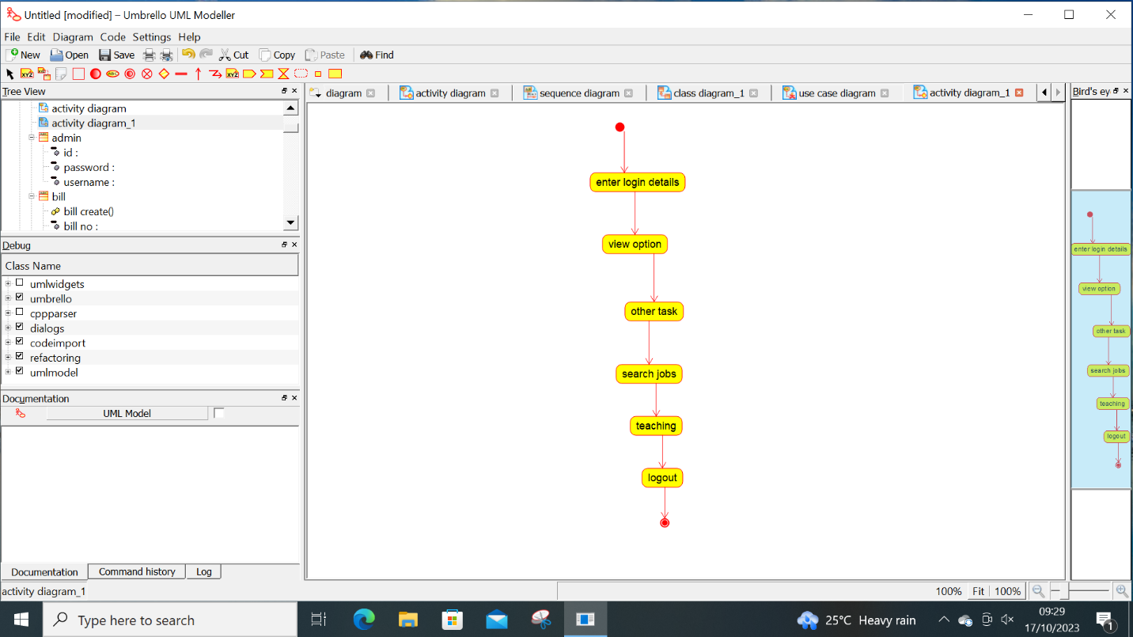

USECASE DIAGRAM:

