NAME-B.SIRI SAHITHI

REG NO-192121102

EXPERIMENT-11- Job Recruitment System

CLASS DIAGRAM:

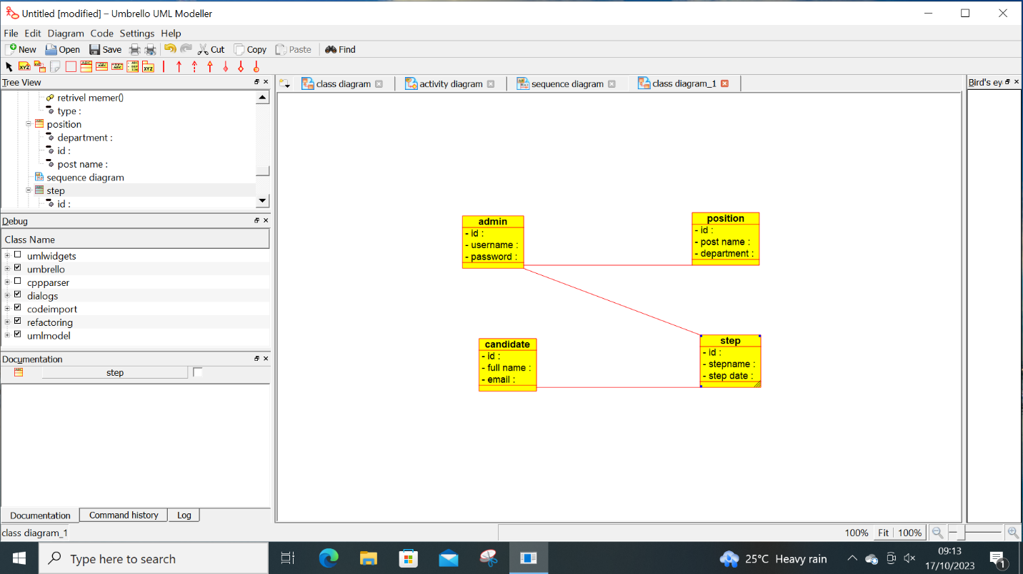

ACTIVITY DIAGRAM: 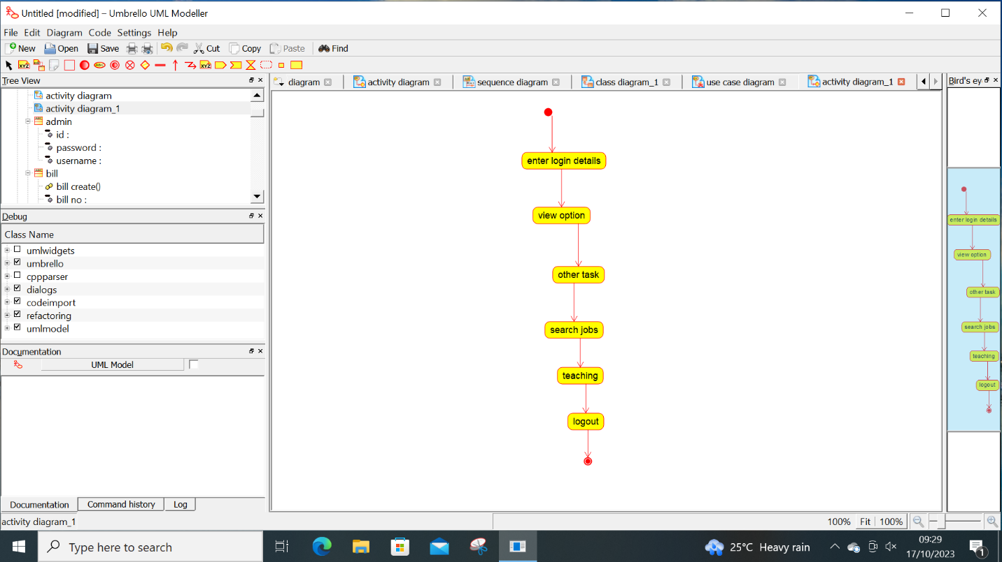

USE CASE DIAGRAM:

