NAME-B.SIRI SAHITHI

REG NO-192121102

EXPERIMENT-12- Conference Management System

CLASS DIAGRAM:

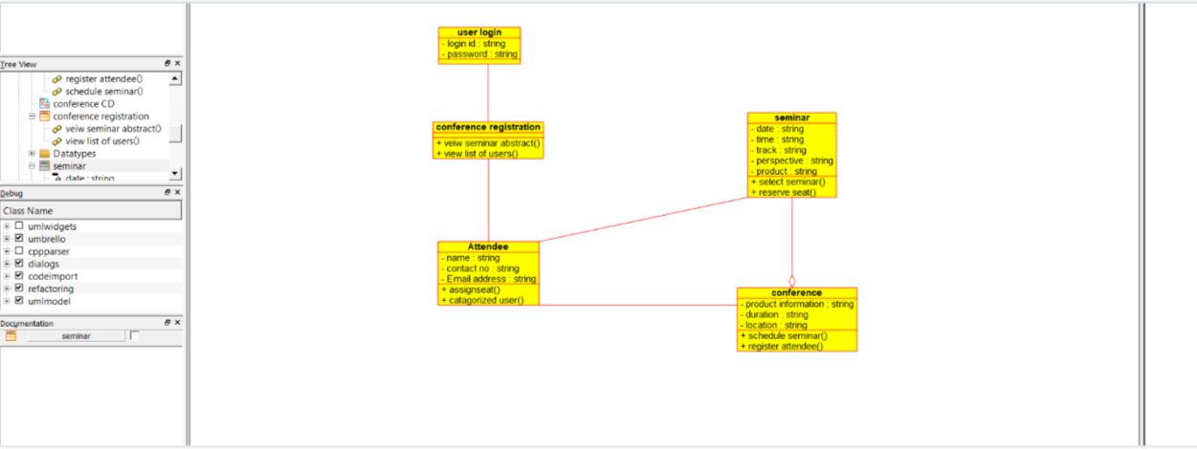

SEQUENCE DIAGRAM:

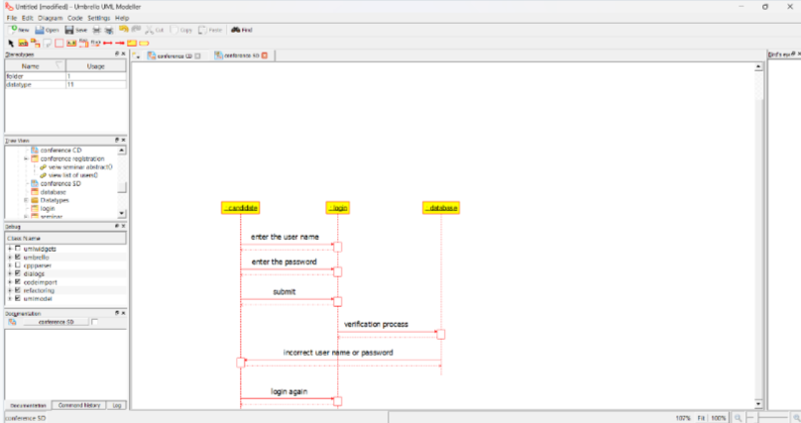

USECASE DIAGRAM:

