NAME-B.SIRI SAHITHI

REG NO-192121102

EXPERIMENT-13- Foreign Trading System

CLASS DIAGRAM:

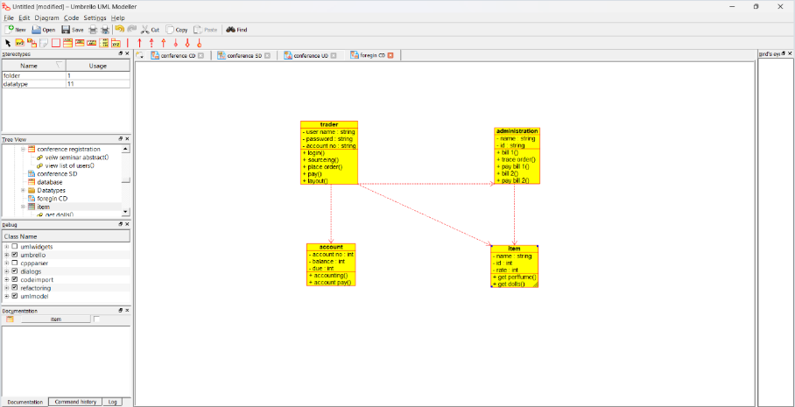

ACTIVITY DIAGRAM:

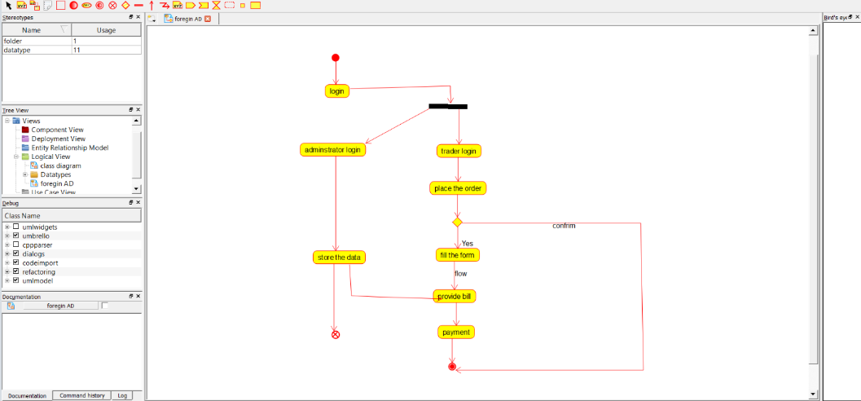

USE CASE DIAGRAM:

