NAME-B.SIRI SAHITHI

REG NO-192121102

EXPERIMENT-14- BPO Management System

CLASS DIAGRAM:

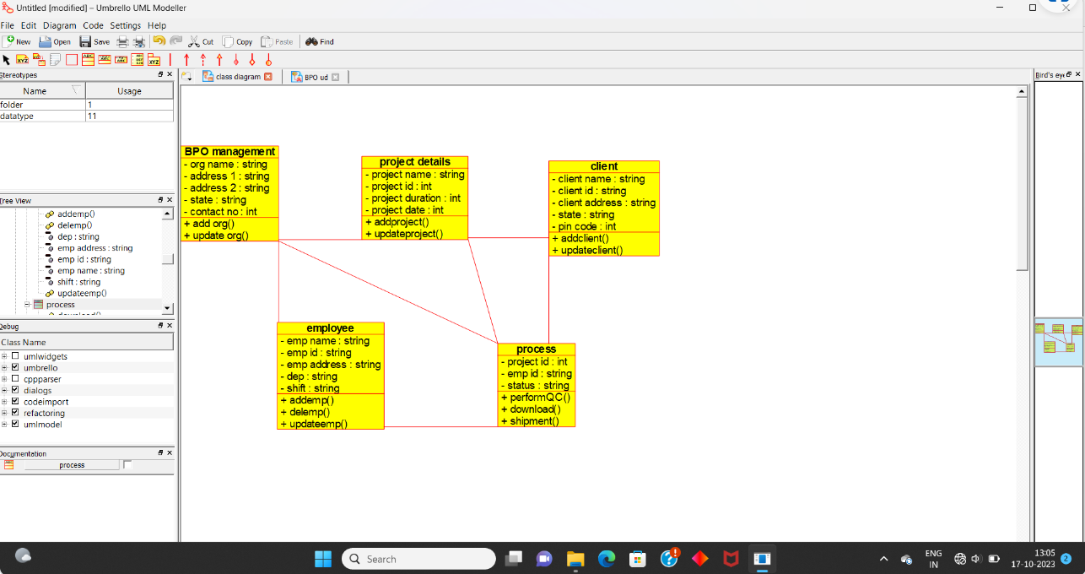

USECASE DIAGRAM:

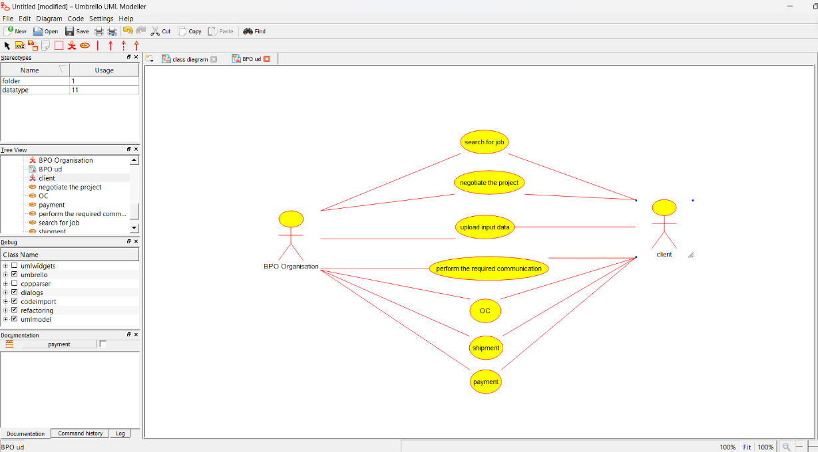

SEQUENCE DIAGRAM:

