NAME-B.SIRI SAHITHI

REG NO-192121102

EXPERIMENT-15- E-Commerce Registration System

CLASS DIAGRAM:

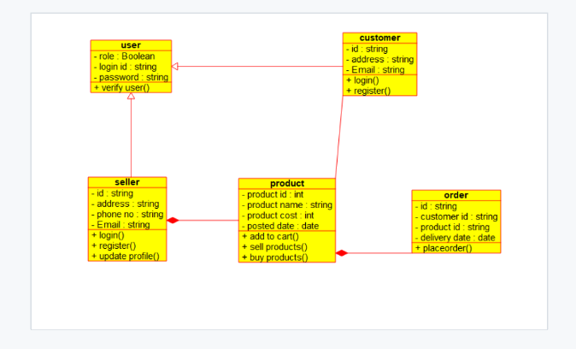

SEQUENCE DIAGRAM:

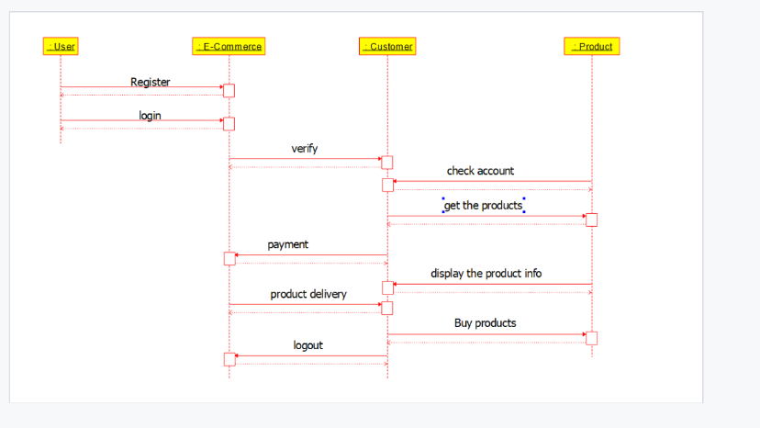

USECASE DIAGRAM:

