NAME-B.SIRI SAHITHI

REG NO-192121102

EXPERIMENT-17- Online Internship Registration System

CLASS DIAGRAM:

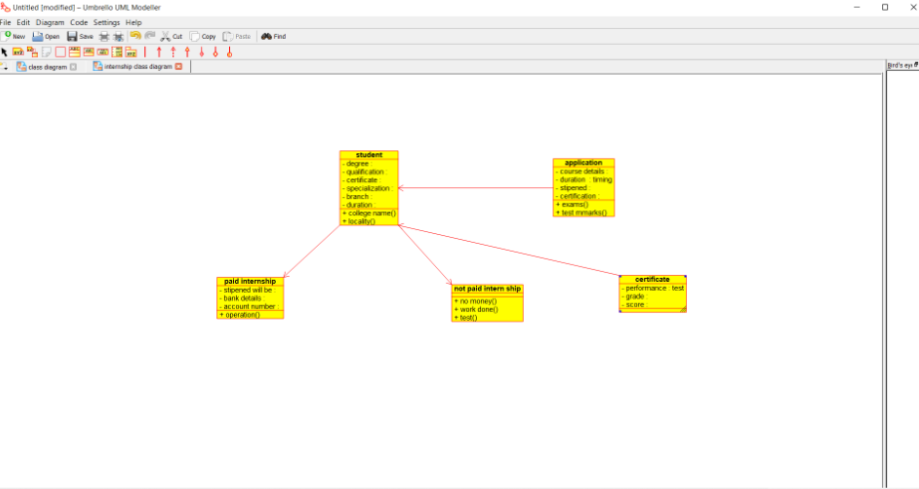

ACTIVITY DIAGRAM:

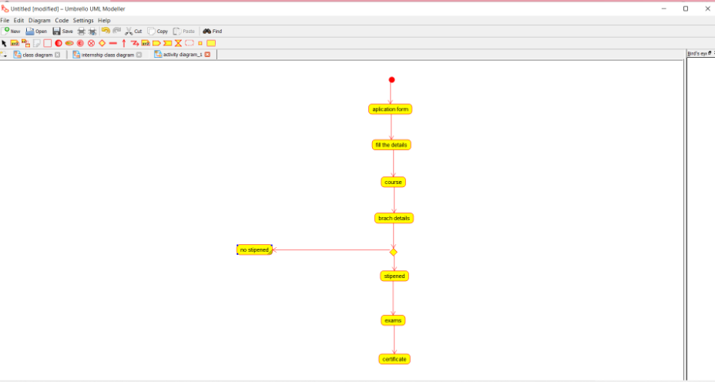

USECASE DIAGRAM:

