NAME-B.SIRI SAHITHI

REG NO-192121102

EXPERIMENT-18- Vehicle Number Registering System

CLASS DIAGRAM:

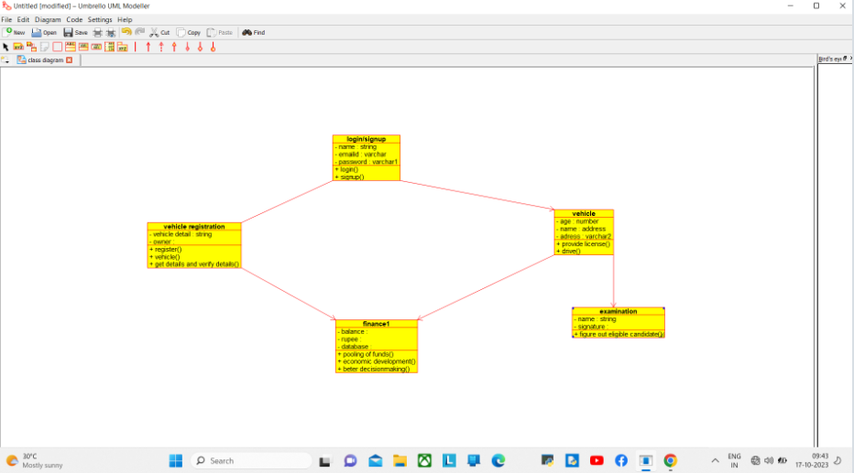

SEQUENCE DIAGRAM:

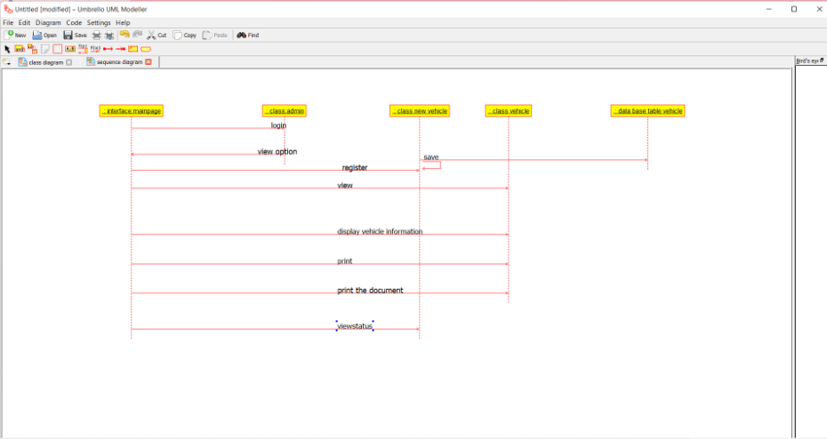

ACTIVITY DIAGRAM:

