NAME-B.SIRI SAHITHI

REG NO-192121102

EXPERIMENT-19- Food Order System

CLASS DIAGRAM:

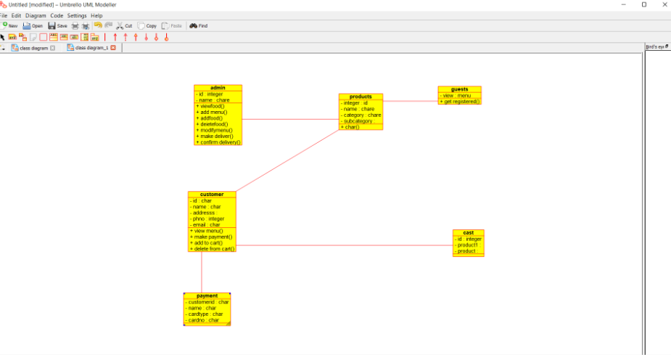

ACTIVITY DIAGRAM:

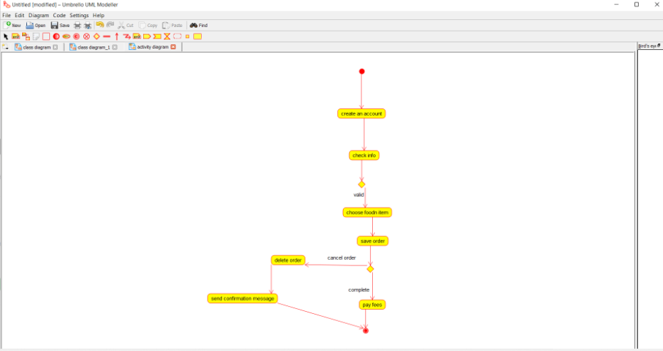

USECASE DIAGRAM:

