NAME-B.SIRI SAHITHI

REG NO-192121102

EXPERIMENT-2-PASSPORT MANAGEMENT SYSTEM

CLASS DIAGRAM:

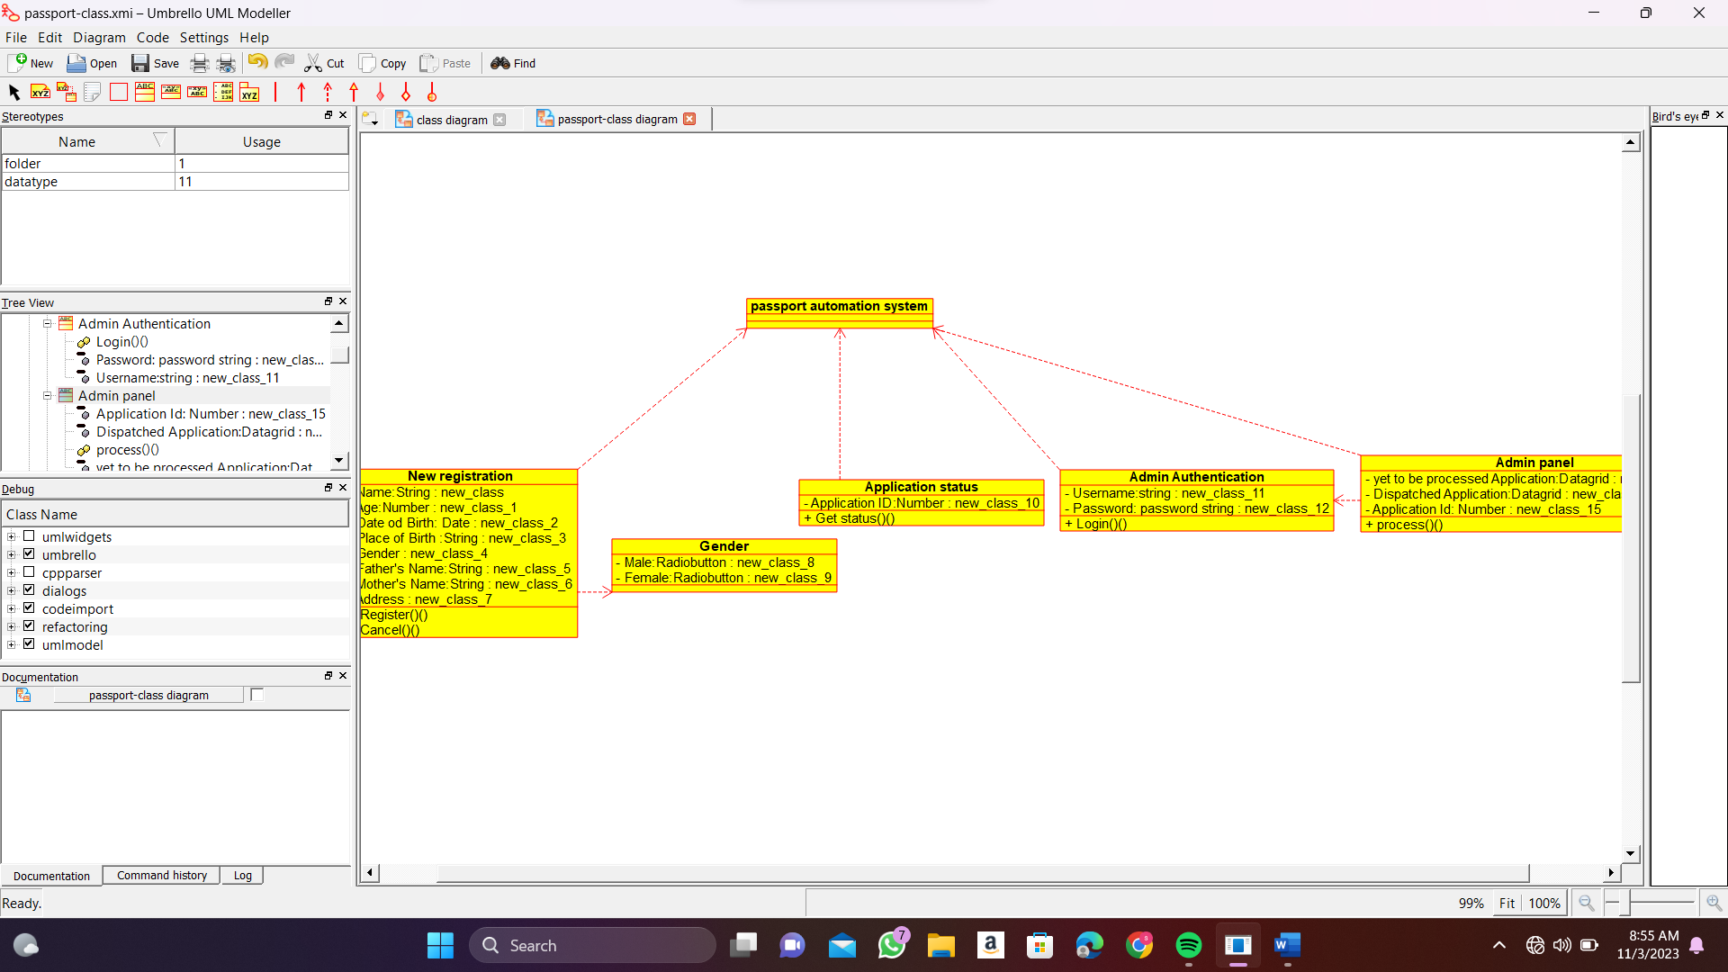

ACTIVITY DIAGRAM:

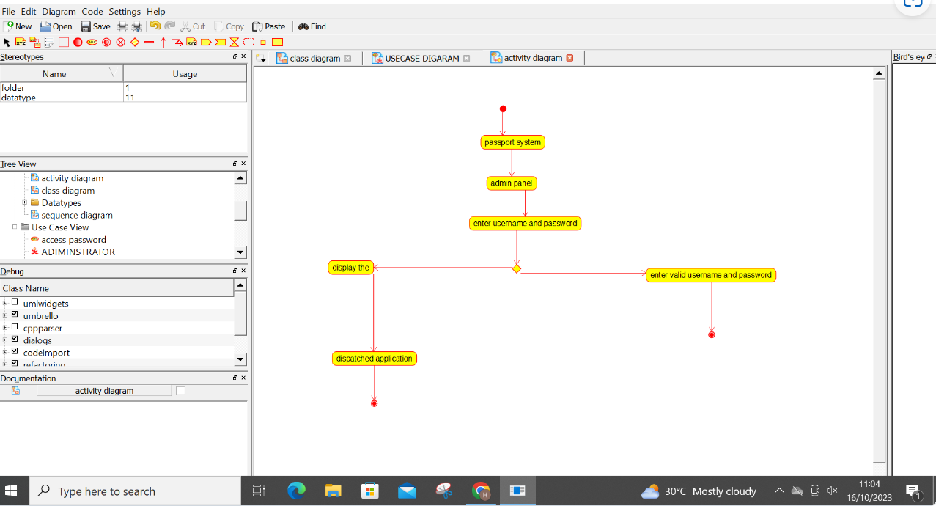

USECASE DIAGRAM:

