NAME-B.SIRI SAHITHI

REG NO-192121102

EXPERIMENT-3- BOOK BANK MANAGEMENT

CLASS DIAGRAM:

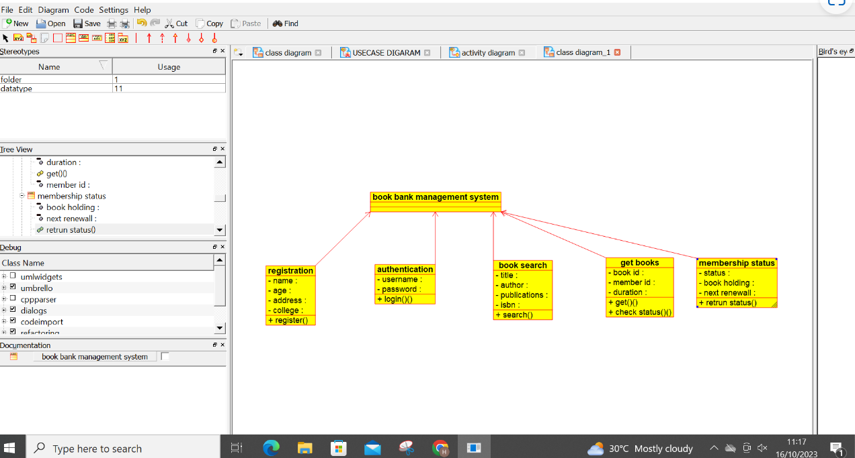

SEQUENCE DIAGRAM:

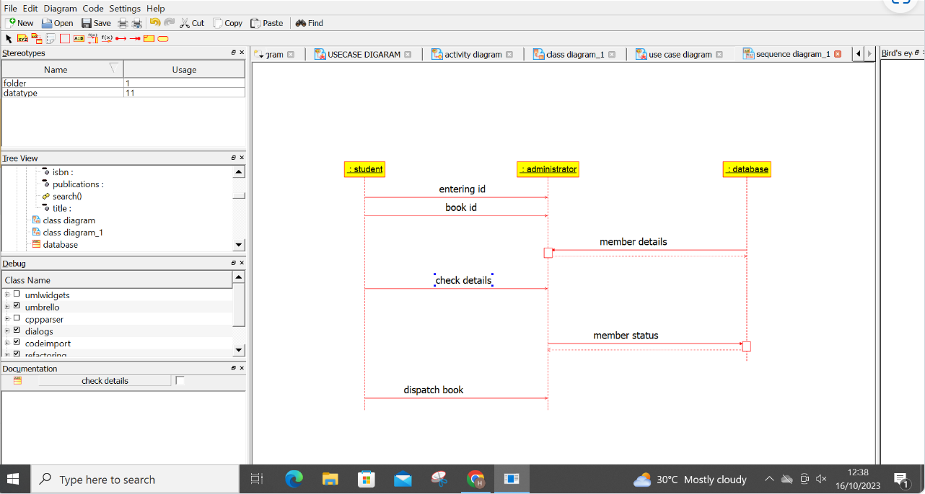

USE CASE DIAGRAM:

