NAME-B.SIRI SAHITHI

REG NO-192121102

EXPERIMENT-4-EXAM REGISTRATION PORTAL

CLASS DIAGRAM:

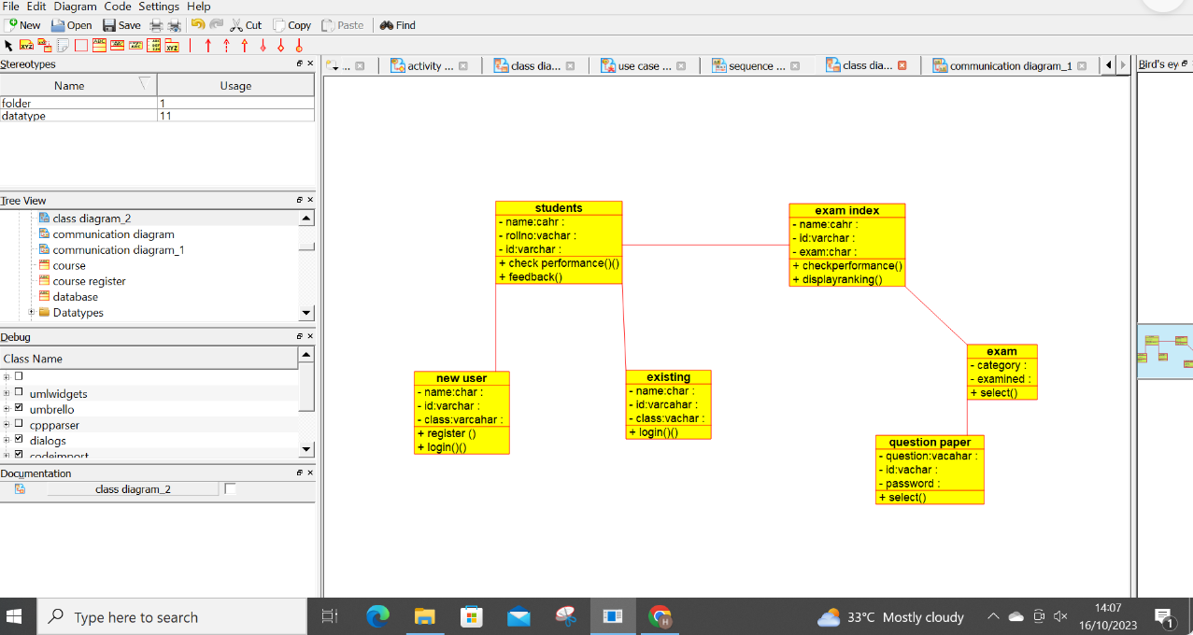

USE CASE DIAGRAM:

