NAME-B.SIRI SAHITHI

REG NO-192121102

EXPERIMENT-5-STOCK MAINTAINANCE SYSTEM

CLASS DIAGRAM:

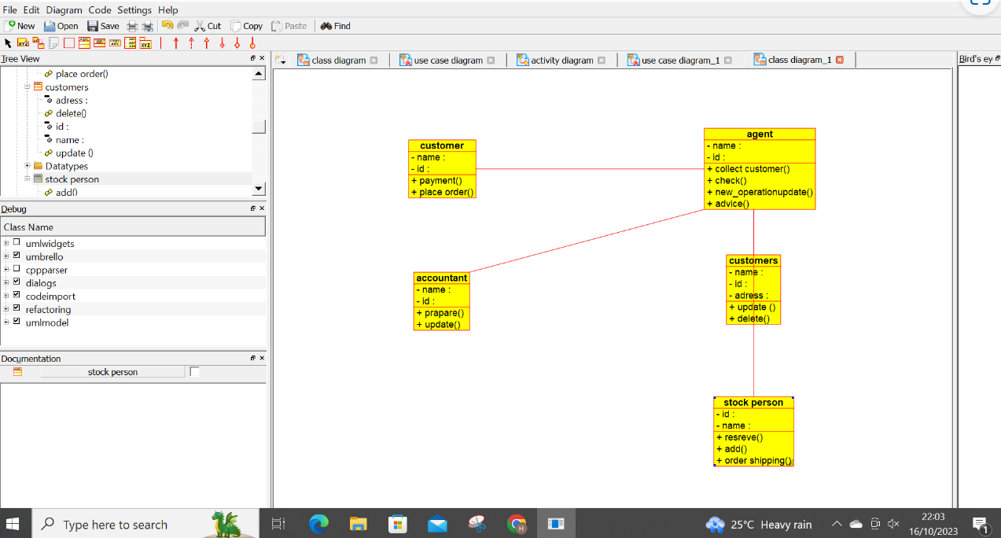

USECASE DIAGRAM:

