NAME-B.SIRI SAHITHI

REG NO-192121102

EXPERIMENT-6-ONLINE COURSE REGERVATION SYSTEM

CLASS DIAGRAM:

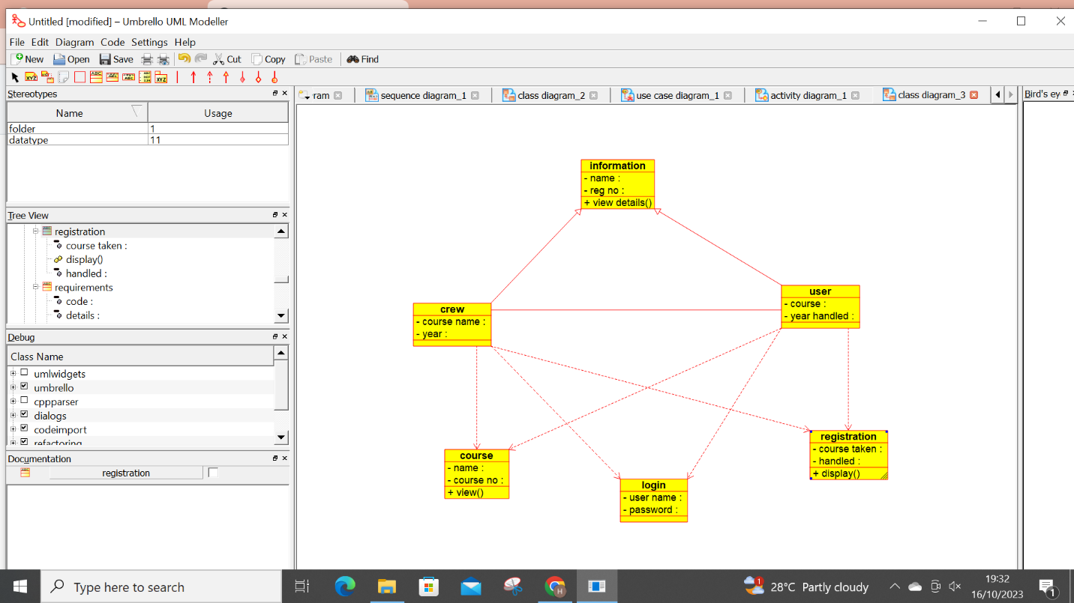

ACTIVITY DIAGRAM:

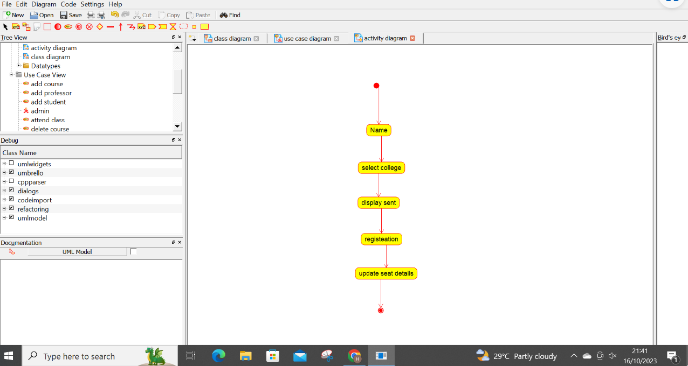

USECASE DIAGRAM:

