NAME-B.SIRI SAHITHI

REG NO-192121102

EXPERIMENT-8- Credit Card Processing System

CLASS DIAGRAM:

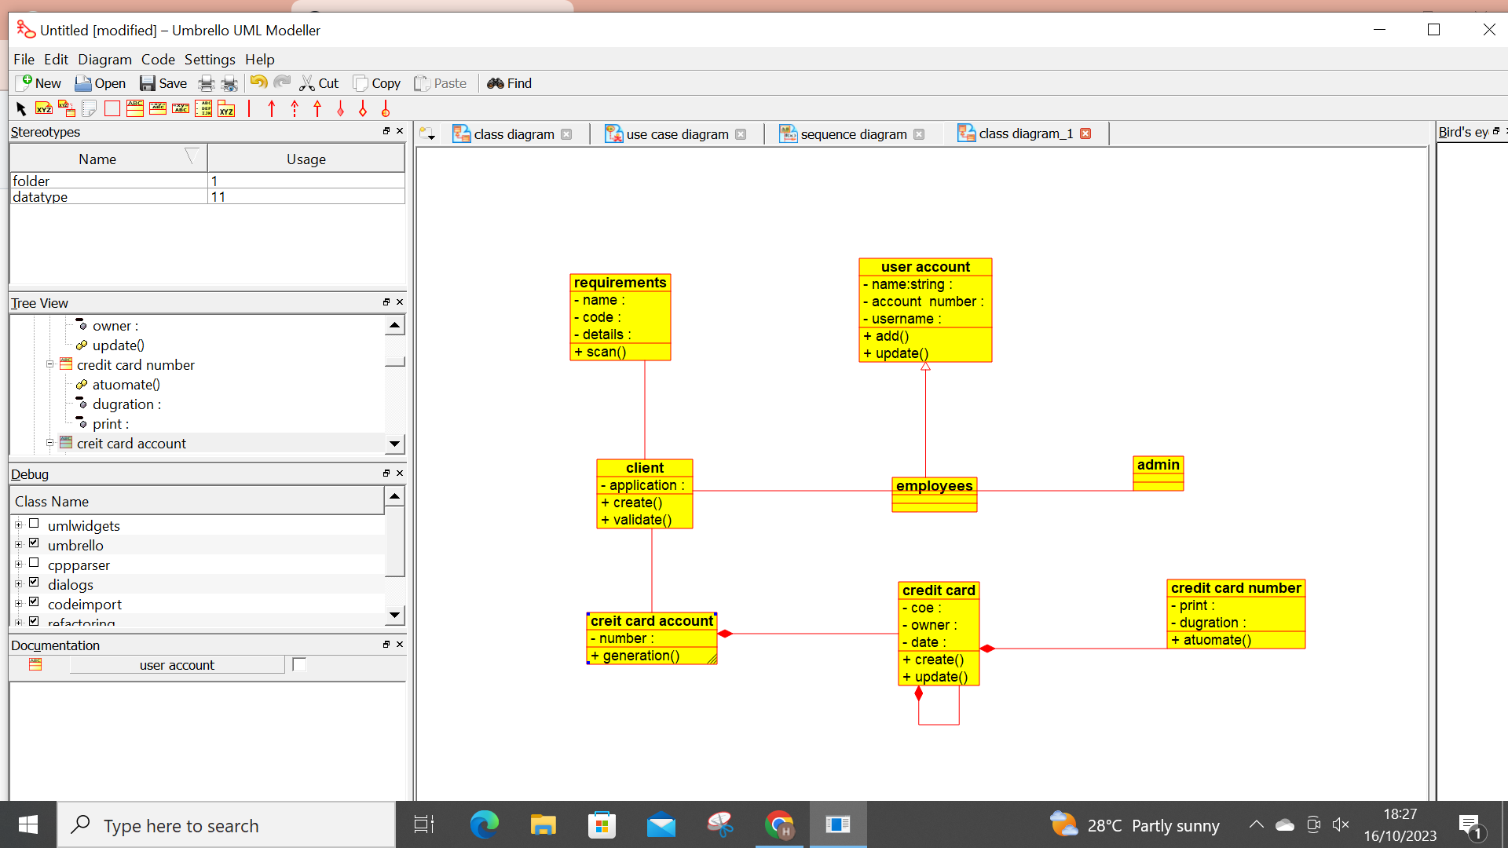

ACTIVITY DIAGRAM:

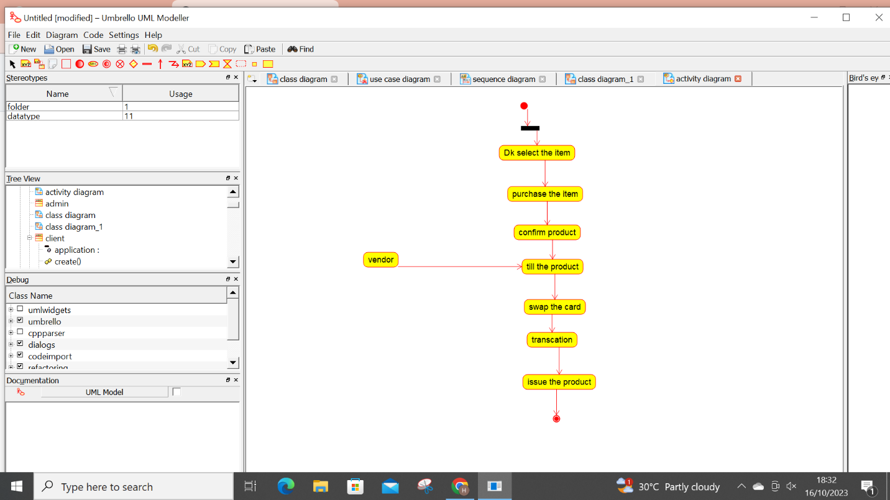

SEQUENCE DIAGRAM:

