NAME-B.SIRI SAHITHI

REG NO-192121102

EXPERIMENT- 9-Software Personnel Management System

CLASS DIAGRAM:

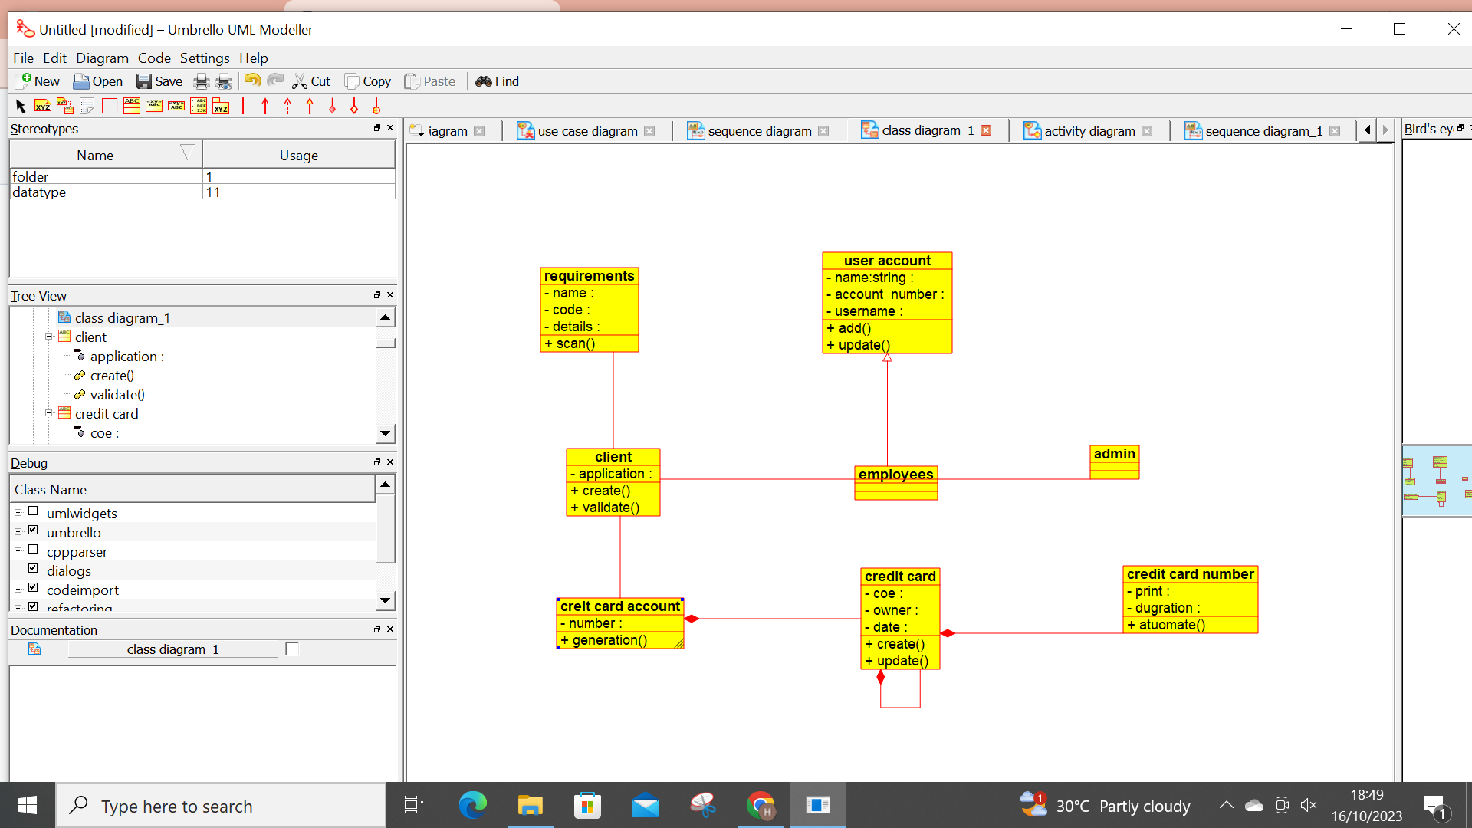

SEQUENCE DIAGRAM:

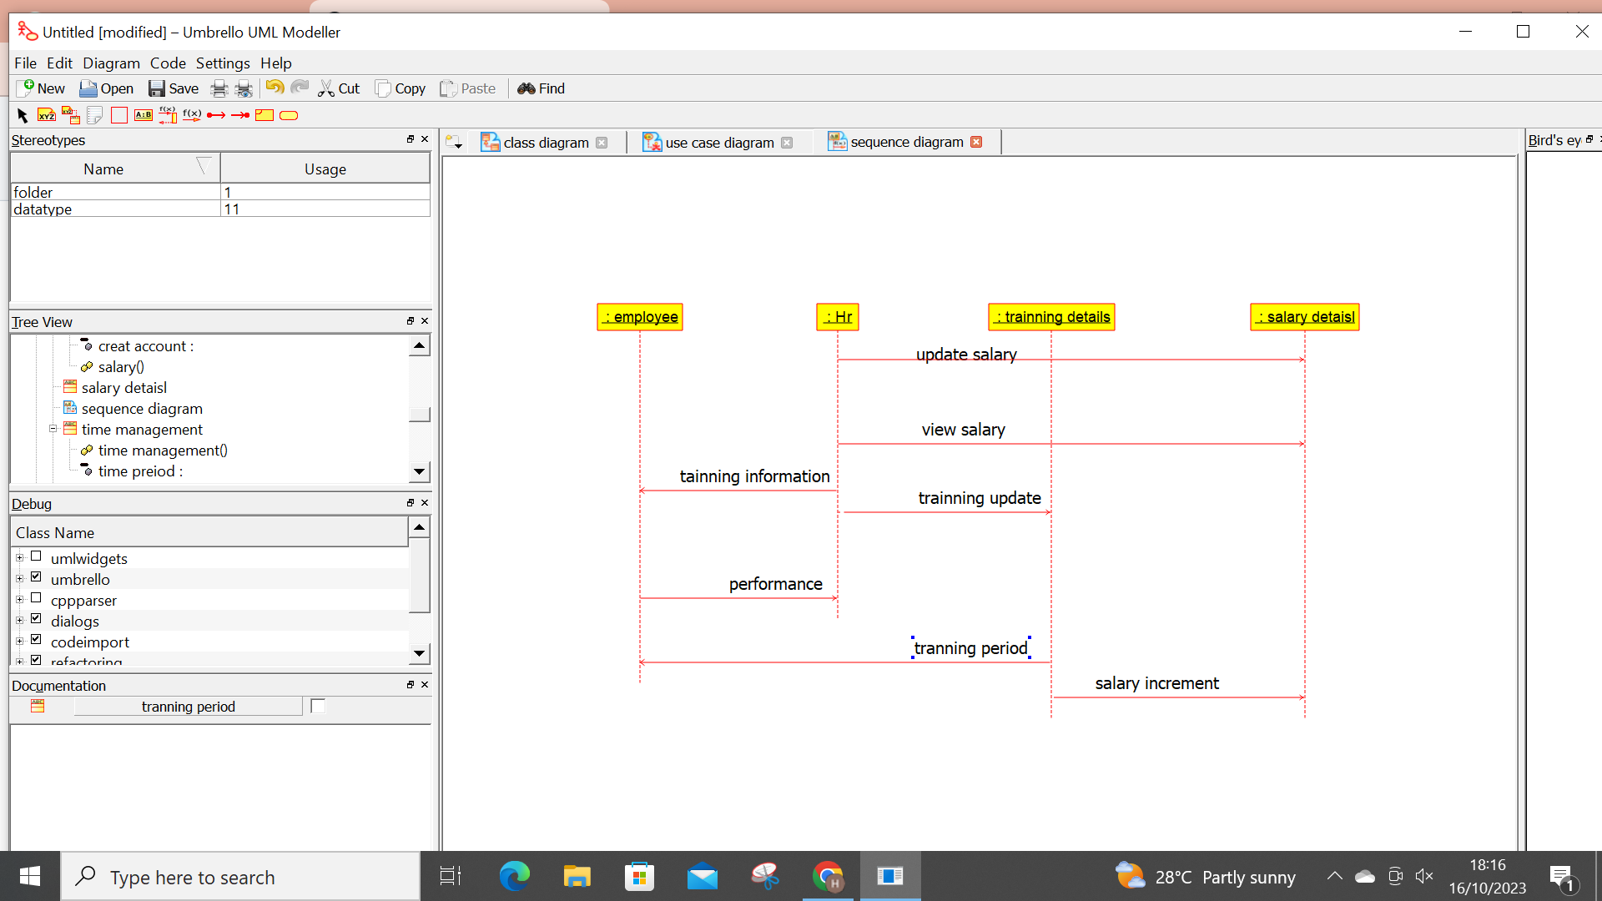

USECASE DIAGRAM:

