**EASY**

1. **PROGRAM**

#include <iostream>

using namespace std;

int main() {

const int myConstant = 10 ;

cout << "Constant value: " << myConstant <<endl;

return 0;

}

**OUTPUT:**

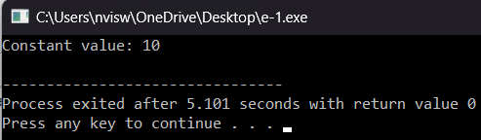

1. **PROGRAM**

#include <iostream>

using namespace std;

int main() {

int integerNumber = 10;

cout << "Integer number: " << integerNumber <<endl;

float floatNumber = 3.14;

cout << "Float number: " << floatNumber <<endl;

char character = 'A';

cout << "Character: " << character <<endl;

return 0;

}

**OUTPUT:**

#include <iostream>

using namespace std;

int main() {

int integerNumber = 10;

cout << "Integer number: " << integerNumber <<endl;

float floatNumber = 3.14;

cout << "Float number: " << floatNumber <<endl;

char character = 'A';

cout << "Character: " << character <<endl;

return 0;

}

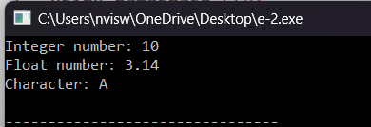

1. **PROGRAM**

#include <iostream>

using namespace std;

int main() {

int integerNumber = 10;

cout << "Integer number: " << integerNumber <<endl;

float floatNumber = 3.14;

cout << "Float number: " << floatNumber <<endl;

char character = 'A';

cout << "Character: " << character <<endl;

return 0;

}

**OUTPUT:**



1. **PROGRAM**

#include <iostream>

using namespace std;

int main() {

int integerVariable = 10;

float floatVariable;

floatVariable = integerVariable;

cout << "Integer variable: " << integerVariable <<endl;

cout << "Float variable: " << floatVariable <<endl;

return 0;

}

**OUTPUT:**

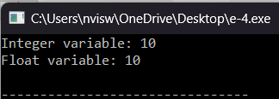

1. **PROGRAM**

#include <iostream>

using namespace std;

int main() {

int num1 = 5;

int num2 = 7;

int sum = num1 + num2;

cout << "The sum of " << num1 << " and " << num2 << " is: " << sum <<endl;

return 0;

}

**OUTPUT:**

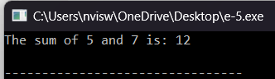

1. **PROGRAM**

#include<iostream>

using namespace std;

int main()

{

int a;

cout<<"enter the number"<<endl;

cin>>a;

if(a==0)

{

cout<<"0 is neither odd nor zero"<<endl;

return 1;

}

if(a%2==0)

{

cout<<"even number"<<endl;

}

else

{

cout<<"odd number"<<endl;

}

return 0;

}

**OUTPUT:**

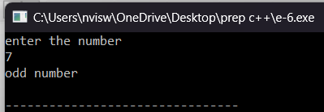

1. **PROGRAM**

#include <iostream>

using namespace std;

int main() {

int arr[] = {1, 2, 3, 4, 5};

int size = sizeof(arr) / sizeof(arr[0]);

cout << "Elements of the array:" <<endl;

for (int i = 0; i < size; ++i) {

cout << arr[i] << " ";

}

cout <<endl;

return 0;

}

**OUTPUT:**

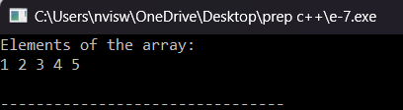

1. **PROGRAM**

#include <iostream>

using namespace std;

int main() {

int dayNumber;

cout << "Enter a number (1-7) to display the corresponding day: ";

cin >> dayNumber;

switch (dayNumber) {

case 1:

cout << "Monday" <<endl;

break;

case 2:

cout << "Tuesday" <<endl;

break;

case 3:

cout << "Wednesday" <<endl;

break;

case 4:

cout << "Thursday" <<endl;

break;

case 5:

cout << "Friday" <<endl;

break;

case 6:

cout << "Saturday" <<endl;

break;

case 7:

cout << "Sunday" <<endl;

break;

default:

cout << "Invalid input! Please enter a number between 1 and 7." <<endl;

}

return 0;

}

**OUTPUT:**

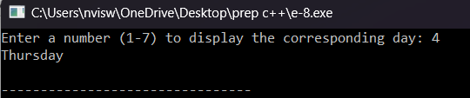

1. **PROGRAM**

#include <iostream>

using namespace std;

int main() {

double length, width;

cout << "Enter the length of the rectangle: ";

cin >> length;

cout << "Enter the width of the rectangle: ";

cin >> width;

double area = length * width;

cout << "The area of the rectangle with length " << length << " and width " << width << " is: " << area <<endl;

return 0;

}

**OUTPUT:**

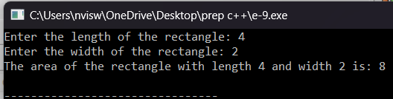

**10.PROGRAM**

#include <iostream>

using namespace std;

int main() {

int num1, num2, num3;

cout << "Enter three numbers: ";

cin >> num1 >> num2 >> num3;

int max;

if (num1 >= num2 && num1 >= num3) {

max = num1;

} else if (num2 >= num1 && num2 >= num3) {

max = num2;

} else {

max = num3;

}

cout << "The maximum of " << num1 << ", " << num2 << ", and " << num3 << " is: " << max <<endl;

return 0;

}

**OUTPUT:**

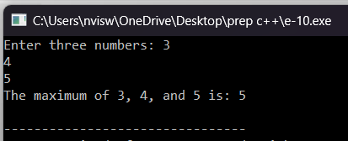

**Medium**

1. **PROGRAM**

#include <iostream>

using namespace std;

int main() {

const double PI = 3.14159;

double radius;

cout << "Enter the radius of the circle: ";

cin >> radius;

double area = PI * radius * radius;

cout << "The area of the circle with radius " << radius << " is: " << area <<endl;

return 0;

}

**Output:**

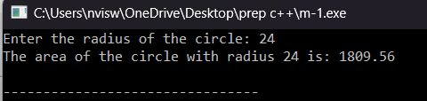

1. **PROGRAM**

#include <iostream>

using namespace std;

int main() {

int integerNumber;

int floatNumber;

cout << "Enter an integer: ";

cin >> integerNumber;

cout << "Enter a float: ";

cin >> floatNumber;

float result = floatNumber / static_cast<float>(integerNumber);

cout << "Result of division: " << result <<endl;

return 0;

}

**Output:**

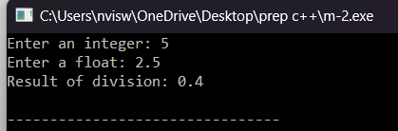

1. **PROGRAM**

#include <iostream>

using namespace std;

int main() {

int year;

cout << "Enter a year: ";

cin >> year;

if ((year % 4 == 0 && year % 100 != 0) || (year % 400 == 0)) {

std::cout << year << " is a leap year." << std::endl;

} else {

std::cout << year << " is not a leap year." << std::endl;

}

return 0;

}

**Output:**

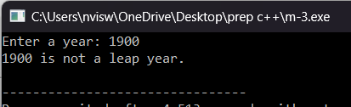

1. **PROGRAM**

#include <iostream>

using namespace std;

int main() {

double length, width;

cout << "Enter the length of the rectangle: ";

cin >> length;

cout << "Enter the width of the rectangle: ";

cin >> width;

double area = length * width;

cout << "The area of the rectangle with length " << length << " and width " << width << " is: " << area <<endl;

return 0;

}

**Output:**

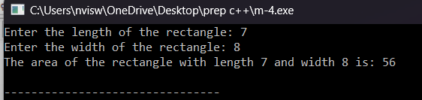

1. **PROGRAM**

#include <iostream>

using namespace std;

int main() {

int number;

cout << "Enter an integer: ";

cin >> number;

if (number & 1) {

cout << number << " is an odd number." <<endl;

} else {

cout << number << " is not an odd number." <<endl;

}

return 0;

}

**Output:**

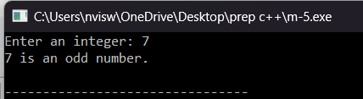

1. **PROGRAM**

#include <iostream>

using namespace std;

int main() {

int monthNumber;

cout << "Enter a month number (1-12): ";

cin >> monthNumber;

switch (monthNumber) {

case 1:

cout << "January" <<endl;

break;

case 2:

cout << "February" <<endl;

break;

case 3:

cout << "March" <<endl;

break;

case 4:

cout << "April" <<endl;

break;

case 5:

cout << "May" <<endl;

break;

case 6:

cout << "June" <<endl;

break;

case 7:

cout << "July" <<endl;

break;

case 8:

cout << "August" <<endl;

break;

case 9:

cout << "September" <<endl;

break;

case 10:

cout << "October" <<endl;

break;

case 11:

cout << "November" <<endl;

break;

case 12:

cout << "December" <<endl;

break;

default:

cout << "Invalid month number! Please enter a number between 1 and 12." <<endl;

}

return 0;

}

**Output:**

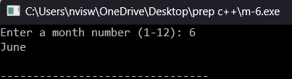

1. **PROGRAM**

#include <iostream>

using namespace std;

int main() {

const double PI = 3.14159;

double radius;

cout << "Enter the radius of the sphere: ";

cin >> radius;

double volume = (4.0 / 3.0) * PI * radius * radius * radius;

cout << "The volume of the sphere with radius " << radius << " is: " << volume <<endl;

return 0;

}

**Output:**

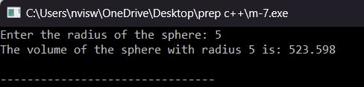

1. **PROGRAM**

#include <iostream>

using namespace std;

int main() {

int numerator, denominator;

cout << "Enter the numerator: ";

cin >> numerator;

cout << "Enter the denominator: ";

cin >> denominator;

if (denominator == 0) {

cout << "Error: Division by zero is not allowed." <<endl;

} else {

double result = static_cast<double>(numerator) / denominator;

cout << "Result of division: " << result <<endl;

}

return 0;

}

**Output:**

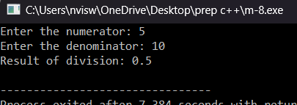

1. **PROGRAM**

#include <iostream>

using namespace std;

class Complex {

private:

double real;

double imaginary;

public:

Complex(double r = 0.0, double i = 0.0) : real(r), imaginary(i) {}

Complex operator+(const Complex& other) const {

return Complex(real + other.real, imaginary + other.imaginary);

}

Complex operator-(const Complex& other) const {

return Complex(real - other.real, imaginary - other.imaginary);

}

void display() const {

cout << real << " + " << imaginary << "i";

}

};

int main() {

Complex c1(2.5, 3.0);

Complex c2(1.5, 2.0);

Complex sum = c1 + c2;

cout << "Sum: ";

sum.display();

cout << std::endl;

Complex diff = c1 - c2;

cout << "Difference: ";

diff.display();

cout <<endl;

return 0;

}

**Output:**

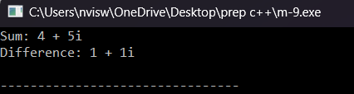

1. **PROGRAM**

#include <iostream>

using namespace std;

int main() {

int number;

unsigned long long factorial = 1;

cout << "Enter a number: ";

cin >> number;

for (int i = 1; i <= number; ++i) {

factorial *= i;

}

cout << "Factorial of " << number << " is: " << factorial <<endl;

return 0;

}

**Output:**

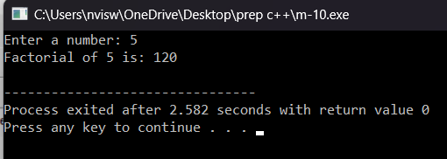

**Hard**

1. **PROGRAM**

#include <iostream>

using namespace std;

int fibonacci(int n) {

if (n <= 1) {

return n;

} else {

return fibonacci(n - 1) + fibonacci(n - 2);

}

}

int main() {

int n;

cout << "Enter the number of Fibonacci terms: ";

cin >> n;

cout << "Fibonacci sequence up to " << n << " terms:" <<endl;

for (int i = 0; i < n; ++i) {

cout << fibonacci(i) << " ";

}

cout <<endl;

return 0;

}

**Output:**

