AI ASSISTED CODING
ASSIGNMENT-4.2
Name: G. Siri Chandana
Ht no:2303A51505
Batch-22

Task-1: Zero-shot: Prompt AI with only the instruction. Write a Python function to determine whether a given number is prime
Prompt: ’’’write a code to check whether a given number is prime or not Include the scenario if the number is less than 1, it should return 'provide a number which is greater than 1’’’
Code:
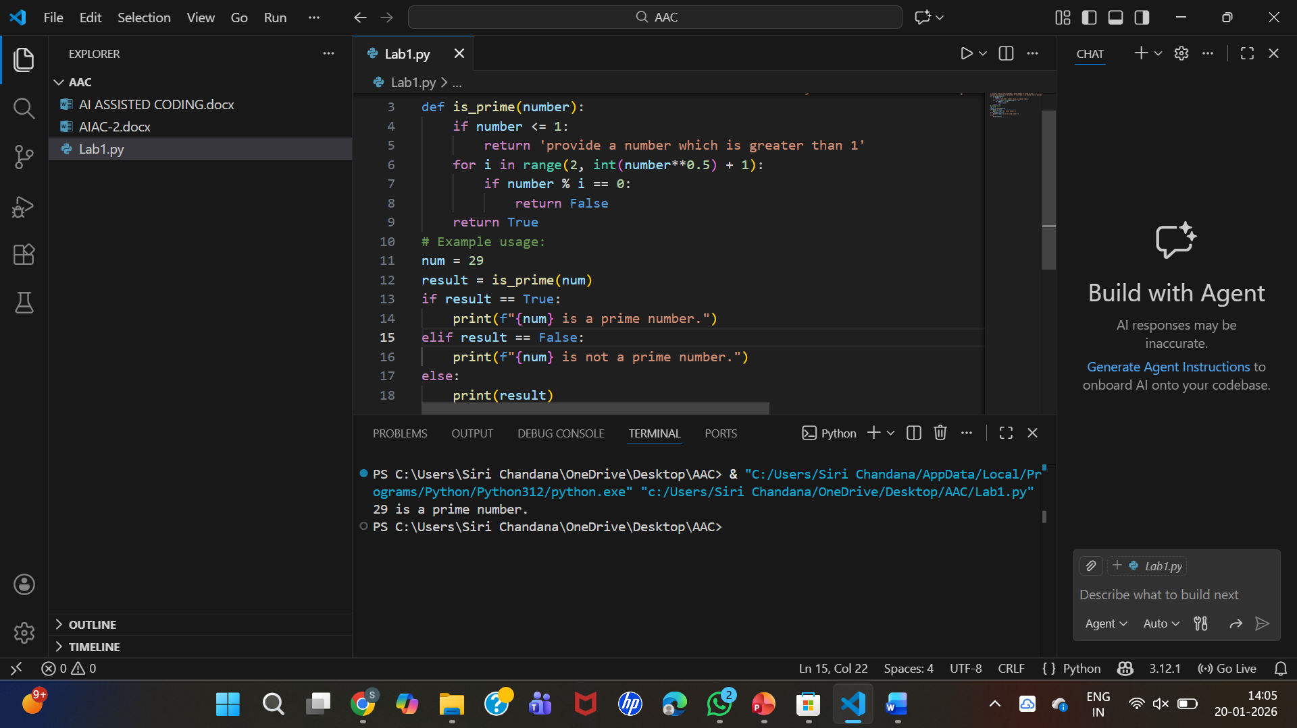

Task-2: One-shot: Provide one example: Input: [1, 2, 3, 4], Output: 10 to help AI generate a function that calculates the sum of elements in a list.
Prompt: '''
Input: [1,2,3,4]
output:10
'''
Code:
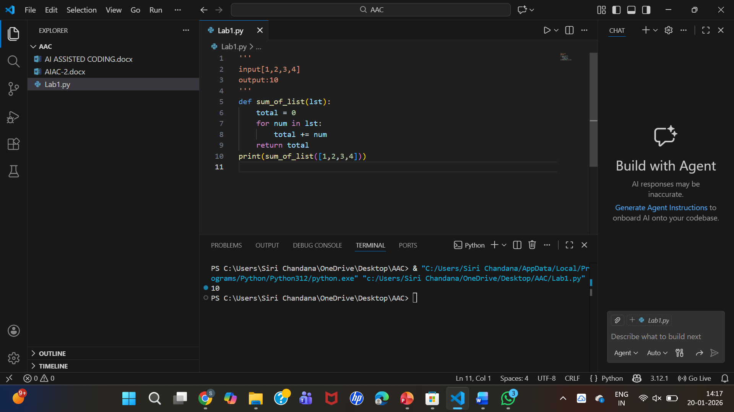
Task-3: Few-shot: Give 2–3 examples to create a function that extracts digits from an
alphanumeric string
Prompt: '''
input1: acde123
output1:123
input2:abc123def
output2:123
input3: hello897
output3:897
'''
Code:
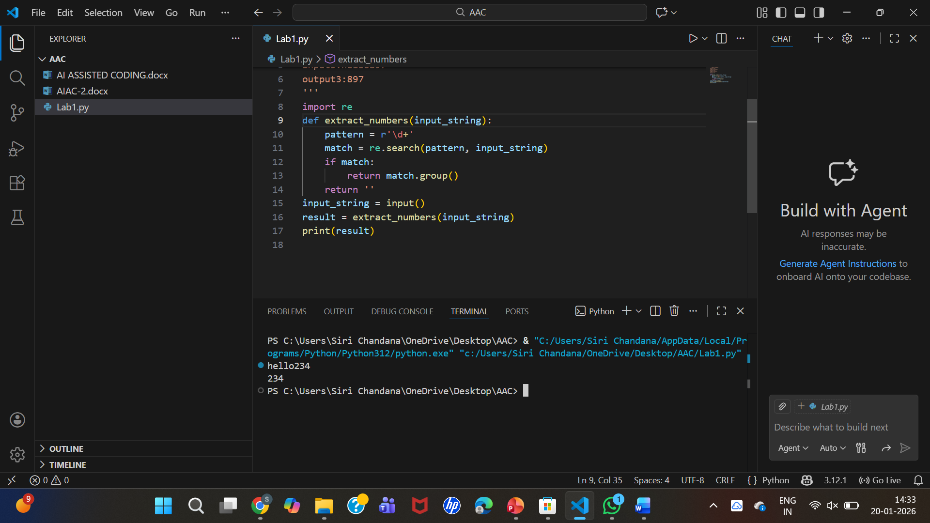
Task-4: Compare zero-shot vs few-shot prompting for generating a function that counts the
number of vowels in a string.
Zero shot programming:
Prompt: Write a function that counts the number of vowels in a given string.
Code:
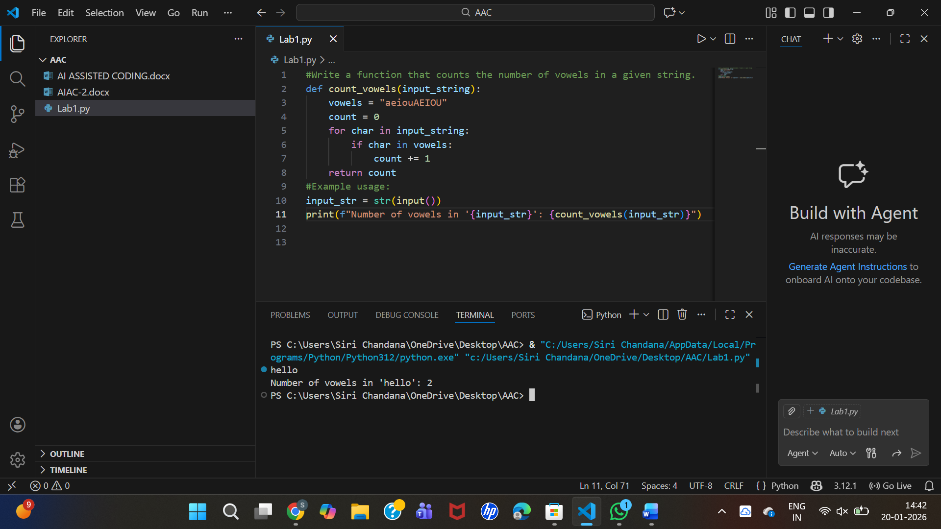

Few shot programming:
Prompt: '''
input1: hello
output1:2
input2: aeiou
output2:5
input3: siri
output3:2'''
Code:
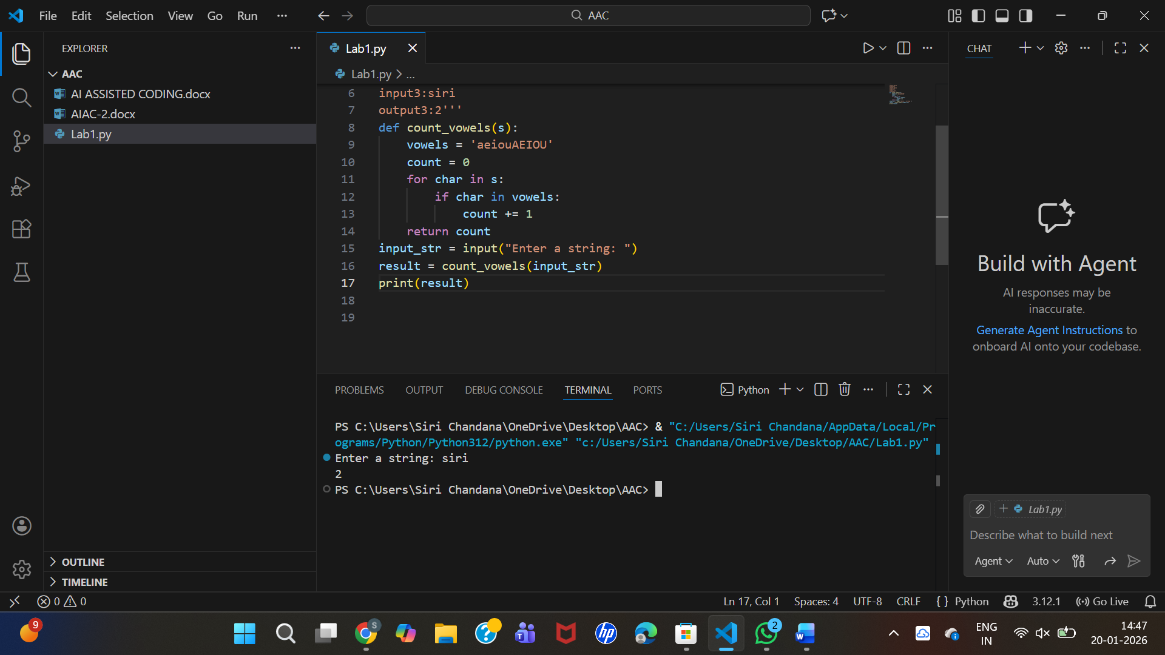
Task-5: Use few-shot prompting with 3 sample inputs to generate a function that determines
the minimum of three numbers without using the built-in min() function.
Prompt: '''Input1: a = 3, b = 7, c = 5
Output1: 3
Input2: a = -2, b = 4, c = 1
Output2: -2
Input3: a = 10, b = 10, c = 15
Output3: 10
without using min() function'''
code:
