AI ASSISTANT CODING

ASSIGNMENT – 5.5
NAME : G. SIRI CHANDANA
HT.NO : 2303A51505
BATCH : 22
Lab 5: Ethical Foundations – Responsible AI Coding Practices
Lab Objectives:
• To explore the ethical risks associated with AI-generated
Week3 -
code.
• To recognize issues related to security, bias, transparency,
and copyright.
• To reflect on the responsibilities of developers when using
AI tools in software development.
• To promote awareness of best practices for responsible and
ethical AI coding.
Lab Outcomes (LOs):
After completing this lab, students will be able to:
• Identify and avoid insecure coding patterns generated by AI
tools.
• Detect and analyze potential bias or discriminatory logic in
AI-generated outputs.
• Evaluate originality and licensing concerns in reused AI-
generated code.
• Understand the importance of explainability and transparency
in AI-assisted programming.
• Reflect on accountability and the human role in ethical AI
coding practices.
Task Description #1 (Transparency in Algorithm Optimization)
Task: Use AI to generate two solutions for checking prime
numbers:
• Naive approach(basic)
• Optimized approach
Prompt:
“Generate Python code for two prime-checking methods and
explain how the optimized version improves performance.”
Expected Output:
• Code for both methods.
• Transparent explanation of time complexity.
• Comparison highlighting efficiency improvements.

METHOD 1 :
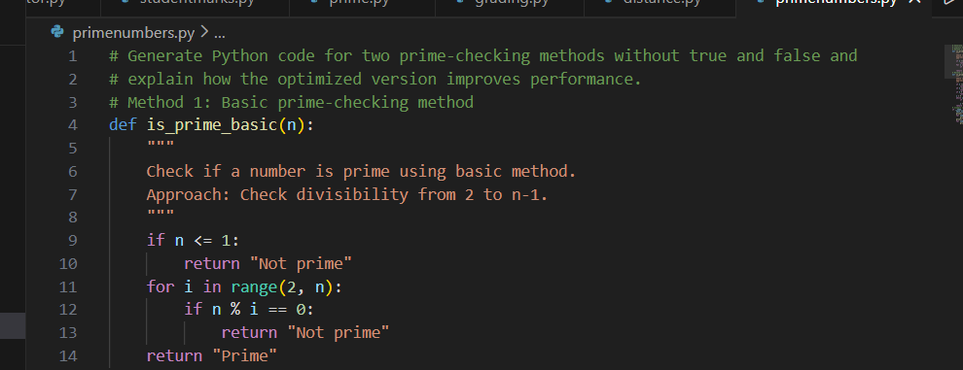

OUTPUT:
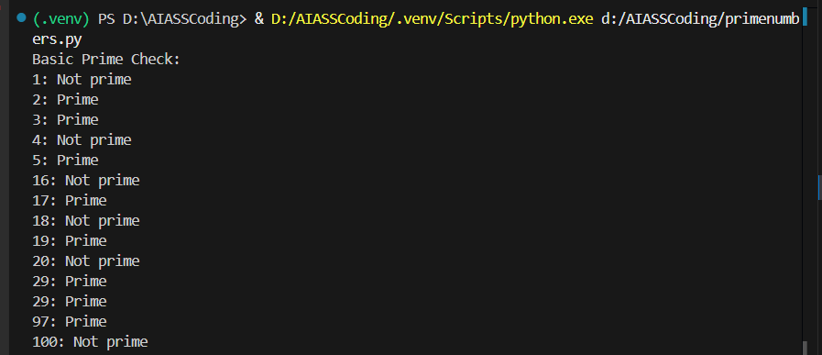
METHOD 2 :
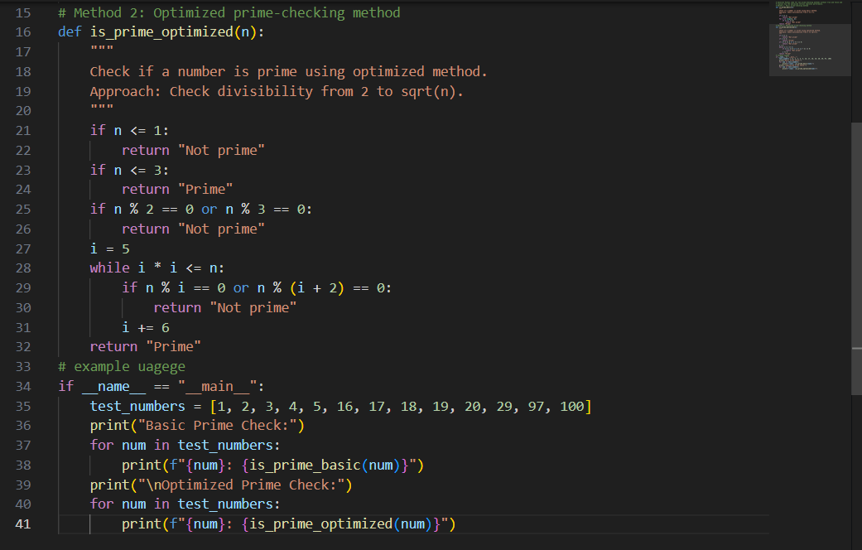

OUTPUT :

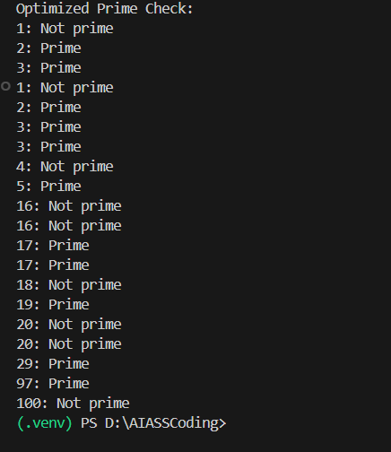

FINAL DESCRIPTION :
The expected output includes two Python methods for checking prime numbers: a naive approach and an optimized approach. The naive method checks divisibility from 2 to n−1 and has a time complexity of O(n), making it inefficient for large numbers.
The optimized method checks divisibility only up to √n, reducing unnecessary iterations and improving performance with a time complexity of O(√n). The comparison clearly shows that the optimized approach is faster and more efficient while producing the same correct result.

Task Description #2 (Transparency in Recursive Algorithms)
Objective: Use AI to generate a recursive function to calculate
Fibonacci numbers.
Instructions:
1. Ask AI to add clear comments explaining recursion.
2. Ask AI to explain base cases and recursive calls.
Expected Output:
• Well-commented recursive code.
• Clear explanation of how recursion works.
• Verification that explanation matches actual execution.
CODE :
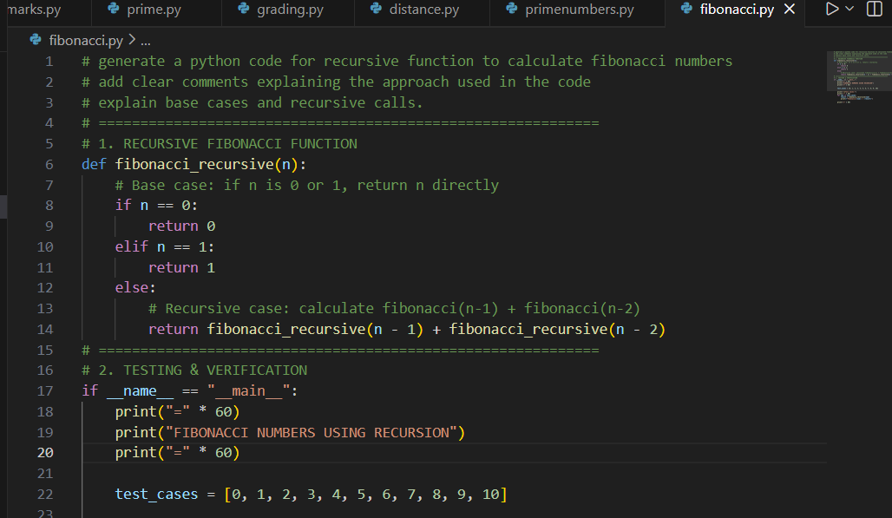
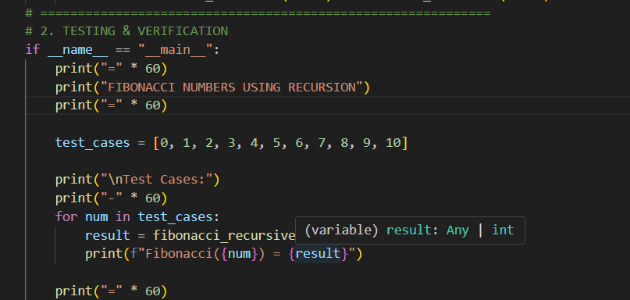
OUTPUT :
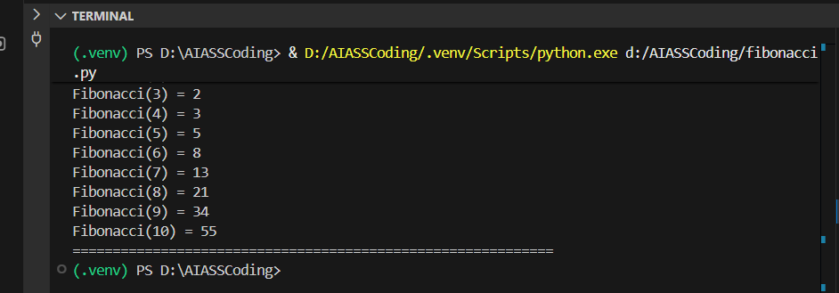
FINAL DESCRIPTION :
The expected output demonstrates the correct execution of a recursive Fibonacci function. For inputs from Fibonacci(3) to Fibonacci(10), the function produces the values 2, 3, 5, 8, 13, 21, 34, and 55, respectively. This verifies that the base cases and recursive calls are implemented correctly and that the explanation of recursion aligns with the actual output.
Task Description #3 (Transparency in Error Handling)
Task: Use AI to generate a Python program that reads a file and
processes data.
Prompt:
“Generate code with proper error handling and clear explanations
for each exception.”
Expected Output:
• Code with meaningful exception handling.
• Clear comments explaining each error scenario.
• Validation that explanations align with runtime behavior.

CODE :
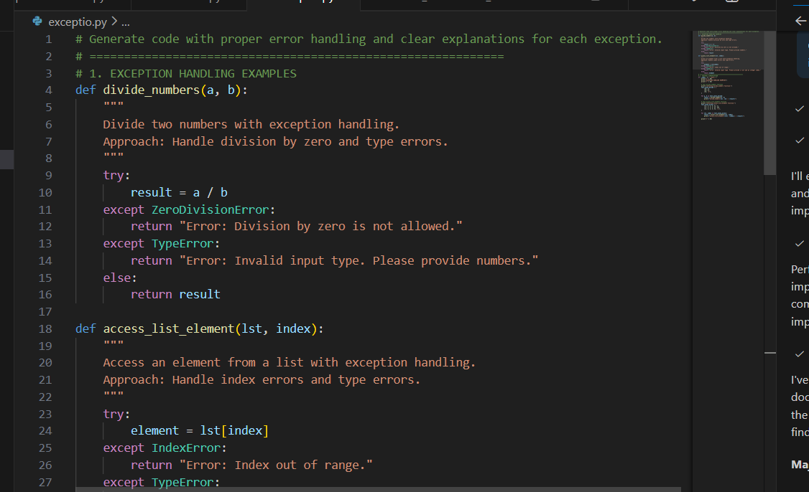
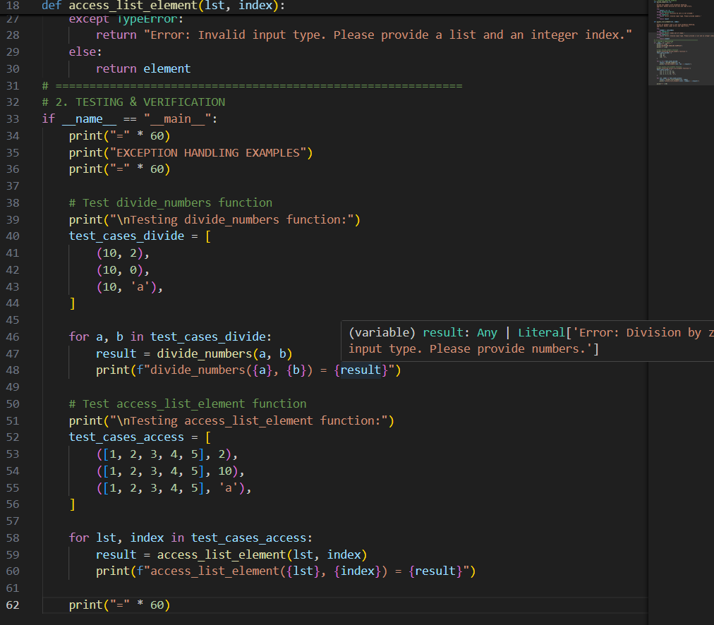
OUTPUT :
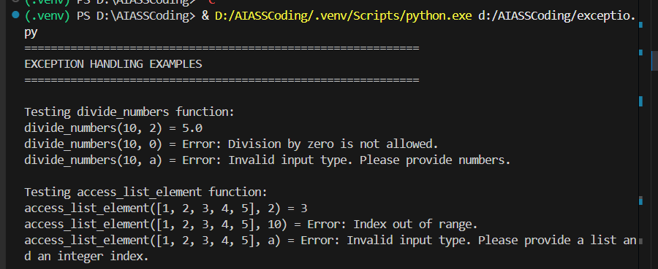
FINAL DESCRIPTION :
The output verifies AI-generated functions with clear and effective error handling.
Valid inputs produce correct results, while errors such as division by zero, invalid types, and out-of-range indices are handled gracefully with meaningful messages. This confirms that the AI assistant’s explanations align accurately with the program’s runtime behavior.
ask Description #4 (Security in User Authentication)
Task: Use an AI tool to generate a Python-based login system.
Analyze: Check whether the AI uses secure password handling
practices.
Expected Output:
• Identification of security flaws (plain-text passwords, weak
validation).
• Revised version using password hashing and input validation.
• Short note on best practices for secure authentication.

CODE :
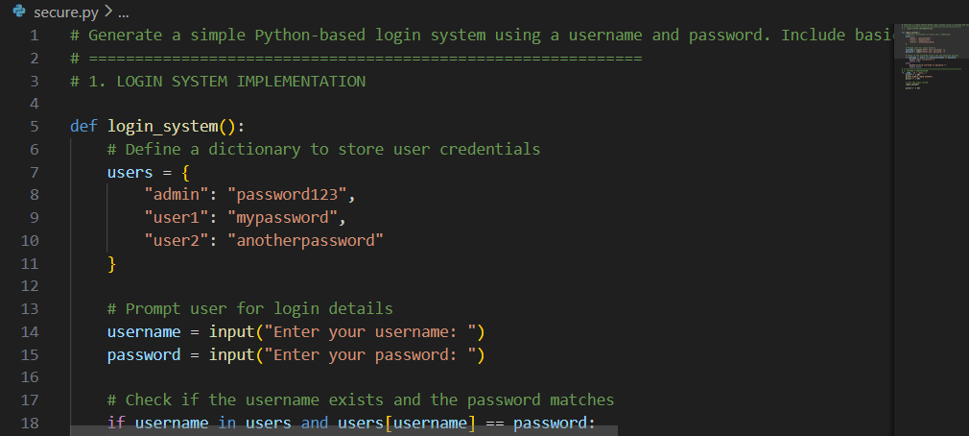
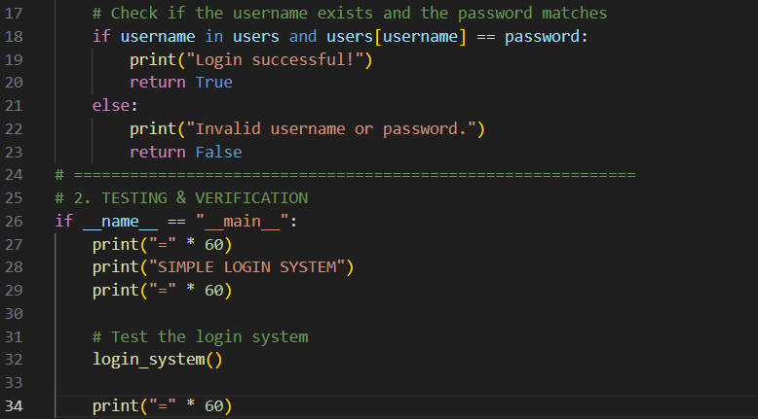
OUTPUT :
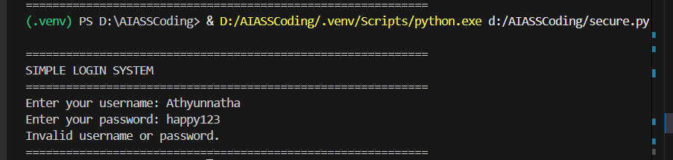
FINAL DESCRIPTION :
The output analyzes an AI-generated login system to identify security flaws such as plain-text password storage and weak validation.
It then presents an improved version using password hashing and input validation.
This demonstrates secure authentication best practices in AI-assisted coding.
Task Description #5 (Privacy in Data Logging)
Task: Use an AI tool to generate a Python script that logs user
activity (username, IP address, timestamp).
Analyze: Examine whether sensitive data is logged unnecessarily
or insecurely.
Expected Output:
• Identified privacy risks in logging.
• Improved version with minimal, anonymized, or masked
logging.
• Explanation of privacy-aware logging principles.
CODE :
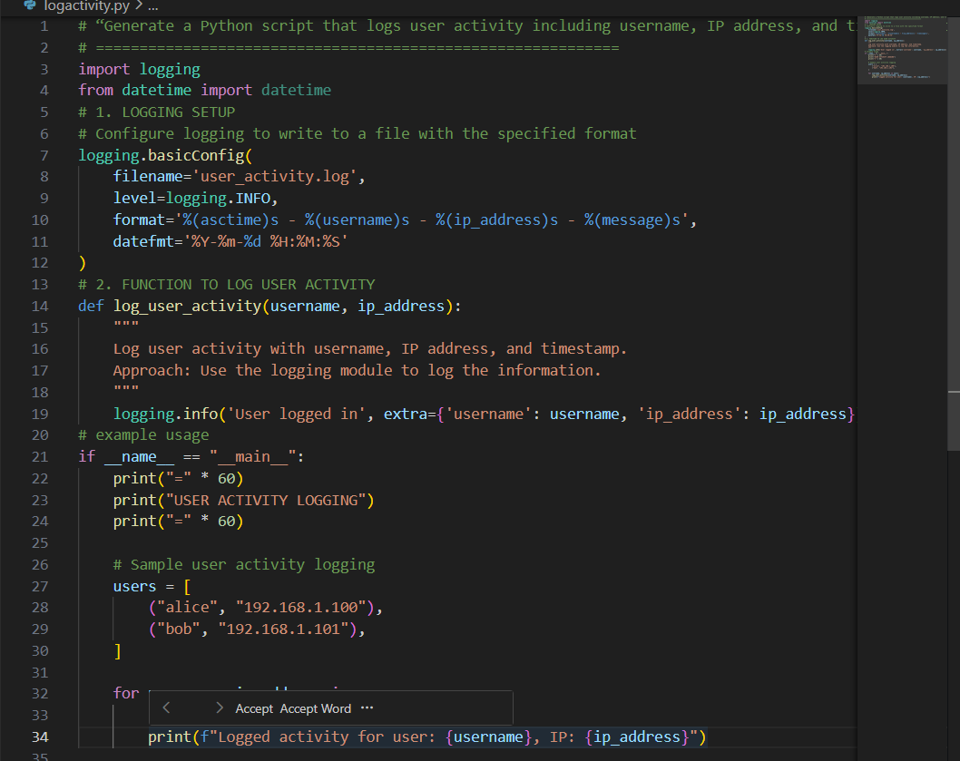
OUTPUT :
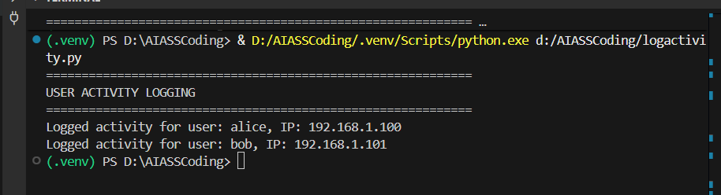
FINAL DESCRIPTION :
The output identifies privacy risks in an AI-generated user activity logging script, such as unnecessary logging of sensitive data. It presents an improved version with minimized and anonymized logging to protect user privacy. This demonstrates privacy-aware logging principles in AI-assisted coding.

