AI ASSISTED CODING
ASSIGNMENT-7.5
G. SIRI CHANDANA
2303A51505
BATCH-22
Task-1: Analyse given code where a mutable default argument causes unexpected
behaviour. Use AI to fix it.
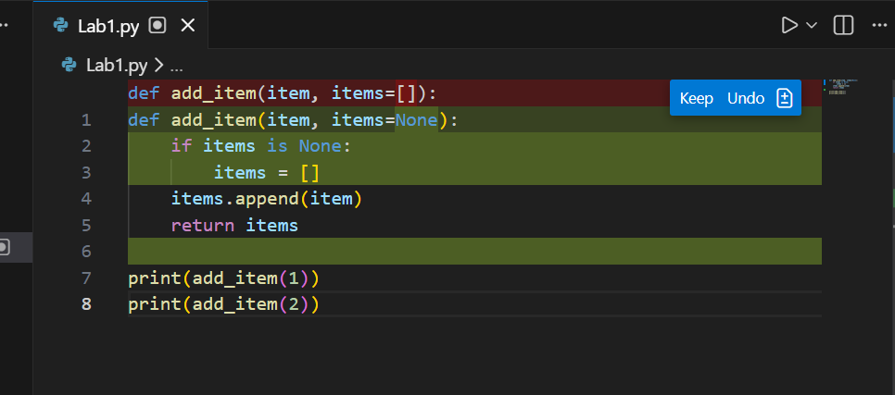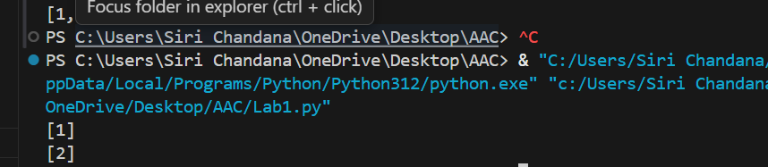
Task-2: Analyse given code where floating-point comparison fails. Use AI to correct with tolerance.
Screenshot:
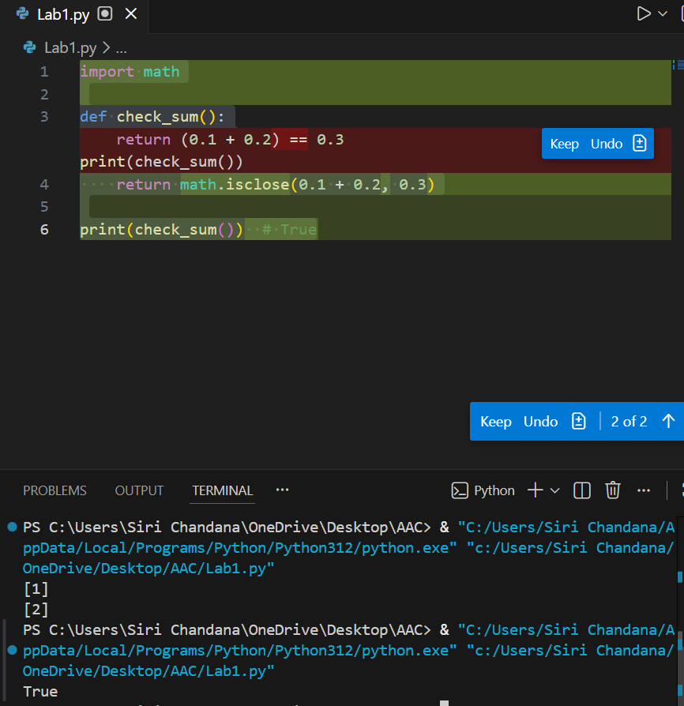

Task-3: Analyse given code where recursion runs infinitely due to missing base case. Use AI to fix.
Screenshot:
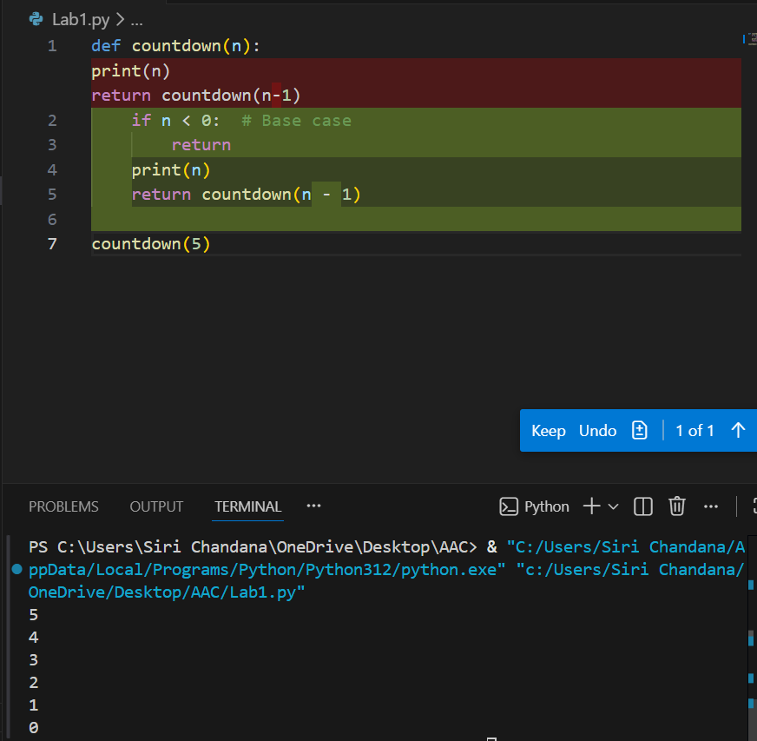

Task-4: Analyse given code where a missing dictionary key causes error. Use AI to fix it.
Screenshot:
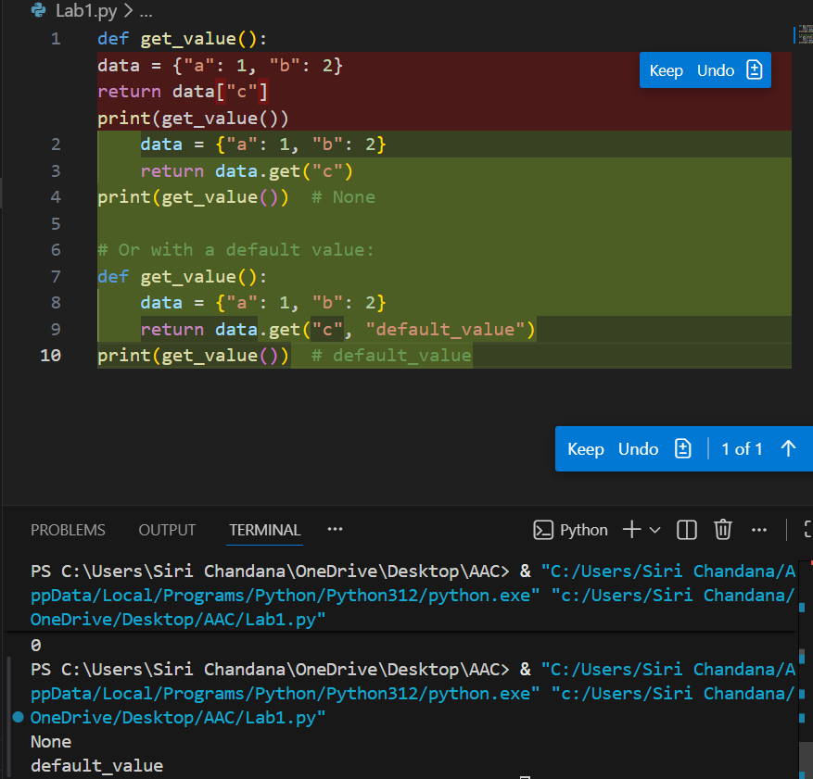

Task-5: Analyse given code where loop never ends. Use AI to detect and fix it.
Screenshot:
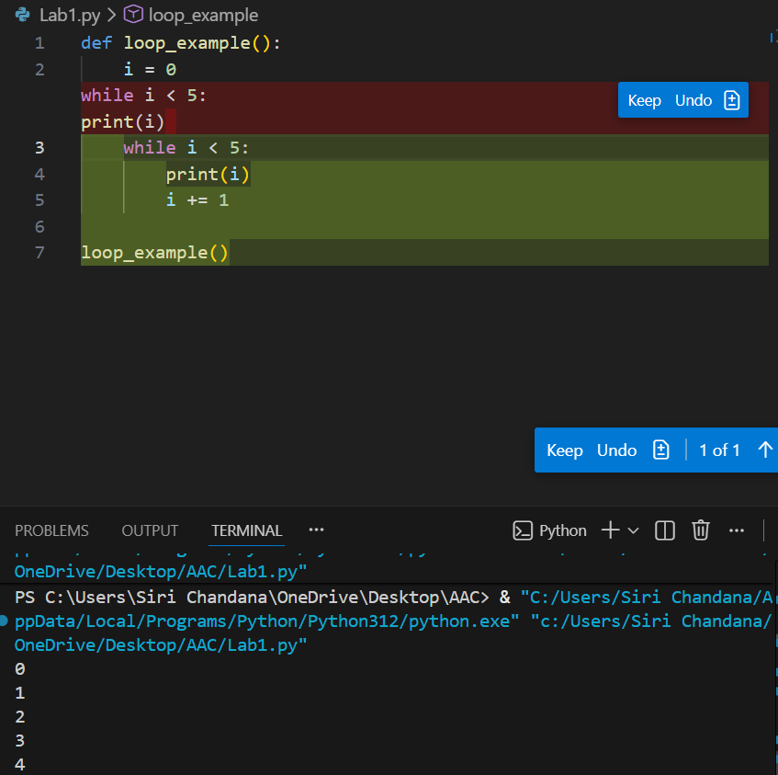

Task-6: Analyse given code where tuple unpacking fails. Use AI to fix it.
Screenshot:
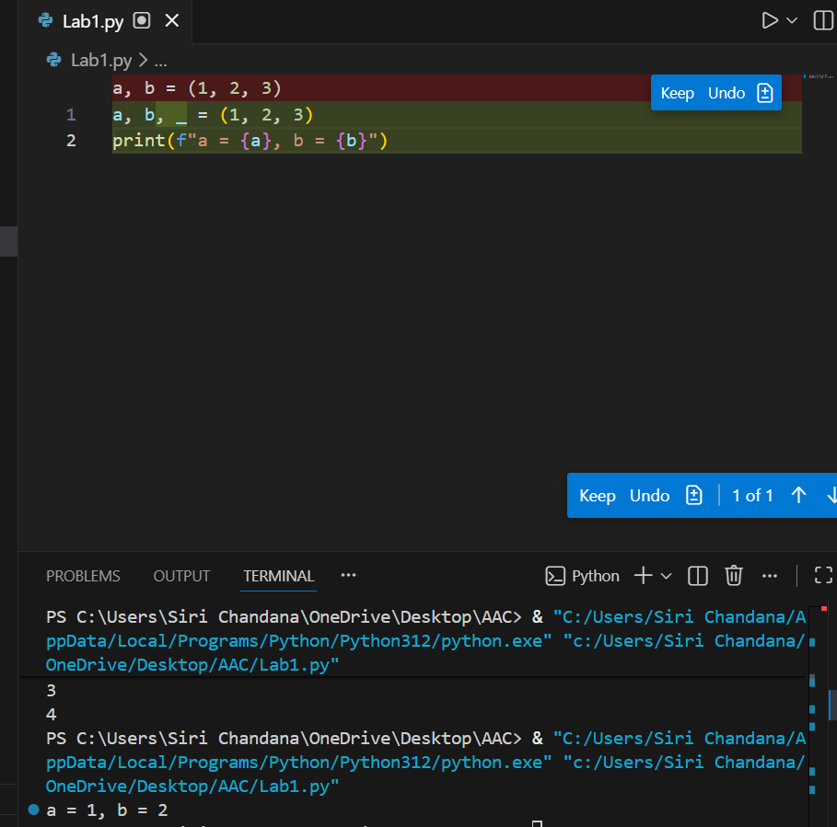

Task-7: Analyse given code where mixed indentation breaks execution. Use AI to fix it.
Screenshot:
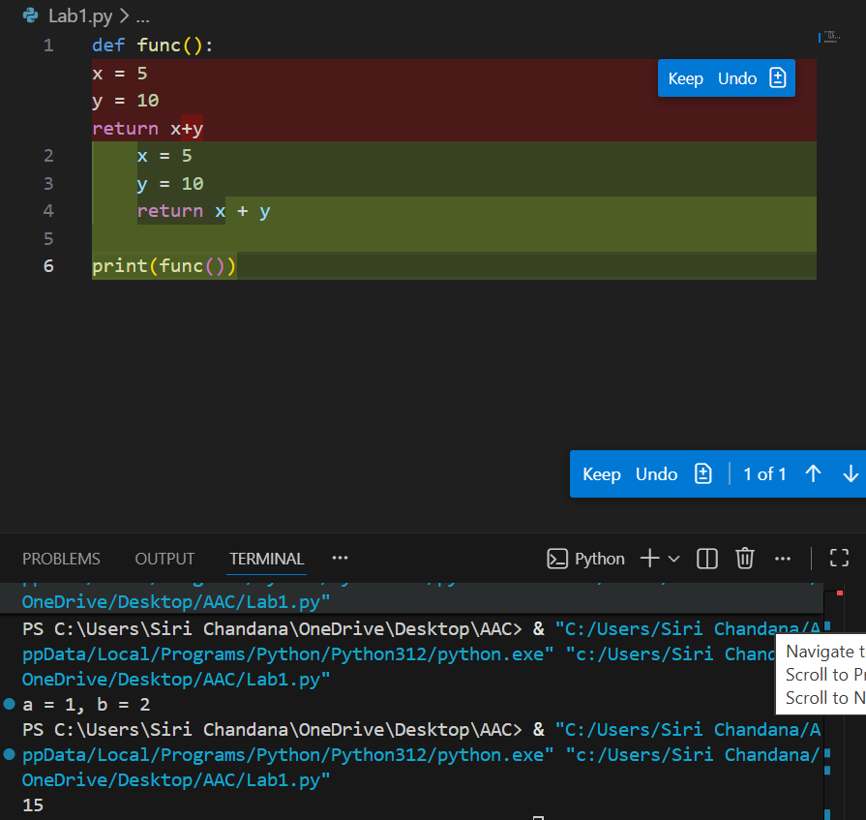

Task-8: Analyse given code with incorrect import. Use AI to fix.
Screenshot:
