Problem statement
There are n cities. Some of them are connected, while some are not. If city a is connected directly with city b, and city b is connected directly with city c, then city a is connected indirectly with city c.
A province is a group of directly or indirectly connected cities and no other cities outside of the group.
You are given an n x n matrix isConnected where isConnected[i][j] = 1 if the i^{th} city and the j^{th} city are directly connected, and isConnected[i][j] = 0 otherwise.
Return the total number of provinces.

Example 1:
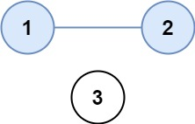
Input: isConnected = [[1,1,0],[1,1,0],[0,0,1]]
Output: 2
Example 2:
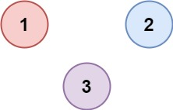
Input: isConnected = [[1,0,0],[0,1,0],[0,0,1]]
Output: 3

Logic
1. Maintain a visited array.
2. Iterate through all cities.
3. If a city is not visited:
- We've found a new province.
- Increment answer.
- Run DFS/BFS from that city and mark every reachable city as visited.
4. Continue until all cities are visited.

Code:
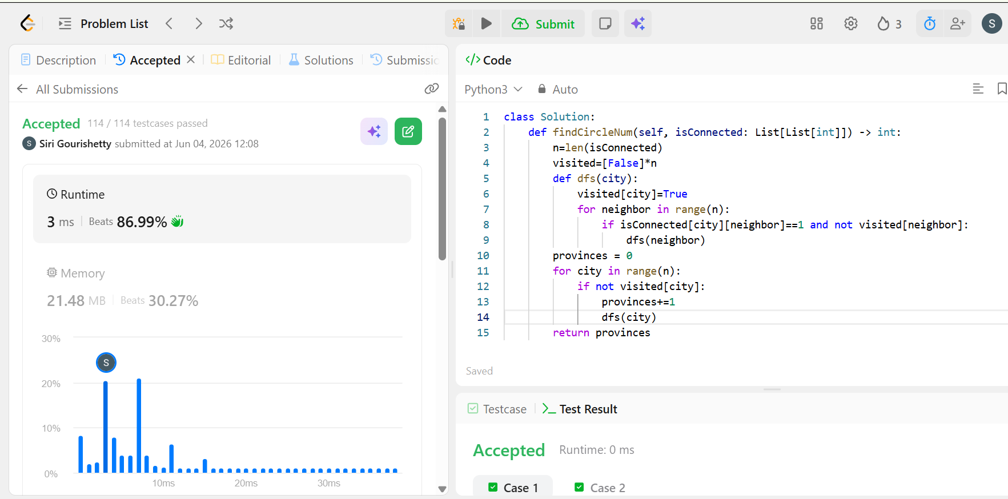

Time complexity
O(n × n) = O(n²)

