Installation Setup
1. Download Oracle VirtualBox for Windows and complete the installation.
2. Download kali linux ( https://www.kali.org/get-kali/#kali-platforms )(running inside VirtualBox)
3. Click on Virtual Machines
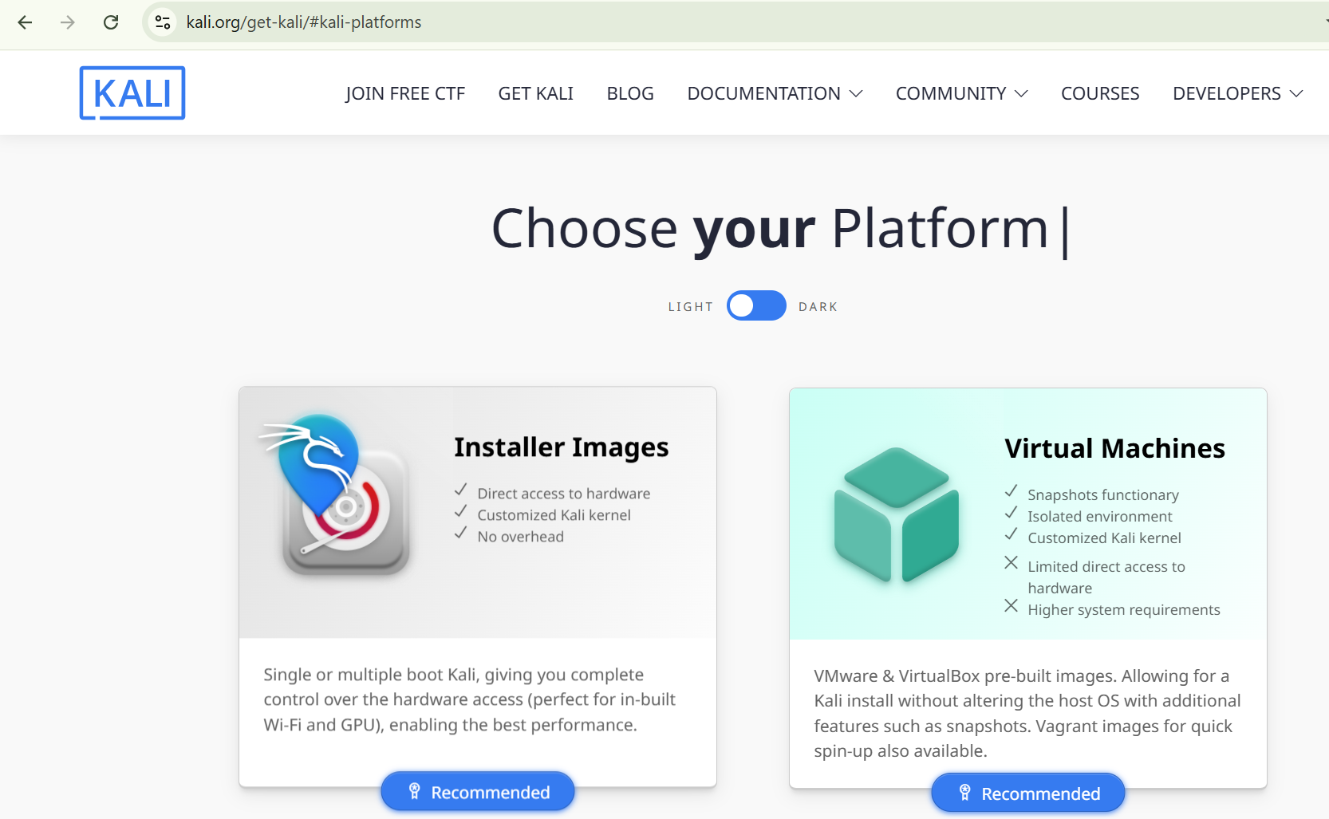
Kali Linux (running inside Virtual Box)
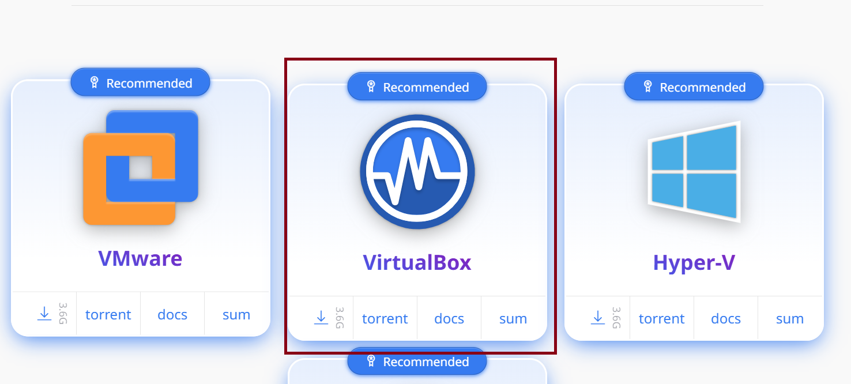
After downloading, extract the file and open it using Oracle VirtualBox, as shown in th image below.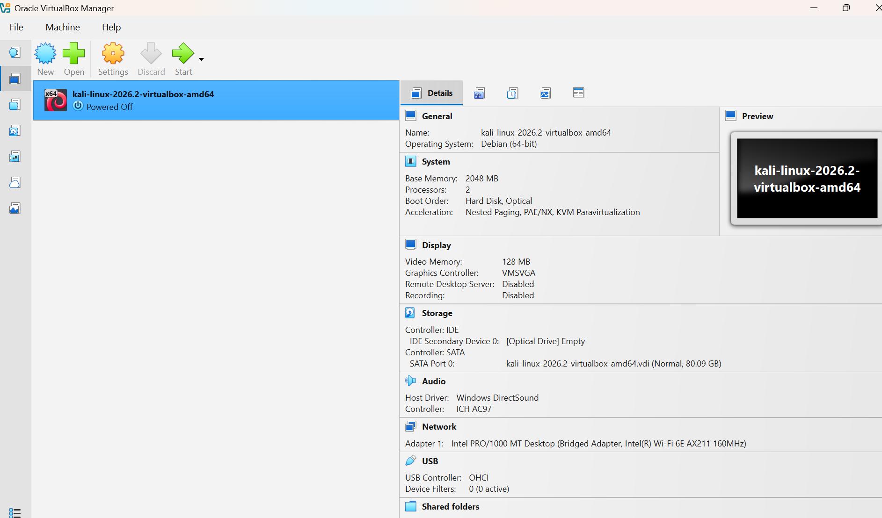
Packet Filtering and Analysis using Wireshark/Burp Suite
Aim
To capture, filter, and analyze network packets using Wireshark on Kali Linux in VirtualBox.
Procedure
- Configure VirtualBox Network for Packet Capture
  - Open VirtualBox → Kali VM → machineSettings → Network.
  - Set Adapter 1:
    - Attached to: Bridged Adapter
    - Promiscuous Mode: Allow All
    - Cable Connected: ✔️
  - Save settings.
- Start Kali Linux VM
  - Boot the Kali Linux VM in VirtualBox.
- Run Wireshark as Root (ApplicationWireshark)
sudo wireshark
- Select the network interface (eth0)
Start Packet Capture
  - Click on eth0 to begin capturing packets.
  - Generate network traffic (open websites, ping servers, or run curl commands).
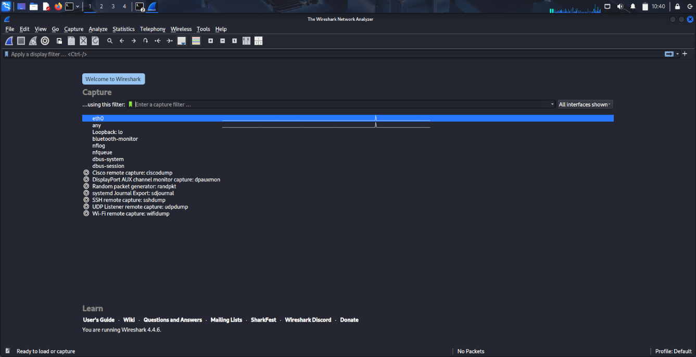
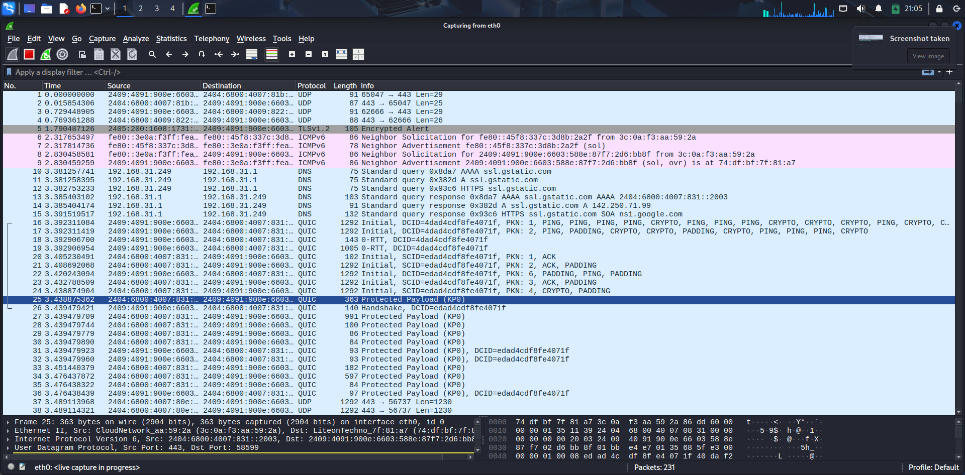
- Apply Display Filters for Analysis
Examples:
  - DNS Packets:
dns
  - HTTPS Packets:
tls
  - Packets from specific IP:
ip.addr == 18.161.216.37
  - TCP Port 443:
tcp.port == 443

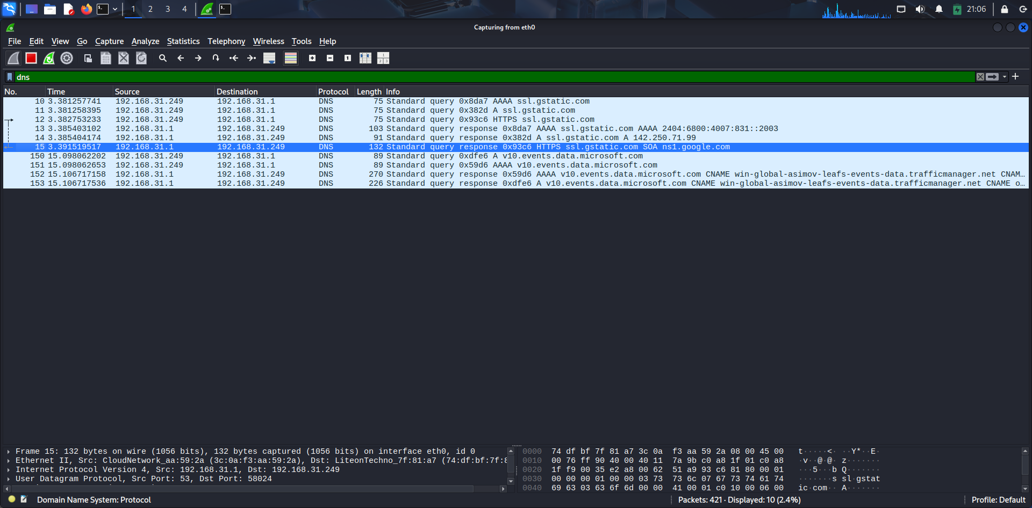
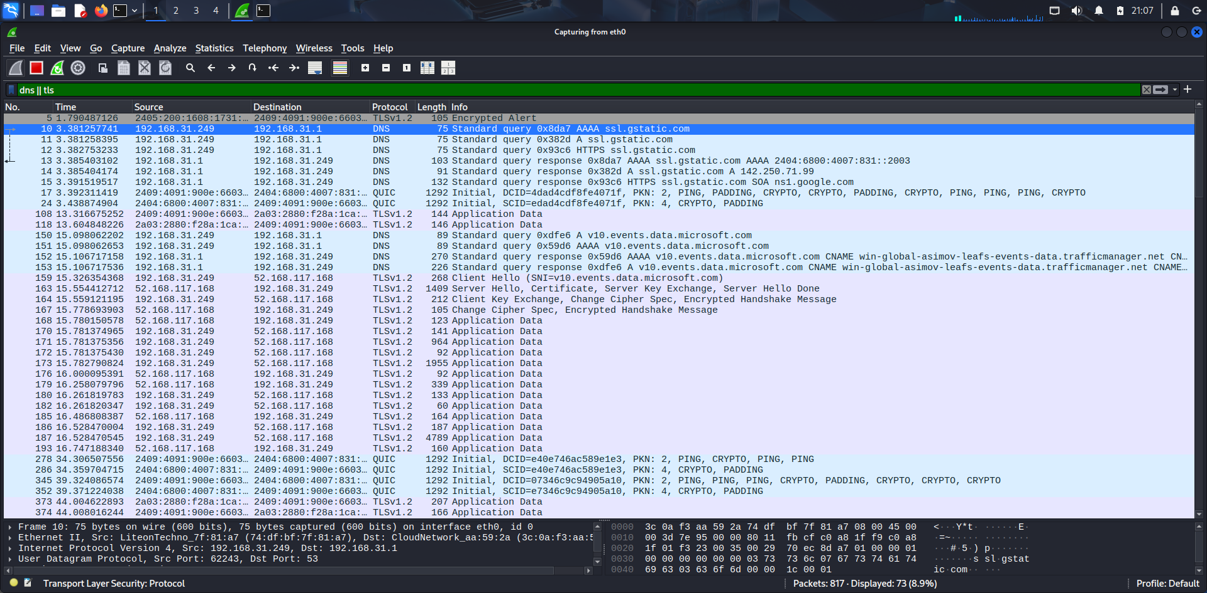
- Analyze Captured Packets
  - Select any packet and expand:
    - Ethernet Layer: Source & Destination MAC addresses
    - IP Layer: Source & Destination IP addresses
    - TCP/UDP Layer: Port numbers, flags (SYN, ACK)
    - Application Layer: Protocol details (DNS query, HTTP request, TLS handshake)
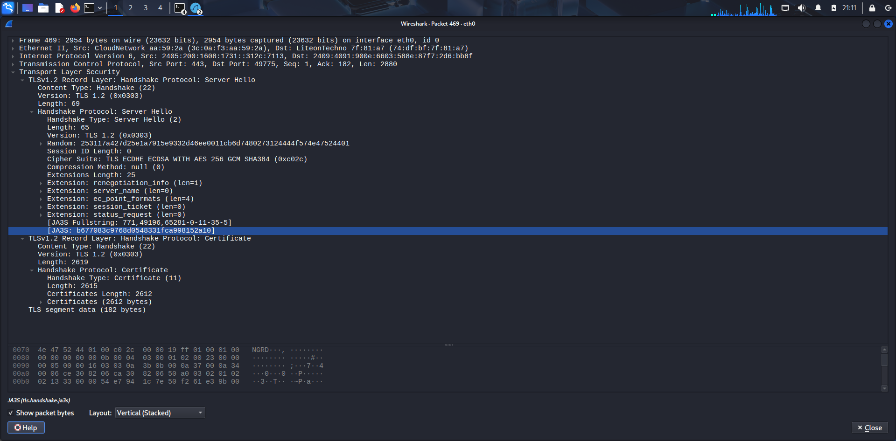
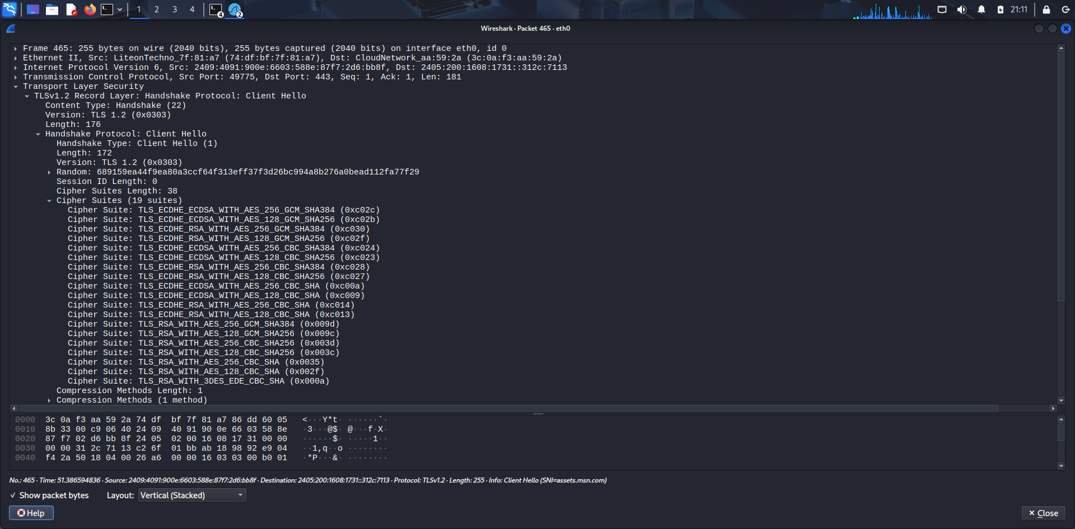
- Stop Capture and Save
Stop the packet capture by clicking the red square button.
Save capture file in .pcap format for submission.
Part B: Capturing Login Credentials over HTTP
Start the Virtual Machine (VM).
open Terminal
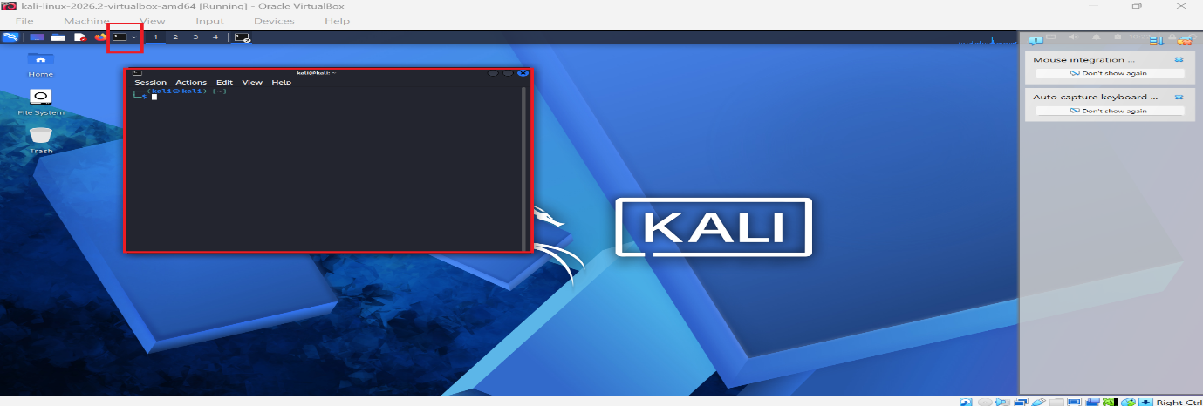
Step 1 – Setup Apache Web Server
sudo service apache2 start
sudo mkdir -p /var/www/html/testlogin
cd /var/www/html/testlogin
Step 2 – Create Login HTML Page
sudo nano login.html

html
CopyEdit
<!DOCTYPE html>
<html>
<head>
<title>Test Login Page</title>
</head>
<body>
<h2>Login Form</h2>
<form action="login.php" method="post">
Username: <input type="text" name="username"><br><br>
Password: <input type="password" name="password"><br><br>
<input type="submit" value="Login">
</form>
</body>
</html>
Save (Ctrl + O → Enter → Ctrl + X).
Step 3 – Create PHP Script
sudo nano login.php

php
CopyEdit
<?php
$username = $_POST['username'];
$password = $_POST['password'];

echo "<h2>Login Attempt</h2>";
echo "Username: " . $username . "<br>";
echo "Password: " . $password . "<br>";
?>
Step 4 – Start/Enable Apache
sudo service apache2 status
sudo service apache2 start
Step 5 – Test Page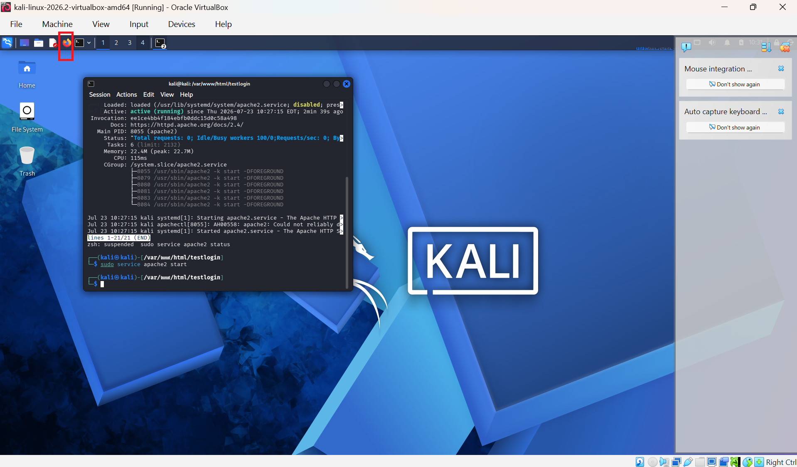
Open Firefox and browse to:http://127.0.0.1/testlogin/login.html
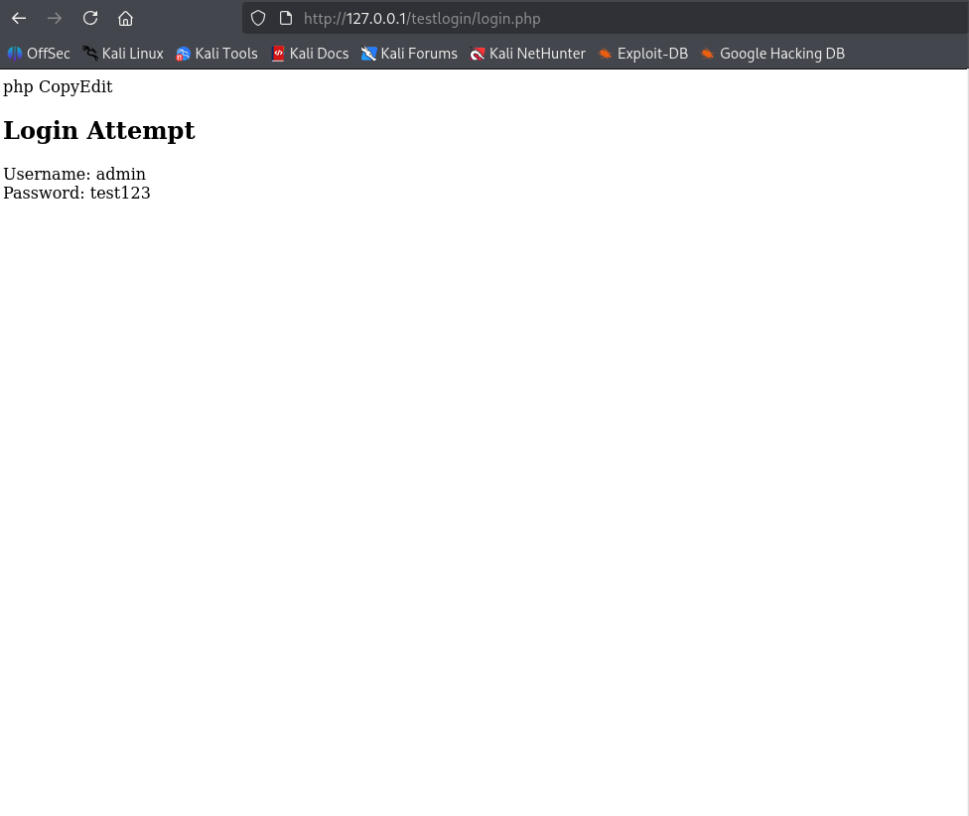
Or: Type in bash
curl http://127.0.0.1/testlogin/login.html

Step 6 – Capture with Wireshark
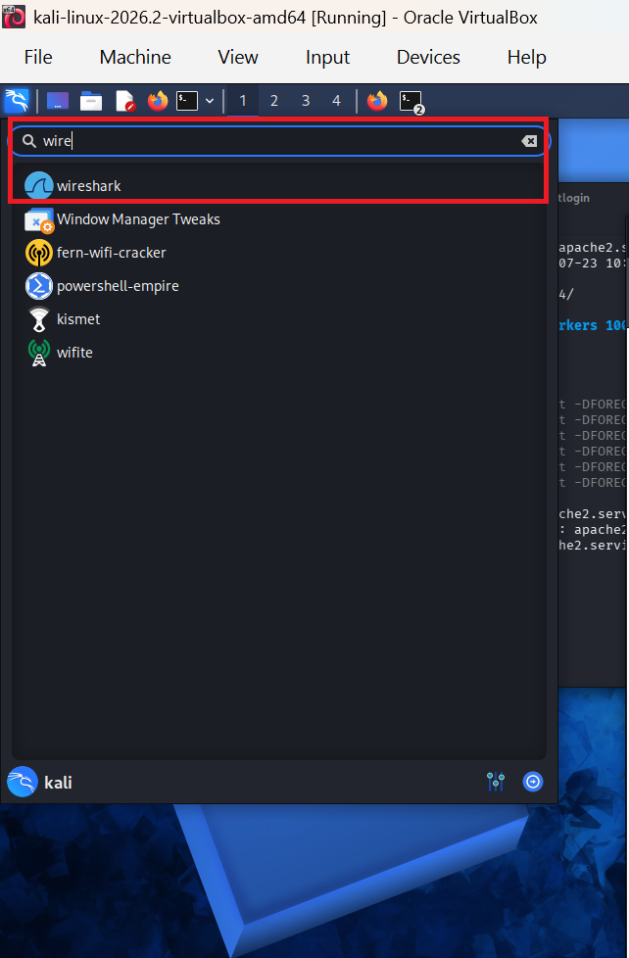
Open Wireshark and select the loopback (lo) interface.
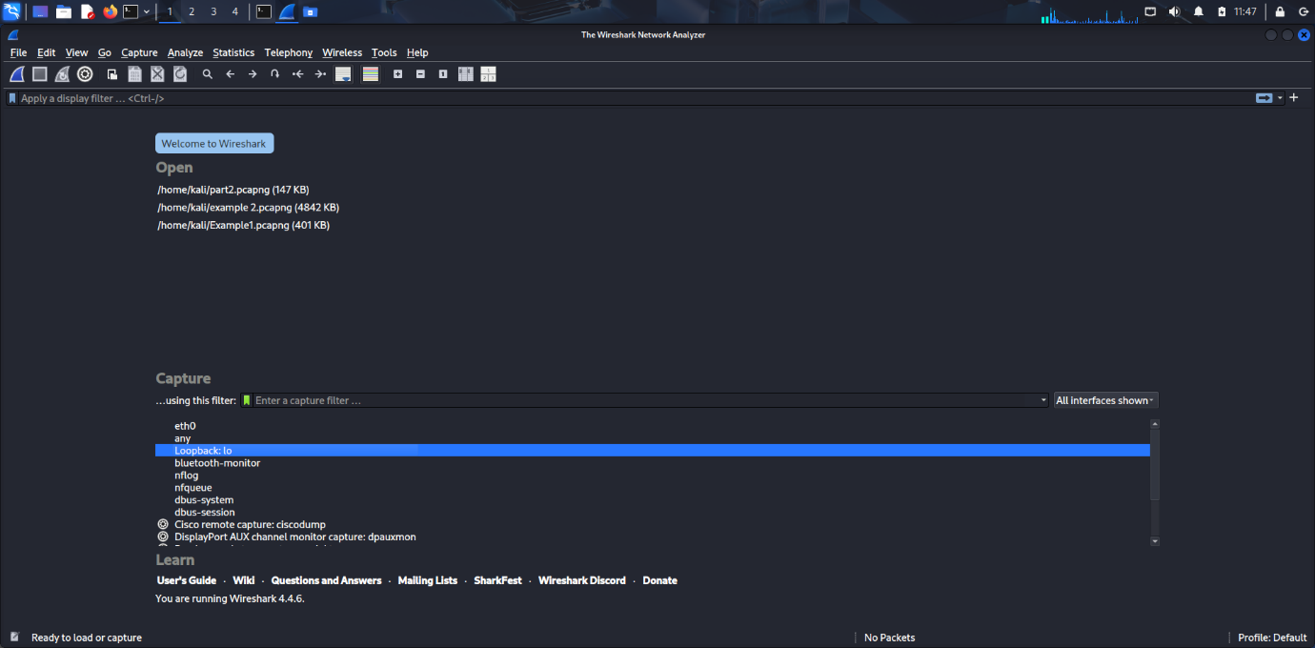
- Start capture.
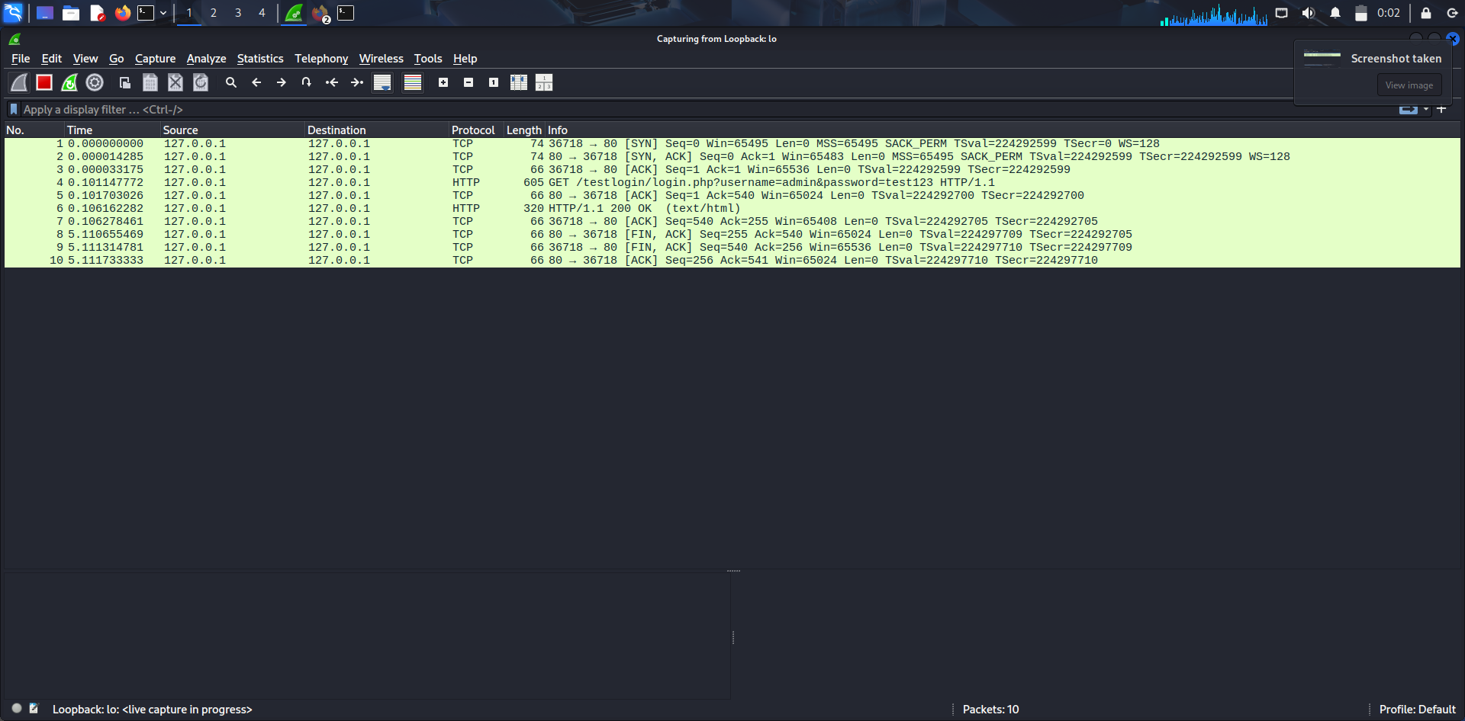
- Apply filter:
http.request.method == "POST"

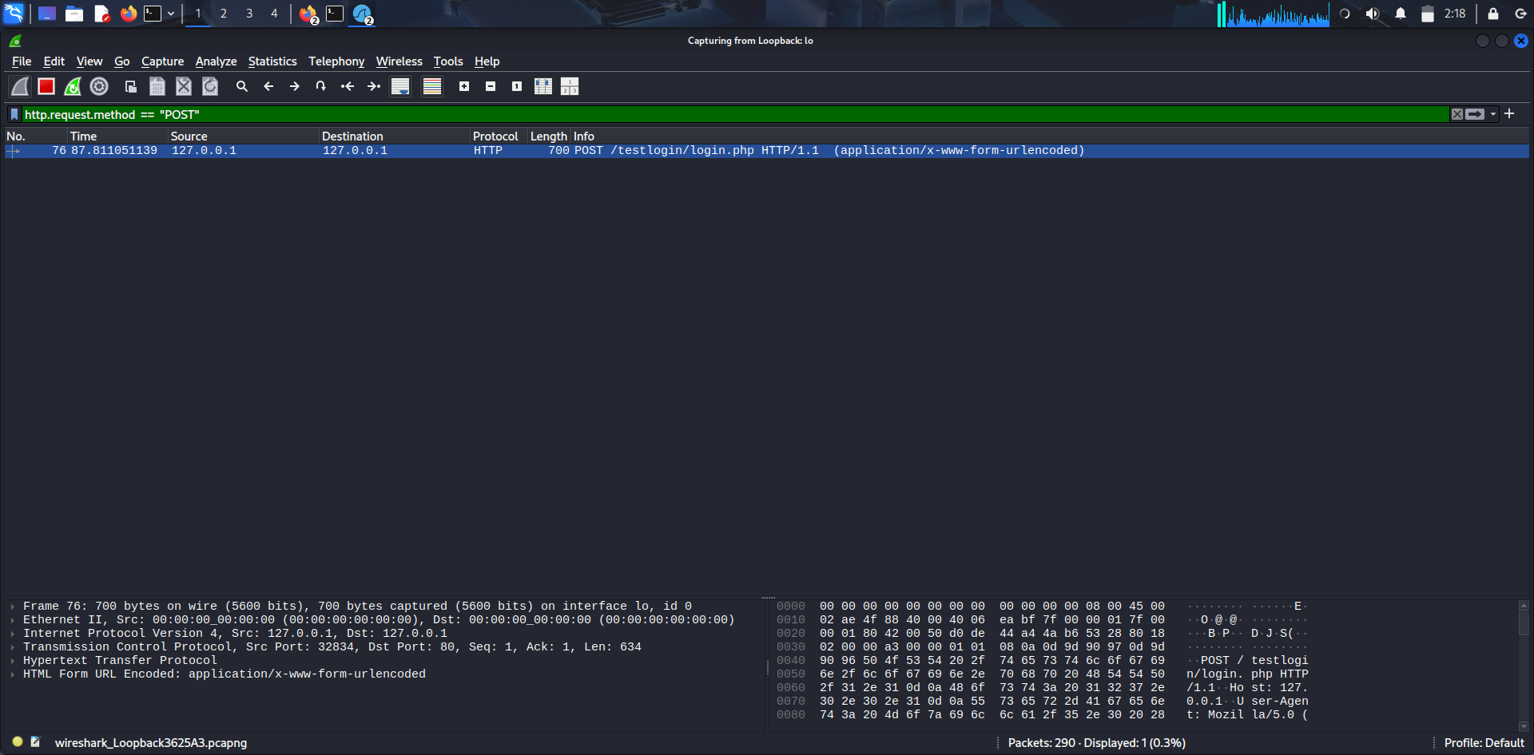
Step 7 – Perform the Login Attempt (Firefox)
- Username: admin
- Password: test123

Click the Login button.

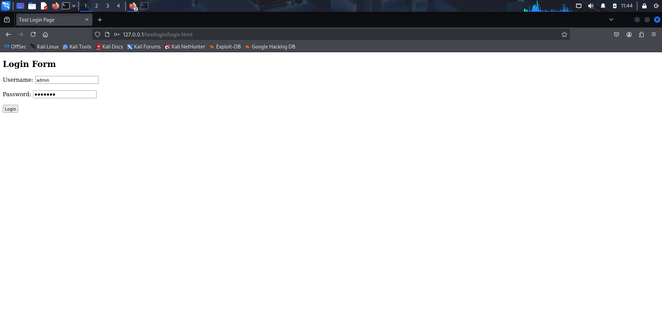

Step 8 – Analyze Packets
- Locate POST packet.
- Right-click → Follow → TCP Stream.
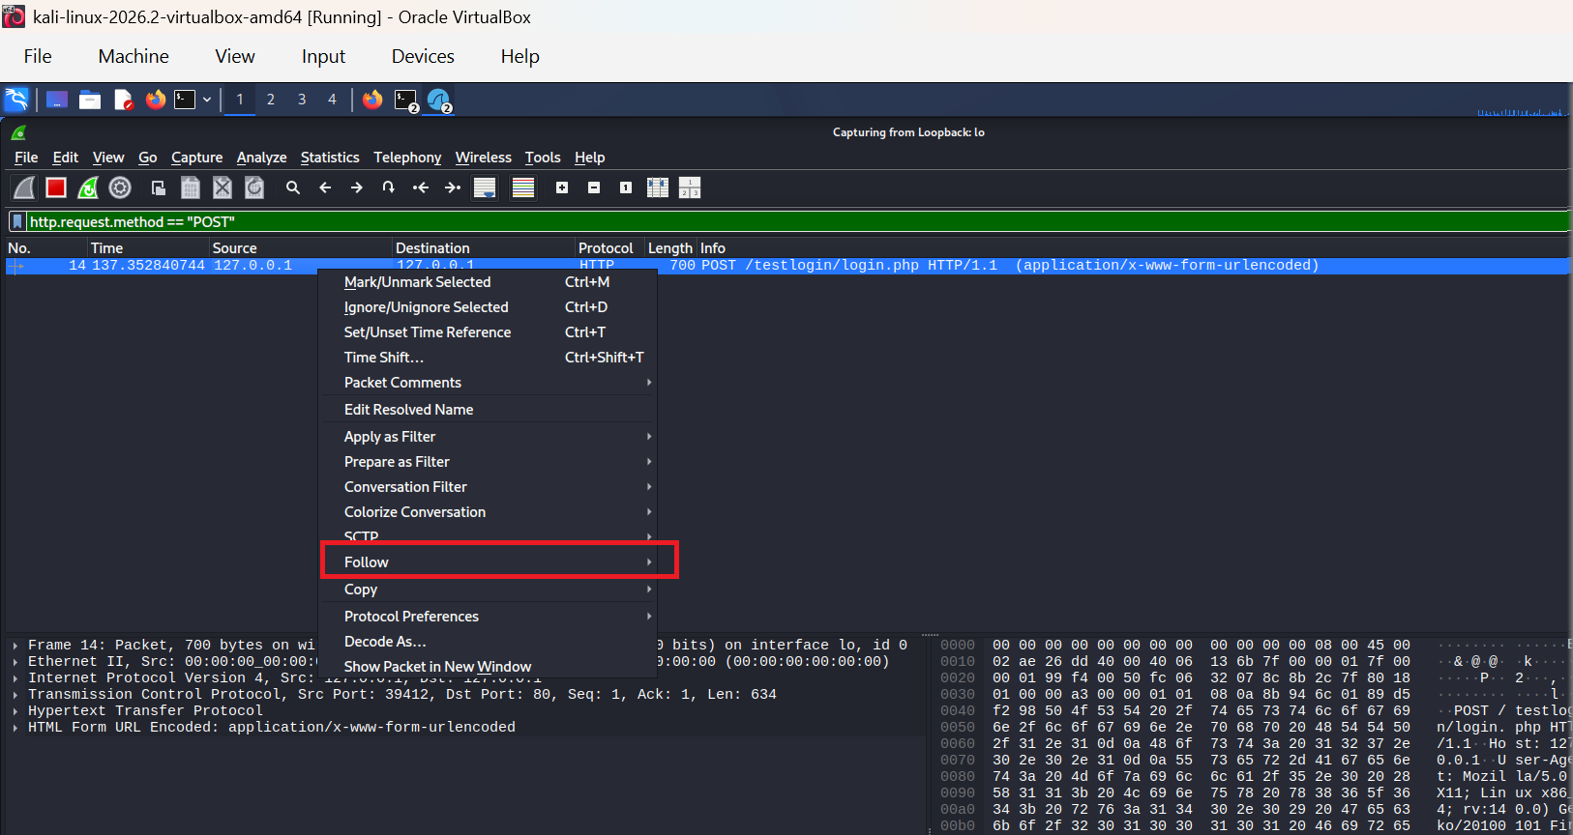
Credentials will be visible in plain text.
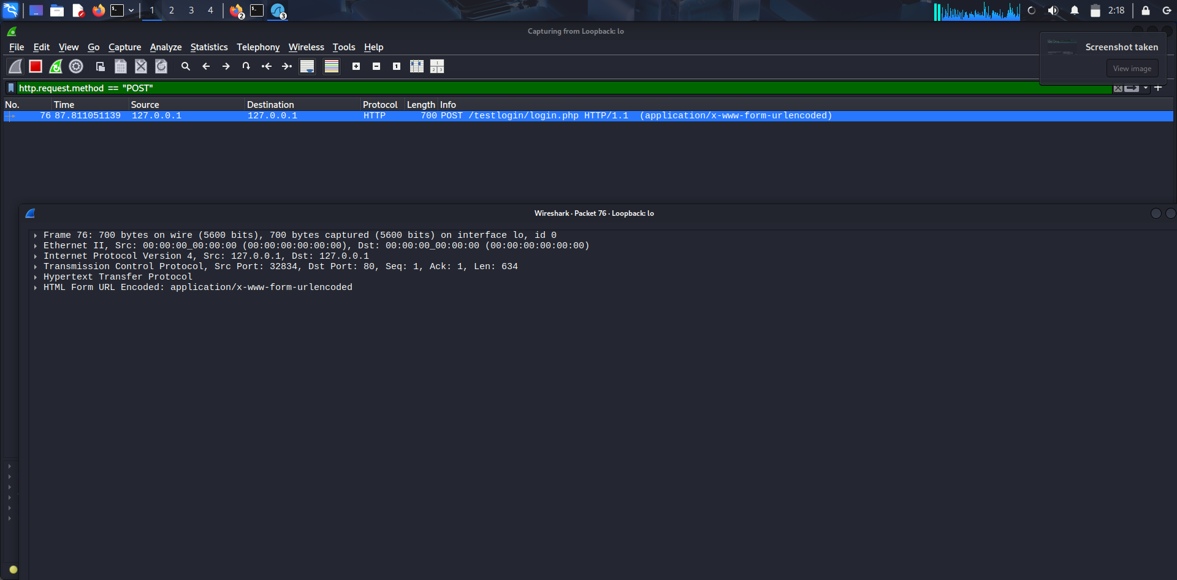
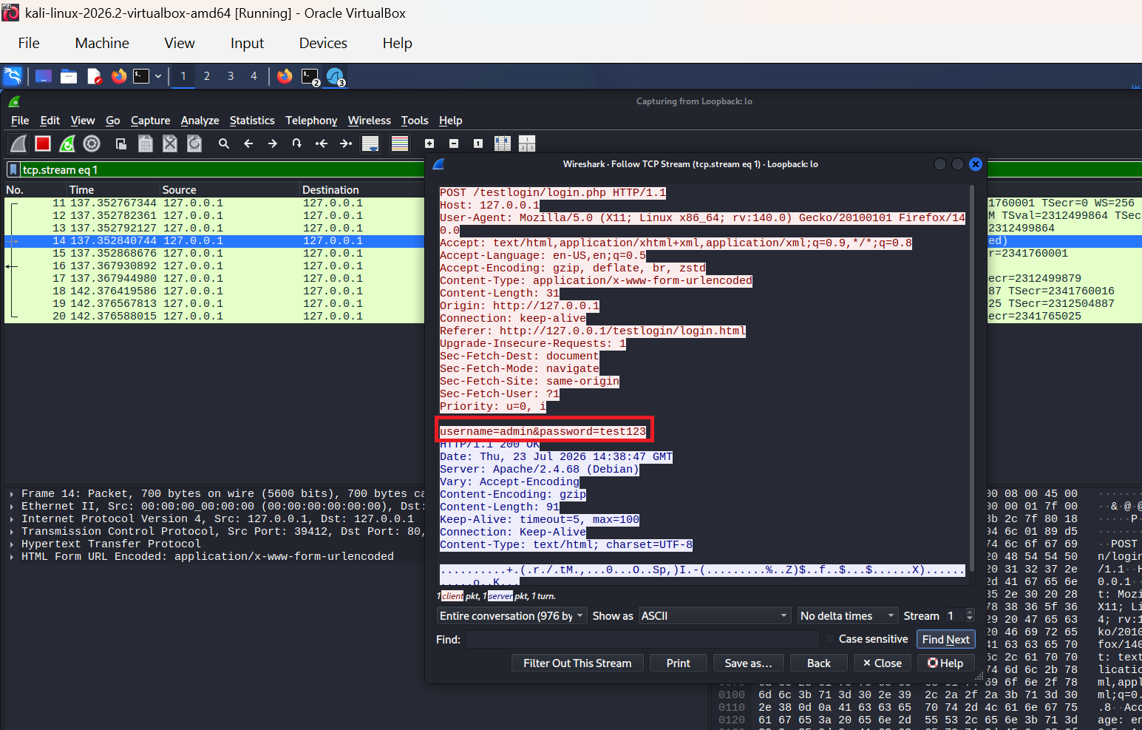
Finally, power off the virtual machine
Close the VirtualBox window

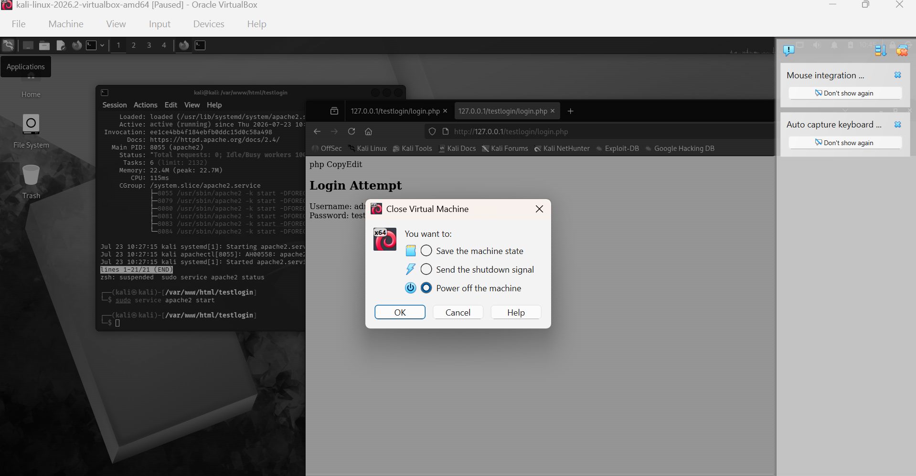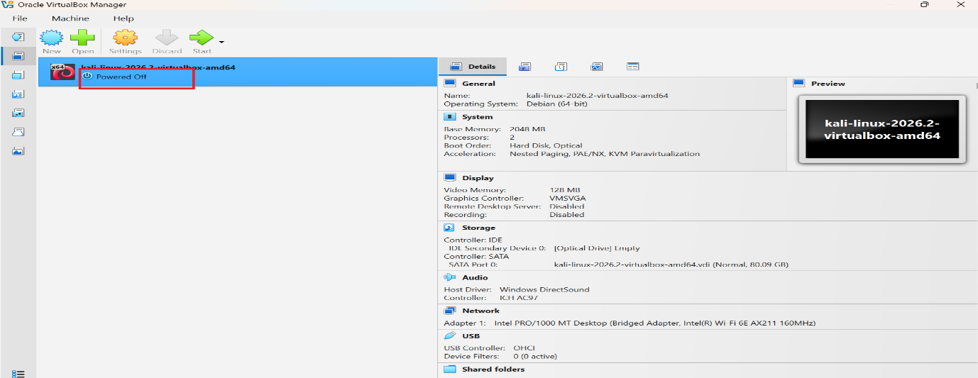
Observations
- Network traffic from various applications can be captured in real-time.
- Protocol filters help narrow down the traffic of interest.
- Details such as source/destination IP, MAC addresses, ports, and application data can be examined.
- HTTP POST requests transmit data in plaintext.
- Credentials can be directly read in the captured packets when using HTTP.
- Using HTTPS would encrypt this data and prevent such interception.

