**Fall 2024**

**CMPE-255**

**Data Mining**

**Project Report**

**Trash Classifier**

**Team : The Next Gen**

**Presented to :**

Mr. Vijay Eranti

**Group Members :**

Praful John(018168514)

Siri Batchu (018238545)

Roshini Joga(018221736)

MohibKhan Pathan(014493934)

**Objective**

The goal of the project is to automate the waste classification process using a deep learning-based model that classifies waste images into three categories: Recyclable, Compostable, and Trash.

**Abstract**

Manual waste sorting is a tedious, costly task that is very dangerous to the health of workers. With growing urbanization and complex localization of wastes that cannot achieve the goals of sustainability and efficiency by traditional methods, the project presents an idea of a waste classification system with automatic functioning using a CLIP-based model that sorts the wastes automatically into three categories: Recyclable, Compostable, Trash. To achieve this, they perform strong preprocessing, augmentation, and finally a custom classification architecture appended to the CLIP feature extractor. Future works should focus on improving recyclables classification performance and expansion of more diverse datasets, so that there will be a grid of recycled items for improved generalization of the model.

**Introduction**

Waste management has become one of the most challenging problems of a rapidly urbanizing world today. Amidst the increase in the volume and complexity of wastes, traditional manual sorting methods are becoming ineffective, expensive, and pose dangers to workers. The high degree of contamination denotes poor segregation and low recycling rates, increasing the amount of waste captured by landfills and increasing loss in opportunities to make money out of valuable material. Manual sorting exposes workers to dangerous contaminants and poses serious health risks. This work aims to overcome these challenges by automating the categorization of waste into three primary classes of waste—Recyclable, Compostable, and Trash. We introduce a deep learning-based method utilizing the pre-trained CLIP to obtain relevant and discriminative features efficiently. The CLIP architecture has been improved by adding custom classification layers and high-performance preprocessing with data augmentation techniques, which has given a high degree of accuracy for waste categorization. The model is capable of handling two major issues:

1. Class Imbalance: The datasets around recyclables are often quite small relative to the total used and lead to poor predictions.

2. Visual Resemblance: Some recyclable materials, like plastics, closely resemble waste visually, leading to incorrect classifications.

Finally, the model is integrated into a real-time, user-friendly Gradio application so that users can upload the images and get instant predictions. This approach creates value in sorting by an increment in payment correctness and transparency, taking into account the resource use, environmental impact, and global reactive development by enhancing collection and recycling.

* **Dataset Used**

The project uses the well-known TrashNet dataset, which is a publicly available dataset used to develop and train the waste classification model.

Data Description:A dataset of waste images in three main classes: Recyclable, Compostable, and Trash. It aims to assist research in automated waste management systems.

Used Datasets: <https://archive.ics.uci.edu/dataset/908/realwaste>

- Overview of Dataset Source: We accessed the TrashNet dataset from the UC Irvine Machine Learning Repository.

- Total Images: The dataset contains 9,607 images, split evenly into three classes.

- Recyclable: Plastics, metals, paper, and other recyclable materials.

- Compostable: Organic waste including food scraps and biodegradable materials.

- Trash: General waste that cannot be recycled or composted.

Issues in the Dataset

1. Class Imbalance: The recyclable class is underrepresented and makes up only 16.9% of the total number of images, while dominant classes are compostable and trash. For example, imbalanced datasets can introduce biased predictions in which the model favors the majority classes.

2. Visual Similarities: Some recyclable items, like plastic wrappers and aluminum cans, look strikingly similar to garbage, hence the challenge of distinguishing them.

3. Variability: Images are different in lighting, background, and angles, making it a more difficult classification task.

**Related Work**

Waste classification has mostly been done with traditional deep learning architectures such as ResNet, VGGNet, and custom CNNs. These models tend to struggle with issues such as:

- Class Imbalance: Very few recyclables are used, harming the model performance.

- Visual Similarities: Some recyclable items look a lot like trash and get misclassified.

Our approach further builds on those limitations as follows:

1. Use of the pre-trained visual encoder in CLIP for robust feature extractions.

2. Training with labor-efficient data generation using the phenomenon; it is further for class imbalance.

3. Making sure the system (in deployment) is usable via a simple Gradio interface.

While typical approaches are focused on accurate model building, our project takes a first step toward building a bridge from accurate model building to realistic usability in a real-world context.

**CRISP-DM Methodology**

**Business Understanding**

The first stage of the CRISP-DM methodology provides an understanding of the objectives of the project and the identification of the problem and determination of the success criteria.

- Problem Statement: Manual waste sorting is extremely inefficient, manpower-intensive, and hazardous, presenting workers’ health hazards beyond the exposure levels matching up with group and volumes of wastes. A growing urban population compounds the inefficiencies associated with manual methods, resulting in higher costs and missed recycling and sustainability opportunities.

- Business Use Case: Design an automated waste sorting system for:

- Improved sorting precision and accuracy.

- Coping up with a shortage of manpower.

- Improving recyclability to support sustainability targets.

- Ensuring waste can be monetized through correct cargo classification.

- Technical Objectives:

- Classify images with a CLIP-based deep learning model in one of three classes:

1. Recyclable

2. Compostable

3. Trash

- High (> 90%) classification accuracy.

- Make it usable by deploying the model as a user-friendly real-time application.

- Challenges:

- Class Imbalance: Because there is a finite amount of recyclable data available, predictions can become unbalanced.

- Visual Similarity: Recyclables can look like trash, which complicates classification.

- Scalability: Make sure the solution is scalable enough for real-world applications.

Success Criteria:

- > 95% accuracy on the test.

- Targeted augmentations to address class imbalance.

- Deploy a running Gradio app to make predictions in real-time.

**Data Understanding**

Collecting, exploring, and analyzing the data to identify trends, issues, and opportunities

- Dataset Sources:

- TrashNet Dataset (UC Irvine Repository): A well-labeled dataset of images of wastes classified into three classes.

- Dataset :

- Total Images: 9,607

- 70% training set

- 15% validation set

- 15% test set

- Classes:

- Recyclable

- Compostable

- Trash

Initial Observations:

- Imbalance: The number of images in the recyclable class is much fewer than those in compostable and trash.

- Visual Challenges: Plastics in the recyclable class look very similar to those in the trash class. Compostable wastes (e.g., food) are more visually differentiating and hence easy to sort.

**Exploratory Data Analysis (EDA):**

1. Class Distribution Analysis:

- Counted the number of images in each class in order to understand the distribution. Found a huge class imbalance in the dataset; the Recyclable class constitutes only 16.9% of the whole dataset, whereas the Compostable and Trash classes dominate with 39.5% and 43.6% respectively.

2. Visual Inspection of Sample Images:

- Key Features/Characteristics:

- Compostable: Often organic in nature, e.g., food waste or plant matter, relatively easy to visually identify.

- Recyclable: Objects such as plastics, cans, and paper; when noisy or have overlapping features can look like trash.

- Trash: General refuse with mixed and inconsistent properties.

- Recyclables visually overlapped with trash in a significant way, particularly for plastics and wrappers. The organic texture and color patterns of compostable items made it easier to pick them out.

3. Sourced Variability:

- Light Conditions: Images contain varying brightness and shadow.

- Angles and Orientations: Items are shot with multiple perspectives that further complicate classification. Because of the individuality described, augmentation techniques would need to rotate, flip, and alter the color property to approximate ideals for methods.

4. Finding Outliers and Noisy Data:

- Randomly reviewed samples for possible outliers or mislabeled data.

- Looked for any corrupted/low-quality images that could have any bad effect on the model performance.

**Data Processing**

In this phase, the data was cleaned, preprocessed, and augmented for training the model.

Preprocessing Steps:

- Resizing: All the images were resized to 224x224 pixels in conformity with the input format of CLIP.

- Normalizing: Pixel values were standardized using the mean and standard deviation of ImageNet to maintain input feature consistency.

Data Augmentation:

- Random Rotation: Added rotation to simulate different angles of waste captured.

- Horizontal Flipping: Reflect images for better generalization.

- Color Jitter: Variance to simulate changing lighting conditions.

- Data Generational Augmentation: For the Recyclable class increases the data size.

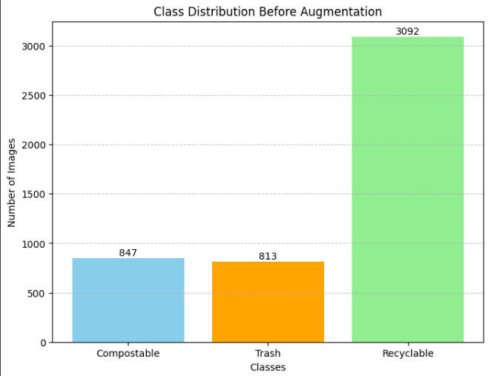

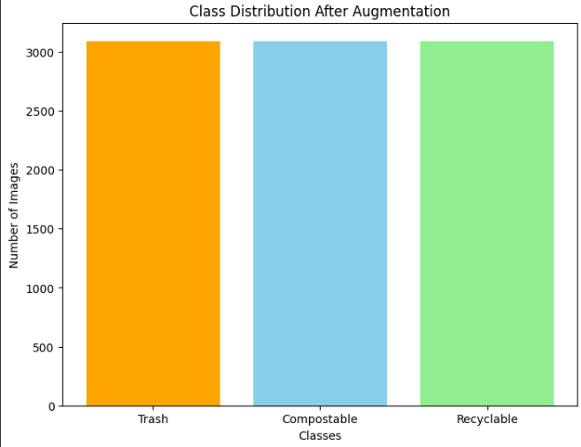

* Data Splitting:

- Training Set: 70% of the dataset is used for training the model.

- Validation Set: 15% used for tuning hyperparameters and checking for overfitting.

- Test Set: 15% reserved for measuring the final model.

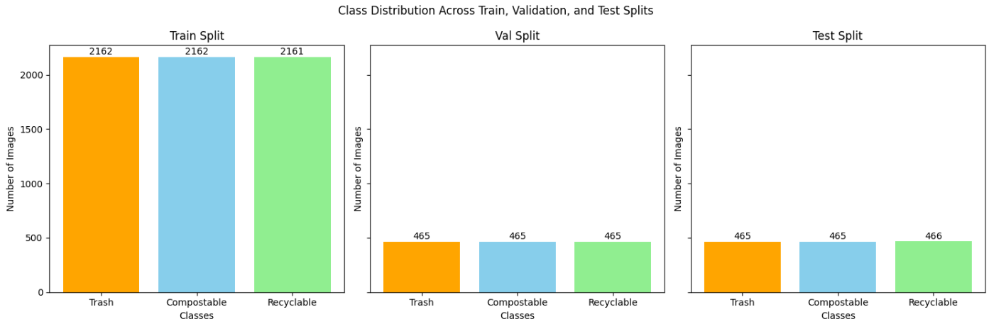

**Modeling**

The modeling phase builds, trains, and evaluates the machine learning model.

Model Selection:

- Utilized CLIP pre-trained model (Contrastive Language-Image Pretraining) for feature extraction.

- CLIP's visual semantic understanding's robustness makes it very suitable for waste classification.

Model Architecture:

- Feature Extraction: A CLIP visual encoder (with frozen weights) extracts high-level features from the image.

- Custom Layers:

- Global Average Pooling Layer → Reduces feature map output.

- Last Layer: Maps extracted features to the output classes.

- Softmax Activation: Returns probabilities of the three classes.

Optimization:

- Optimizer: AdamW optimizer (lr=1e - 4).

- Loss Function: Cross-entropy with class weights for imbalance classes.

Training Configuration:

- Batch Size: 32

- Epochs: 10

Framework: PyTorch

**Evaluation**

The model evaluated on the test set at multiple metrics

Performance Metrics:

- Accuracy: Overall model accuracy on test data (95.24%).

* **Class-Wise Metrics**:

| Class | Precision | Recall | F1-Score |
| --- | --- | --- | --- |
| Compostable | 0.99 | 0.99 | 0.99 |
| Trash | 0.98 | 0.96 | 0.97 |
| Recyclable | 0.87 | 0.91 | 0.89 |

* Confusion Matrix: Indicated that the majority of misclassifications occurred between recyclable and trash because of visual similarities.

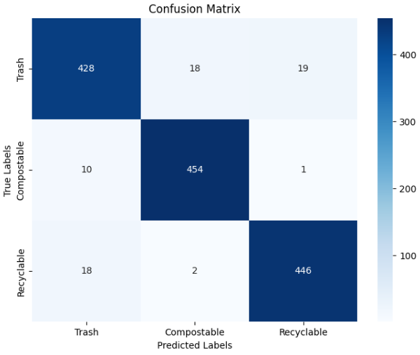

Insights:

- Compostable and trash classes did great.

- The recyclable class left some room for improvement, mainly in visually similar items.

* **Plot Training and Evaluation Metrics:**

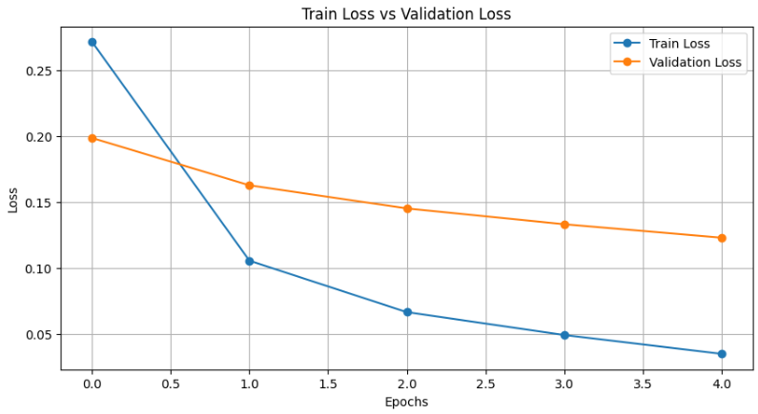

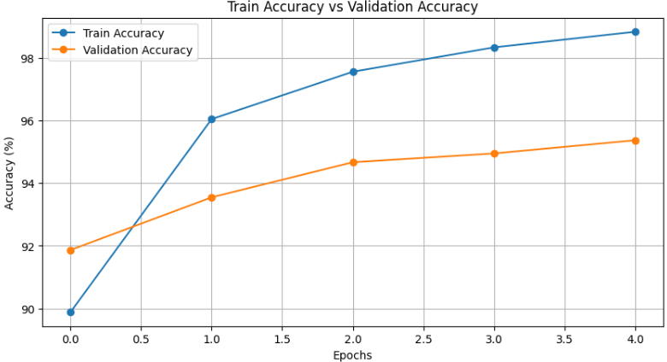

**Deployment**

Deployment ensures the model is usable and accessible for end-users.

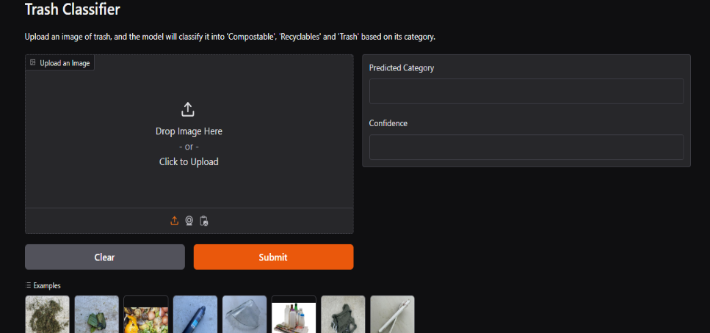

* Gradio Application:

- We used Gradio to build an application that allows users to upload images that classify the real-time waste.

- Predictions are shown for Recyclable, Compostable, and Trash classes.

* Hosting:

- The application is hosted on Huggingface Spaces to make it scalable and publicly accessible.

* User Experience:

- The interface is approachable and easy to work for non-technical users.

- Provides fast and accurate output of the predictions.

**Conclusion**

Meanwhile, we were able to automate waste classification using a CLIP-based model for feature extraction and a custom classification pipeline. Key takeaways from the results are as follows:

* 95.24% test accuracy.
* Real-time prediction using a Gradio app deployed on Huggingface Spaces.
* Prior optimization of the problems with class imbalance and visual similarity.

**Future Directions**

1. Apply targeted augmentations and oversampling where appropriate to get better performance on the recyclable class.
2. Expand the dataset by acquiring images of real-world wastes under varying conditions for a deeper understanding.
3. Train the model at smaller learning rates more to generalize.