PRINCIPAL COMPONENT ANALYSIS

head(AustralianOpen_Finalists_allstats)

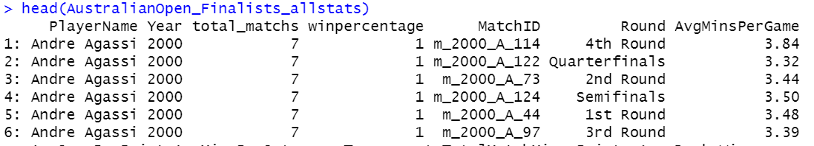

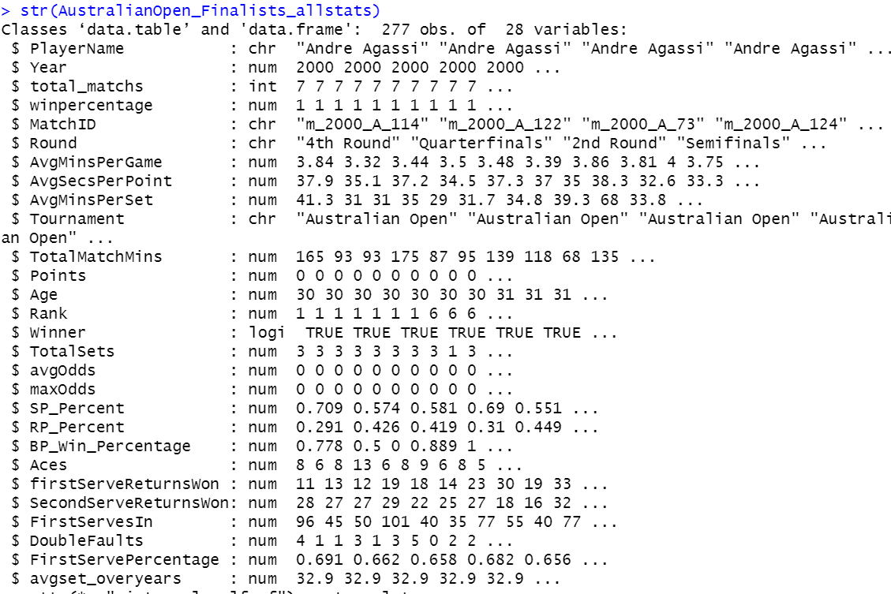

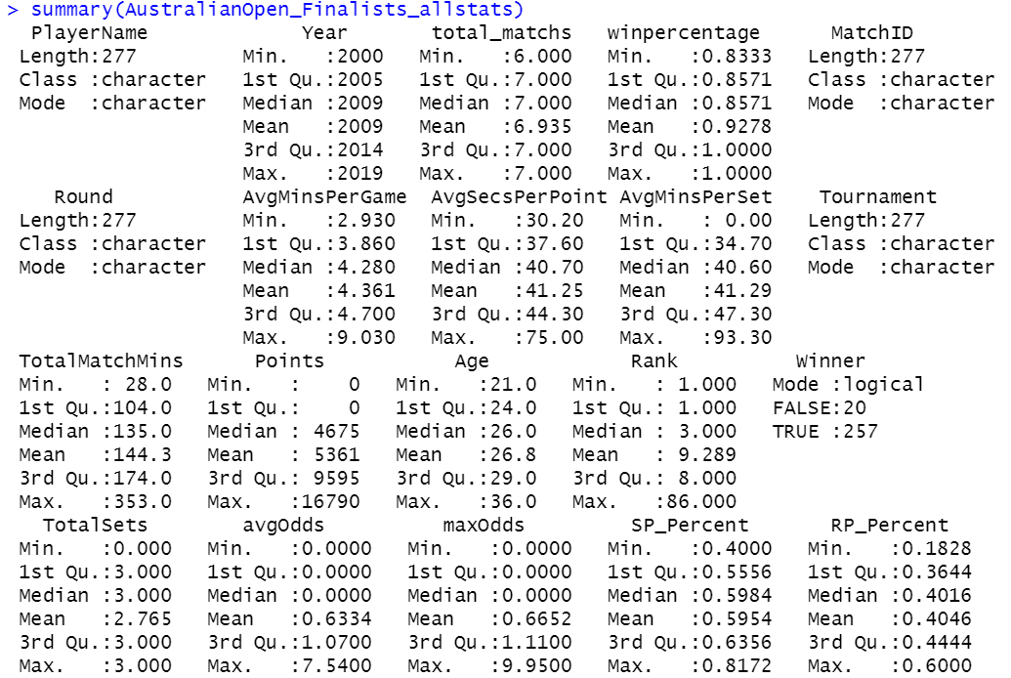

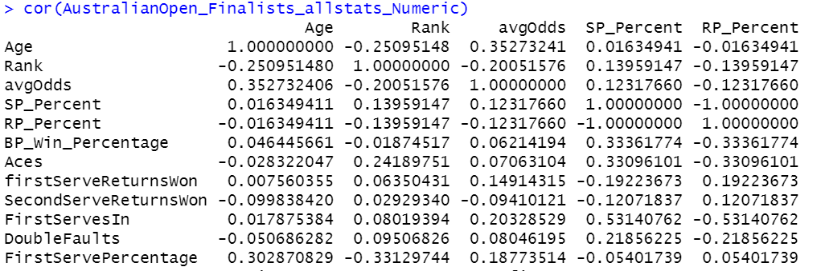

plot(cor(AustralianOpen_Finalists_allstats_Numeric))

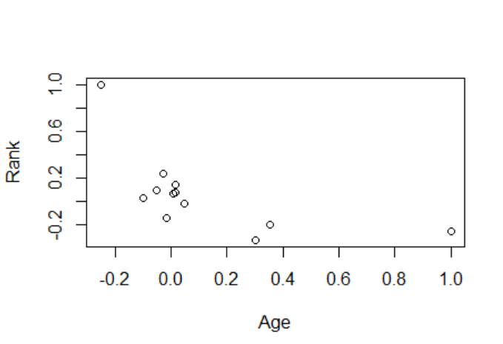

AustralianOpen_Finalists_allstats_pca<-prcomp(AustralianOpen_Finalists_allstats_Numeric,scale=TRUE)

plot(AustralianOpen_Finalists_allstats_pca)

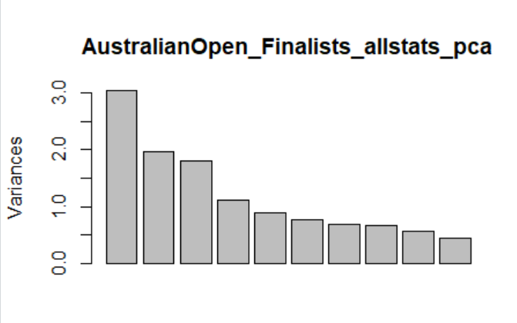

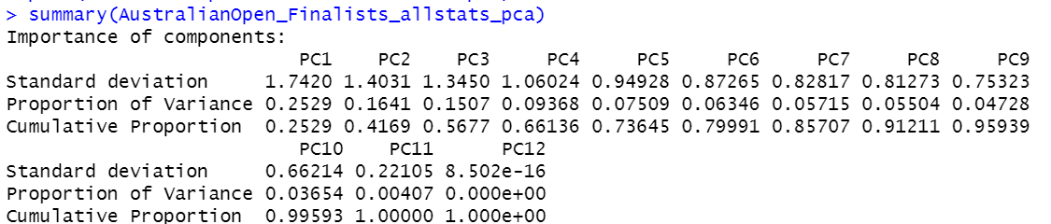

View(AustralianOpen_Finalists_allstats_pca)

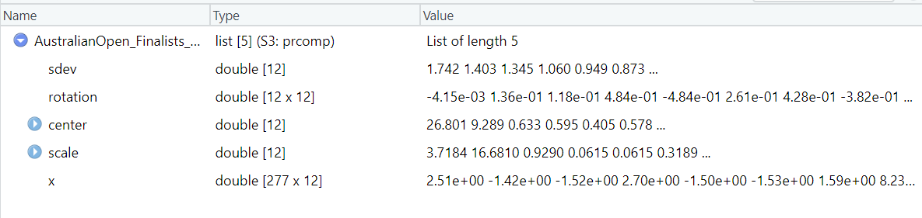

eigen_AO_Finalists <-AustralianOpen_Finalists_allstats_pca$sdev^2

> eigen_AO_Finalists

[1] 3.034501e+00 1.968804e+00 1.808901e+00 1.124111e+00 9.011337e-01 7.615134e-01

[7] 6.858578e-01 6.605265e-01 5.673569e-01 4.384332e-01 4.886229e-02 7.227796e-31

>

> names(eigen_AO_Finalists) <- paste("PC",1:12,sep="")

> eigen_AO_Finalists

PC1 PC2 PC3 PC4 PC5 PC6 PC7

3.034501e+00 1.968804e+00 1.808901e+00 1.124111e+00 9.011337e-01 7.615134e-01 6.858578e-01

PC8 PC9 PC10 PC11 PC12

6.605265e-01 5.673569e-01 4.384332e-01 4.886229e-02 7.227796e-31

> sumlambdas<-sum(eigen_AO_Finalists)

> sumlambdas

[1] 12

> propvar<-eigen_AO_Finalists/sumlambdas

> propvar

PC1 PC2 PC3 PC4 PC5 PC6 PC7

2.528751e-01 1.640670e-01 1.507418e-01 9.367588e-02 7.509447e-02 6.345945e-02 5.715482e-02

PC8 PC9 PC10 PC11 PC12

5.504387e-02 4.727975e-02 3.653610e-02 4.071857e-03 6.023163e-32

> cumvar_AO_Finalists<-cumsum(propvar)

> cumvar_AO_Finalists

PC1 PC2 PC3 PC4 PC5 PC6 PC7 PC8 PC9

0.2528751 0.4169420 0.5676838 0.6613597 0.7364542 0.7999136 0.8570684 0.9121123 0.9593920

PC10 PC11 PC12

0.9959281 1.0000000 1.0000000

> matlambdas<-rbind(eigen_AO_Finalists,propvar,cumvar_AO_Finalists)

> rownames(matlambdas)

[1] "eigen_AO_Finalists" "propvar" "cumvar_AO_Finalists"

> round(matlambdas,5)

PC1 PC2 PC3 PC4 PC5 PC6 PC7 PC8 PC9

eigen_AO_Finalists 3.03450 1.96880 1.80890 1.12411 0.90113 0.76151 0.68586 0.66053 0.56736

propvar 0.25288 0.16407 0.15074 0.09368 0.07509 0.06346 0.05715 0.05504 0.04728

cumvar_AO_Finalists 0.25288 0.41694 0.56768 0.66136 0.73645 0.79991 0.85707 0.91211 0.95939

PC10 PC11 PC12

eigen_AO_Finalists 0.43843 0.04886 0

propvar 0.03654 0.00407 0

cumvar_AO_Finalists 0.99593 1.00000 1

> summary(AustralianOpen_Finalists_allstats_pca)

Importance of components:

PC1 PC2 PC3 PC4 PC5 PC6 PC7 PC8 PC9

Standard deviation 1.7420 1.4031 1.3450 1.06024 0.94928 0.87265 0.82817 0.81273 0.75323

Proportion of Variance 0.2529 0.1641 0.1507 0.09368 0.07509 0.06346 0.05715 0.05504 0.04728

Cumulative Proportion 0.2529 0.4169 0.5677 0.66136 0.73645 0.79991 0.85707 0.91211 0.95939

PC10 PC11 PC12

Standard deviation 0.66214 0.22105 8.502e-16

Proportion of Variance 0.03654 0.00407 0.000e+00

Cumulative Proportion 0.99593 1.00000 1.000e+00

> print(AustralianOpen_Finalists_allstats_pca)

Standard deviations (1, .., p=12):

[1] 1.741982e+00 1.403141e+00 1.344954e+00 1.060241e+00 9.492806e-01 8.726473e-01

[7] 8.281653e-01 8.127278e-01 7.532310e-01 6.621429e-01 2.210482e-01 8.501644e-16

Rotation (n x k) = (12 x 12):

PC1 PC2 PC3 PC4 PC5

Age -0.00415178 0.42830942 -0.232554474 0.314609668 -0.04632629

Rank 0.13630501 -0.38197446 0.243595669 0.155808021 0.34813788

avgOdds 0.11807701 0.34188696 -0.274509489 0.476805302 -0.14611186

SP_Percent 0.48391843 0.19453812 0.308779847 -0.007946174 -0.03292276

RP_Percent -0.48391843 -0.19453812 -0.308779847 0.007946174 0.03292276

BP_Win_Percentage 0.26061584 0.18226722 -0.006836468 -0.395263686 0.11221296

Aces 0.31732681 -0.19283950 -0.016447010 0.370417984 0.37960882

firstServeReturnsWon 0.11056995 -0.24004315 -0.506991061 0.241247978 0.26234179

SecondServeReturnsWon 0.13556848 -0.30358565 -0.404359859 -0.397499499 -0.08812446

FirstServesIn 0.46875952 -0.01812074 -0.326892184 -0.188532278 0.10380643

DoubleFaults 0.27786436 -0.21598416 -0.157093786 0.054974387 -0.70441043

FirstServePercentage -0.05423925 0.45923720 -0.261023158 -0.317897990 0.33598190

PC6 PC7 PC8 PC9 PC10

Age 0.07970268 -0.63457440 -0.335950103 0.29919590 0.22054563

Rank -0.15206363 -0.05060044 -0.744818085 -0.19909378 -0.09768241

avgOdds -0.10789635 0.22739381 -0.013033622 -0.69122593 -0.04389392

SP_Percent 0.14662673 0.10424547 0.006397133 0.07541969 0.15795541

RP_Percent -0.14662673 -0.10424547 -0.006397133 -0.07541969 -0.15795541

BP_Win_Percentage -0.76231012 -0.32625171 0.141283958 -0.14915111 -0.01480656

Aces 0.16206350 -0.34295605 0.451779918 0.02147937 -0.47944497

firstServeReturnsWon -0.29723940 0.30625163 0.069620240 0.36171974 0.30759324

SecondServeReturnsWon 0.37873653 -0.33614764 -0.030957822 -0.37581689 0.13408444

FirstServesIn 0.16173311 0.19139591 -0.109800818 0.03343799 0.15240337

DoubleFaults -0.16974263 0.01768431 -0.179256050 0.25843657 -0.47111092

FirstServePercentage 0.14744370 0.23135101 -0.240979790 0.13776595 -0.54967266

PC11 PC12

Age -0.035617950 -1.370222e-16

Rank 0.032917599 7.204847e-18

avgOdds 0.043408318 8.019690e-17

SP_Percent 0.261611057 7.071068e-01

RP_Percent -0.261611057 7.071068e-01

BP_Win_Percentage -0.001685847 8.964077e-17

Aces -0.047078812 1.996870e-16

firstServeReturnsWon 0.365577301 -2.776579e-17

SecondServeReturnsWon 0.378901466 3.509267e-16

FirstServesIn -0.726337635 -4.471402e-16

DoubleFaults 0.047482294 -9.629723e-17

FirstServePercentage 0.222776913 1.520023e-16

AustralianOpen_Finalists_allstats_pca$rotation

PC1 PC2 PC3 PC4 PC5

Age -0.00415178 0.42830942 -0.232554474 0.314609668 -0.04632629

Rank 0.13630501 -0.38197446 0.243595669 0.155808021 0.34813788

avgOdds 0.11807701 0.34188696 -0.274509489 0.476805302 -0.14611186

SP_Percent 0.48391843 0.19453812 0.308779847 -0.007946174 -0.03292276

RP_Percent -0.48391843 -0.19453812 -0.308779847 0.007946174 0.03292276

BP_Win_Percentage 0.26061584 0.18226722 -0.006836468 -0.395263686 0.11221296

Aces 0.31732681 -0.19283950 -0.016447010 0.370417984 0.37960882

firstServeReturnsWon 0.11056995 -0.24004315 -0.506991061 0.241247978 0.26234179

SecondServeReturnsWon 0.13556848 -0.30358565 -0.404359859 -0.397499499 -0.08812446

FirstServesIn 0.46875952 -0.01812074 -0.326892184 -0.188532278 0.10380643

DoubleFaults 0.27786436 -0.21598416 -0.157093786 0.054974387 -0.70441043

FirstServePercentage -0.05423925 0.45923720 -0.261023158 -0.317897990 0.33598190

PC6 PC7 PC8 PC9 PC10

Age 0.07970268 -0.63457440 -0.335950103 0.29919590 0.22054563

Rank -0.15206363 -0.05060044 -0.744818085 -0.19909378 -0.09768241

avgOdds -0.10789635 0.22739381 -0.013033622 -0.69122593 -0.04389392

SP_Percent 0.14662673 0.10424547 0.006397133 0.07541969 0.15795541

RP_Percent -0.14662673 -0.10424547 -0.006397133 -0.07541969 -0.15795541

BP_Win_Percentage -0.76231012 -0.32625171 0.141283958 -0.14915111 -0.01480656

Aces 0.16206350 -0.34295605 0.451779918 0.02147937 -0.47944497

firstServeReturnsWon -0.29723940 0.30625163 0.069620240 0.36171974 0.30759324

SecondServeReturnsWon 0.37873653 -0.33614764 -0.030957822 -0.37581689 0.13408444

FirstServesIn 0.16173311 0.19139591 -0.109800818 0.03343799 0.15240337

DoubleFaults -0.16974263 0.01768431 -0.179256050 0.25843657 -0.47111092

FirstServePercentage 0.14744370 0.23135101 -0.240979790 0.13776595 -0.54967266

PC11 PC12

Age -0.035617950 -1.370222e-16

Rank 0.032917599 7.204847e-18

avgOdds 0.043408318 8.019690e-17

SP_Percent 0.261611057 7.071068e-01

RP_Percent -0.261611057 7.071068e-01

BP_Win_Percentage -0.001685847 8.964077e-17

Aces -0.047078812 1.996870e-16

firstServeReturnsWon 0.365577301 -2.776579e-17

SecondServeReturnsWon 0.378901466 3.509267e-16

FirstServesIn -0.726337635 -4.471402e-16

DoubleFaults 0.047482294 -9.629723e-17

FirstServePercentage 0.222776913 1.520023e-16

#Sample scores stores in AustralianOpen_Finalists_allstats_pca$x

> head(AustralianOpen_Finalists_allstats_pca$x)

PC1 PC2 PC3 PC4 PC5 PC6 PC7

[1,] 2.514665 1.5872062 0.67009186 -1.6517068 -0.8693204 1.1465220 -0.5494237

[2,] -1.421527 0.8228852 0.34733753 -0.8177448 -0.1415148 0.8181356 -1.0280831

[3,] -1.524914 0.5108870 0.42306493 -0.1243265 -0.2168012 2.1702613 -0.6302430

[4,] 2.702994 1.1160577 -0.09989699 -1.2755796 0.1607227 0.7739094 -0.7391820

[5,] -1.503460 0.9591323 0.11138776 -0.9395291 0.2447338 -0.9883880 -1.2552731

[6,] -1.533669 -0.5137968 0.85399134 0.7820955 -1.5077049 1.4263890 -0.9865489

PC8 PC9 PC10 PC11 PC12

[1,] -0.5895241723 0.61394048 -0.02831829 -0.29491498 1.173952e-15

[2,] -0.2525658813 0.01698936 0.13897452 0.13608186 7.844005e-16

[3,] -0.3310518040 0.22489122 0.04211636 -0.05066367 2.824750e-17

[4,] 0.0315090168 0.73644588 0.13172698 -0.26313280 1.111926e-15

[5,] 0.0758887799 0.19662481 0.12504675 0.07637995 1.181607e-15

[6,] -0.0008126966 0.41926563 0.42383211 0.06513463 4.774504e-16

#Identifying scores by their conversion status

> AO_type_finalists_pca<-cbind(data.frame(AustralianOpen_Finalists_allstats$Winner),AustralianOpen_Finalists_allstats_pca$x)

>

> head(AO_type_finalists_pca)

AustralianOpen_Finalists_allstats.Winner PC1 PC2 PC3 PC4

1 TRUE 2.514665 1.5872062 0.67009186 -1.6517068

2 TRUE -1.421527 0.8228852 0.34733753 -0.8177448

3 TRUE -1.524914 0.5108870 0.42306493 -0.1243265

4 TRUE 2.702994 1.1160577 -0.09989699 -1.2755796

5 TRUE -1.503460 0.9591323 0.11138776 -0.9395291

6 TRUE -1.533669 -0.5137968 0.85399134 0.7820955

PC5 PC6 PC7 PC8 PC9 PC10 PC11

1 -0.8693204 1.1465220 -0.5494237 -0.5895241723 0.61394048 -0.02831829 -0.29491498

2 -0.1415148 0.8181356 -1.0280831 -0.2525658813 0.01698936 0.13897452 0.13608186

3 -0.2168012 2.1702613 -0.6302430 -0.3310518040 0.22489122 0.04211636 -0.05066367

4 0.1607227 0.7739094 -0.7391820 0.0315090168 0.73644588 0.13172698 -0.26313280

5 0.2447338 -0.9883880 -1.2552731 0.0758887799 0.19662481 0.12504675 0.07637995

6 -1.5077049 1.4263890 -0.9865489 -0.0008126966 0.41926563 0.42383211 0.06513463

PC12

1 1.173952e-15

2 7.844005e-16

3 2.824750e-17

4 1.111926e-15

5 1.181607e-15

6 4.774504e-16

#Means of scores for all PC's classified by Winners of Finals

> tabmeansPC

Winner PC1 PC2 PC3 PC4 PC5 PC6 PC7

1 FALSE 1.4964560 0.44209629 0.96920003 0.33131294 -0.8892816 -0.085349151 0.63719083

2 TRUE -0.1164557 -0.03440438 -0.07542413 -0.02578311 0.0692048 0.006641957 -0.04958683

PC8 PC9 PC10 PC11 PC12

1 -0.42899660 -0.1914264 0.050570026 -0.22116832 8.466044e-16

2 0.03338495 0.0148970 -0.003935411 0.01721154 5.773858e-16

> tabmeansPC<-tabmeansPC[rev(order(tabmeansPC$Winner)),]

> tabmeansPC

Winner PC1 PC2 PC3 PC4 PC5 PC6 PC7

2 TRUE -0.1164557 -0.03440438 -0.07542413 -0.02578311 0.0692048 0.006641957 -0.04958683

1 FALSE 1.4964560 0.44209629 0.96920003 0.33131294 -0.8892816 -0.085349151 0.63719083

PC8 PC9 PC10 PC11 PC12

2 0.03338495 0.0148970 -0.003935411 0.01721154 5.773858e-16

1 -0.42899660 -0.1914264 0.050570026 -0.22116832 8.466044e-16

> tabfmeans<-t(tabmeansPC[,-1])

> tabfmeans

2 1

PC1 -1.164557e-01 1.496456e+00

PC2 -3.440438e-02 4.420963e-01

PC3 -7.542413e-02 9.692000e-01

PC4 -2.578311e-02 3.313129e-01

PC5 6.920480e-02 -8.892816e-01

PC6 6.641957e-03 -8.534915e-02

PC7 -4.958683e-02 6.371908e-01

PC8 3.338495e-02 -4.289966e-01

PC9 1.489700e-02 -1.914264e-01

PC10 -3.935411e-03 5.057003e-02

PC11 1.721154e-02 -2.211683e-01

PC12 5.773858e-16 8.466044e-16

> colnames(tabfmeans)<-t(as.vector(tabmeansPC[1]))

> tabfmeans

TRUE FALSE

PC1 -1.164557e-01 1.496456e+00

PC2 -3.440438e-02 4.420963e-01

PC3 -7.542413e-02 9.692000e-01

PC4 -2.578311e-02 3.313129e-01

PC5 6.920480e-02 -8.892816e-01

PC6 6.641957e-03 -8.534915e-02

PC7 -4.958683e-02 6.371908e-01

PC8 3.338495e-02 -4.289966e-01

PC9 1.489700e-02 -1.914264e-01

PC10 -3.935411e-03 5.057003e-02

PC11 1.721154e-02 -2.211683e-01

PC12 5.773858e-16 8.466044e-16

#Standard Deviations of scores for all the PC's Classified by Winner Yes/NO

> tabsdsPC<-aggregate(AO_type_finalists_pca[,2:13],by=list(Winner=AustralianOpen_Finalists_allstats$Winner),sd)

> tabsds<-t(tabsdsPC[,-1])

> colnames(tabsds)<-t(as.vector(tabsdsPC[1]))

> tabsds

FALSE TRUE

PC1 1.255267e+00 1.722225e+00

PC2 1.880504e+00 1.357829e+00

PC3 1.924780e+00 1.263392e+00

PC4 1.149186e+00 1.051034e+00

PC5 9.378078e-01 9.163349e-01

PC6 6.748801e-01 8.868987e-01

PC7 4.988461e-01 8.287238e-01

PC8 1.015771e+00 7.874357e-01

PC9 1.078374e+00 7.226948e-01

PC10 6.740626e-01 6.623809e-01

PC11 2.538462e-01 2.092325e-01

PC12 6.048802e-16 7.344560e-16

#t test on all the principal components

> t.test(PC1~AustralianOpen_Finalists_allstats$Winner,data=AO_type_finalists_pca)

Welch Two Sample t-test

data: PC1 by AustralianOpen_Finalists_allstats$Winner

t = 5.3667, df = 24.935, p-value = 1.46e-05

alternative hypothesis: true difference in means is not equal to 0

95 percent confidence interval:

0.9938503 2.2319731

sample estimates:

mean in group FALSE mean in group TRUE

1.4964560 -0.1164557

Significant

> t.test(PC2~AustralianOpen_Finalists_allstats$Winner,data=AO_type_finalists_pca)

Welch Two Sample t-test

data: PC2 by AustralianOpen_Finalists_allstats$Winner

t = 1.1109, df = 20.571, p-value = 0.2794

alternative hypothesis: true difference in means is not equal to 0

95 percent confidence interval:

-0.416662 1.369663

sample estimates:

mean in group FALSE mean in group TRUE

0.44209629 -0.03440438

Not significant

> t.test(PC3~AustralianOpen_Finalists_allstats$Winner,data=AO_type_finalists_pca)

Welch Two Sample t-test

data: PC3 by AustralianOpen_Finalists_allstats$Winner

t = 2.3874, df = 20.294, p-value = 0.0268

alternative hypothesis: true difference in means is not equal to 0

95 percent confidence interval:

0.132758 1.956490

sample estimates:

mean in group FALSE mean in group TRUE

0.96920003 -0.07542413

Significant

> t.test(PC4~AustralianOpen_Finalists_allstats$Winner,data=AO_type_finalists_pca)

Welch Two Sample t-test

data: PC4 by AustralianOpen_Finalists_allstats$Winner

t = 1.3465, df = 21.547, p-value = 0.1921

alternative hypothesis: true difference in means is not equal to 0

95 percent confidence interval:

-0.1935606 0.9077527

sample estimates:

mean in group FALSE mean in group TRUE

0.33131294 -0.02578311

Not significant

> t.test(PC5~AustralianOpen_Finalists_allstats$Winner,data=AO_type_finalists_pca)

Welch Two Sample t-test

data: PC5 by AustralianOpen_Finalists_allstats$Winner

t = -4.4099, df = 21.919, p-value = 0.0002233

alternative hypothesis: true difference in means is not equal to 0

95 percent confidence interval:

-1.4093407 -0.5076321

sample estimates:

mean in group FALSE mean in group TRUE

-0.8892816 0.0692048

Significant

> t.test(PC6~AustralianOpen_Finalists_allstats$Winner,data=AO_type_finalists_pca)

Welch Two Sample t-test

data: PC6 by AustralianOpen_Finalists_allstats$Winner

t = -0.57234, df = 24.418, p-value = 0.5723

alternative hypothesis: true difference in means is not equal to 0

95 percent confidence interval:

-0.4234195 0.2394373

sample estimates:

mean in group FALSE mean in group TRUE

-0.085349151 0.006641957

Not Significant

> t.test(PC7~AustralianOpen_Finalists_allstats$Winner,data=AO_type_finalists_pca)

Welch Two Sample t-test

data: PC7 by AustralianOpen_Finalists_allstats$Winner

t = 5.5862, df = 27.942, p-value = 5.643e-06

alternative hypothesis: true difference in means is not equal to 0

95 percent confidence interval:

0.4349194 0.9386359

sample estimates:

mean in group FALSE mean in group TRUE

0.63719083 -0.04958683

Significant

> t.test(PC8~AustralianOpen_Finalists_allstats$Winner,data=AO_type_finalists_pca)

Welch Two Sample t-test

data: PC8 by AustralianOpen_Finalists_allstats$Winner

t = -1.9897, df = 20.815, p-value = 0.05992

alternative hypothesis: true difference in means is not equal to 0

95 percent confidence interval:

-0.94591102 0.02114792

sample estimates:

mean in group FALSE mean in group TRUE

-0.42899660 0.03338495

Not Significant

> t.test(PC9~AustralianOpen_Finalists_allstats$Winner,data=AO_type_finalists_pca)

Welch Two Sample t-test

data: PC9 by AustralianOpen_Finalists_allstats$Winner

t = -0.84107, df = 20.35, p-value = 0.4101

alternative hypothesis: true difference in means is not equal to 0

95 percent confidence interval:

-0.7174673 0.3048205

sample estimates:

mean in group FALSE mean in group TRUE

-0.1914264 0.014897

Not Significant

> t.test(PC10~AustralianOpen_Finalists_allstats$Winner,data=AO_type_finalists_pca)

Welch Two Sample t-test

data: PC10 by AustralianOpen_Finalists_allstats$Winner

t = 0.34876, df = 21.954, p-value = 0.7306

alternative hypothesis: true difference in means is not equal to 0

95 percent confidence interval:

-0.2696509 0.3786617

sample estimates:

mean in group FALSE mean in group TRUE

0.050570026 -0.003935411

Not Significant

> t.test(PC11~AustralianOpen_Finalists_allstats$Winner,data=AO_type_finalists_pca)

Welch Two Sample t-test

data: PC11 by AustralianOpen_Finalists_allstats$Winner

t = -4.0929, df = 21.058, p-value = 0.000518

alternative hypothesis: true difference in means is not equal to 0

95 percent confidence interval:

-0.3594824 -0.1172773

sample estimates:

mean in group FALSE mean in group TRUE

-0.22116832 0.01721154

Significant

> t.test(PC12~AustralianOpen_Finalists_allstats$Winner,data=AO_type_finalists_pca)

Welch Two Sample t-test

data: PC12 by AustralianOpen_Finalists_allstats$Winner

t = 1.8852, df = 23.587, p-value = 0.07178

alternative hypothesis: true difference in means is not equal to 0

95 percent confidence interval:

-2.578742e-17 5.642246e-16

sample estimates:

mean in group FALSE mean in group TRUE

8.466044e-16 5.773858e-16

Not Significant

> var.test(PC1~AustralianOpen_Finalists_allstats$Winner,data=AO_type_finalists_pca)

F test to compare two variances

data: PC1 by AustralianOpen_Finalists_allstats$Winner

F = 0.53124, num df = 19, denom df = 256, p-value = 0.1057

alternative hypothesis: true ratio of variances is not equal to 1

95 percent confidence interval:

0.297964 1.150953

sample estimates:

ratio of variances

0.5312421

Not Significant

> var.test(PC2~AustralianOpen_Finalists_allstats$Winner,data=AO_type_finalists_pca)

F test to compare two variances

data: PC2 by AustralianOpen_Finalists_allstats$Winner

F = 1.918, num df = 19, denom df = 256, p-value = 0.02655

alternative hypothesis: true ratio of variances is not equal to 1

95 percent confidence interval:

1.075795 4.155501

sample estimates:

ratio of variances

1.918043

Significant

> var.test(PC3~AustralianOpen_Finalists_allstats$Winner,data=AO_type_finalists_pca)

F test to compare two variances

data: PC3 by AustralianOpen_Finalists_allstats$Winner

F = 2.3211, num df = 19, denom df = 256, p-value = 0.003531

alternative hypothesis: true ratio of variances is not equal to 1

95 percent confidence interval:

1.301838 5.028643

sample estimates:

ratio of variances

2.321056

Significant

> var.test(PC4~AustralianOpen_Finalists_allstats$Winner,data=AO_type_finalists_pca)

F test to compare two variances

data: PC4 by AustralianOpen_Finalists_allstats$Winner

F = 1.1955, num df = 19, denom df = 256, p-value = 0.5225

alternative hypothesis: true ratio of variances is not equal to 1

95 percent confidence interval:

0.6705294 2.5900714

sample estimates:

ratio of variances

1.195492

Not Significant

> var.test(PC5~AustralianOpen_Finalists_allstats$Winner,data=AO_type_finalists_pca)

F test to compare two variances

data: PC5 by AustralianOpen_Finalists_allstats$Winner

F = 1.0474, num df = 19, denom df = 256, p-value = 0.8142

alternative hypothesis: true ratio of variances is not equal to 1

95 percent confidence interval:

0.5874765 2.2692607

sample estimates:

ratio of variances

1.047416

Not Significant

> var.test(PC6~AustralianOpen_Finalists_allstats$Winner,data=AO_type_finalists_pca)

F test to compare two variances

data: PC6 by AustralianOpen_Finalists_allstats$Winner

F = 0.57904, num df = 19, denom df = 256, p-value = 0.1609

alternative hypothesis: true ratio of variances is not equal to 1

95 percent confidence interval:

0.3247704 1.2544991

sample estimates:

ratio of variances

0.5790356

Not Significant

> var.test(PC7~AustralianOpen_Finalists_allstats$Winner,data=AO_type_finalists_pca)

F test to compare two variances

data: PC7 by AustralianOpen_Finalists_allstats$Winner

F = 0.36234, num df = 19, denom df = 256, p-value = 0.01176

alternative hypothesis: true ratio of variances is not equal to 1

95 percent confidence interval:

0.2032285 0.7850161

sample estimates:

ratio of variances

0.3623376

Significant

> var.test(PC8~AustralianOpen_Finalists_allstats$Winner,data=AO_type_finalists_pca)

F test to compare two variances

data: PC8 by AustralianOpen_Finalists_allstats$Winner

F = 1.664, num df = 19, denom df = 256, p-value = 0.08524

alternative hypothesis: true ratio of variances is not equal to 1

95 percent confidence interval:

0.9333235 3.6051731

sample estimates:

ratio of variances

1.664029

Not Significant

> var.test(PC9~AustralianOpen_Finalists_allstats$Winner,data=AO_type_finalists_pca)

F test to compare two variances

data: PC9 by AustralianOpen_Finalists_allstats$Winner

F = 2.2265, num df = 19, denom df = 256, p-value = 0.005751

alternative hypothesis: true ratio of variances is not equal to 1

95 percent confidence interval:

1.248821 4.823853

sample estimates:

ratio of variances

2.226532

Significant

> var.test(PC10~AustralianOpen_Finalists_allstats$Winner,data=AO_type_finalists_pca)

F test to compare two variances

data: PC10 by AustralianOpen_Finalists_allstats$Winner

F = 1.0356, num df = 19, denom df = 256, p-value = 0.8407

alternative hypothesis: true ratio of variances is not equal to 1

95 percent confidence interval:

0.5808394 2.2436236

sample estimates:

ratio of variances

1.035583

Not Significant

> var.test(PC11~AustralianOpen_Finalists_allstats$Winner,data=AO_type_finalists_pca)

F test to compare two variances

data: PC11 by AustralianOpen_Finalists_allstats$Winner

F = 1.4719, num df = 19, denom df = 256, p-value = 0.1909

alternative hypothesis: true ratio of variances is not equal to 1

95 percent confidence interval:

0.8255709 3.1889541

sample estimates:

ratio of variances

1.471916

Not Significant

> var.test(PC12~AustralianOpen_Finalists_allstats$Winner,data=AO_type_finalists_pca)

F test to compare two variances

data: PC12 by AustralianOpen_Finalists_allstats$Winner

F = 0.67828, num df = 19, denom df = 256, p-value = 0.3215

alternative hypothesis: true ratio of variances is not equal to 1

95 percent confidence interval:

0.3804332 1.4695092

sample estimates:

ratio of variances

0.6782772

Not Significant

> (LTPC_1<-leveneTest(PC1~AustralianOpen_Finalists_allstats$Winner,data=AO_type_finalists_pca))

Levene's Test for Homogeneity of Variance (center = median)

Df F value Pr(>F)

group 1 3.5103 0.06205 .

275

---

Signif. codes: 0 ‘***’ 0.001 ‘**’ 0.01 ‘*’ 0.05 ‘.’ 0.1 ‘ ’ 1

Warning message:

In leveneTest.default(y = y, group = group, ...) : group coerced to factor.

> (p_PC1_1sided<-LTPC_1[[3]][1]/2)

[1] 0.03102489

> (LTPC_1<-leveneTest(PC2~AustralianOpen_Finalists_allstats$Winner,data=AO_type_finalists_pca))

Levene's Test for Homogeneity of Variance (center = median)

Df F value Pr(>F)

group 1 4.1808 0.04184 *

275

---

Signif. codes: 0 ‘***’ 0.001 ‘**’ 0.01 ‘*’ 0.05 ‘.’ 0.1 ‘ ’ 1

Warning message:

In leveneTest.default(y = y, group = group, ...) : group coerced to factor.

> (p_PC2_1sided<-LTPC_1[[3]][1]/2)

[1] 0.02091785

> (LTPC_1<-leveneTest(PC3~AustralianOpen_Finalists_allstats$Winner,data=AO_type_finalists_pca))

Levene's Test for Homogeneity of Variance (center = median)

Df F value Pr(>F)

group 1 10.58 0.001286 **

275

---

Signif. codes: 0 ‘***’ 0.001 ‘**’ 0.01 ‘*’ 0.05 ‘.’ 0.1 ‘ ’ 1

Warning message:

In leveneTest.default(y = y, group = group, ...) : group coerced to factor.

> (p_PC3_1sided<-LTPC_1[[3]][1]/2)

[1] 0.0006430479

> (LTPC_1<-leveneTest(PC4~AustralianOpen_Finalists_allstats$Winner,data=AO_type_finalists_pca))

Levene's Test for Homogeneity of Variance (center = median)

Df F value Pr(>F)

group 1 0.2254 0.6354

275

Warning message:

In leveneTest.default(y = y, group = group, ...) : group coerced to factor.

> (p_PC4_1sided<-LTPC_1[[3]][1]/2)

[1] 0.317683

> (LTPC_1<-leveneTest(PC5~AustralianOpen_Finalists_allstats$Winner,data=AO_type_finalists_pca))

Levene's Test for Homogeneity of Variance (center = median)

Df F value Pr(>F)

group 1 3e-04 0.9864

275

Warning message:

In leveneTest.default(y = y, group = group, ...) : group coerced to factor.

> (p_PC5_1sided<-LTPC_1[[3]][1]/2)

[1] 0.493195

> (LTPC_1<-leveneTest(PC6~AustralianOpen_Finalists_allstats$Winner,data=AO_type_finalists_pca))

Levene's Test for Homogeneity of Variance (center = median)

Df F value Pr(>F)

group 1 1.3002 0.2552

275

Warning message:

In leveneTest.default(y = y, group = group, ...) : group coerced to factor.

> (p_PC6_1sided<-LTPC_1[[3]][1]/2)

[1] 0.1275801

> (LTPC_1<-leveneTest(PC7~AustralianOpen_Finalists_allstats$Winner,data=AO_type_finalists_pca))

Levene's Test for Homogeneity of Variance (center = median)

Df F value Pr(>F)

group 1 4.8222 0.02893 *

275

---

Signif. codes: 0 ‘***’ 0.001 ‘**’ 0.01 ‘*’ 0.05 ‘.’ 0.1 ‘ ’ 1

Warning message:

In leveneTest.default(y = y, group = group, ...) : group coerced to factor.

> (p_PC7_1sided<-LTPC_1[[3]][1]/2)

[1] 0.01446502

> (LTPC_1<-leveneTest(PC8~AustralianOpen_Finalists_allstats$Winner,data=AO_type_finalists_pca))

Levene's Test for Homogeneity of Variance (center = median)

Df F value Pr(>F)

group 1 1.1873 0.2768

275

Warning message:

In leveneTest.default(y = y, group = group, ...) : group coerced to factor.

> (p_PC8_1sided<-LTPC_1[[3]][1]/2)

[1] 0.1384192

|  |
| --- |
| > (LTPC_1<-leveneTest(PC9~AustralianOpen_Finalists_allstats$Winner,data=AO_type_finalists_pca))  Levene's Test for Homogeneity of Variance (center = median)  Df F value Pr(>F)  group 1 6.4889 0.0114 *  275  ---  Signif. codes: 0 ‘***’ 0.001 ‘**’ 0.01 ‘*’ 0.05 ‘.’ 0.1 ‘ ’ 1  Warning message:  In leveneTest.default(y = y, group = group, ...) : group coerced to factor.  > (p_PC9_1sided<-LTPC_1[[3]][1]/2)  [1] 0.005699886 |
|  |
| |  | | --- | |  | |

> (LTPC_1<-leveneTest(PC10~AustralianOpen_Finalists_allstats$Winner,data=AO_type_finalists_pca))

Levene's Test for Homogeneity of Variance (center = median)

Df F value Pr(>F)

group 1 0.1651 0.6848

275

Warning message:

In leveneTest.default(y = y, group = group, ...) : group coerced to factor.

> (p_PC10_1sided<-LTPC_1[[3]][1]/2)

[1] 0.3424184

> (LTPC_1<-leveneTest(PC11~AustralianOpen_Finalists_allstats$Winner,data=AO_type_finalists_pca))

Levene's Test for Homogeneity of Variance (center = median)

Df F value Pr(>F)

group 1 0.5815 0.4464

275

Warning message:

In leveneTest.default(y = y, group = group, ...) : group coerced to factor.

> (p_PC11_1sided<-LTPC_1[[3]][1]/2)

[1] 0.2231903

> (LTPC_1<-leveneTest(PC12~AustralianOpen_Finalists_allstats$Winner,data=AO_type_finalists_pca))

Levene's Test for Homogeneity of Variance (center = median)

Df F value Pr(>F)

group 1 1.4859 0.2239

275

Warning message:

In leveneTest.default(y = y, group = group, ...) : group coerced to factor.

> (p_PC12_1sided<-LTPC_1[[3]][1]/2)

[1] 0.1119506

> #Plotting scores for first and second component

> plot(AO_type_finalists_pca$PC1,pch=ifelse(AO_type_finalists_pca$AustralianOpen_Finalists_allstats.Winner=="TRUE",1,16),xlab = "PC1",ylab = "PC2",main="Australian Open Finals Winner Response for PC1 and PC2")

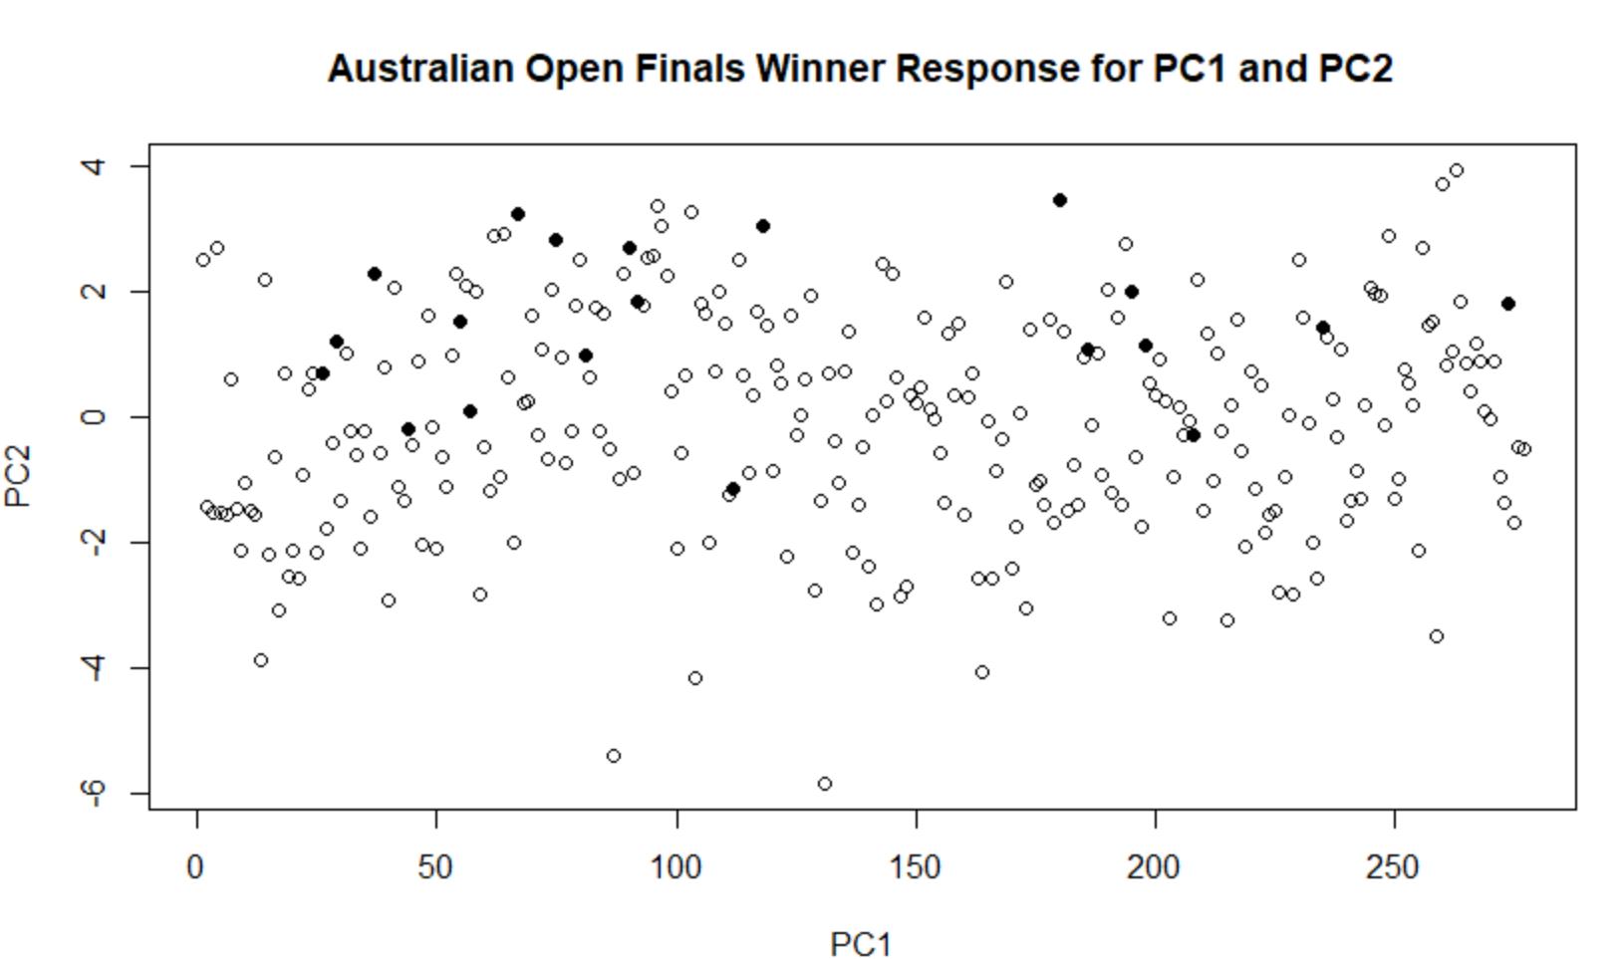

> plot(eigen_AO_Finalists, xlab = "Component number", ylab = "Component variance", type = "l", main = "Scree diagram")

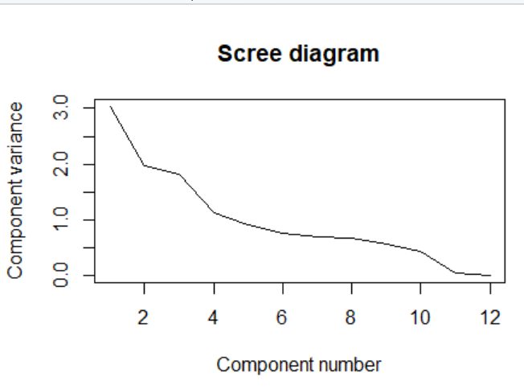

Component number after 11 are discarded

plot(log(eigen_AO_Finalists), xlab = "Component number",ylab = "log(Component variance)", type="l",main = "Log(eigenvalue) diagram")

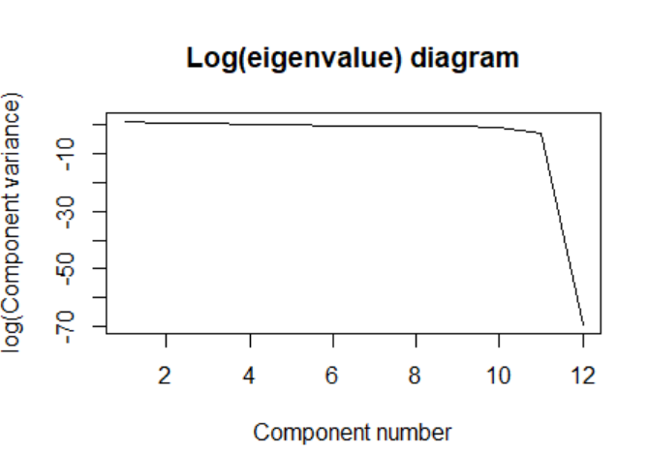

Component 12 is discarded

> print(summary(AustralianOpen_Finalists_allstats_pca))

Importance of components:

PC1 PC2 PC3 PC4 PC5 PC6 PC7 PC8 PC9

Standard deviation 1.7420 1.4031 1.3450 1.06024 0.94928 0.87265 0.82817 0.81273 0.75323

Proportion of Variance 0.2529 0.1641 0.1507 0.09368 0.07509 0.06346 0.05715 0.05504 0.04728

Cumulative Proportion 0.2529 0.4169 0.5677 0.66136 0.73645 0.79991 0.85707 0.91211 0.95939

PC10 PC11 PC12

Standard deviation 0.66214 0.22105 8.502e-16

Proportion of Variance 0.03654 0.00407 0.000e+00

Cumulative Proportion 0.99593 1.00000 1.000e+00

> diag(cov(AustralianOpen_Finalists_allstats_pca$x))

PC1 PC2 PC3 PC4 PC5 PC6 PC7

3.034501e+00 1.968804e+00 1.808901e+00 1.124111e+00 9.011337e-01 7.615134e-01 6.858578e-01

PC8 PC9 PC10 PC11 PC12

6.605265e-01 5.673569e-01 4.384332e-01 4.886229e-02 5.303971e-31

> xlim <- range(AustralianOpen_Finalists_allstats_pca$x[,1])

> head(AustralianOpen_Finalists_allstats_pca$x[,1])

[1] 2.514665 -1.421527 -1.524914 2.702994 -1.503460 -1.533669

> plot(AustralianOpen_Finalists_allstats_pca$x,xlim=xlim,ylim=xlim)

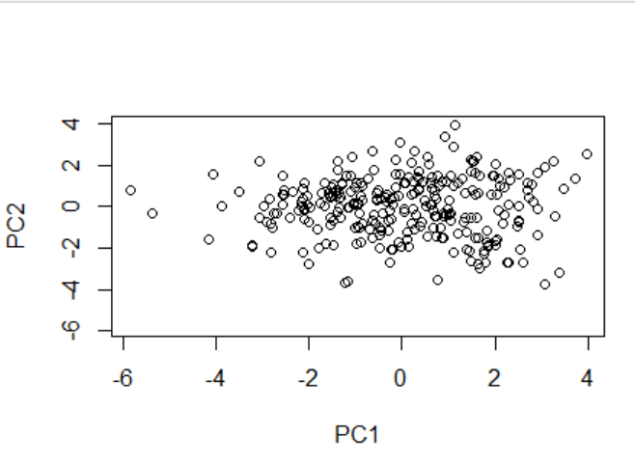

> AustralianOpen_Finalists_allstats_pca$rotation[,1]

Age Rank avgOdds SP_Percent

-0.00415178 0.13630501 0.11807701 0.48391843

RP_Percent BP_Win_Percentage Aces firstServeReturnsWon

-0.48391843 0.26061584 0.31732681 0.11056995

SecondServeReturnsWon FirstServesIn DoubleFaults FirstServePercentage

0.13556848 0.46875952 0.27786436 -0.05423925

AustralianOpen_Finalists_allstats_pca$rotation[,2]

Age Rank avgOdds SP_Percent

0.42830942 -0.38197446 0.34188696 0.19453812

RP_Percent BP_Win_Percentage Aces firstServeReturnsWon

-0.19453812 0.18226722 -0.19283950 -0.24004315

SecondServeReturnsWon FirstServesIn DoubleFaults FirstServePercentage

-0.30358565 -0.01812074 -0.21598416 0.45923720

> AustralianOpen_Finalists_allstats_pca$rotation[,3]

Age Rank avgOdds SP_Percent

-0.232554474 0.243595669 -0.274509489 0.308779847

RP_Percent BP_Win_Percentage Aces firstServeReturnsWon

-0.308779847 -0.006836468 -0.016447010 -0.506991061

SecondServeReturnsWon FirstServesIn DoubleFaults FirstServePercentage

-0.404359859 -0.326892184 -0.157093786 -0.261023158

> AustralianOpen_Finalists_allstats_pca$rotation

PC1 PC2 PC3 PC4 PC5

Age -0.00415178 0.42830942 -0.232554474 0.314609668 -0.04632629

Rank 0.13630501 -0.38197446 0.243595669 0.155808021 0.34813788

avgOdds 0.11807701 0.34188696 -0.274509489 0.476805302 -0.14611186

SP_Percent 0.48391843 0.19453812 0.308779847 -0.007946174 -0.03292276

RP_Percent -0.48391843 -0.19453812 -0.308779847 0.007946174 0.03292276

BP_Win_Percentage 0.26061584 0.18226722 -0.006836468 -0.395263686 0.11221296

Aces 0.31732681 -0.19283950 -0.016447010 0.370417984 0.37960882

firstServeReturnsWon 0.11056995 -0.24004315 -0.506991061 0.241247978 0.26234179

SecondServeReturnsWon 0.13556848 -0.30358565 -0.404359859 -0.397499499 -0.08812446

FirstServesIn 0.46875952 -0.01812074 -0.326892184 -0.188532278 0.10380643

DoubleFaults 0.27786436 -0.21598416 -0.157093786 0.054974387 -0.70441043

FirstServePercentage -0.05423925 0.45923720 -0.261023158 -0.317897990 0.33598190

PC6 PC7 PC8 PC9 PC10

Age 0.07970268 -0.63457440 -0.335950103 0.29919590 0.22054563

Rank -0.15206363 -0.05060044 -0.744818085 -0.19909378 -0.09768241

avgOdds -0.10789635 0.22739381 -0.013033622 -0.69122593 -0.04389392

SP_Percent 0.14662673 0.10424547 0.006397133 0.07541969 0.15795541

RP_Percent -0.14662673 -0.10424547 -0.006397133 -0.07541969 -0.15795541

BP_Win_Percentage -0.76231012 -0.32625171 0.141283958 -0.14915111 -0.01480656

Aces 0.16206350 -0.34295605 0.451779918 0.02147937 -0.47944497

firstServeReturnsWon -0.29723940 0.30625163 0.069620240 0.36171974 0.30759324

SecondServeReturnsWon 0.37873653 -0.33614764 -0.030957822 -0.37581689 0.13408444

FirstServesIn 0.16173311 0.19139591 -0.109800818 0.03343799 0.15240337

DoubleFaults -0.16974263 0.01768431 -0.179256050 0.25843657 -0.47111092

FirstServePercentage 0.14744370 0.23135101 -0.240979790 0.13776595 -0.54967266

PC11 PC12

Age -0.035617950 -1.370222e-16

Rank 0.032917599 7.204847e-18

avgOdds 0.043408318 8.019690e-17

SP_Percent 0.261611057 7.071068e-01

RP_Percent -0.261611057 7.071068e-01

BP_Win_Percentage -0.001685847 8.964077e-17

Aces -0.047078812 1.996870e-16

firstServeReturnsWon 0.365577301 -2.776579e-17

SecondServeReturnsWon 0.378901466 3.509267e-16

FirstServesIn -0.726337635 -4.471402e-16

DoubleFaults 0.047482294 -9.629723e-17

FirstServePercentage 0.222776913 1.520023e-16

**Inference : We are discarding the PC12 component based on scree plot and Eigen plot**