**1 LOW LEVEL DESIGN** 

Low Level Design

**Amazon Sales Data Analysis**

|  |  |
| --- | --- |
| **Written By** | Siri S |
| **Document Version** | 0.3 |
| **Last Revised Date** |  |
|  |  |

**Amazon Sales Data Analysis** 1

**2 LOW LEVEL DESIGN** 

**DOCUMENT CONTROL**

**Change Record:**

|  |  |  |  |
| --- | --- | --- | --- |
| **VERSION** | **DATE** | **AUTHOR** | **COMMENTS** |
| 0.1 | 28-April -  2024 | Siri S | Introduction and architecture defined |
|  |  |  |  |
|  |  |  |  |
|  |  |  |  |

**Reviews:**

|  |  |  |  |
| --- | --- | --- | --- |
| **VERSION** | **DATE** | **REVIEWER** | **COMMENTS** |
|  |  |  |  |

**Approval Status:**

|  |  |  |  |  |  |
| --- | --- | --- | --- | --- | --- |
| **VERSION** | **REVIEW**  **DATE** | **REVIEWED BY** |  | **APPROVED BY** | **COMMENTS** |
|  |  |  |  |  |  |

**Amazon Sales Data Analysis**

**3 LOW LEVEL DESIGN** 

**Contents**

1. Introduction………………………………………………………………………………………………………… 03

1.1 What is Low-Level Design Document? …………………………………………………….. 03

1.2 Scope ……………………………………………………………………………………………………... 03

2. Introduction……………………………………………………………………………………………………………04

2.1 Project Objectives and Scope………………………………………………………………………04

2.2 Importance of Sales management in E-commerce……………………………………….04

3. Data Extraction and Pre-processing……………………………………………………………………………05

3.1Steps Involved in Data Extraction…………………………………………………………….05

3.2 Data Cleaning and Pre-processing Techniques Applied………………………………05

4. Exploratory Data Analysis (EDA)…………………………………………………………………………..06

4.1 Analysis of Sales Trends……………………………………………………………………………06

4.2 Distribution Analysis of Key Variables…………………………………………………………06

4.3 Calculation and Interpretation of Key Metrics…………………………………………06…

5. Sales Trend Analysis…………………………………………………………………………………………….07

5.1 Monthly Sales Trend Analysis……………………………………………………………………07

5.2 Yearly Sales Trend Analysis……………………………………………………………………..07

5.3 Yearly-Monthly Sales Trend Analysis…………………………………………………….07

6. Key Metrics and Factors………………………………………………………………………………………08

6.1Average Resolution Time………………………………………………………………………08

6.2 Average Requester Wait Time……………………………………………………………….08

6.3 Analysis of Satisfaction Scores……………………………………………………………08

7. Conclusion………………………………………………………………………………………………………….09

**Amazon Sales Data Analysis** 3

**4 LOW LEVEL DESIGN** 

**1. Introduction**

**1.1 What is Low-Level design document?**

The goal of the LDD or Low-level design document (LLDD) is to give the internal logic design of the actual program code for the House Price Prediction dashboard. LDD describes the class diagrams with the methods and relations between classes and programs specs. It describes the modules so that the programmer can directly code the program from the document.

**1.2 Scope**

Low-level design (LLD) is a component-level design process that follows a step-by-step refinement process. The process can be used for designing data structures, required software architecture, source code and ultimately, performance algorithms. Overall, the data organization may be defined during requirement analysis and then refined during data design work.

**Amazon Sales Data Analysis** 4

**5 LOW LEVEL DESIGN**

**2. Introduction**

**2.1 Project Objectives and Scope**

* Analyze Amazon sales data to derive insights into sales trends, customer satisfaction, and operational efficiency.
* Scope includes examining sales patterns, identifying key metrics, and providing actionable recommendations for sales management.

**2.2 Importance of Sales Management in E-commerce**

* Effective sales management is crucial for e-commerce businesses to remain competitive, reduce costs, and maximize profits.
* 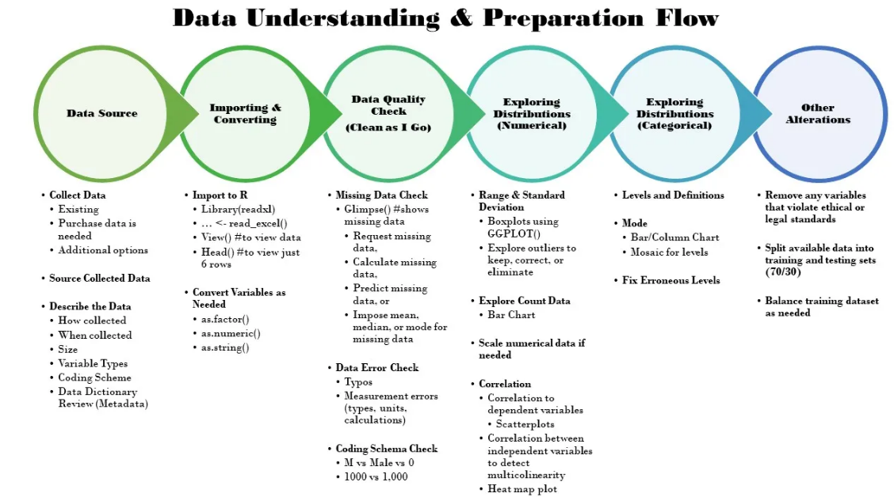Analyzing sales data helps optimize inventory management, pricing strategies, and customer support processes.

**Amazon Sales Data Analysis** 5

**6 LOW LEVEL DESIGN** 

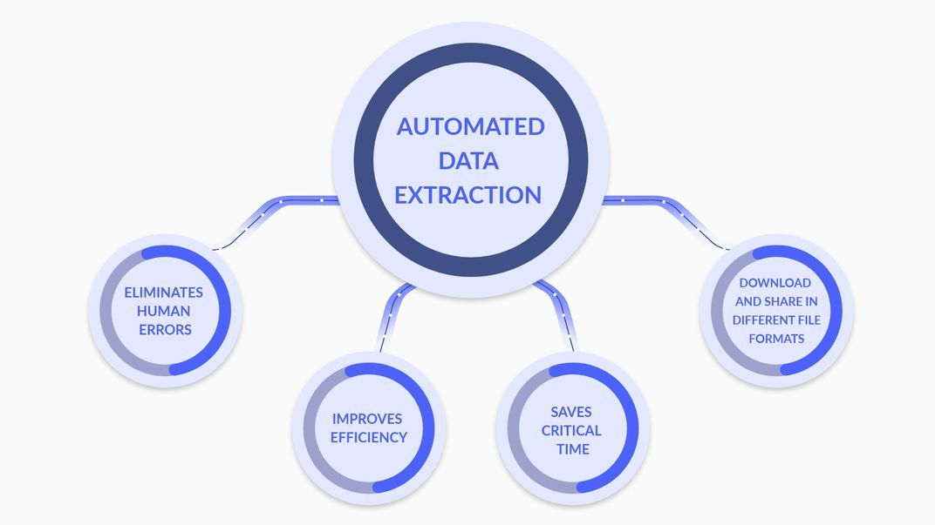

**3. Data Extractio3. Data Extraction and Pre-processing**

**3.1 Steps Involved in Data Extraction**

* Load the dataset using pandas' read_csv() function to create a Data Frame.
* Extract relevant columns and rows based on project objectives and requirements.

**3.2 Data Cleaning and Pre-processing Techniques Applied**

* **Handle missing values**: Identify missing values in the dataset and decide whether to impute them or remove rows/columns with missing values based on the impact on analysis results.
* **Remove duplicates**: Check for duplicate records in the dataset and remove them to ensure data integrity and avoid bias in analysis.
* **Convert data types**: Convert date strings to date time objects to facilitate time-based analysis. Convert categorical variables to numerical format using one-hot encoding or label encoding if necessary.
* **Handle outliers**: Identify outliers using statistical methods or visualization techniques and decide whether to remove them or transform them to mitigate their impact on analysis

**Amazon Sales Data Analysis** 6

**7 LOW LEVEL DESIGN** 

**4. Exploratory Data Analysis (EDA)**

* 1. **Analysis of Sales Trends**
* **Monthly Analysis:** Plot the total sales volume or revenue over each month to identify seasonal patterns or trends.
* **Yearly Analysis**: Plot the total sales volume or revenue for each year to identify long-term growth patterns or trends.
* **Yearly-Monthly Analysis:** Plot the total sales volume or revenue for each month across different years to observe variations or trends within months over time.

**4.2 Distribution Analysis of Key Variables**

* **Sales Volume:** Visualize the distribution of sales volume using histograms or density plots to understand its variability and central tendency.
* **Resolution Time:** Analyze the distribution of resolution times for support queries to identify the typical time taken to resolve issues.
* **Satisfaction Scores:** Plot the distribution of satisfaction scores using bar plots or pie charts to understand the distribution of customer feedback.

**4.3 Calculation and Interpretation of Key Metrics**

* **Average Resolution Time:** Calculate the mean resolution time for support queries to assess the efficiency of customer support processes.
* **Average Requester Wait Time:** Calculate the mean time customers wait for resolution to evaluate the responsiveness of support services.
* **Satisfaction Scores Analysis:** Analyze the distribution of satisfaction scores and identify factors influencing satisfaction levels, such as product quality, shipping times, or customer service.

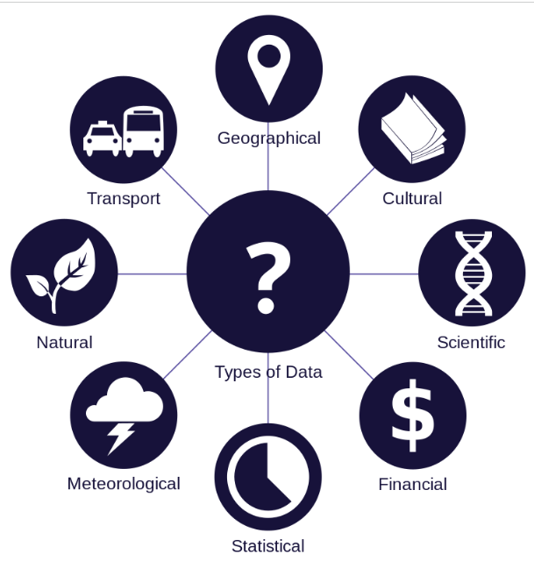

**Amazon Sales Data Analysis** 7

**8 LOW LEVEL DESIGN** 

**5. Sales Trend Analysis**

**5.1 Monthly Sales Trend Analysis**

* Calculate total sales volume or revenue for each month and plot it over time to identify seasonal patterns or trends.

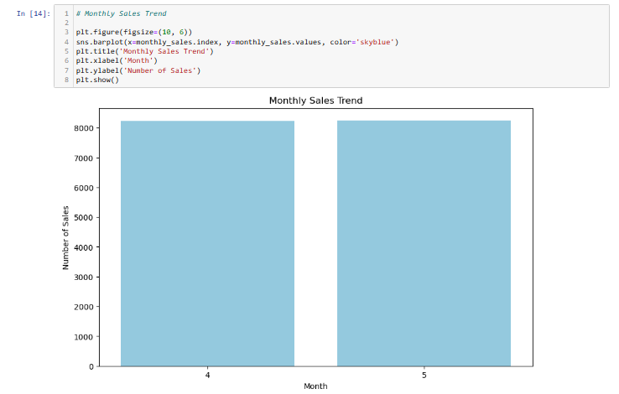

**5.2 Yearly Sales Trend Analysis**

* Calculate total sales volume or revenue for each year and plot it over time to identify long-term growth patterns or trends.

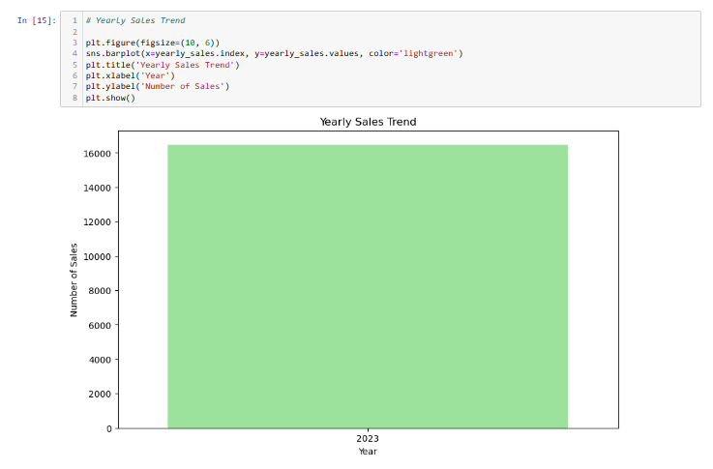

**5.3 Yearly-Monthly Sales Trend Analysis**

* Aggregate sales data by both year and month and plot it to observe variations or trends within months across different years.

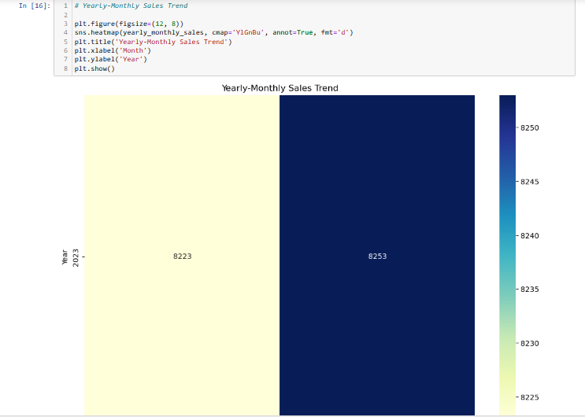

**Amazon Sales Data Analysis** 8

**9 LOW LEVEL DESIGN** 

**6. Key Metrics and Factors**

**6.1 Average Resolution Time**

* Calculate the average resolution time for support queries to evaluate the efficiency of customer support processes.

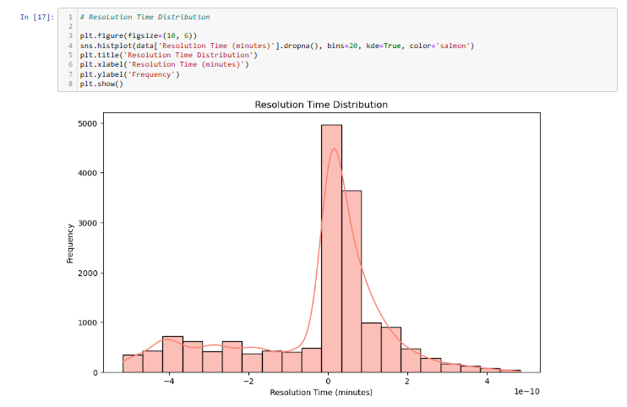

**6.2 Average Requester Wait Time**

* Calculate the average time customers wait for resolution to assess the responsiveness of support services.

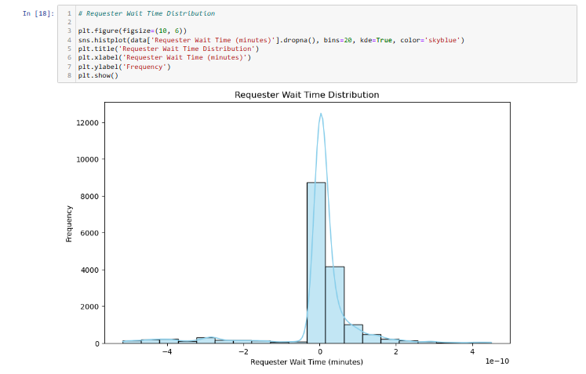

**6.3 Analysis of Satisfaction Scores**

* Analyze the distribution of satisfaction scores and identify factors influencing satisfaction levels, such as product quality, shipping times, or customer service.

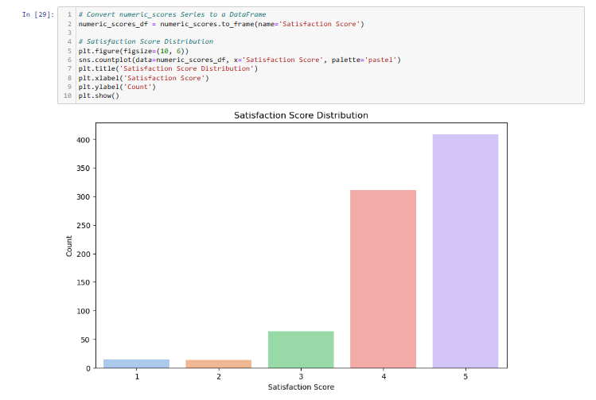

**Amazon Sales Data Analysis** 9

**10 LOW LEVEL DESIGN** 

**7. Conclusion**

In conclusion, the low-level document outlines a detailed plan for analyzing Amazon sales data, starting from data extraction and preprocessing to visualization and dashboard creation. Each section provides specific tasks and methodologies to be implemented, ensuring a systematic approach to the analysis process.

The data extraction and preprocessing section outlines steps to handle missing values, remove duplicates, convert data types, and handle outliers to ensure data quality and integrity. The exploratory data analysis section includes analysis of sales trends, distribution of key variables, and calculation of key metrics to derive meaningful insights from the dataset.

The sales trend analysis section focuses on analyzing monthly, yearly, and yearly-monthly sales trends to identify patterns and fluctuations over time. Key metrics such as average resolution time, average requester wait time, and satisfaction scores are calculated and analyzed to evaluate operational efficiency and customer satisfaction levels.

Finally, the visualization section highlights the importance of visual representations in conveying insights effectively. Interactive dashboards created using Tableau or Power BI enable stakeholders to explore data dynamically and derive actionable insights.

Overall, the low-level document provides a comprehensive roadmap for conducting the analysis of Amazon sales data, ensuring that all aspects of the project are addressed systematically and effectively.