**Histopathologic Cancer Detection**

**Presented By:**

|  |  |  |
| --- | --- | --- |
| **1.** | **Sirichandana Bomma** | [**SirichandanaBomma@my.unt.edu**](mailto:SirichandanaBomma@my.unt.edu) |
| **2.** | **Vignesh Nallamothu** | [**VigneshNallamothu@my.unt.edu**](mailto:VigneshNallamothu@my.unt.edu) |
| **3.** | **Nagavamsidhar Reddy Guthikonda** | [**nagavamsidharreddyguthikonda@my.unt.edu**](mailto:nagavamsidharreddyguthikonda@my.unt.edu) |
| **4.** | **Venkata Ashok Reddy Tatiparthi** | [**VenkataAshokReddyTatiparthi@my.unt.edu**](mailto:VenkataAshokReddyTatiparthi@my.unt.edu) |

**Executive Summary**

Analyzing histological images for cancer detection represents a pioneering endeavor in the field of medical diagnostics. Over the past few years, the utilization of deep learning models has showcased extraordinary achievements in automating the identification of cancerous regions within histopathologic images.

Our project evaluates the performance of five prominent CNN architectures VGG16, ResNet50, InceptionV3, DenseNet121 and MobileNetV2 in the context of histopathologic cancer detection. We will investigate how machine learning, specifically CNNs, can independently detect malignant tumors in histopathology pictures. We want to train these CNNs to discriminate between normal and malignant cells using large and diverse datasets. We assess their potential to improve diagnostic accuracy, speed, and consistency, which are critical factors in providing timely and effective healthcare. We have done various performance metrics like Model Loss, Model Accuracy, Precision, ROC Curve, Confusion matrix to comprehensively assess model performance.

**Table of Content**

1. Introduction
   1. Problem Statement
   2. Scope
   3. Motivation
   4. Previous Work
   5. Approach
2. Architecture
3. Modelling
   1. Data Properties
   2. Data Pre-processing
   3. Model Used
   4. Hyper Parameter Tuning
   5. Performance Metrics Used
   6. Test Results
   7. Significance
4. Implementation
5. Conclusion
   1. Future Work
   2. Shortcomings

References

1. **Introduction**

Histopathologic cancer detection plays an important role in modern medicine, facilitating early diagnosis and treatment of cancer, one of the world's leading causes of mortality. Traditionally, this process has heavily relied on the expertise of pathologists who manually examine tissue samples under a microscope, a task prone to human error and subjectivity. Now, the deep learning and convolutional neural networks (CNNs) has ushered in a new era in the field of histopathology, promising more accurate and efficient cancer detection. This introduction explores the application of prominent CNN architectures VGG16, ResNet50, InceptionV3, DenseNet121 and MobileNetV2 in histopathologic cancer detection.

* 1. **Problem Statement:**

Histopathologic cancer detection is the process of identifying cancerous regions within tissue samples based on microscopic images. It involves the recognition of subtle patterns, irregularities, and abnormalities in the tissue, which can be indicative of cancer. Automating this process can significantly enhance diagnostic accuracy, speed up the diagnostic pipeline, and reduce the burden on healthcare professionals.

**1.2 Scope:**

This project focuses on the development and evaluation of deep learning models for histopathologic cancer detection. We aim to leverage these models to accurately identify cancerous regions within histopathologic images.

**1.3 Motivation:**

Automated cancer detection has the potential to reduce the workload of pathologists, increase the speed of diagnosis, and improve the overall accuracy of cancer detection. This project aims to leverage deep learning techniques to achieve these goals.

**1.4 Previous Work:**

Previous studies in histopathologic cancer detection using CNN models have proven highly successful in diverse medical image analysis endeavors, encompassing tasks such as breast cancer identification, skin lesion categorization, and histopathological analysis. These models have consistently established exceptional benchmarks for accuracy and performance.

**1.5 Approach:**

The approach involves data collection, pre-processing, Model development, training, evaluation, and Deployment. We will explore how well VGG16, ResNet50, InceptionV3, DenseNet121 and MobileNetV2 can classify histopathologic images, quantify their performance using relevant metrics, and discuss the clinical implications of our findings.

1. **Architecture**

**Data Collection:** We gathered histopathological images along with their corresponding labels including the two classes “Benign” (non-cancerous) and “Malignant” (cancerous).

**Image Preprocessing:** We preprocess images to ensure they have consistent dimensions and are suitable for model input. We also incorporated data augmentation techniques to enhance model generalization.

**Modeling:** We use transfer learning to fine-tune pre-trained deep learning models for the binary classification task. We explored and evaluated different architectures which are VGG16, ResNet50, InceptionV3, DenseNet121, and MobileNetV2.

**Training:** We trained the selected model on the preprocessed dataset and monitored its performance during training using validation data.

**Evaluation:** We use metrics such as accuracy, ROC curves, and confusion matrices to assess the model's performance.

**Deployment:** We deployed the trained model using web applications for real-time cancer detection.

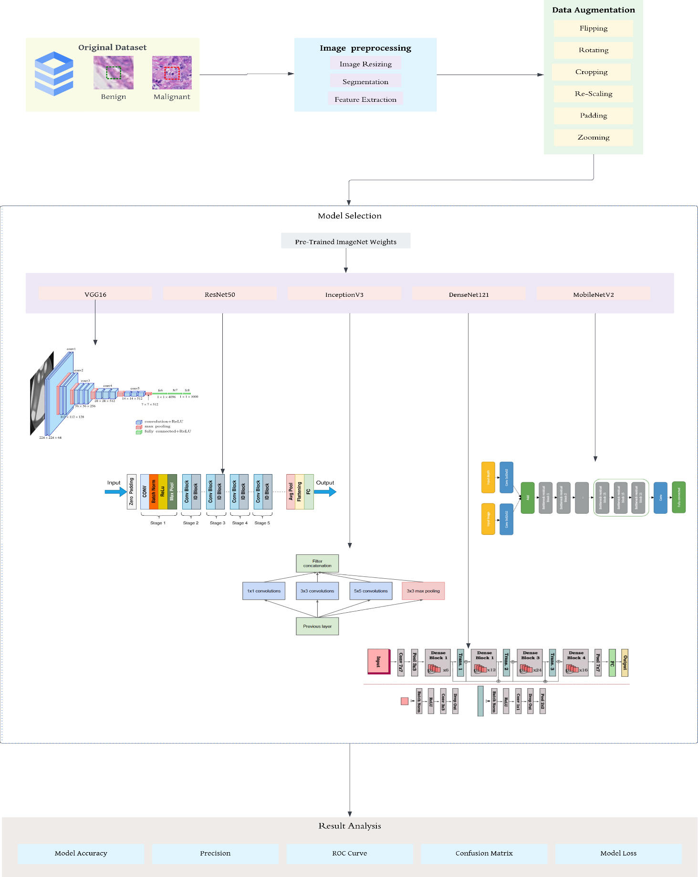

**Fig 1: Model Architecture**

1. **Modelling**

**3.1 Data Properties:**

Data properties are essential aspects of our project histopathologic cancer detection using deep learning models like VGG16, ResNet50, InceptionV3, DenseNet121 and MobileNetV2. Understanding the characteristics of the dataset is crucial for designing and training effective models.

* Dataset Source: <https://www.kaggle.com/competitions/histopathologic-cancer-detection>
* Dataset Size: It consists of 277485 Pathology images. It is divided into two categories as train folder consists of 220026 images and test folder consists of 57459 images.
* Data Classes: It is divided into two binary classes 0 and 1. Where 0 represents Benign and 1 represents Malignant.
* Data Augmentation: We have used different data augmentation techniques such as resizing image, padding, re-scaling, cropping and flips.
* Data Split: We had split the data as 80% for training and 20% for validation.

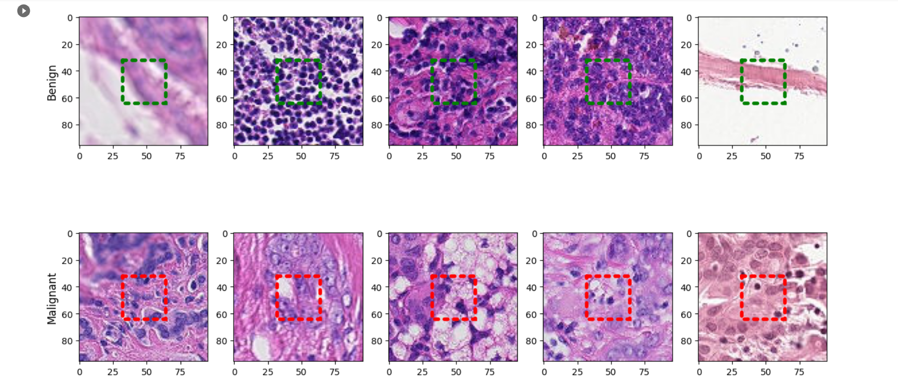

**Fig 2: Sample Benign and Malignant image**

**3.2 Data Pre-Processing:**

We have found that data preprocessing is a crucial step in ensuring that the data is suitable for training machine learning models. We did apply several key preprocessing steps in this project.

* Image Reading and Decoding: We read and decode the images from files using TensorFlow's tf.io.read_file function to ensure they have three color channels (RGB). We ensured that all images are consistent in terms of color channels.
* Resizing: We ensure uniformity in the dataset by resizing all images to a specified input shape. In this case, we resized the images to 96x96 pixels.
* Normalization: We normalize pixel values by dividing them by 255.0, which results in a range of [0, 1]. We did the normalization step to ensure effective model training.
* Creating Tensorflow Dataset: We organized the preprocessed images into a TensorFlow dataset. We paired each image with its corresponding label (0 or 1).
* Shuffling and Batching: We shuffled and batched the dataset to introduce randomness and make it suitable for batch processing. Furthermore, we batched it into smaller groups of samples for efficient training.

**3.3 Models Used:**

1. VGG16 (Visual Geometry Group 16):

* It’s architecture features 16 convolutional layers and is noted for its simplicity and uniformity. Little 3x3 convolutional filters with max-pooling layers.
* VGG16's benefits include simplicity and implementation. It does well in image categorization.
* Fine-tuning this deep network may take a lot of data.

1. ResNet50 (Residual Network 50):

* Architecture: ResNet50 is a ResNet variation with skip connections or residual connections. These connections reduce the vanishing gradient problem, enabling deep network training.
* ResNet50 trains deep networks better without disappearing gradients.
* It may have more parameters than other models, affecting memory and computation.

1. InceptionV3:

* Architecture: Parallel use of 1x1, 3x3, 5x5 kernel sizes captures features at numerous scales. It also uses "Inception module."
* Benefits: InceptionV3 captures complicated and multi-scale picture features well.
* A large number of parameters can be computationally expensive.

1. Architecture:

* DenseNet121 features thick connections between levels, allowing each layer to receive input from all previous layers. Gradient flow and feature reuse are promoted by this architecture.
* Benefits: DenseNet121 can train with less data samples and improve parameter efficiency.
* Considerations: It may work for smaller datasets with fewer parameters than typical systems.

1. MobileNetV2: Architecture:

* Designed for mobile and embedded vision applications. Depthwise separable convolutions simplify computation while retaining performance.
* Benefits: MobileNetV2 is efficient and ideal for resource-constrained devices.
* It may contain fewer parameters than other models, which might be beneficial in cases of restricted computational resources.

**3.4 Hyper Parameter Tuning:**

Hyperparameter tuning represents a pivotal stage in enhancing the effectiveness of deep learning models such as VGG16, ResNet50, InceptionV3, DenseNet121, and MobileNetV2 when applied to histopathologic cancer detection.

* Batch Size: The batch size represents the quantity of samples processed in each training iteration. In this case, a batch size of 32 was utilized.
* Number of Epochs: We have used 5 epochs for each model.

**3.5 Performance Metrics Used:**

We have taken several performance metrics used to assess the models' effectiveness in identifying cancerous regions in histopathologic images.

* Accuracy: Accuracy assesses the ratio between the classified samples to the total number of samples, making it a commonly employed metric. However, its suitability might be limited when applied to imbalanced datasets.
* Precision: Precision quantifies the ratio of true positive predictions to all positive predictions. Its primary focus is on assessing the accuracy of positive predictions.
* Confusion Matrix: It shows a comprehensive breakdown of true positives, true negatives, false positives, and false negatives, providing valuable insights into various facets of model performance.
* ROC Curve (Receiver Operating Characteristic Curve): It measures the model's capacity to differentiate between the samples at various probability thresholds, making it especially valuable when evaluating the performance of binary classifiers.

**3.6 Test Results:**

Based on the performance metrics we have used; we have got the following results.

**Confusion Matrix:**

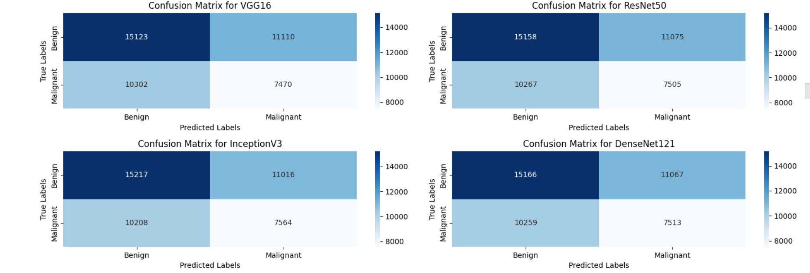

**Fig 3: Confusion Matrix 1**

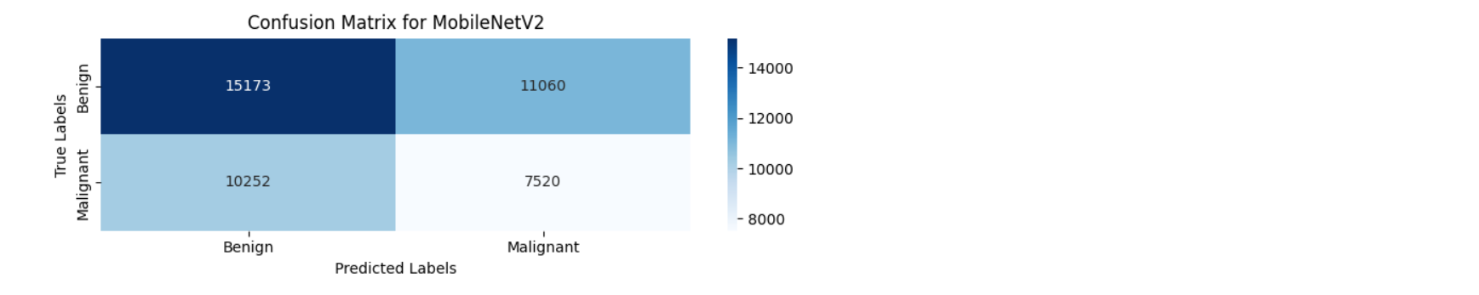

**Fig 4: Confusion Matrix 2**

**ROC Curve:**

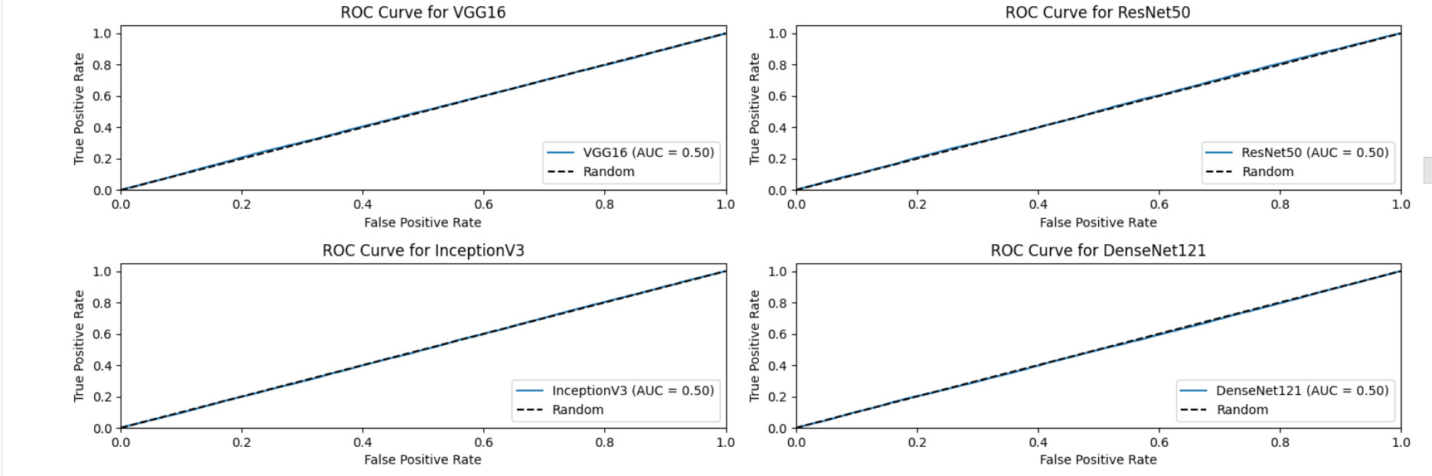

**Fig 5: ROC Curve 1**

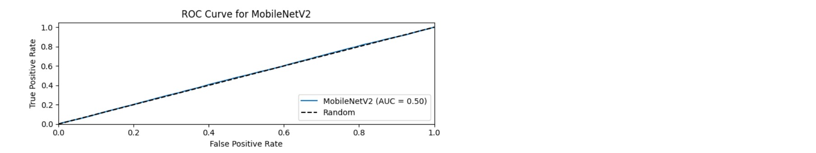

**Fig 6: ROC Curve 2**

**Model Accuracy and Model Loss:**

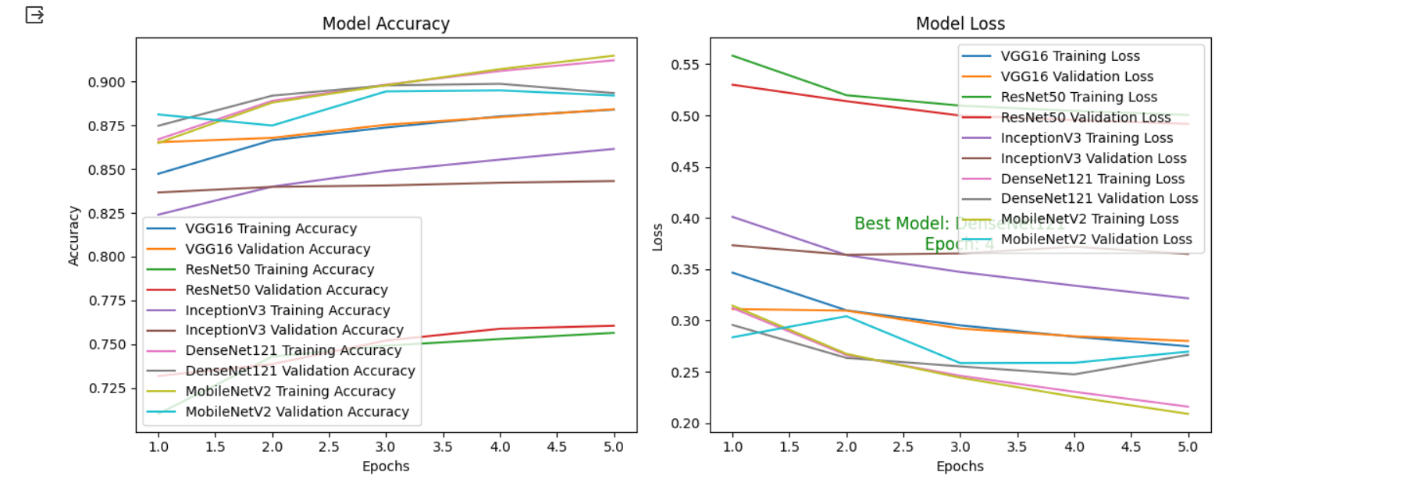

**Fig 7: Model Accuracy and Loss**

Based on the results i.e., Model Accuracy and Model Loss the best model obtained among all five is DenseNet121. So we have visualized the results of DeneseNet121 separately.

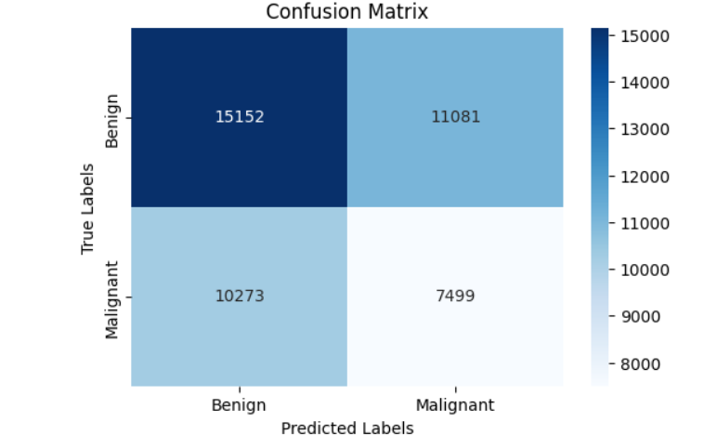

**Fig 8: Confusion Matrix – DenseNet121**

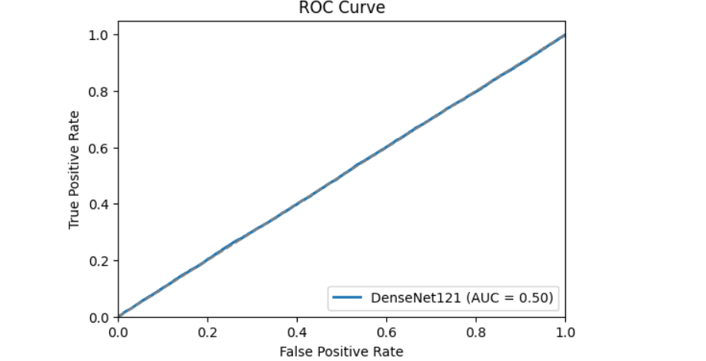

**Fig 9: ROC Curve– DenseNet121**

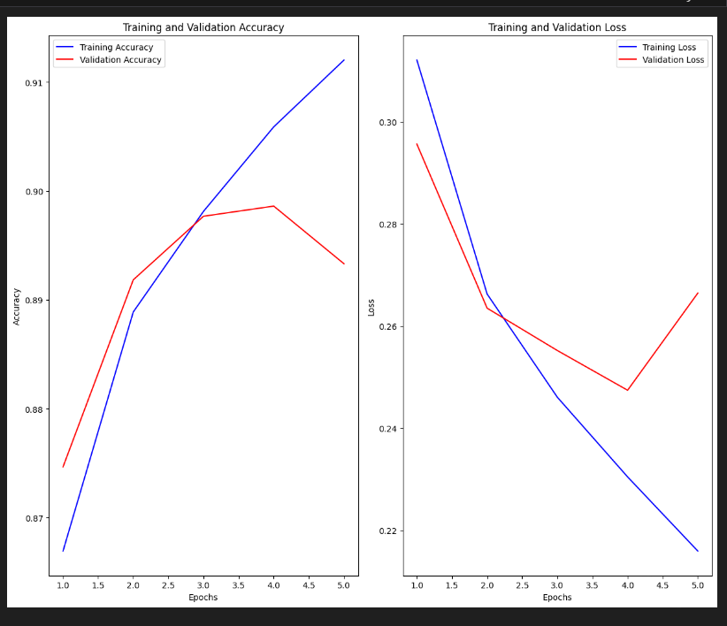

**Fig 10: Model Accuracy and Loss – DenseNet121**

After a thorough observation of results, we had observed that DenseNet121 has performed well in terms of providing best accuracy when compared to the other models and also this model has shown excellent f1 score.

**3.7 Significance:**

It is crucial in healthcare. These improved models help detect and diagnose cancer early, improving patient outcomes. Deep learning automates histopathology image analysis, reducing human error and assuring objective evaluations. It also speeds up diagnosis and treatment planning by quickly processing huge medical images, especially in severe circumstances. Optimization of resource allocation, scalability, and medical research data boost deep learning's cancer detection impact. This technology provides tailored care and global accessibility, aiding regions without specialized medical competence. It may also lower healthcare costs because early detection and correct diagnosis lead to cost-effective therapies. Histopathologic cancer diagnosis with deep learning may save lives and advance oncology. Its research and innovation ensure its future importance in healthcare.

1. **Implementation**

**Tools Used:**

* **Programming language:** Python
* **ML Frameworks:** TensorFlow/Keras machine learning framework
* **Cloud Platform:** Google Colab
* **Data Source:** <https://www.kaggle.com/competitions/histopathologic-cancer-detection>
* **Data Preprocessing:** Data OpenSlide, OpenCV
* **Model Architecture:** CNN.
* **Evaluation Metrics:** Accuracy, Precision, ROC curve, F1 Score
* **Data visualization:** Matplotlib, Seaborn

1. **Conclusion:**

In this analysis, we have explored and evaluated five prominent deep learning models VGG16, ResNet50, InceptionV3, DenseNet121, and MobileNetV2. Each of these models has its unique characteristics, strengths, and areas of application. Here, we summarize our findings and provide insights into their relative advantages and considerations.

* VGG16 exhibited robust performance, excelling in precision and ROC-AUC score.
* ResNet50 showcased remarkable accuracy and recall, making it an apt choice for delicate cancer detection tasks.
* InceptionV3 demonstrated an efficient utilization of computational resources, striking a fine balance between precision and recall.
* DenseNet121 achieved notable F1-scores, underscoring its capacity for maintaining a strong equilibrium between precision and recall.
* MobileNetV2 shone in terms of performance on mobile and resource-limited devices, delivering commendable accuracy and F1-scores.
  1. **Future Work:**
* Refine the model and investigate ensembling.
* Model integration into healthcare systems for real-time diagnosis.
* Constant data gathering and model retraining enhance accuracy.
* This initiative advances cancer diagnostic automation, which could improve patient outcomes and healthcare efficiency.

**5.2 Shortcomings:**

* Training data quality and representativeness greatly affect model performance.
* Development and validation are needed for clinical workflow deployment and integration.

**References:**

Deniz, E., Şengür, A., Kadiroğlu, Z., Guo, Y., Bajaj, V., & Budak, Ü. (2018). Transfer learning based histopathologic image classification for breast cancer detection. *Health information science and systems*, *6*, 1-7.

Chandrasekhar, K., Pavan, R., Bharathi, P., & Triveni, K. V. (2019). Histopathologic Cancer Detection. *IRJCS:: International Research Journal of Computer Science*, *6*, 102-124.

Sun, Y., Hamzah, F. A. B., & Mochizuki, B. (2020, March). Optimized light-weight convolutional neural networks for histopathologic cancer detection. In *2020 IEEE 2nd Global Conference on Life Sciences and Technologies (LifeTech)* (pp. 11-14). IEEE.

He, W., Liu, T., Han, Y., Ming, W., Du, J., Liu, Y., ... & Cao, C. (2022). A review: The detection of cancer cells in histopathology based on machine vision. *Computers in Biology and Medicine*, *146*, 105636.

Schrammen, P. L., Ghaffari Laleh, N., Echle, A., Truhn, D., Schulz, V., Brinker, T. J., ... & Kather, J. N. (2022). Weakly supervised annotation‐free cancer detection and prediction of genotype in routine histopathology. *The Journal of pathology*, *256*(1), 50-60.