SCHOOL OF COMPUTER SCIENCE AND ARTIFICIAL INTELLIGENCE |  |  |  |  | DEPARTMENT OF COMPUTER SCIENCE ENGINEERING
ProgramName:B. Tech |  |  |  | Assignment Type: Lab |  |  | AcademicYear:2025-2026
CourseCoordinatorName |  |  |  | Venkataramana Veeramsetty
Instructor(s)Name |  |  |  | 1. Dr. Mohammed Ali Shaik  2. Dr. T Sampath Kumar  3. Mr. S Naresh Kumar  4. Dr. V. Rajesh  5. Dr. Brij Kishore  6. Dr Pramoda Patro  7. Dr. Venkataramana  8. Dr. Ravi Chander  9. Dr. Jagjeeth Singh
CourseCode |  |  | 24CS002PC215 | CourseTitle |  | AI Assisted Coding
Year/Sem |  |  | II/I | Regulation |  | R24
Date and Day  of Assignment |  |  |  | Time(s)
Duration |  |  | 2 Hours | Applicableto  Batches
AssignmentNumber:3.3(Present assignment number)/24(Total number of assignments)
 | Q.No. | Question |  |  |  |  |  | ExpectedTime  to complete
 | 1 | Lab 3: Prompt Engineering – Improving Prompts and Context Management  Lab Objectives:  - To understand how prompt structure and wording influence AI-generated code.  - To explore how context (like comments and function names) helps AI generate relevant output.  - To evaluate the quality and accuracy of code based on prompt clarity.  - To develop effective prompting strategies for AI-assisted programming.  Lab Outcomes (LOs):  After completing this lab, students will be able to:  - Generate Python code using Google Gemini in Google Colab.  - Analyze the effectiveness of code explanations and suggestions by Gemini.  - Set up and use Cursor AI for AI-powered coding assistance.  - Evaluate and refactor code using Cursor AI features.  - Compare AI tool behavior and code quality across different platforms.  Task Description#1  - Try 3 different prompts to generate a factorial function.  Expected Output#1  - Comparison of AI-generated code styles  Prompt1: Write a python program using functions to generate a factorial by user  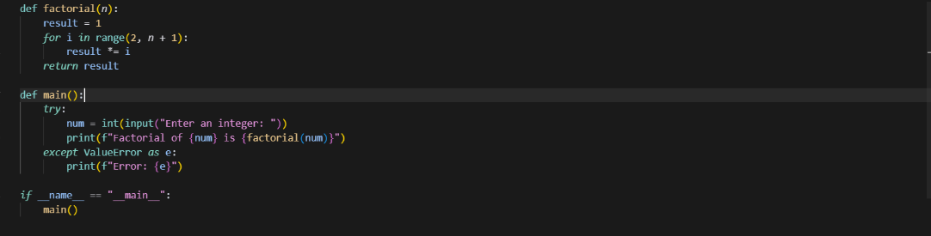  Output:  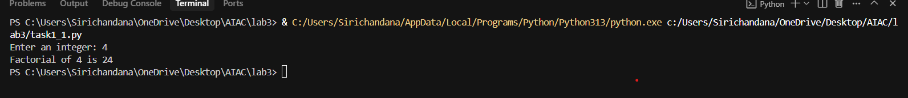  Prompt2: Write Python program to generate a factorial function  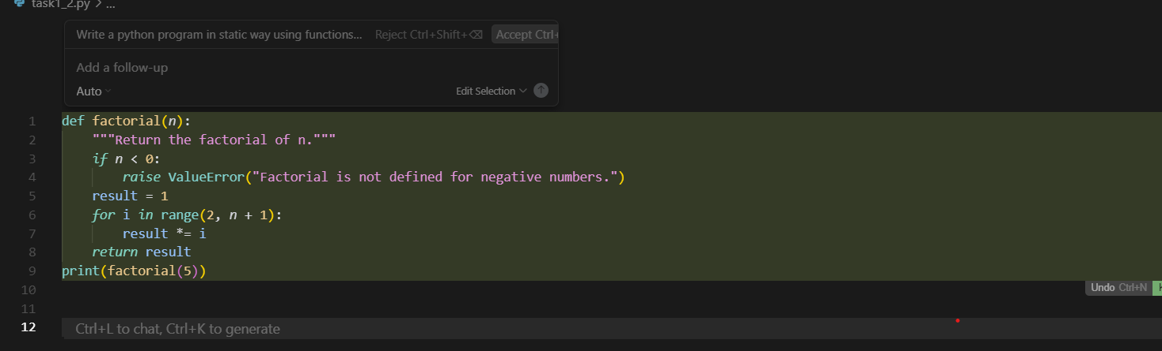  Output:  Prompt3: Write a python program using functions to generate the factorial of a non-negative integer  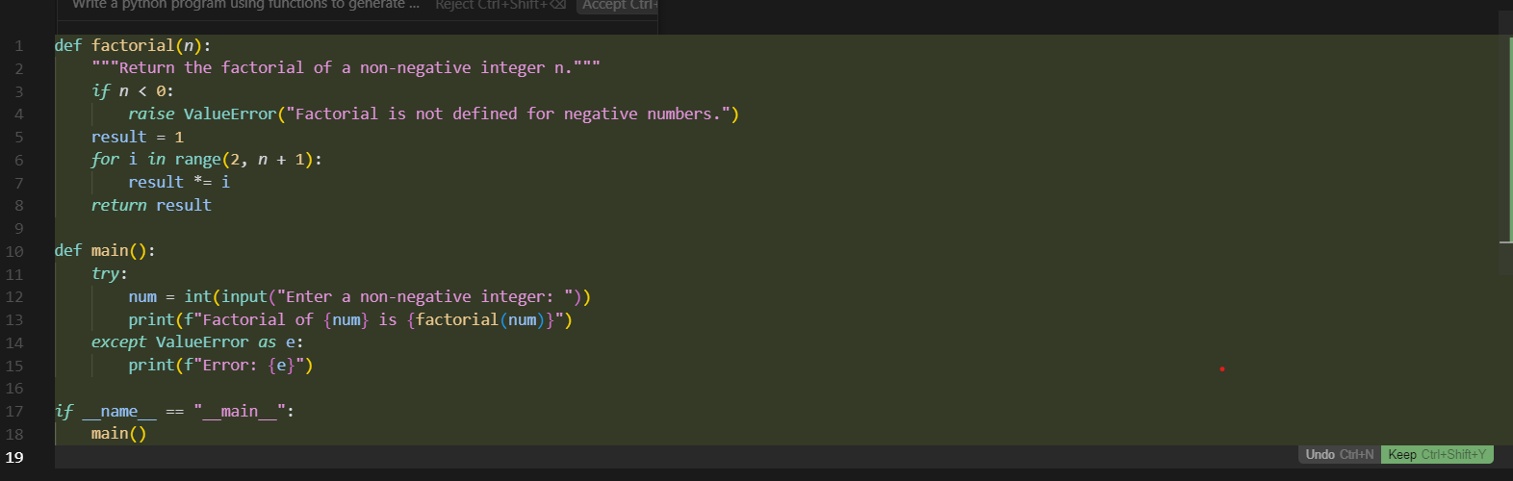  Output:  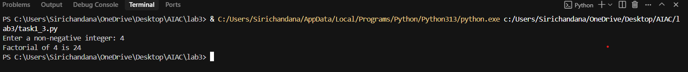  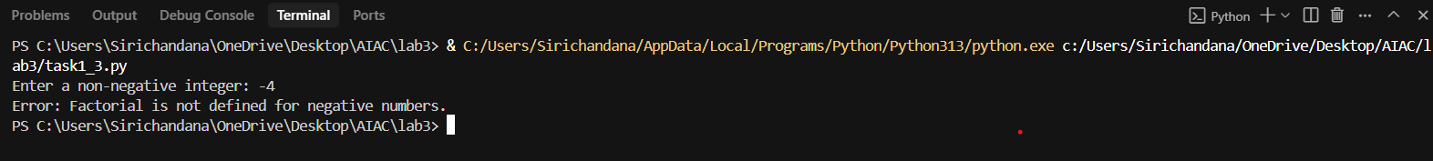  Analyze:  In the first given prompt the code is to ask the user to give the number What they wanted to give  .Then in the second given prompt the code is to take the output by the given AI tool itself and. In the third given prompt the code is to find the positive integer only. Then it should show the output if not if we give the negative integer then it should show the error.  Task Description#2  - Provide a clear example input-output prompt to generate a sorting function.  Expected Output#2  - Functional sorting code from AI  Prompt: Write a python program to generate a clear example of a sorting function  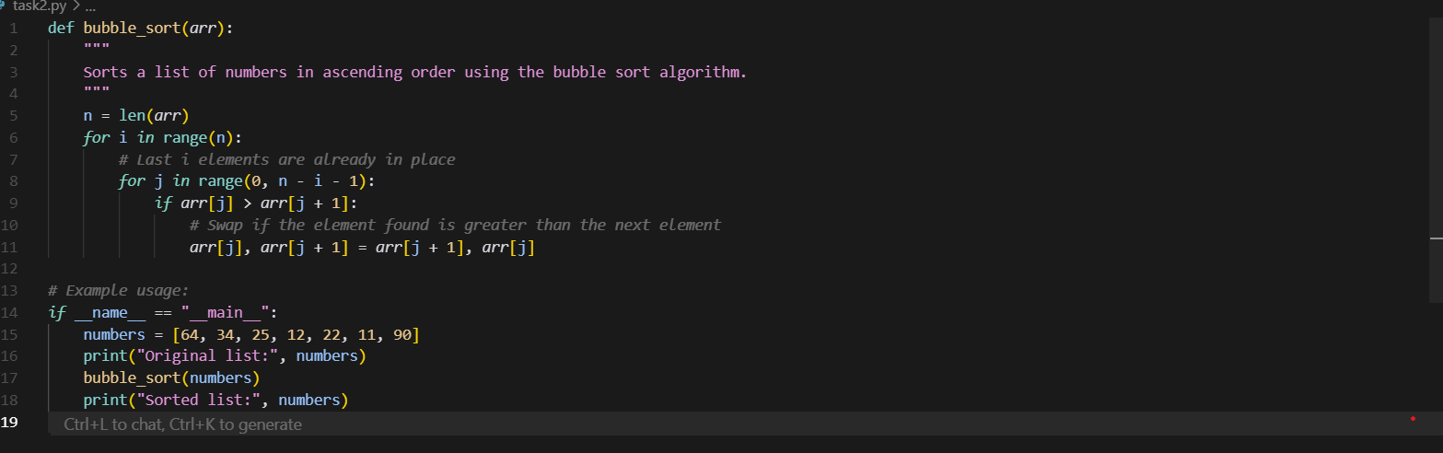  Output:  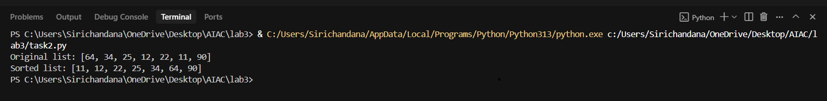  Task Description#3  - Start with the vague prompt “Generate python code to calculate power bill” and improve it step-by-step  Expected Output#3  - Enhanced AI output with clearer prompts  Prompt1: Generate python code to calculate power bill  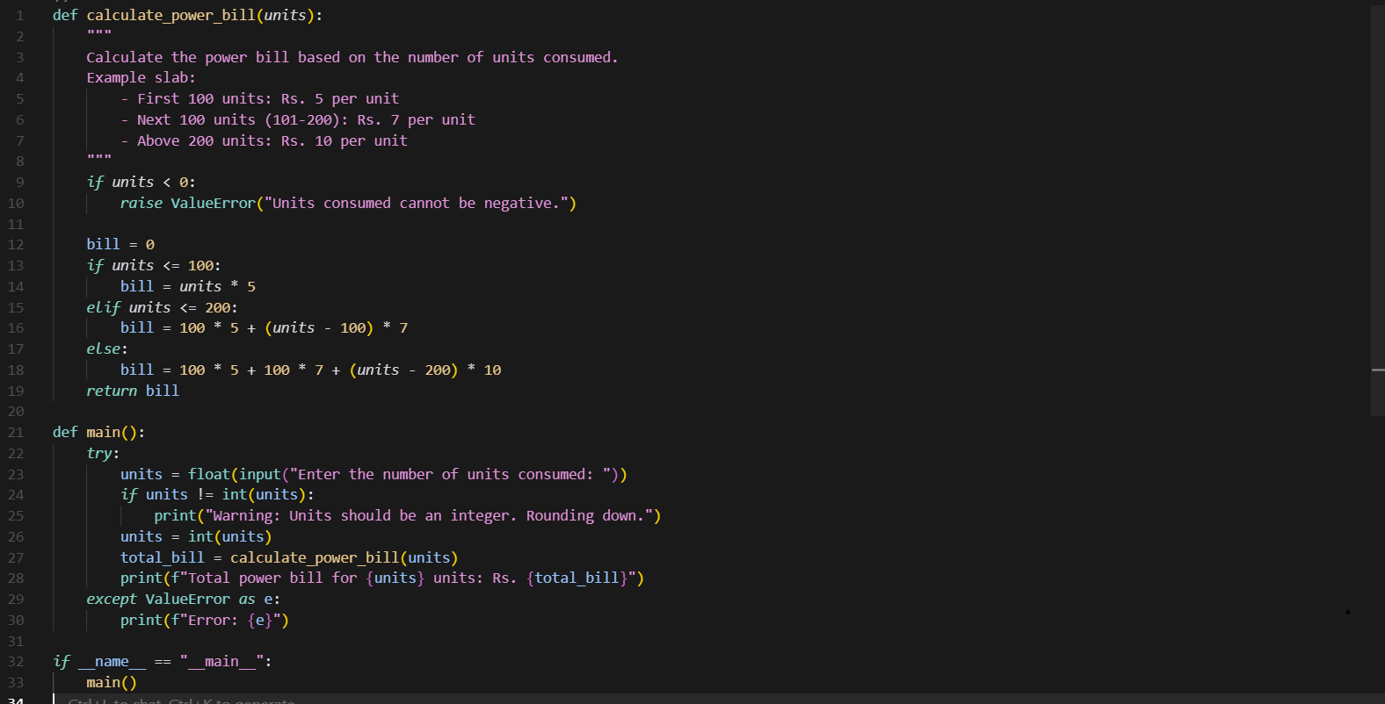  Output:  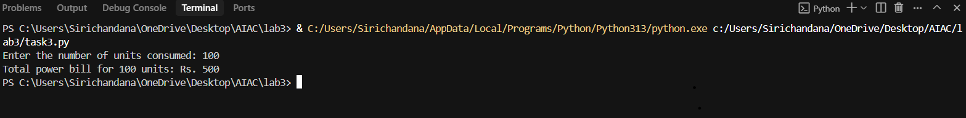  Prompt2: Generate Python code to calculate a monthly electricity bill based on total kilowatt-hours (kWh) used and a fixed rate per kWh.  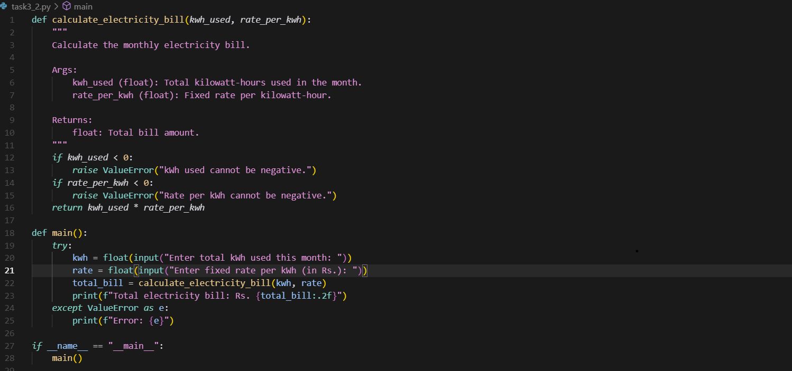  Output:  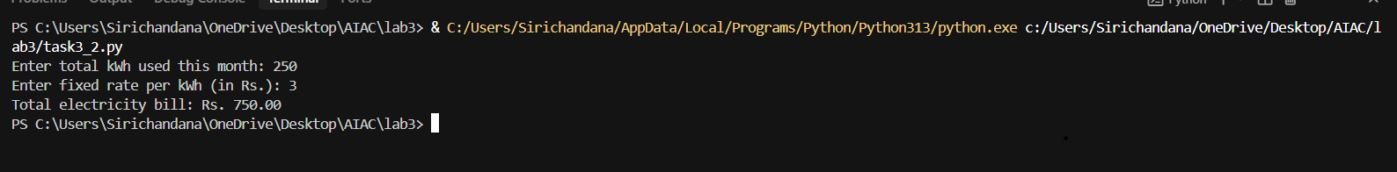  Analyze:  Prompt 1: is general. It just says "calculate power bill" without explaining how the bill should be calculated. So, it could mean anything—maybe using tiered rates, fixed  charges, or even time-based pricing. It leaves room for interpretation.  Prompt 2: is specific. It clearly says to calculate a monthly electricity bill using the total kilowatt-hours (kWh) used and a fixed rate per kWh. That means the calculation is straightforward: multiply the usage by the rate.  Task Description#4  - Write structured comments to help AI generate two linked functions (e.g., login_user() and register_user()).  Expected Output#4  - Consistent functions with shared logic  Prompt: Write Python code that includes two linked functions login user() and register user()  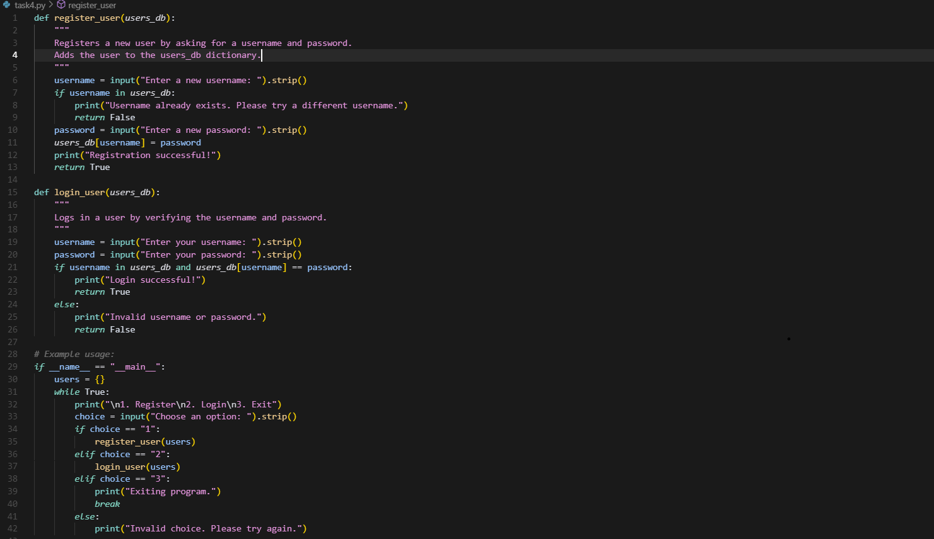  Output:  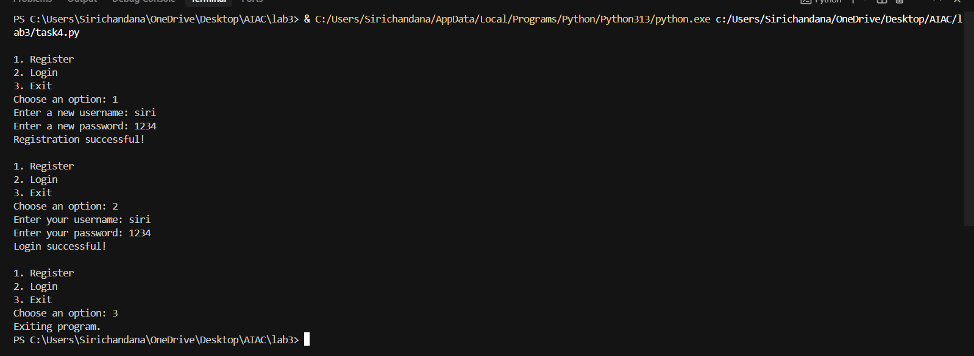  Task Description#5  - Analyzing Prompt Specificity: Improving Temperature Conversion Function with Clear Instructions  Expected Output#5  - Code quality difference analysis for various prompts  Prompt1: Write a python function to convert temperature.  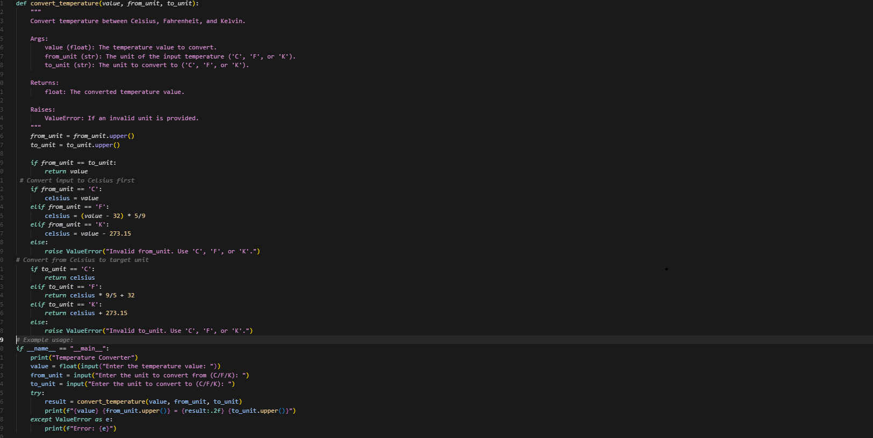  Output:  Prompt2: Write a Python function to convert Celsius to Fahrenheit.  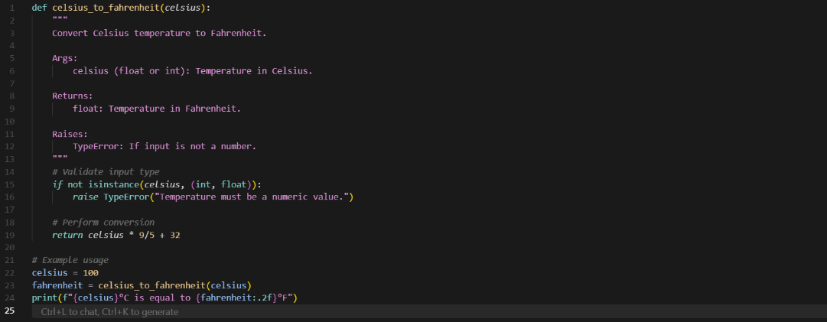  Output:  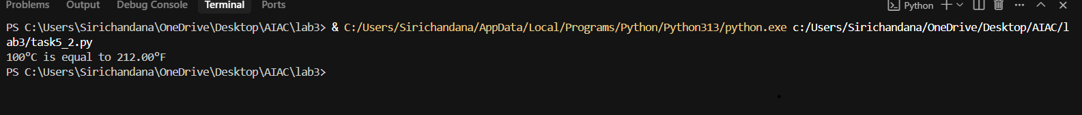  Analyze:  Prompt1 asks for a general temperature conversion function that can handle multiple units like Celsius, Fahrenheit, and Kelvin, while  Prompt2 specifically requests a function that converts only from Celsius to Fahrenheit.  Note: Report should be submitted a word document for all tasks in a single document with prompts, comments & code explanation, and output and if required, screenshots  Evaluation Criteria:  Criteria Max Marks  Factorial Function (Task#1) 0.5  Sorting Function (Task#2) 0.5  Vogue Vs. Specific Prompting (Task #3) 0.5  Linked Functions (Task #4) 0.5  Temperature Conversion Function (Task #5) 0.5  Total 2.5 Marks |  |  |  |  |  | 03.08.2025 EOD

