PROJECT TITLE
Resume Maker Web Application

A course project report submitted in partial fulfilment of the requirement
of
DEVOPS AND FULLSTACK
by

K Siri Chandana (2303A52256)

Under the guidance of
Dr. N.VENKATESH
Asst. Professor, Department of CS & AI


SR University, Warangal
APRIL-2026

ABSTRACT
This project presents the design and implementation of a Resume Maker Web Application using the MERN stack (MongoDB, Express.js, React, and Node.js), integrated with DevOps practices. The primary objective of the system is to provide users with a platform to efficiently create, edit, and download professional resumes.
The application incorporates secure user authentication using JSON Web Tokens (JWT) and bcrypt, ensuring safe storage and management of user credentials in MongoDB. Unlike traditional static resume-building methods, this system offers a dynamic and user-friendly interface that supports real-time editing, customization of templates, and instant preview of resume content.
DevOps practices such as version control, continuous integration, and deployment are implemented to ensure efficient development, scalability, and reliability of the application. The system is designed to be deployment-ready, enabling seamless communication between frontend and backend through RESTful APIs while eliminating dependency on local storage.
Overall, this project demonstrates how full-stack development combined with DevOps methodologies can be used to build a secure, scalable, and production-ready web application.

CONTENTS

ABSTRACT ii

Chapter No. Title Page No.

1 INTRODUCTION 04
1.1 About the project 04
1.2 Objectives 04

2 LITERATURE REVIEW 05
2.1 Overview of DevOps and Full-Stack Development 03
2.2 Related Studies and Existing Solutions 05
2.3 Tools and Technologies Used 06

3 METHODOLOGY 07
3.1 System Architecture 07
3.2 Data handling 07
3.3 Functional Modules 07

4 RESULTS AND DISCUSSION 08
4.1 System Output and Features 11
4.2 Performance Analysis 11
4.3 Discussion 11

5 CONCLUSION AND FUTURE WORK
5.1 Conclusion 11
5.2 Future Scope 12

CHAPTER NO. 1: INTRODUCTION
1.1 About the Project
The Resume Maker Web Application is a full-stack web-based system designed to help users create professional and structured resumes efficiently. The application is developed using the MERN stack (MongoDB, Express.js, React, and Node.js) along with DevOps practices to ensure scalability, reliability, and efficient deployment.
Traditional resume creation methods are often time-consuming and lack flexibility. This project addresses these limitations by providing a dynamic and user-friendly platform where users can create, edit, and customize resumes in real time. The system supports multiple resume templates, including one-column and two-column layouts, allowing users to choose formats based on their preferences.
The application includes features such as real-time preview, dynamic editing, and PDF generation, enabling users to visualize their resume instantly while making changes. Secure user authentication is implemented using JSON Web Tokens (JWT) and bcrypt, ensuring safe access and protection of user data.
The backend is responsible for handling API requests, authentication, and resume data management, while the frontend provides an interactive interface for users. MongoDB is used to store user information and resume data in a flexible format, allowing easy updates and scalability.
Overall, this project demonstrates the integration of full-stack development and DevOps practices to build a modern, efficient, and production-ready web application for resume creation.

1.2 Objectives
The main objectives of the Resume Maker Web Application are:

• To develop a user-friendly platform for creating professional resumes
• To implement real-time editing and live preview functionality
• To provide multiple customizable resume templates
• To enable secure user authentication using JWT and bcrypt
• To store and manage resume data efficiently using MongoDB
• To generate downloadable resumes in PDF format
• To integrate frontend and backend using RESTful APIs
• To apply DevOps practices such as version control and CI/CD
• To design a scalable and deployment-ready application
• To enhance user experience with responsive and interactive UI

CHAPTER 2: LITERATURE REVIEW
DevOps and Full-Stack Application Development

DevOps is a modern approach in software engineering that integrates development and operations to improve collaboration, efficiency, and delivery speed. In the Resume Maker Web Application, DevOps practices are used to streamline development, testing, and deployment processes.
Continuous Integration and Continuous Deployment (CI/CD) play a significant role in maintaining system efficiency. Automated pipelines using tools like GitHub Actions help in building, testing, and deploying the application without manual intervention, ensuring reliability and faster delivery.
Full-stack development forms the foundation of this project. The frontend is developed using React, providing a dynamic and responsive user interface, while the backend is built using Node.js and Express.js to handle API requests and data processing. MongoDB is used as a flexible NoSQL database to store user and resume data efficiently.
Overall, this integration enables seamless communication between client and server, ensuring a smooth and efficient user experience.

2.2 Related Studies and Existing Solutions
Various online resume-building platforms such as Canva, Novoresume, and Resume.io provide users with tools to create professional resumes. These platforms offer pre-designed templates and basic customization features.
However, many existing solutions have limitations such as restricted template customization, lack of real-time editing, and limited control over formatting. Some platforms require paid subscriptions to access advanced features, making them less accessible to all users.
Research studies in web application development emphasize the importance of dynamic interfaces and user-centric design. Modern systems focus on real-time data rendering, responsive layouts, and seamless integration between frontend and backend components.
Compared to existing solutions, the Resume Maker Web Application provides enhanced flexibility through real-time editing, customizable templates, and complete control over resume structure. It also integrates secure authentication and backend storage, making it more scalable and efficient than traditional tools.

2.3 Tools and Technologies Used
The development of the Resume Maker Web Application involves the use of various modern tools and technologies:
• React.js: Used for building a dynamic and responsive frontend interface with reusable components.
• Node.js: Provides a runtime environment for executing JavaScript on the server side.
• Express.js: Used to create RESTful APIs and handle backend logic such as authentication and data processing.
• MongoDB: A NoSQL database used to store user information and resume data in a flexible JSON format.
• JSON Web Tokens (JWT): Used for secure user authentication and session management.
• bcrypt: Used for encrypting user passwords to ensure data security.
• Git and GitHub: Used for version control and collaborative development.
• GitHub Actions (CI/CD): Used to automate building, testing, and deployment processes.
• HTML2PDF / jsPDF: Used for generating downloadable resumes in PDF format.
These technologies collectively enable the development of a scalable, secure, and efficient full-stack web application.

CHAPTER 3: METHODOLOGY
3.1 System Architecture
• The system follows a three-tier architecture: frontend (React), backend (Node.js/Express), and database (MongoDB).
• Communication between frontend and backend is done using RESTful APIs.
• Secure authentication is implemented using JWT for user access control.
3.2 Data Handling
• User and resume data are stored in MongoDB in JSON format for flexibility.
• Passwords are encrypted using bcrypt to ensure data security.
• Data is dynamically managed on the frontend and updated in real time.

3.3 Functional Modules
• User Signup
• User Login
• Home Page UI
• Authentication Module: Handles signup and login using JWT.
• Resume Editor Module: Allows users to create and edit resumes with live preview.
• PDF Module: Generates and downloads resumes in PDF format.

CHAPTER 4: RESULTS AND DISCUSSION
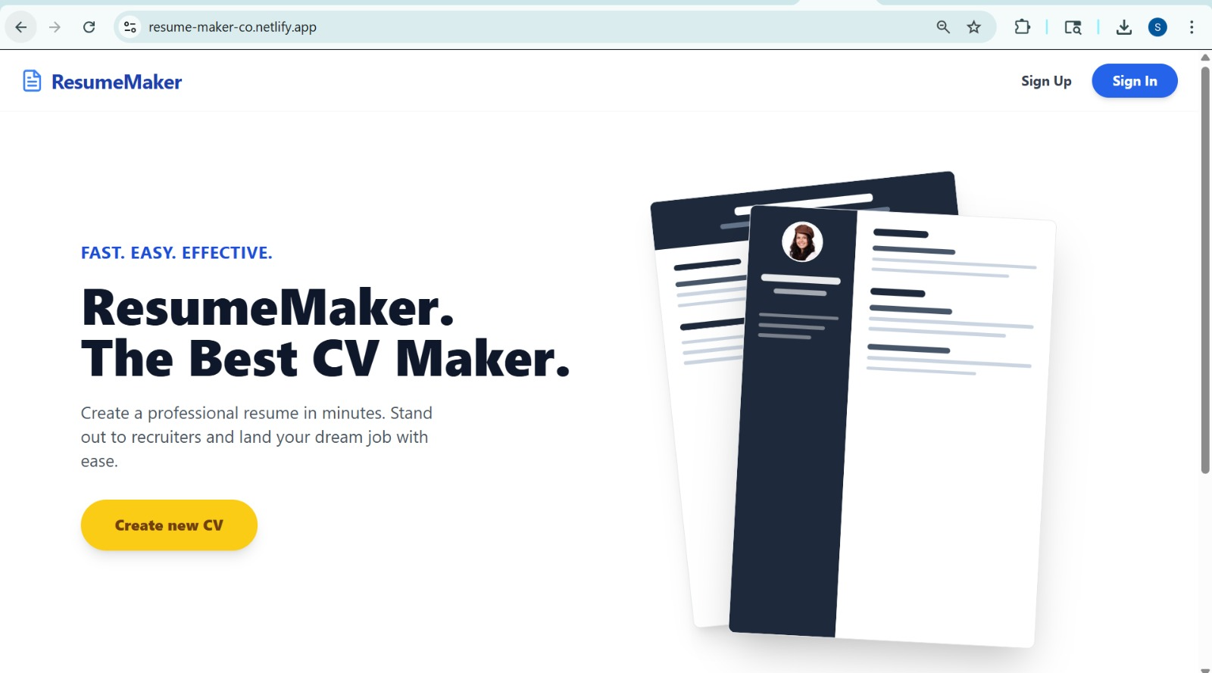Figure 4.1: home page
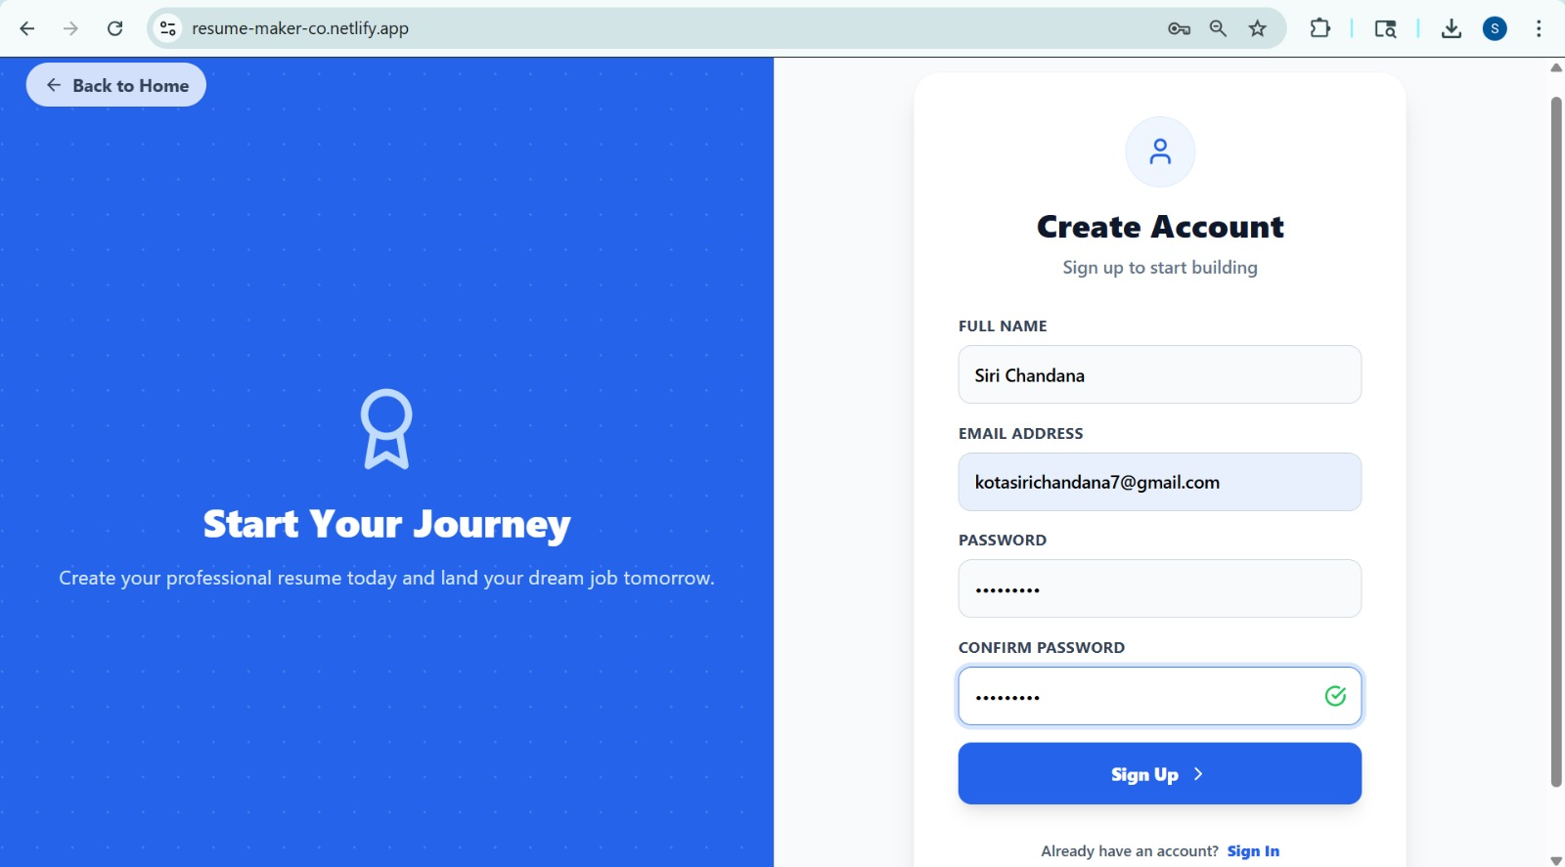
Figure 4.2: create account page

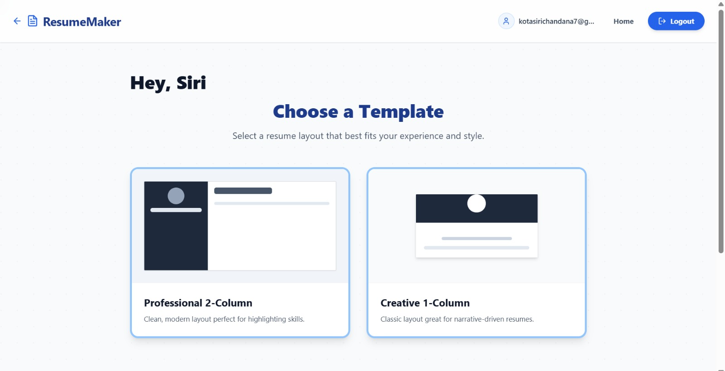
Figure 4.3: choosing a template
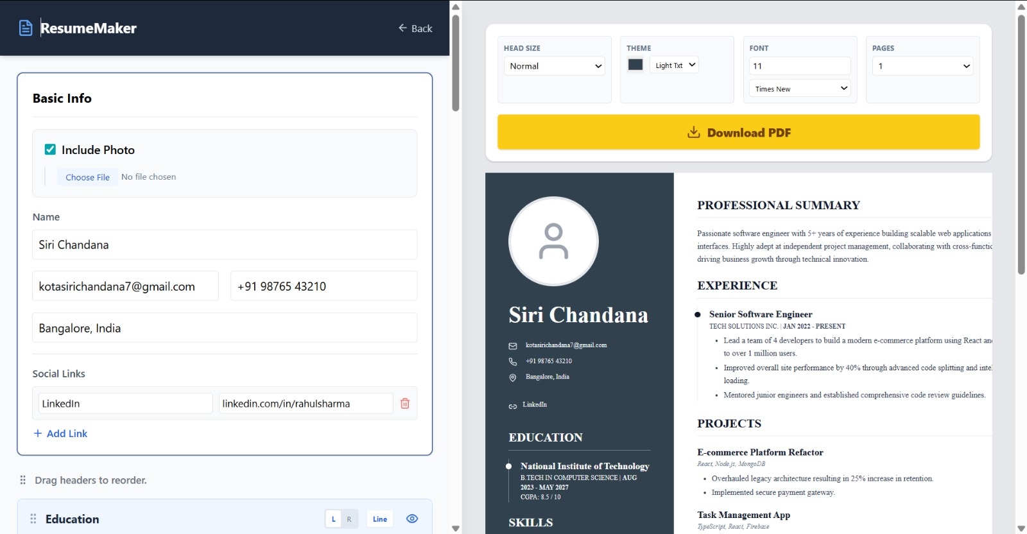
Figure 4.4: 2 column resume layout

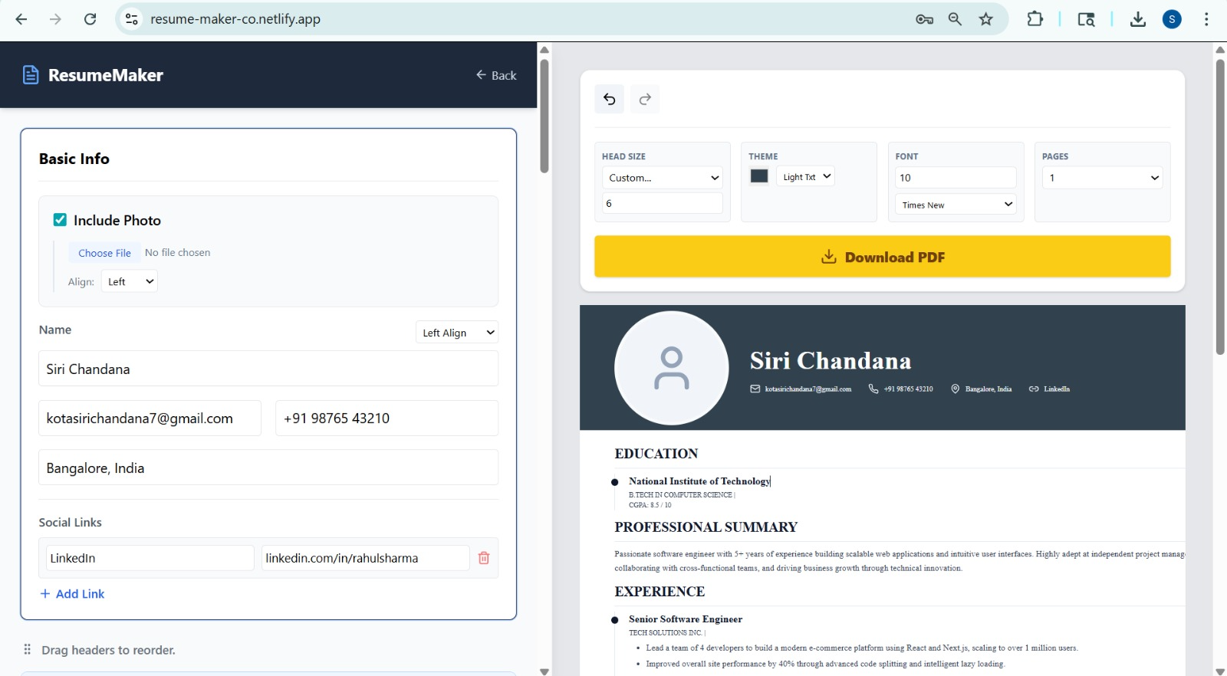
Figure 4.5: 1 column resume layout
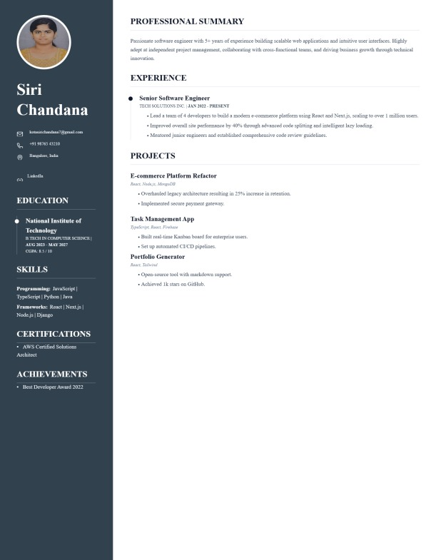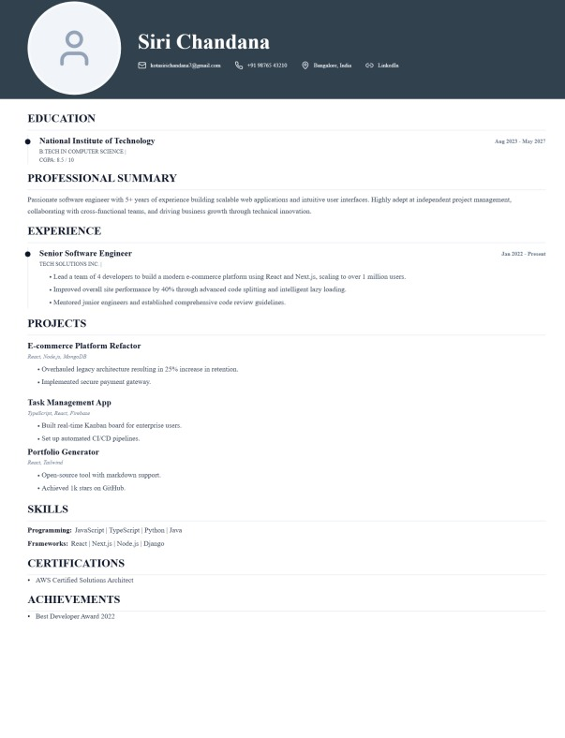

Figure 4.5 & Figure 4.6: final downloaded resumes

4.1 System Output and Features
• The application successfully generates professional resumes with real-time preview and multiple template options.
• Users can create, edit, save, and download resumes in PDF format efficiently.
• Secure login and data storage ensure personalized and safe user experience.

4.3 Discussion
• The system improves traditional resume creation by providing dynamic and user-friendly features.
• Integration of full-stack technologies ensures scalability and flexibility.
• The project demonstrates practical implementation of DevOps and modern web development concepts.

4.3 Discussion
• The system improves traditional resume creation by providing dynamic and user-friendly features.
• Integration of full-stack technologies ensures scalability and flexibility.
• The project demonstrates practical implementation of DevOps and modern web development concepts.

CHAPTER 5: CONCLUSION AND FUTURE WORK

5.1 Conclusion
• The Resume Maker Web Application successfully provides a platform for creating and managing professional resumes.
• It integrates MERN stack technologies with secure authentication and dynamic user interface.
• The system is scalable, user-friendly, and demonstrates effective use of full-stack development and DevOps concepts.

5.2 Future Work
• Integration of AI-based resume suggestions and ATS scoring system.
• Addition of more customizable templates and drag-and-drop features.
• Cloud storage and sharing options for resumes.

