LAB ASSIGNMENT – 3.3
Name : Chunchu Siri
Hall Ticket No. : 2303A51281
Batch No.: 05

Task 1: AI-Generated Logic for Reading Consumer Details
Scenario
An electricity billing system must collect accurate consumer data.
Task Description
Use an AI tool (GitHub Copilot / Gemini) to generate a Python program that:
• Reads:
o Previous Units (PU)
o Current Units (CU)
o Type of Customer
• Calculates units consumed
• Implements logic directly in the main program (no functions)

AI Generated Python Code:

#An electricity billing system must collect accurate consumer data and calculate units consumed.
# Task 1: Reading Consumer Details - Pervious Units, Current Units, Type of customer
consumer_name = input("Enter Consumer Name: ")
previous_units = int(input("Enter Previous Units: "))
current_units = int(input("Enter Current Units: "))
customer_type = input("Enter Customer Type (Domestic/Commercial): ")
# Task 2: Calculates units consumed.Implements logic directly in the main program (no functions)
units_consumed = current_units - previous_units
#print units consumed only
print("Units Consumed:", units_consumed)

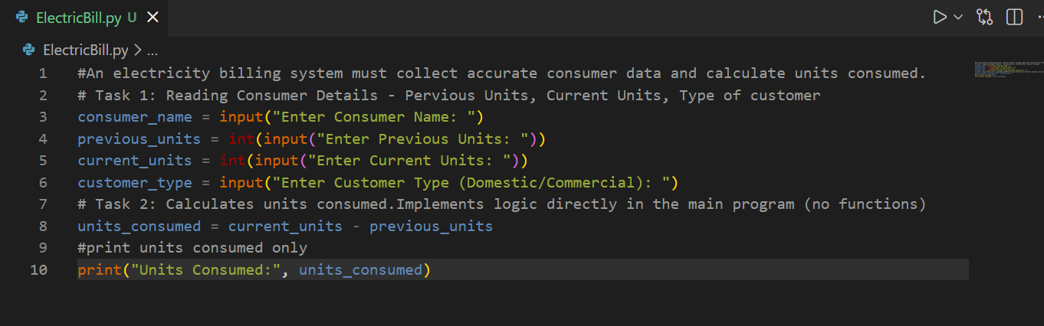

Sample Input and Output:

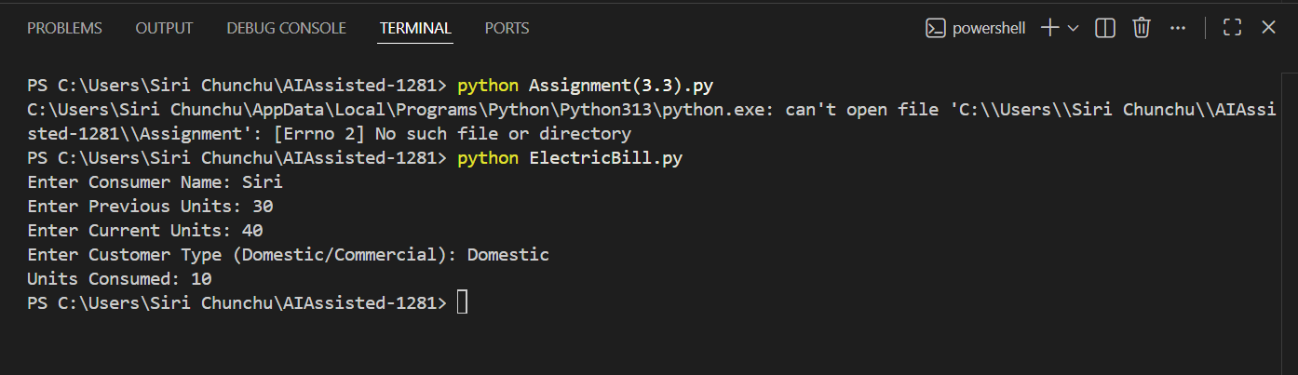

Task 2: Energy Charges Calculation Based on Units Consumed
Scenario
Energy charges depend on the number of units consumed and customer type.
Task Description
Review the AI-generated code from Task 1 and extend it to:
• Calculate Energy Charges (EC)
• Use conditional statements based on:
o Domestic
o Commercial
o Industrial consumers
• Improve readability using AI prompts such as:
o “Simplify energy charge calculation logic”
o “Optimize conditional statements”

AI Generated Code:

#Energy charges depend on the number of units consumed and customer type.• Calculate Energy Charges (EC)
#Use conditional statements based on:Domestic,Commercial,Industrial consumers
if customer_type == "Domestic":
energy_charges = units_consumed * 5.0
elif customer_type == "Commercial":
energy_charges = units_consumed * 7.0
elif customer_type == "Industrial":
energy_charges = units_consumed * 10.0
else:
print("Invalid customer type.")
print("Energy Charges:", energy_charges)
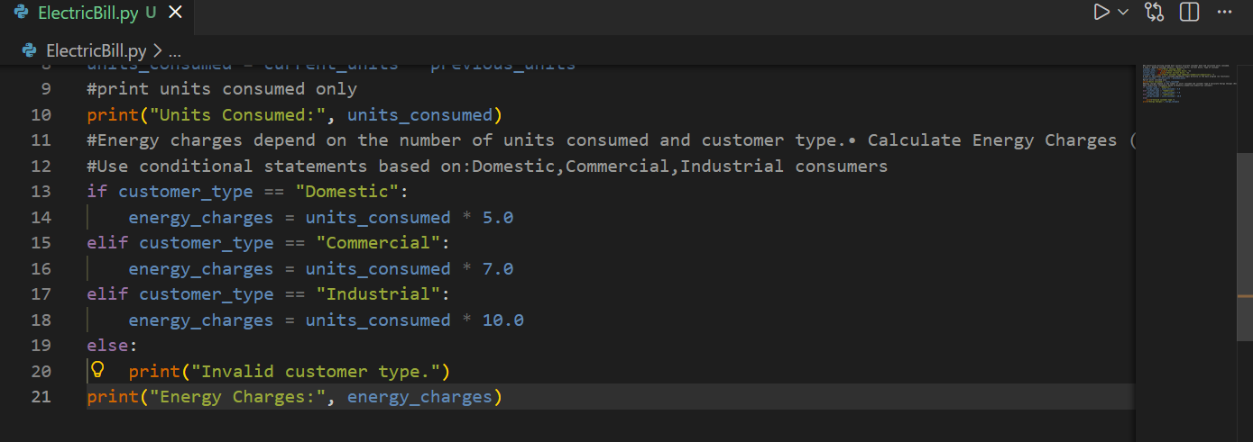

Sample Input and Output:

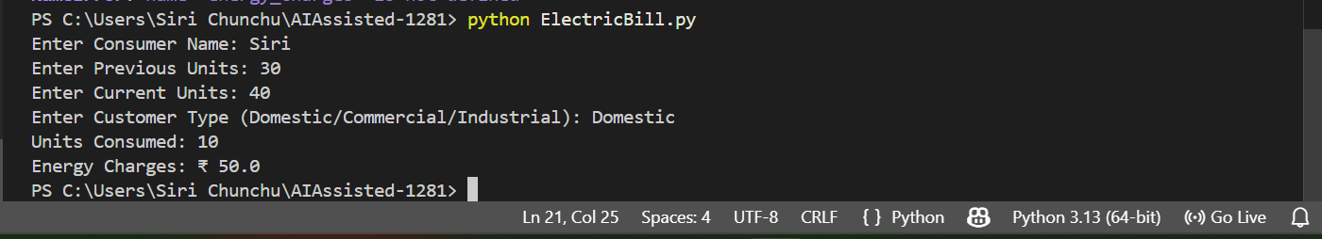

Task 3: Modular Design Using AI Assistance (Using Functions)
Scenario
Billing logic must be reusable for multiple consumers.
Task Description
Use AI assistance to generate a Python program that:
• Uses user-defined functions to:
o Calculate Energy Charges
o Calculate Fixed Charges
• Returns calculated values
• Includes meaningful comments

AI Generated Code:

#Billing logic must be reusable for multiple consumers. Uses user-defined functions to:Calculate Energy Charges and Calculate Fixed Charges
def calculate_fixed_charges(customer_type):
if customer_type == "Domestic":
return 50.0
elif customer_type == "Commercial":
return 100.0
elif customer_type == "Industrial":
return 200.0
else:
return 0.0
fixed_charges = calculate_fixed_charges(customer_type)
print("Fixed Charges: ₹", fixed_charges)

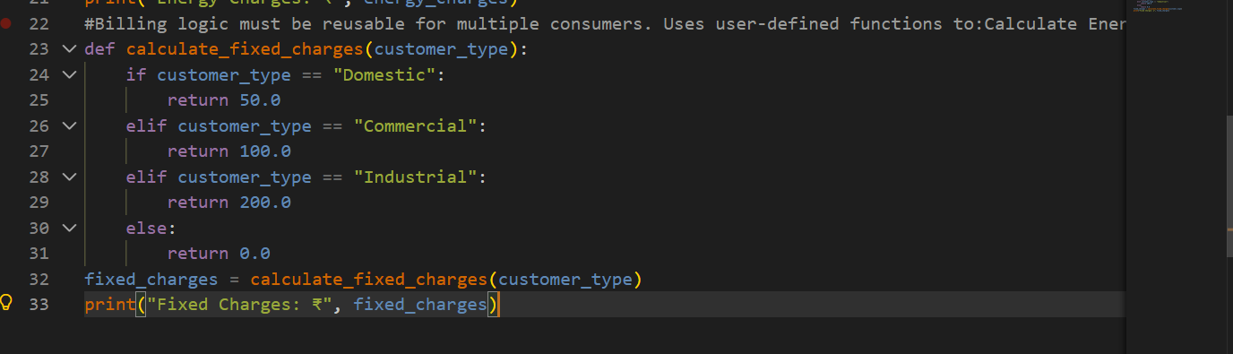

Sample Input and Output:

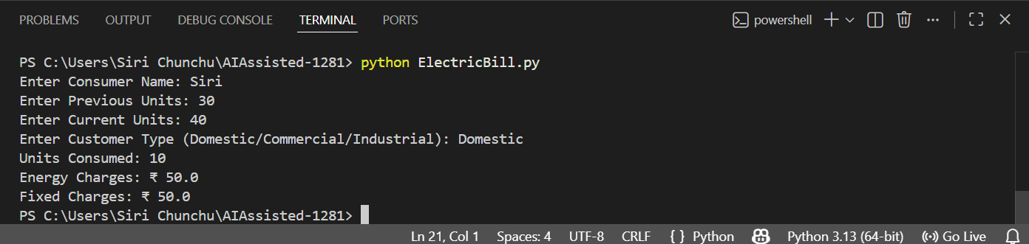

Task 4: Calculation of Additional Charges
Scenario
Electricity bills include multiple additional charges.
Task Description
Extend the program to calculate:
• FC – Fixed Charges
• CC – Customer Charges
• ED – Electricity Duty (percentage of EC)
Use AI prompts like:
• “Add electricity duty calculation”
• “Improve billing accuracy”

AI Generated Code:

# “Add electricity duty calculation”
# “Improve billing accuracy”
customer_charges = 30.0 # Flat customer charge for all types
electricity_duty = energy_charges * 0.05 # 5% electricity duty
total_bill = energy_charges + fixed_charges + customer_charges + electricity_duty
print("Customer Charges: ₹", customer_charges)
print("Electricity Duty: ₹", electricity_duty)
print("Total Bill Amount: ₹", total_bill)

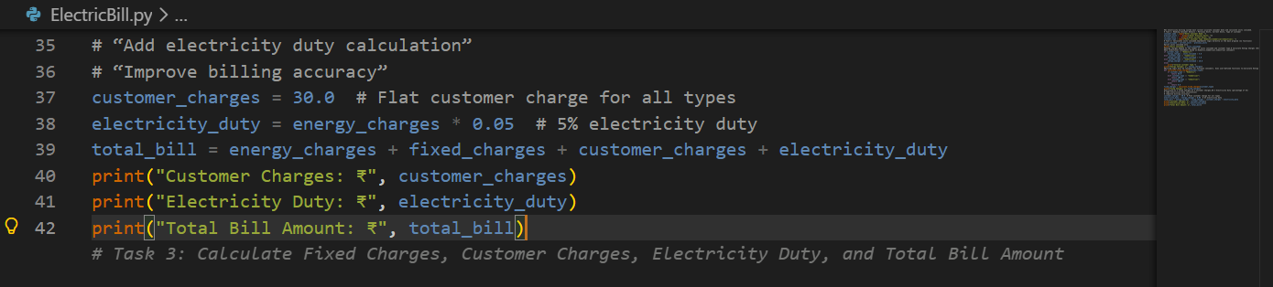

Sample Input and Output:

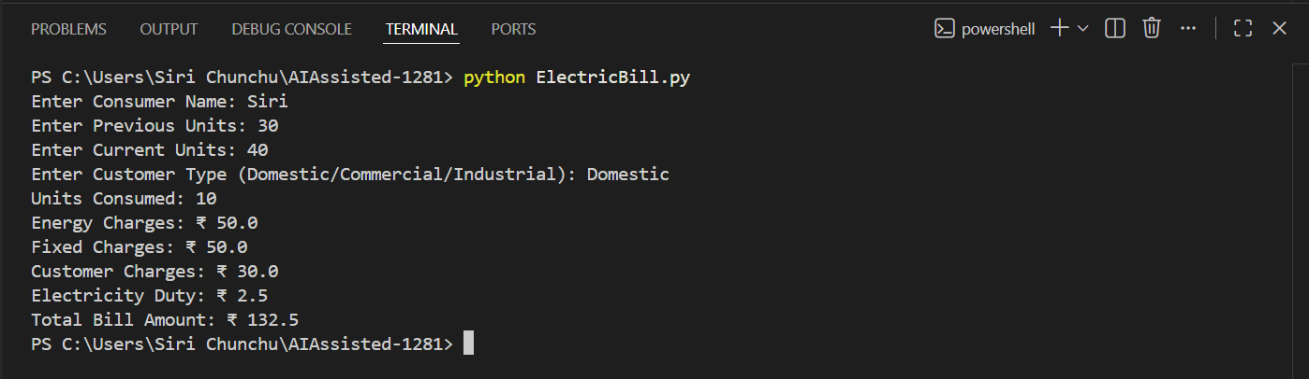

Task 5: Final Bill Generation and Output Analysis
Scenario
The final electricity bill must present all values clearly.
Task Description
Develop the final Python application to:
• Calculate total bill:
• Total Bill = EC + FC + CC + ED
• Display:
o Energy Charges (EC)
o Fixed Charges (FC)
o Customer Charges (CC)
o Electricity Duty (ED)
o Total Bill Amount
• Analyze the program based on:
o Accuracy
o Readability
o Real-world applicability

AI Generated Code:

#An electricity billing system must collect accurate consumer data and calculate units consumed.
# Task 1: Reading Consumer Details - Pervious Units, Current Units, Type of customer
consumer_name = input("Enter Consumer Name: ")
previous_units = int(input("Enter Previous Units: "))
current_units = int(input("Enter Current Units: "))
customer_type = input("Enter Customer Type (Domestic/Commercial/Industrial): ")
# Task 2: Calculates units consumed.Implements logic directly in the main program (no functions)
units_consumed = current_units - previous_units
#print units consumed only
#Energy charges depend on the number of units consumed and customer type.• Calculate Energy Charges (EC)
#Use conditional statements based on:Domestic,Commercial,Industrial consumers
if customer_type == "Domestic":
energy_charges = units_consumed * 5.0
elif customer_type == "Commercial":
energy_charges = units_consumed * 7.0
elif customer_type == "Industrial":
energy_charges = units_consumed * 10.0
else:
print("Invalid customer type.")
#Billing logic must be reusable for multiple consumers. Uses user-defined functions to:Calculate Energy Charges and Calculate Fixed Charges
def calculate_fixed_charges(customer_type):
if customer_type == "Domestic":
return 50.0
elif customer_type == "Commercial":
return 100.0
elif customer_type == "Industrial":
return 200.0
else:
return 0.0

fixed_charges = calculate_fixed_charges(customer_type)
#Calculate:FC – Fixed Charges,CC – Customer Charges,ED – Electricity Duty (percentage of EC)
# “Add electricity duty calculation”
# “Improve billing accuracy”
customer_charges = 30.0 # Flat customer charge for all types
electricity_duty = energy_charges * 0.05 # 5% electricity duty
total_bill = energy_charges + fixed_charges + customer_charges + electricity_duty

#The final electricity bill must present all values clearly.calculate and display the total bill amount
# Display all details clearly
print("\n--- Electricity Bill ---")
print("Consumer Name:", consumer_name)
print("Previous Units:", previous_units)
print("Current Units:", current_units)
print("Units Consumed:", units_consumed)
print("Customer Type:", customer_type)
print("Energy Charges: ₹", energy_charges)
print("Fixed Charges: ₹", fixed_charges)
print("Customer Charges: ₹", customer_charges)
print("Electricity Duty: ₹", electricity_duty)
print("Total Bill Amount: ₹", total_bill)

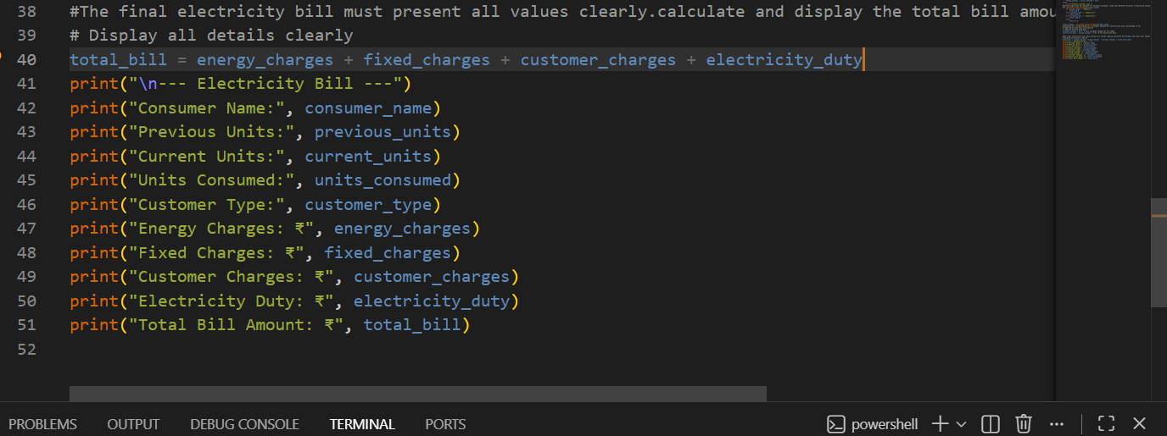

Sample Input and Output:

