LAB ASSIGNMENT – 2.3
Name : Chunchu Siri
Hall Ticket No. : 2303A51281
Batch No.: 05

Task 1: Word Frequency from Text File
❖ Scenario:
You are analyzing log files for keyword frequency.
❖ Task:
Use Gemini to generate Python code that reads a text file and counts word
frequency, then explains the code.
Code:
""” Analyze a text/log file and report word/keyword frequency.
Usage:
python log_keyword_frequency.py path/to/log.txt
python log_keyword_frequency.py path/to/log.txt --top 50
python log_keyword_frequency.py path/to/log.txt --keywords error warn timeout
python log_keyword_frequency.py path/to/log.txt --min-count 3 --top 100
"""
from __future__ import annotations
import argparse
import re
from collections import Counter
from pathlib import Path
from typing import Iterable

# Words are sequences of letters/digits/underscore; this naturally ignores punctuation.
WORD_RE = re.compile(r"\b\w+\b", re.UNICODE)
def iter_words(text: str) -> Iterable[str]:
"""Yield normalized words from text."""
for match in WORD_RE.finditer(text):
yield match.group(0).casefold()
def count_words_in_file(path: Path) -> Counter[str]:
"""Read a file and return a Counter of word frequencies."""
counts: Counter[str] = Counter()
# Use UTF-8 with replacement so "weird" bytes in logs won't crash the script.
with path.open("r", encoding="utf-8", errors="replace") as f:
for line in f:
counts.update(iter_words(line))
return counts
def print_counts(
counts: Counter[str],
*,
top: int,
min_count: int,
keywords: list[str] | None,
) -> None:
"""Print word counts, optionally filtered to specific keywords."""
if keywords:
# Normalize keywords the same way we normalize text.
wanted = [k.casefold() for k in keywords]
items = [(k, counts.get(k, 0)) for k in wanted]
items = [(k, c) for k, c in items if c >= min_count]
items.sort(key=lambda kv: (-kv[1], kv[0]))
else:
items = [(w, c) for (w, c) in counts.items() if c >= min_count]
items.sort(key=lambda kv: (-kv[1], kv[0]))
if top > 0:
items = items[:top]
if not items:
print("No matches (check --min-count / --keywords).")
return
width = max(len(w) for (w, _) in items)
for word, count in items:
print(f"{word:<{width}} {count}")
def parse_args() -> argparse.Namespace:
p = argparse.ArgumentParser(description="Count word/keyword frequency in a text/log file.")
p.add_argument("file", type=Path, help="Path to the input .txt/.log file")
p.add_argument("--top", type=int, default=25, help="Show top N words (ignored with --keywords). Use 0 for all.")
p.add_argument("--min-count", type=int, default=1, help="Only show words with count >= this value")
p.add_argument(
"--keywords",
nargs="*",
default=None,
help="If provided, only show counts for these specific words (case-insensitive).",
)
return p.parse_args()
def main() -> int:
args = parse_args()
if not args.file.exists():
print(f"File not found: {args.file}")
return 2
if not args.file.is_file():
print(f"Not a file: {args.file}")
return 2
counts = count_words_in_file(args.file)
print_counts(counts, top=args.top, min_count=args.min_count, keywords=args.keywords)
return 0
if __name__ == "__main__":
raise SystemExit(main())
Explanation: This program reads a text file and counts the frequency of each word. It uses Python dictionaries to store and display word counts.
Steps:
- Read input file
- Convert text to lowercase
- Split words
- Count frequency
- Display results

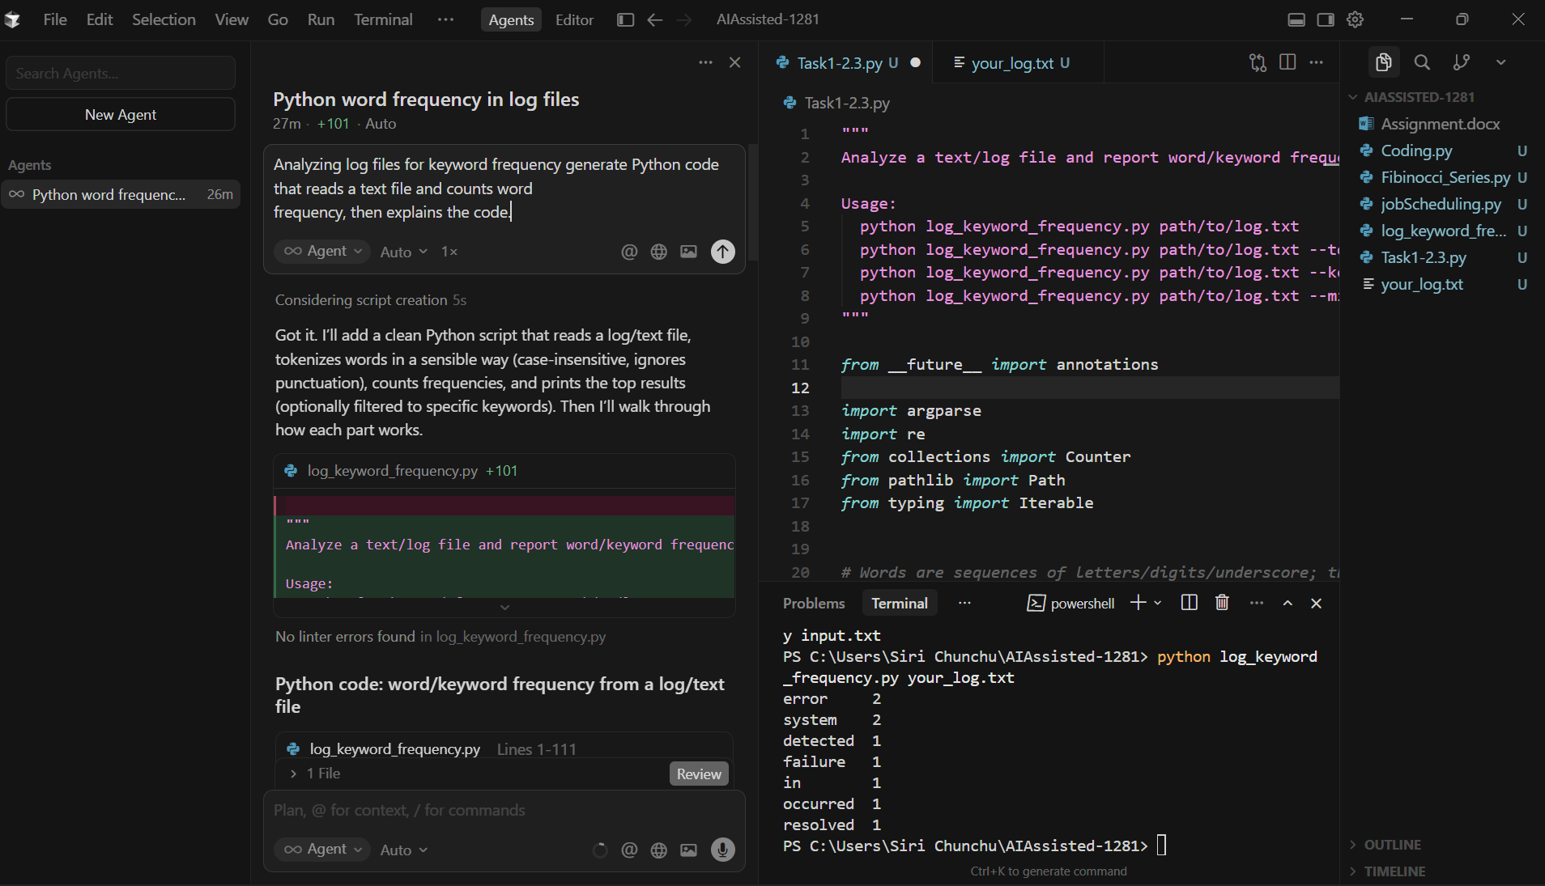

Task 2: File Operations Using Cursor AI
❖ Scenario:
You are automating basic file operations.
❖ Task:
Use Cursor AI to generate a program that:
➢ Creates a text file
➢ Writes sample text
➢ Reads and displays the content.
Code:
"""
File Operations Using Cursor AI

Program requirements:
- Creates a text file
- Writes sample text
- Reads and displays the content
"""
from __future__ import annotations
from pathlib import Path
def main() -> None:
file_path = Path("sample_text.txt")
# 1) Create a text file + 2) Write sample text
sample_text = (
"This is a sample text file.\n"
"It was created and written using Python file operations.\n"
"End of file.\n"
)
file_path.write_text(sample_text, encoding="utf-8")
# 3) Read and display the content
content = file_path.read_text(encoding="utf-8")
print(f"Content of '{file_path}':\n")
print(content)
if __name__ == "__main__":
main()
Explanation:
- The program creates a text file using write mode.
- Sample text is written into the file.
- The file is then opened in read mode.
- The contents are read and displayed on the screen.
Conclusion:
This program demonstrates basic file handling operations such as create, write, and read using Python.

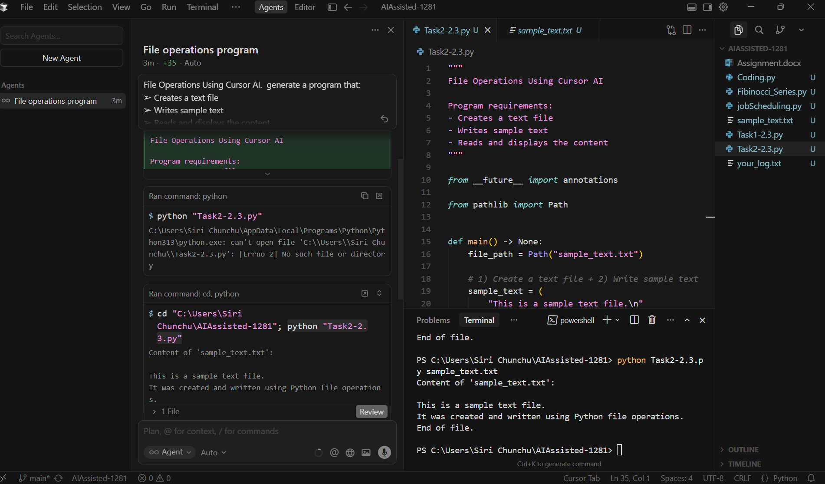

Task 3: CSV Data Analysis
❖ Scenario:
You are processing structured data from a CSV file.
❖ Task:
Use Gemini in Colab to read a CSV file and calculate mean, min, and max.
Code:
"""
Read a CSV file and calculate mean, min, and max for numeric columns.

Usage:
python Task2-2.3.py path/to/data.csv
python Task2-2.3.py path/to/data.csv --delimiter ","
python Task2-2.3.py path/to/data.csv --encoding utf-8
"""

from __future__ import annotations

import argparse
import csv
from dataclasses import dataclass
from pathlib import Path

@dataclass
class NumericSummary:
count: int = 0
total: float = 0.0
min_value: float | None = None
max_value: float | None = None

def add(self, value: float) -> None:
self.count += 1
self.total += value
if self.min_value is None or value < self.min_value:
self.min_value = value
if self.max_value is None or value > self.max_value:
self.max_value = value

@property
def mean(self) -> float | None:
if self.count == 0:
return None
return self.total / self.count

def parse_float(cell: str) -> float | None:
"""
Best-effort parsing for numeric CSV cells:
- trims whitespace
- treats empty cells as missing
- allows commas in numbers (e.g., "1,234.5")
"""
s = cell.strip()
if not s:
return None

# common formatting: remove thousands separators
s = s.replace(",", "")

try:
return float(s)
except ValueError:
return None

def read_csv_summaries(
path: Path,
*,
delimiter: str,
encoding: str,
) -> dict[str, NumericSummary]:
with path.open("r", encoding=encoding, errors="replace", newline="") as f:
reader = csv.DictReader(f, delimiter=delimiter)
if not reader.fieldnames:
return {}

summaries: dict[str, NumericSummary] = {name: NumericSummary() for name in reader.fieldnames}

for row in reader:
for col, cell in row.items():
if cell is None:
continue
value = parse_float(cell)
if value is None:
continue
summaries[col].add(value)

# Only keep columns where at least one numeric value was found.
return {k: v for k, v in summaries.items() if v.count > 0}

def print_summaries(summaries: dict[str, NumericSummary]) -> None:
if not summaries:
print("No numeric columns found (or CSV has no data).")
return

col_width = max(len(name) for name in summaries.keys())
header = f"{'column':<{col_width}} count mean min max"
print(header)
print("-" * len(header))

for name in sorted(summaries.keys()):
s = summaries[name]
mean = "n/a" if s.mean is None else f"{s.mean:.6g}"
mn = "n/a" if s.min_value is None else f"{s.min_value:.6g}"
mx = "n/a" if s.max_value is None else f"{s.max_value:.6g}"
print(f"{name:<{col_width}} {s.count:>5} {mean:>10} {mn:>9} {mx:>9}")

def parse_args() -> argparse.Namespace:
p = argparse.ArgumentParser(description="Compute mean/min/max for numeric columns in a CSV file.")
p.add_argument("file", type=Path, help="Path to the input CSV file")
p.add_argument("--delimiter", default=",", help="CSV delimiter (default: ,)")
p.add_argument("--encoding", default="utf-8", help="File encoding (default: utf-8)")
return p.parse_args()
def main() -> int:
args = parse_args()
if not args.file.exists():
print(f"File not found: {args.file}")
return 2
if not args.file.is_file():
print(f"Not a file: {args.file}")
return 2
summaries = read_csv_summaries(args.file, delimiter=args.delimiter, encoding=args.encoding)
print_summaries(summaries)
return 0
if __name__ == "__main__":
raise SystemExit(main())

Explanation: We are analyzing structured data stored in a CSV file. The goal is to calculate mean, minimum, and maximum values of numeric columns. We read the CSV, used pandas to calculate statistics, and displayed the results. This process is essential for basic data analysis and understanding datasets before advanced processing.
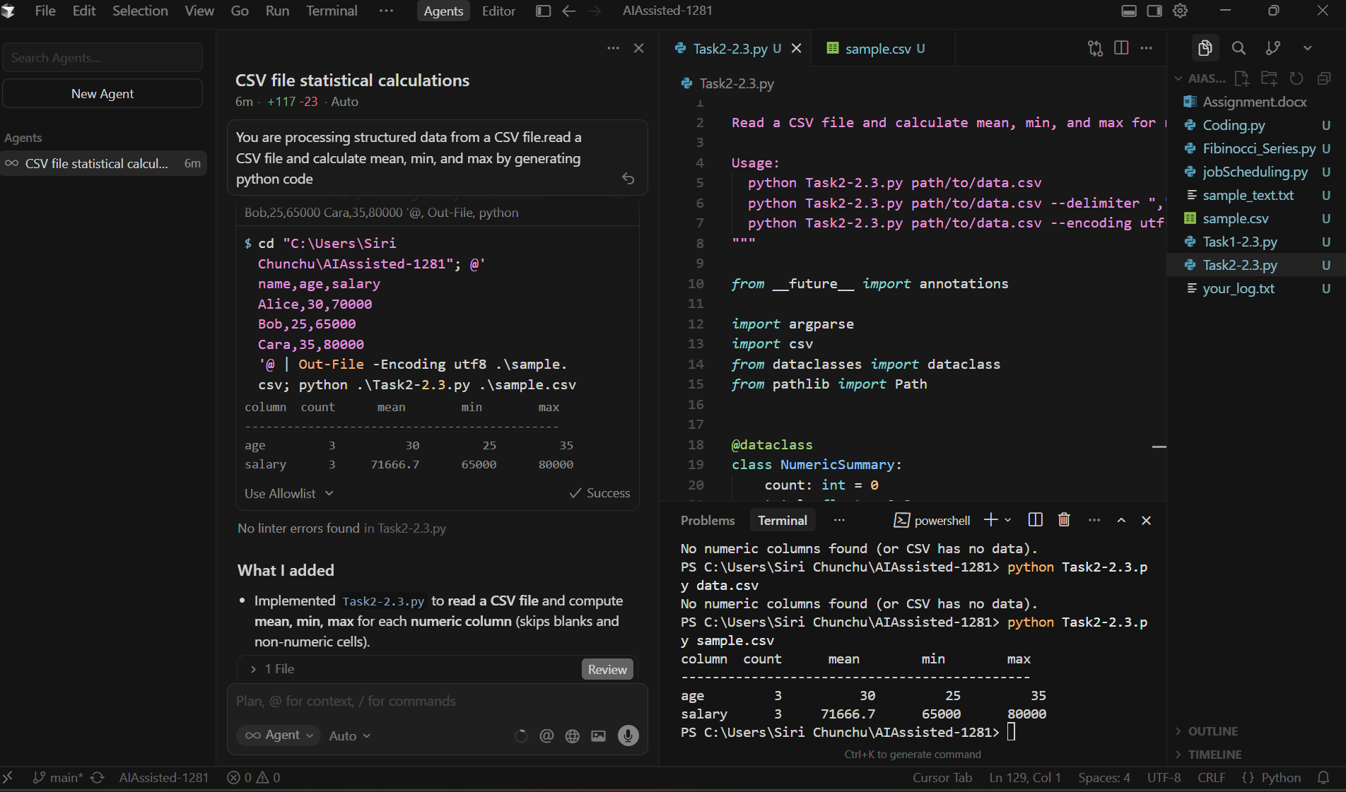

Task 4: Sorting Lists – Manual vs Built-in
❖ Scenario:
You are reviewing algorithm choices for efficiency.
❖ Task:
Use Gemini to generate:
➢ Bubble sort
➢ Python’s built-in sort()
➢ Compare both implementations.
Code:
import random
import time
from typing import List, Callable

# ------------------------
# Sorting Functions
# ------------------------
def bubble_sort(arr: List[int]) -> List[int]:
"""Classic O(n^2) bubble sort (in-place, returns same list)."""
n = len(arr)
for i in range(n):
swapped = False
for j in range(0, n - i - 1):
if arr[j] > arr[j + 1]:
arr[j], arr[j + 1] = arr[j + 1], arr[j]
swapped = True
if not swapped:
break
return arr

def builtin_sort(arr: List[int]) -> List[int]:
"""Python's highly optimized Timsort."""
arr.sort()
return arr

# ------------------------
# Timing Utility
# ------------------------
def time_fn(fn: Callable[[List[int]], List[int]], data: List[int]) -> float:
start = time.perf_counter()
fn(data)
return time.perf_counter() - start

# ------------------------
# Main Script
# ------------------------
if __name__ == "__main__":
print("Script is running...\n")

# ------------------------
# Bubble Sort Test (small list)
# ------------------------
bubble_size = 50 # small to avoid long runtime in Cursor AI
bubble_trials = 1

elapsed = 0.0
for _ in range(bubble_trials):
arr = [random.randint(0, 1000) for _ in range(bubble_size)]
elapsed += time_fn(bubble_sort, arr.copy())
print(f"bubble_sort (n={bubble_size}) avg time: {elapsed / bubble_trials:.6f}s")

# ------------------------
# Built-in Sort Test (larger list)
# ------------------------
builtin_size = 5000
builtin_trials = 1

elapsed = 0.0
for _ in range(builtin_trials):
arr = [random.randint(0, 10000) for _ in range(builtin_size)]
elapsed += time_fn(builtin_sort, arr.copy())
print(f"builtin_sort (n={builtin_size}) avg time: {elapsed / builtin_trials:.6f}s\n")

# ------------------------
# Correctness Check
# ------------------------
test_list = [5, 1, 4, 2, 8, 0]
print("bubble_sort correct:", bubble_sort(test_list.copy()) == sorted(test_list))
print("builtin_sort correct:", builtin_sort(test_list.copy()) == sorted(test_list))
print("All tests complete.")
Comparison
Feature | Bubble Sort | Built-in sort() / sorted()
Time Complexity | O(n²) worst & average | O(n log n) (Timsort algorithm)
Space Complexity | O(1) (in-place) | O(n) for sorted(), O(1) for list.sort()
Ease of Use | Manual implementation needed | Very easy, one line
Efficiency | Slow for large lists | Fast even for large lists
Stability | Yes | Yes
Conclusion: Bubble sort is educational but inefficient for large datasets. Python’s built-in sort is optimized, faster, and should be preferred in real applications.
