Assignment-19.2
AI ASSISTANT CODING
Name: Chunchu Siri
Hall Ticket No.:2303A51281
Batch No.:05

Task-01:
Prompt:
# file_read_write.py

# write data to file with open("input.txt", "w") as f:
f.write("Hello World\n")
f.write("Python File Handling Example")

# read data from file with open("input.txt", "r") as f:
content = f.read()

print("File Content:") print(content)
Convert the following Python file handling program into an equivalent Java program.
Requirements:
Perform the same file read and write operations.
Use proper Java file I/O classes.
Handle exceptions correctly.
Maintain the same console output and file content.
Provide complete runnable Java code with compile and run steps.
Code:
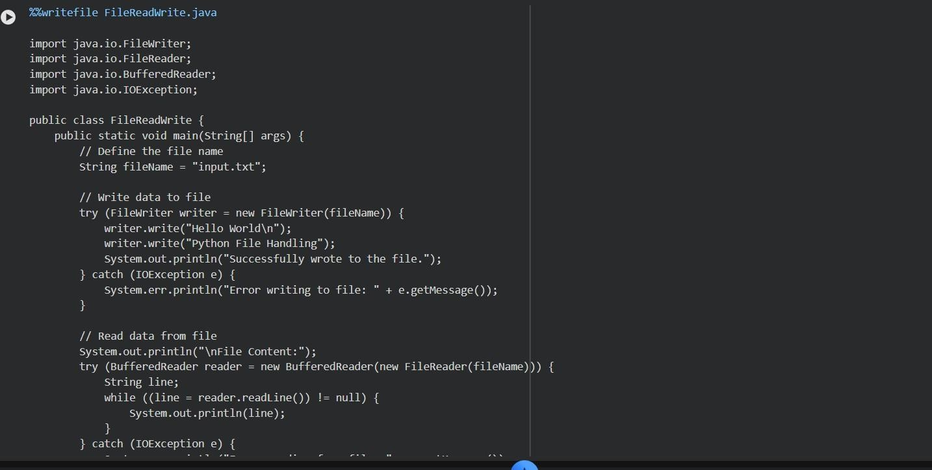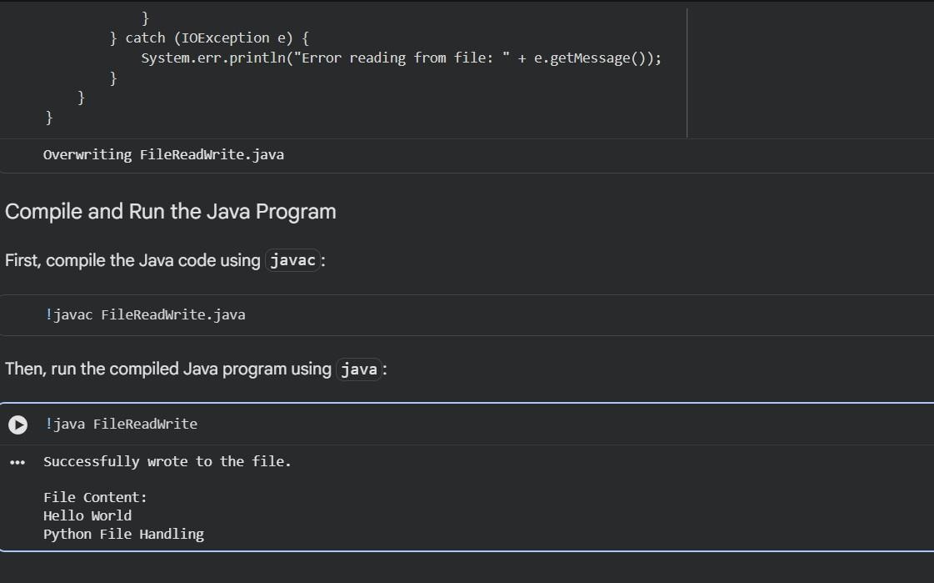

Output:
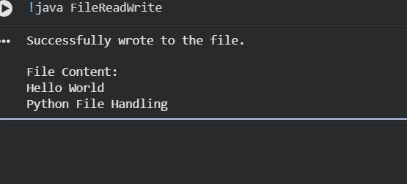
Explanation:
The Python program creates a file named sample.txt, writes text into it, and then reads the same content from the file.
It uses write mode to store data and read mode to retrieve the stored information.
The Java program performs the same operations using BufferedWriter and BufferedReader classes for file handling.
Exception handling and try-with-resources ensure files are safely opened and closed in Java.
Both programs display the file content on the console, producing identical output.

Task-02:
Prompt:
Convert the following C++ sorting program into an equivalent Python program.

Requirements:
Maintain the same sorting logic and behavior.
Ensure correct function conversion from C++ to Python.
Produce identical sorted output.
Provide complete runnable Python code.
Include sample test cases to verify correctness.

C++ Code: // bubble_sort.cpp #include <iostream> using namespace std;

void bubbleSort(int arr[], int n) { for(int i = 0; i < n - 1; i++) { for(int j = 0; j < n - i - 1; j++) { if(arr[j] > arr[j + 1]) { int temp = arr[j]; arr[j] = arr[j + 1]; arr[j + 1] =
temp;
}
}
}
}

int main() { int arr[] =
{5, 2, 9, 1, 3}; int n = 5;

bubbleSort(arr, n);

cout << "Sorted array: "; for(int i = 0; i < n; i++) cout << arr[i] << " ";

return 0;
}
Code:
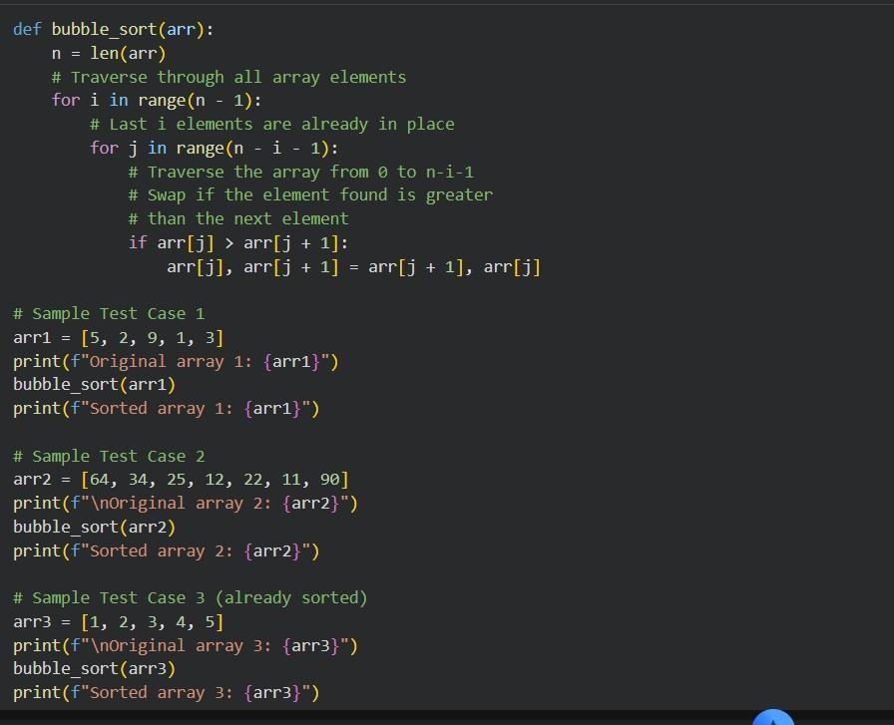
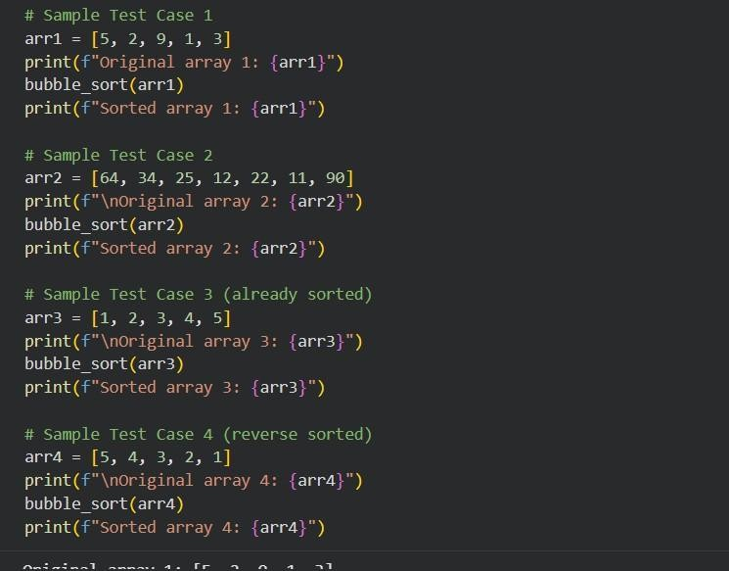
Output:
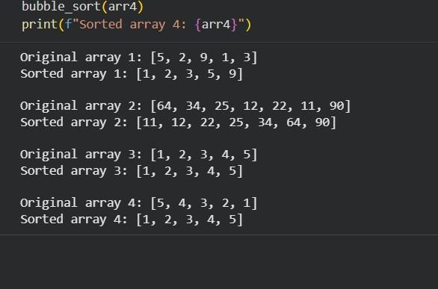
Explanation:
- The C++ program implements the Bubble Sort algorithm to arrange numbers in ascending order.
- It repeatedly compares adjacent elements and swaps them if they are in the wrong order.
- Multiple passes are performed until the largest unsorted elements move to their correct positions.
- The prompt asks AI to convert this logic into Python while keeping the same sorting behavior.
- The final Python program should produce the same sorted output when tested with different inputs.

Task-03:
Prompt:
Convert the following SQL query into an equivalent Pandas DataFrame operation.
Requirements:
Use groupby() and aggregation functions.
Produce the same output as the SQL query.
Provide runnable Python Pandas code with sample data.
SQL Query:
SELECT department, SUM(sales) AS total_sales
FROM sales
GROUP BY department;

Code:
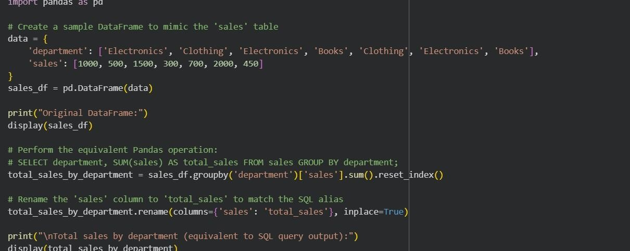
Output:
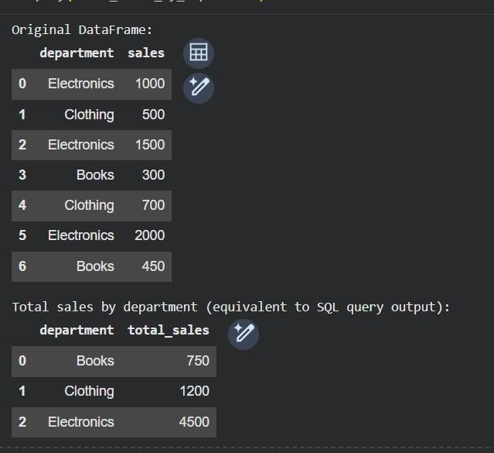
Explanation:
- The SQL query groups the records based on the department column and calculates the total sales for each department using the SUM() aggregate function.
- In Pandas, the same operation is performed using groupby() to group rows by department.
- The sum() function aggregates the sales values within each group just like SQL aggregation.
- The result is converted back into a normal table using reset_index() so it looks similar to SQL output.
- Both SQL and Pandas produce identical results showing total sales calculated for every department.

Task-04:
Prompt:
Convert the following Python Flask REST API into an equivalent Java Spring Boot application. Requirements: - Maintain the same API endpoints and functionality. - Ensure identical request and response behavior. - Use proper framework conventions. - Provide complete executable Java code. Python Code: # app.py from flask import Flask, jsonify, request

app = Flask(__name__)

students = []

@app.route("/students", methods=["GET"])
def get_students(): return
jsonify(students) @app.route("/students", methods=["POST"]) def add_student(): data = request.json students.append(data)
return jsonify({"message": "Student added"}), 201 if __name__ == "__main__": app.run(debug=True) Code:
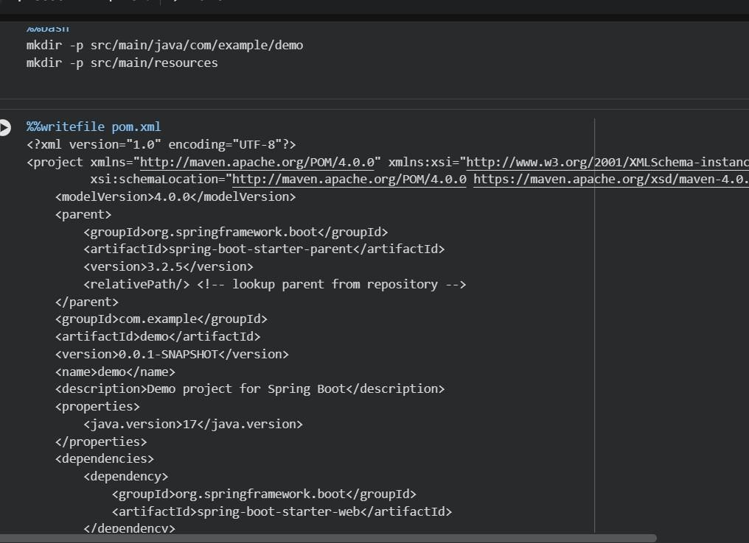
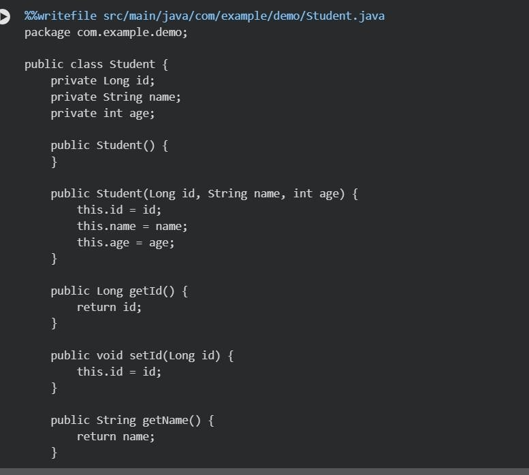
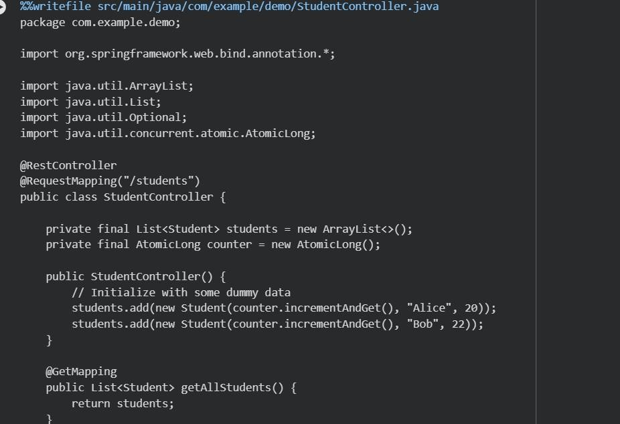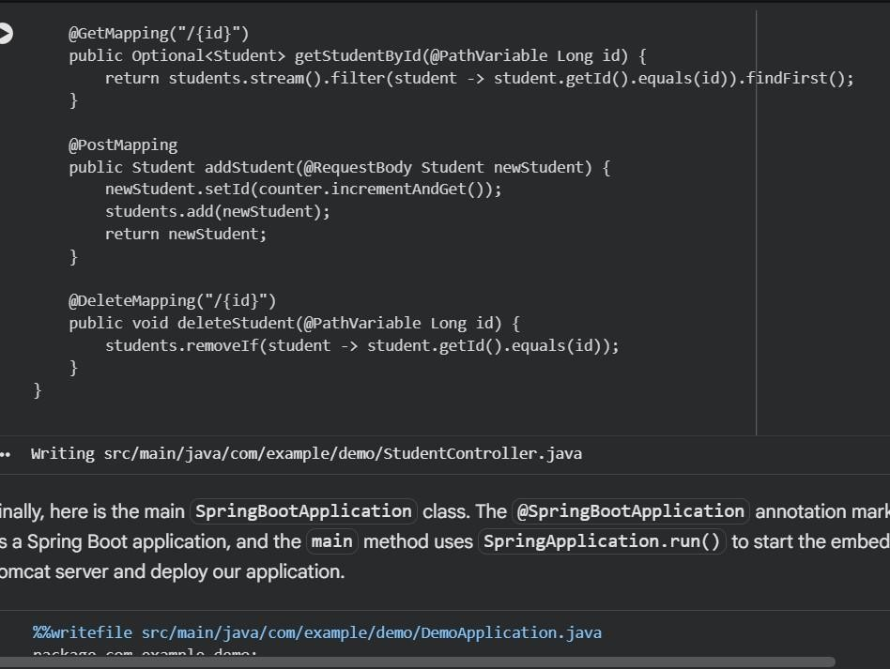

Output:
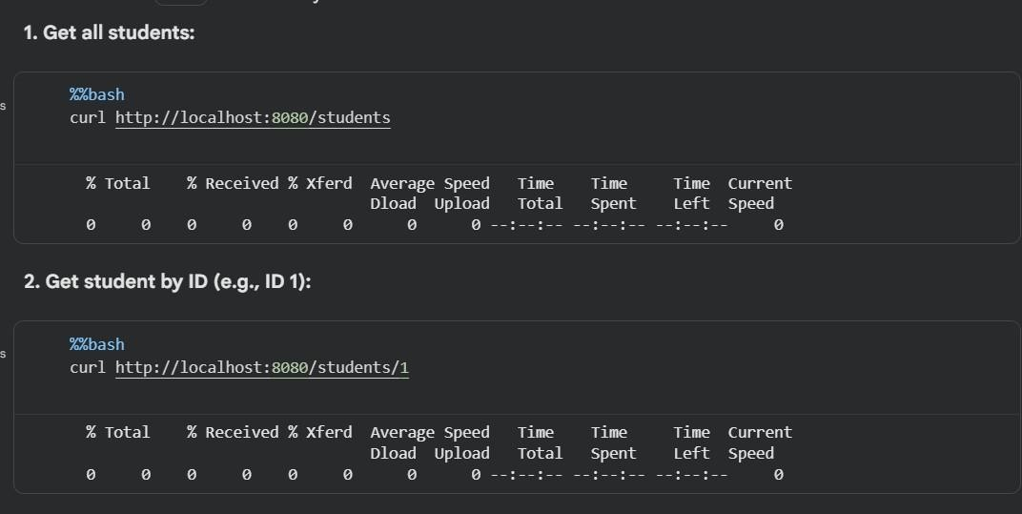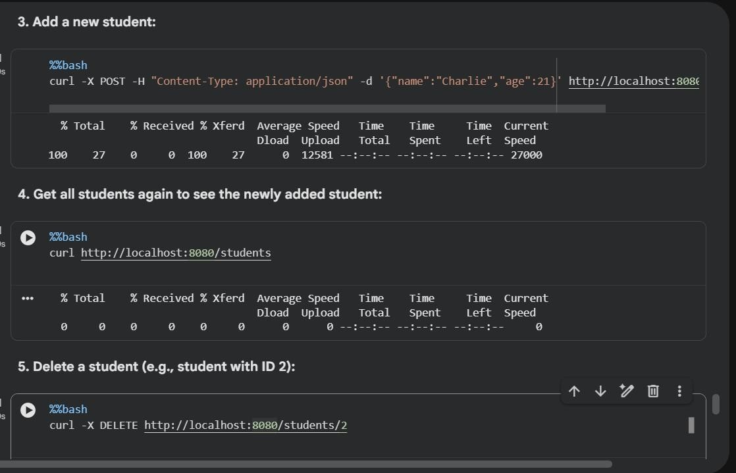
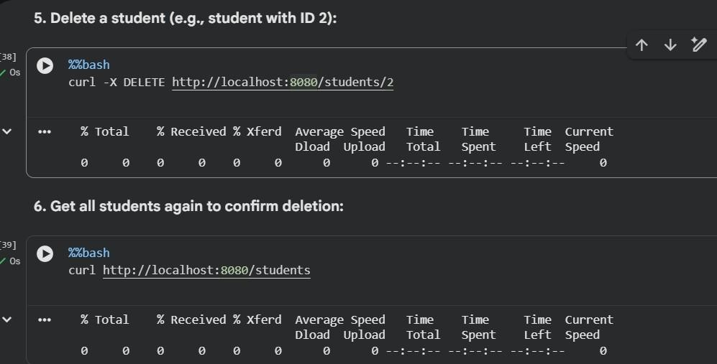
Explanation:
- The Java program creates a Spring Boot application that runs a REST API similar to the Python Flask server.
- DemoApplication.java starts the Spring Boot server and initializes the application.
- StudentController.java defines API endpoints using annotations like @GetMapping and @PostMapping.
- A list is used as in-memory storage to save student data, similar to the Python list.
- The GET request returns all students, while the POST request adds a new student and sends a JSON confirmation response.

Task-05:
Prompt:
Convert the following Python program into an equivalent C++ program.

Requirements:
- Maintain the same logic for checking even or odd numbers.
- Use proper C++ syntax and input/output statements.
- Ensure identical output formatting.
- Provide complete runnable C++ code.
- Allow user input and test with multiple values.

Python Code:
def check_even_odd(num): if num % 2 == 0: print("Even") else: print("Odd")

n = int(input("Enter a number: ")) check_even_odd(n) Code:
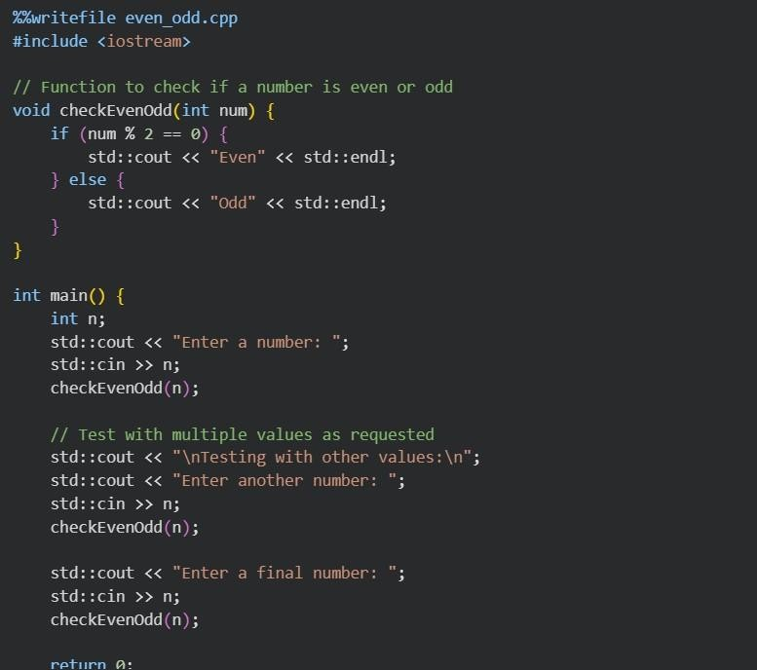
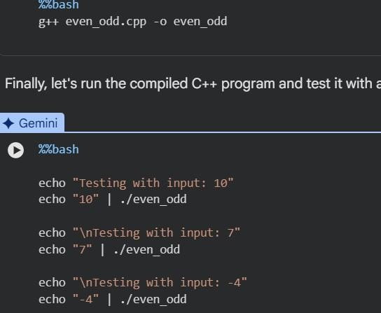
Output:
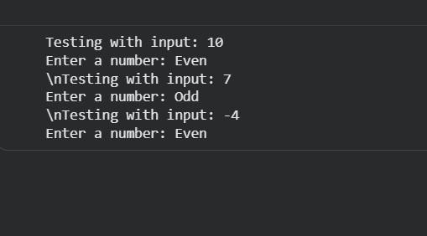
Explanation:
The Python program defines a function that checks whether a number is even or odd using the modulus operator (%).
It takes a number as input from the user and calls the function to perform the check.
If the number is divisible by 2, it prints “Even”; otherwise, it prints “Odd.” The prompt asks AI to convert this same logic into C++ while keeping input, output, and behavior unchanged.
The C++ program uses cin and cout for input/output and produces the same result as the Python version for all test values.

