AI ASSISTANT CODING
ASSIGNMENT-8.4
NAME : Chunchu Siri
HTNO:2303A51281
BATCH:05

Lab 8: Test-Driven Development (TDD) with AI
TASK-1 : Developing a Utility Function Using TDD
Scenario
You are working on a small utility library for a larger software system. One of
the required functions should calculate the square of a given number, and
correctness is critical because other modules depend on it.
Task Description
Following the Test Driven Development (TDD) approach:
1. First, write unit test cases to verify that a function correctly returns the
square of a number for multiple inputs.
2. After defining the test cases, use GitHub Copilot or Cursor AI to
generate the function implementation so that all tests pass.
Ensure that the function is written only after the tests are created.
PROMPT :
#write unit test cases to verify that a function correctly returns the square of a number for multiple inputs.
#Ensure that the function is written only after the tests are created.
CODE:
import unittest
def square(num):
return num * num

class TestSquareFunction(unittest.TestCase):
def test_square_positive_integer(self):
self.assertEqual(square(4), 16)
self.assertEqual(square(7), 49)
def test_square_negative_integer(self):
self.assertEqual(square(-3), 9)
self.assertEqual(square(-5), 25)
def test_square_zero(self):
self.assertEqual(square(0), 0)
def test_square_float(self):
self.assertAlmostEqual(square(2.5), 6.25)
self.assertAlmostEqual(square(-1.5), 2.25)
if __name__ == '__main__':
unittest.main()
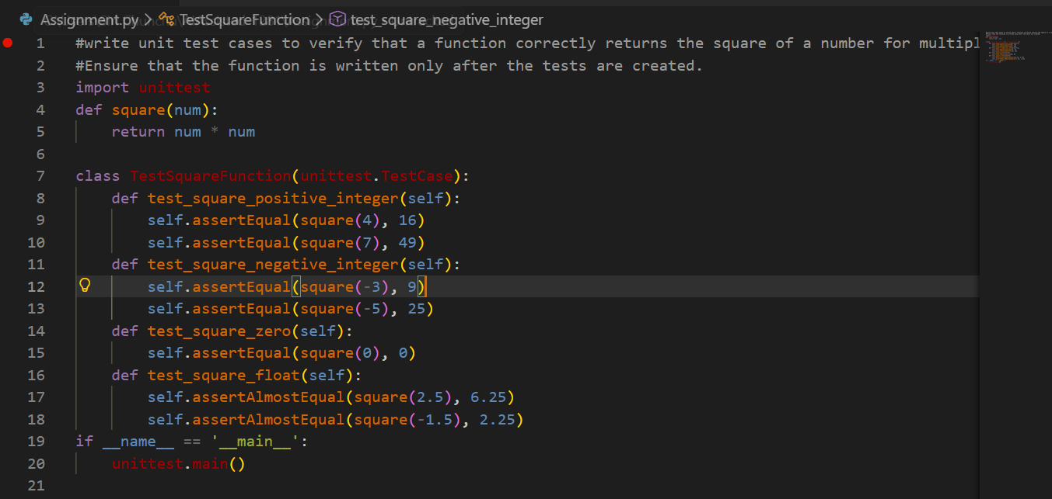
OUTPUT:
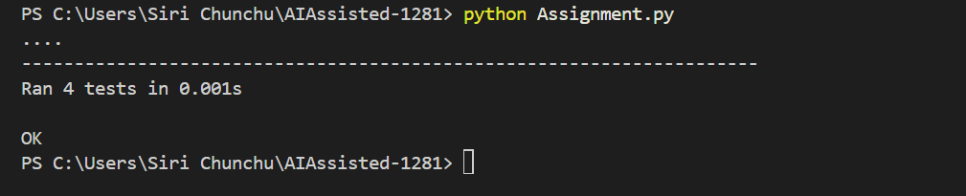
EXPLAINATION:
- This task follows the Test-Driven Development (TDD) approach.
- Unit test cases are written first to verify the square of different numbers.
- Initially, tests fail because the function does not exist.
- Using AI assistance, the square function is implemented to satisfy all test cases.
- This demonstrates the full TDD cycle: test → fail → implement → pass.

TASK-2 : Email Validation for a User Registration System
Scenario
You are developing the backend of a user registration system. One
requirement is to validate user email addresses before storing them in the
database.
Task Description
Apply Test Driven Development by:
1. Writing unit test cases that define valid and invalid email formats (e.g.,
missing @, missing domain, incorrect structure).
2. Using AI assistance to implement the validate_email() function based
strictly on the behavior described by the test cases.
The implementation should be driven entirely by the test expectations.
PROMPT:
# unit test cases that define valid and invalid email formats (e.g., missing @, missing domain, incorrect structure).
# implement the validate_email() function based strictly on the behavior described by the test cases.
#The implementation should be driven entirely by the test expectations.
CODE:
import unittest
import re
def validate_email(email):
pattern = r'^[a-zA-Z0-9._%+-]+@[a-zA-Z0-9.-]+\.[a-zA-Z]{2,}$'
return re.match(pattern, email) is not None
class TestValidateEmailFunction(unittest.TestCase):
def test_valid_email(self):
self.assertTrue(validate_email("test@example.com"))
self.assertTrue(validate_email("user.name@domain.co.uk"))
self.assertTrue(validate_email("user+tag@example.org"))
def test_invalid_email(self):
self.assertFalse(validate_email("invalid.email"))
self.assertFalse(validate_email("@example.com"))
self.assertFalse(validate_email("test@"))
self.assertFalse(validate_email("test@example"))
self.assertFalse(validate_email("test@.com"))
self.assertFalse(validate_email("test@com."))
self.assertFalse(validate_email("test@exam_ple.com"))
if __name__ == '__main__':
unittest.main()
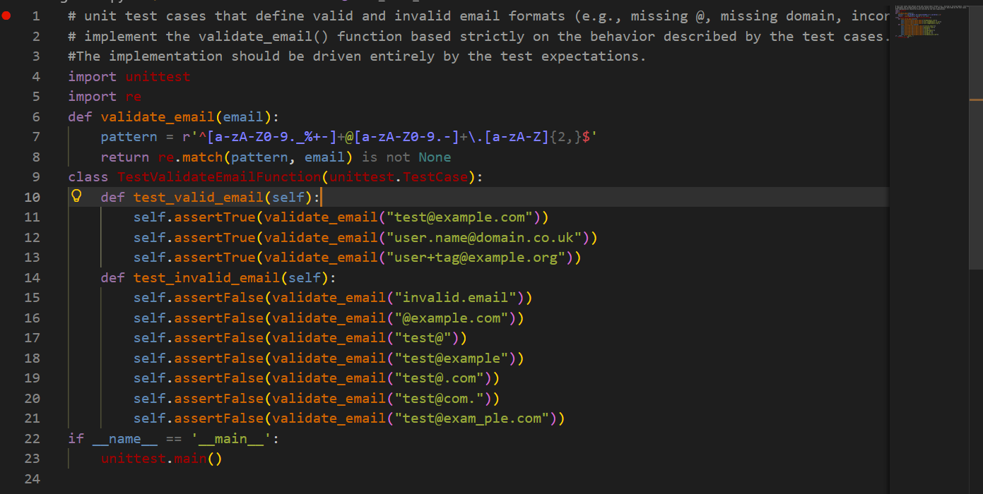
OUTPUT:
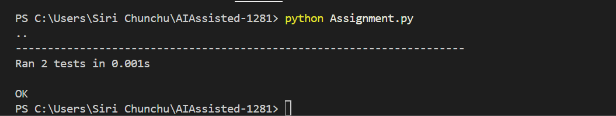
EXPLAINATION:
- Test cases are written to define valid and invalid email formats.
- Examples include missing @, missing domain name, and incorrect structure.
- Based on these tests, AI generates the validate_email() function.
- The function behavior strictly follows test expectations.
- All test cases passing confirms correct email validation logic.

TASK-3 : Decision Logic Development Using TDD
Scenario
In a grading or evaluation module, a function is required to determine the
maximum value among three inputs. Accuracy is essential, as incorrect results
could affect downstream decision logic.
Task Description
Using the TDD methodology:
1. Write test cases that describe the expected output for different
combinations of three numbers.
2. Prompt GitHub Copilot or Cursor AI to implement the function logic
based on the written tests.
Avoid writing any logic before test cases are completed.
PROMPT:
# a function is required to determine the maximum value among three inputs.
# Accuracy is essential, as incorrect results could affect downstream decision logic.
# test cases that describe the expected output for different combinations of three numbers.

CODE:
import unittest
def max_of_three(a, b, c):
return max(a, b, c)
class TestMaxOfThreeFunction(unittest.TestCase):
def test_max_first(self):
self.assertEqual(max_of_three(5, 3, 1), 5)
self.assertEqual(max_of_three(10, 0, -10), 10)
def test_max_second(self):
self.assertEqual(max_of_three(2, 8, 4), 8)
self.assertEqual(max_of_three(-1, 1, 0), 1)
def test_max_third(self):
self.assertEqual(max_of_three(1, 2, 3), 3)
self.assertEqual(max_of_three(-5, -2, -1), -1)
def test_all_equal(self):
self.assertEqual(max_of_three(7, 7, 7), 7)
self.assertEqual(max_of_three(0, 0, 0), 0)
if __name__ == '__main__':
unittest.main()
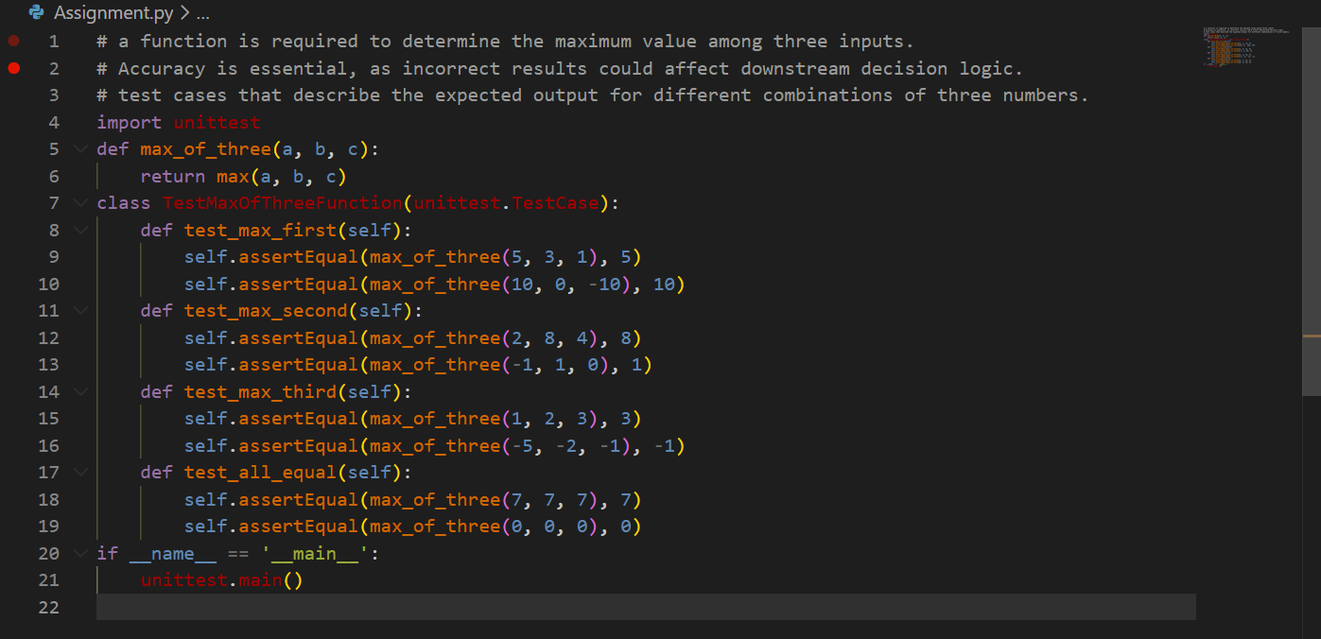

OUTPUT :
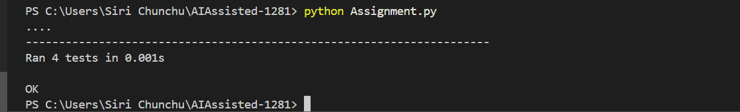
EXPLAINATION:
- Unit tests are created to find the maximum of three numbers.
- Test cases cover normal values and edge cases (equal numbers, negatives).
- AI generates the function only after tests are defined.
- Successful test execution confirms accuracy of decision logic.
- Shows that logic is derived from tests, not assumptions.

TASK-4: Shopping Cart Development with AI-Assisted TDD
Scenario
You are building a simple shopping cart module for an e-commerce
application. The cart must support adding items, removing items, and
calculating the total price accurately.
Task Description
Follow a test-driven approach:
1. Write unit tests for each required behavior:
o Adding an item
o Removing an item
o Calculating the total price
2. After defining all tests, use AI tools to generate the ShoppingCart class
and its methods so that the tests pass.
Focus on behavior-driven testing rather than implementation details.
PROMPT:
#The cart must support adding items, removing items, and calculating the total price accurately.
#unit tests for each required behavior: Adding an item,Removing an item, Calculating the total price
#Focus on behavior-driven testing rather than implementation details.
CODE:
import unittest
class ShoppingCart:
def __init__(self):
self.items = []
def add_item(self, name, price):
self.items.append({'name': name, 'price': price})
def remove_item(self, name):
self.items = [item for item in self.items if item['name'] != name]
def total_price(self):
return sum(item['price'] for item in self.items)
class TestShoppingCart(unittest.TestCase):
def setUp(self):
self.cart = ShoppingCart()
def test_add_item(self):
self.cart.add_item("apple", 1.0)
self.cart.add_item("banana", 2.0)
self.assertEqual(len(self.cart.items), 2)
self.assertEqual(self.cart.items[0]['name'], "apple")
self.assertEqual(self.cart.items[1]['price'], 2.0)
def test_remove_item(self):
self.cart.add_item("apple", 1.0)
self.cart.add_item("banana", 2.0)
self.cart.remove_item("apple")
self.assertEqual(len(self.cart.items), 1)
self.assertEqual(self.cart.items[0]['name'], "banana")
def test_total_price(self):
self.cart.add_item("apple", 1.0)
self.cart.add_item("banana", 2.0)
self.cart.add_item("orange", 3.0)
self.assertEqual(self.cart.total_price(), 6.0)
self.cart.remove_item("banana")
self.assertEqual(self.cart.total_price(), 4.0)
if __name__ == '__main__':
unittest.main()
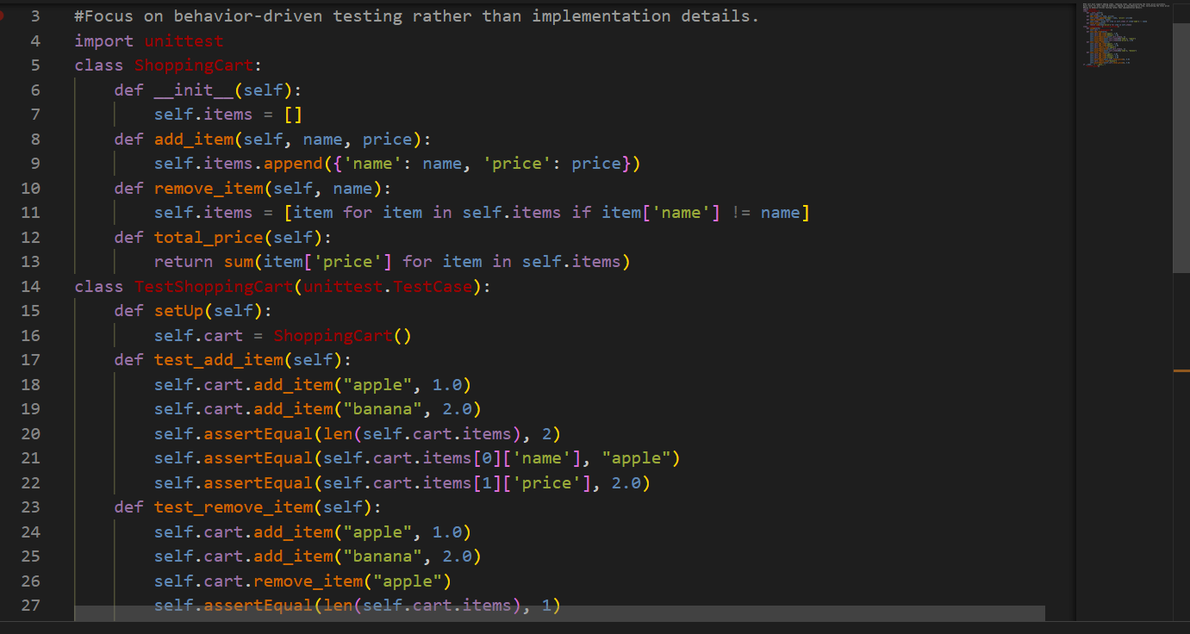

OUTPUT:
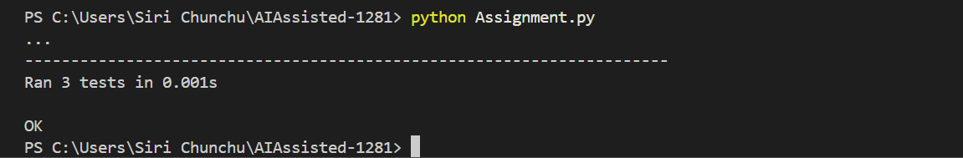
EXPLAINATION:
- Tests define shopping cart behaviors:
- Adding items
- Removing items
- Calculating total price
- AI generates the ShoppingCart class based on test behavior.
- The focus is on what the cart should do, not how it is implemented.
- All passing tests validate correct cart functionality.
- Demonstrates TDD applied to class-based design.

TASK-5 : String Validation Module Using TDD
Scenario
You are working on a text-processing module where a function is required to
identify whether a given string is a palindrome. The function must handle
different cases and inputs reliably.
Task Description
Using Test Driven Development:
1. Write test cases for a palindrome checker covering:
o Simple palindromes
o Non-palindromes
o Case variations
2. Use GitHub Copilot or Cursor AI to generate the is_palindrome()
function based on the test case expectations.
The function should be implemented only after tests are written.
PROMPT:
# where a function is required to identify whether a given string is a palindrome. The function must handle different cases and inputs reliably.
#a palindrome checker covering: Simple palindromes, Non-palindromes, Case variations
CODE:
import unittest
def is_palindrome(s):
cleaned = ''.join(c.lower() for c in s if c.isalnum())
return cleaned == cleaned[::-1]
class TestIsPalindromeFunction(unittest.TestCase):
def test_simple_palindromes(self):
self.assertTrue(is_palindrome("racecar"))
self.assertTrue(is_palindrome("madam"))
self.assertTrue(is_palindrome("level"))
def test_non_palindromes(self):
self.assertFalse(is_palindrome("hello"))
self.assertFalse(is_palindrome("world"))
self.assertFalse(is_palindrome("python"))
def test_case_variations(self):
self.assertTrue(is_palindrome("RaceCar"))
self.assertTrue(is_palindrome("MadAm"))
self.assertTrue(is_palindrome("LeVeL"))
def test_palindromes_with_spaces_and_punctuation(self):
self.assertTrue(is_palindrome
("A man, a plan, a canal: Panama"))
self.assertTrue(is_palindrome("No 'x' in Nixon"))
self.assertFalse(is_palindrome("This is not a palindrome!"))
if __name__ == '__main__':
unittest.main()
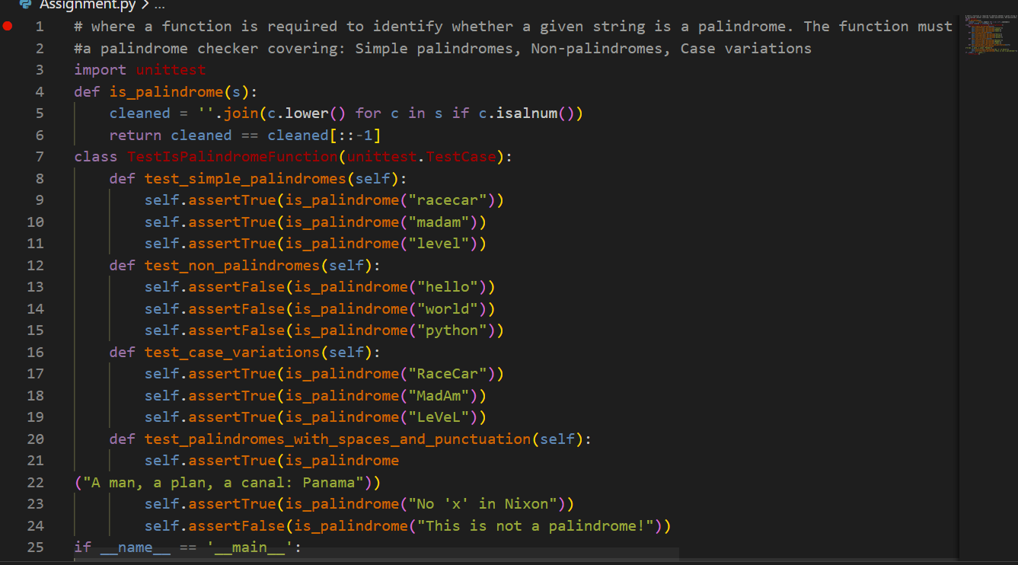
OUTPUT:
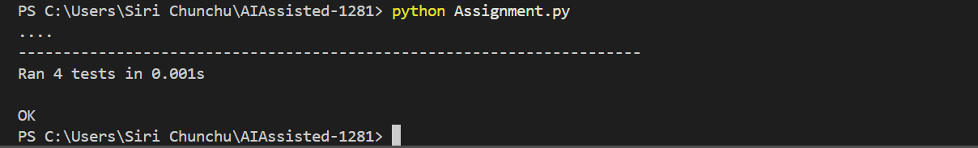
EXPLAINATION:
- Test cases are written for palindrome checking.
- Covers simple palindromes, non-palindromes, and case variations.
- AI generates the is_palindrome() function after tests are ready.
- Passing test results confirm reliable string validation.
- Ensures correct handling of different input scenarios using TDD.

