AI Assistant Coding
Assignment -20.3
Name : Chunchu Siri
Hall Ticket No.:2303A51281
Batch No.:05

Lab 20 – Security Testing: Identifying Vulnerabilities in AI- Generated Code
Task 1 – Password Strength & Validation Check
Task:
Analyze an AI-generated user registration script for weak password handling.
Instructions:
• Prompt AI to generate a Python user registration program
• Check whether:
o Password length is validated
o Weak passwords are allowed
• Suggest secure improvements such as:
o Minimum length checks
o Use of regular expressions
o Rejecting common passwords
Expected Output:
A secure registration script with strong password validation rules.

Prompt:
Generate a Python program for user registration that takes username and password as input.
Do not include strong validation initially.
AI Generated Code:
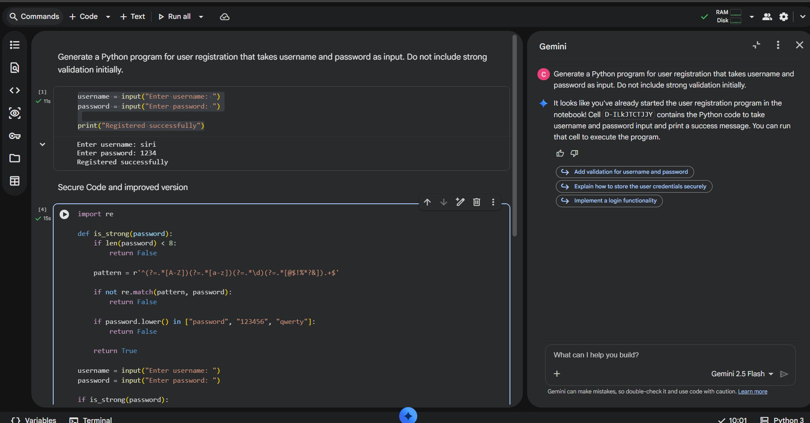
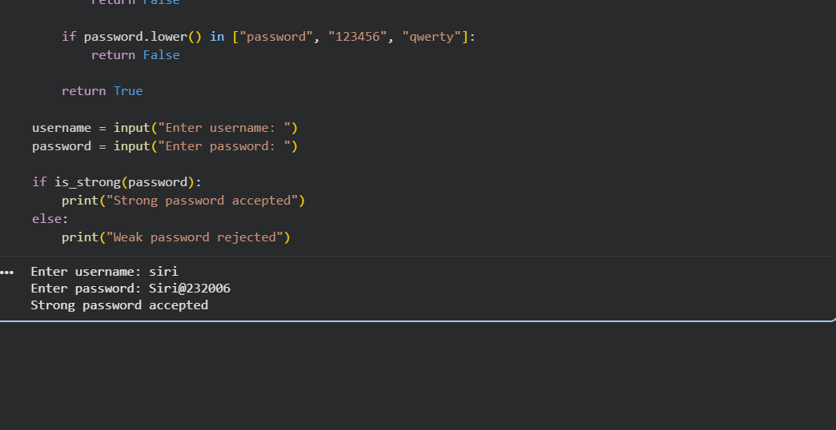
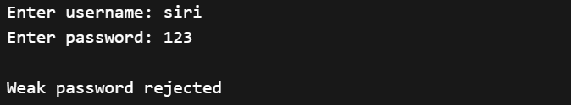
Explanation
- No password rules → weak passwords allowed
- Example: 123, abc, password all accepted

Task 2 – Insecure File Upload Handling
Task:
Evaluate an AI-generated file upload program for security risks.
Instructions:
• Prompt AI to generate a Python or Flask-based file upload script
• Identify vulnerabilities such as:
o No file type validation
o Unrestricted file size
• Implement secure measures:
o File extension validation
o Size limits
o Safe file storage paths
Expected Output:
A secure file upload implementation that prevents malicious uploads.

Prompt:
Generate a Python file upload validation script without security checks.
AI Generated Code:
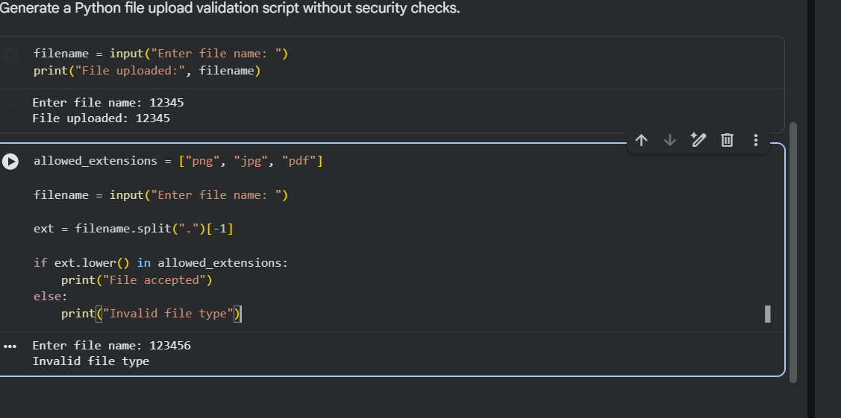
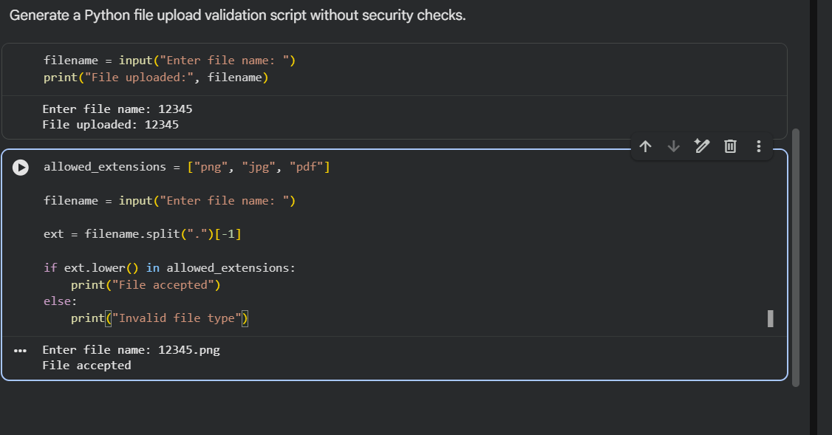
Explanation
- Any file allowed
- Dangerous files like .exe accepted

Task 3 – Real-Time Application: API Security Review
Scenario:
An AI-generated API endpoint is used in a web application.
Instructions:
• Review the API code for:
o Missing authentication
o Insecure HTTP methods
o Lack of rate limiting
• Prompt AI to suggest security improvements such as:
o Token-based authentication
o Input validation
o Rate limiting
Expected Output:
A security-reviewed API endpoint with documented vulnerabilities and fixes.

Prompt:
Generate a Python API-like function that returns sensitive data without authentication.
AI Generated Code:
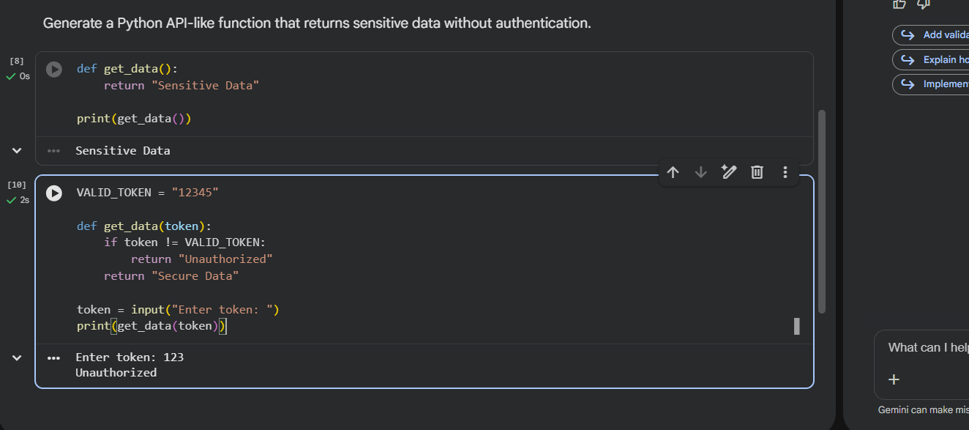
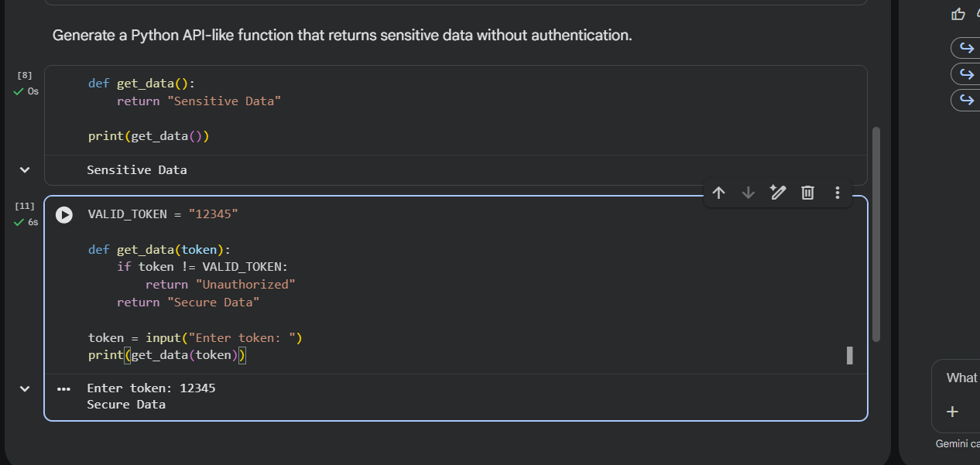
Explanation
- Anyone can access data
- No authentication

Task 4 – Cross-Site Scripting (XSS) Check
Task:
Evaluate an AI-generated HTML form with JavaScript for XSS vulnerabilities.
Instructions:
• Ask AI to generate a feedback form with JavaScript-based output.
• Test whether untrusted inputs are directly rendered without escaping.
• Implement secure measures (e.g., escaping HTML entities, using CSP).
Expected Output:
• A secure form that prevents XSS attacks.

Prompt:
Generate a simple program that displays user input directly without validation.
AI Generated Code:
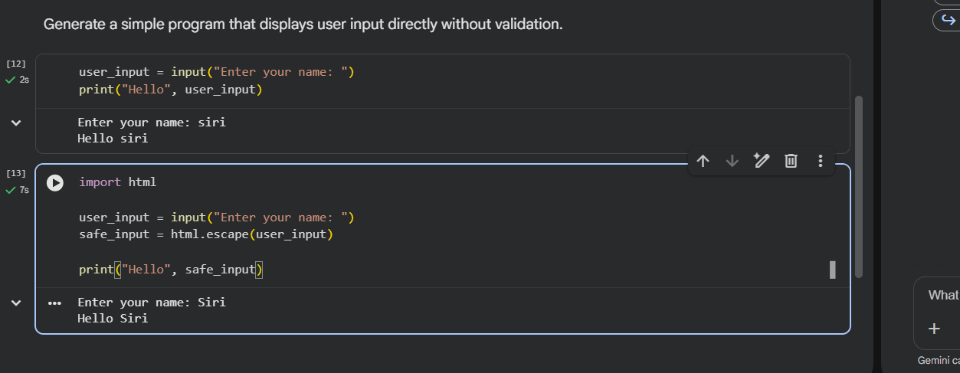
Explanation:
- In web apps → <script> can run

Task 5 – SQL Injection Prevention
Task:
Test an AI-generated script that performs SQL queries on a database.
Instructions:
• Ask AI to generate a Python script using SQLite/MySQL to fetch user details.
• Identify if the code is vulnerable to SQL injection (e.g., using string concatenation in queries).
• Refactor using parameterized queries (prepared statements).
Expected Output:
• A secure database query script resistant to SQL injection.

Prompt:
Generate a Python script using SQLite that fetches user details using string concatenation.
AI Generated Code:
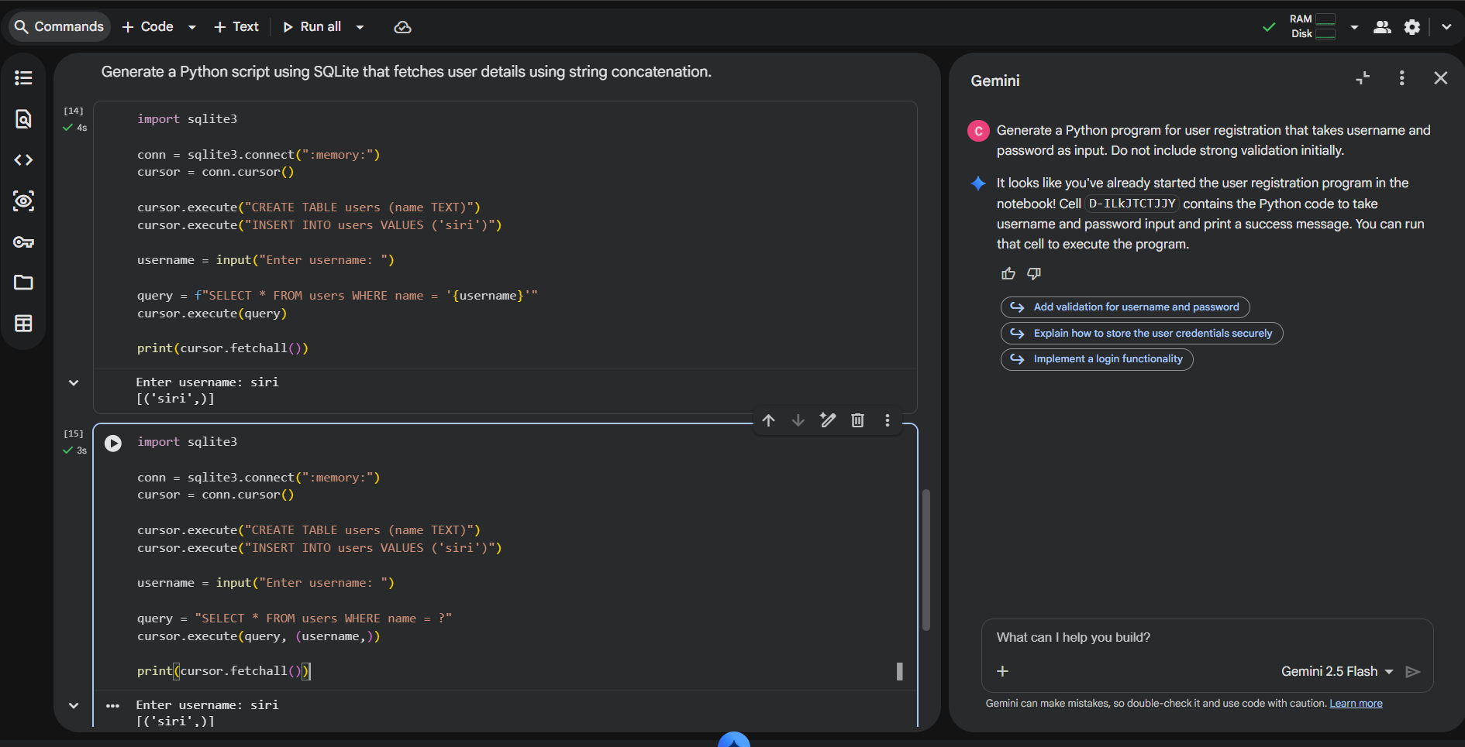
Explanation
- Input like ' OR '1'='1 bypasses security

