Assignment-6.3
Name : Chunchu Siri
Hall Ticket Number :2303A51281
Batch Number :05

Lab 6: AI-Based Code Completion – Classes, Loops, and Conditionals
Task Description #1: Classes (Student Class)
Scenario
You are developing a simple student information management module.
Task
• Use an AI tool (GitHub Copilot / Cursor AI / Gemini) to complete a Student class.
• The class should include attributes such as name, roll number, and branch.
• Add a method display_details() to print student information.
• Execute the code and verify the output.
• Analyze the code generated by the AI tool for correctness and clarity.

AI Prompt Used
Generate a Python class named Student with attributes name, roll number, and branch. Add a method display_details() to print the student information.

AI Generated Code
#Generate a Python class named Student with attributes name, roll number, and branch. Add a method display_details() to print the student information.
class Student:
def __init__(self, name, roll_number, branch):
self.name = name
self.roll_number = roll_number
self.branch = branch

def display_details(self):
print(f"Name: {self.name}")
print(f"Roll Number: {self.roll_number}")
print(f"Branch: {self.branch}")
# Example usage:
student1 = Student("Alice", "101", "Computer Science")
student1.display_details()
student2 = Student("Bob", "102", "Mechanical Engineering")
student2.display_details()
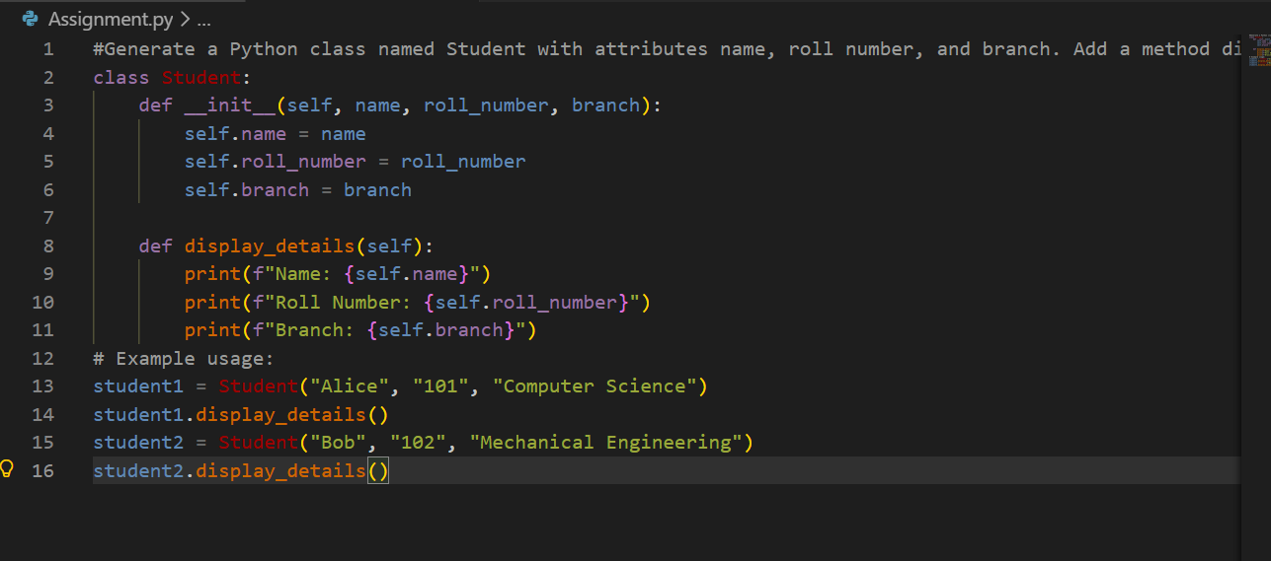
Output:
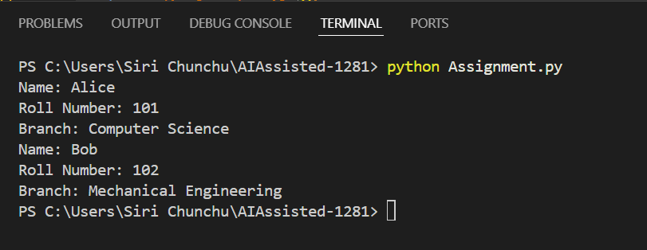
Analysis
- The AI correctly generated:
  - A constructor using __init__()
  - Instance variables
  - A display method
- Code is readable and logically structured.
- Suitable for beginner-level OOP understanding.
- No syntax or logical errors.
Correct and well-structured implementation.

Task Description #2: Loops (Multiples of a Number)
Scenario
You are writing a utility function to display multiples of a given number.
Task
• Prompt the AI tool to generate a function that prints the first 10 multiples of a given number
using a loop.
• Analyze the generated loop logic.
• Ask the AI to generate the same functionality using another controlled looping structure (e.g.,
while instead of for).

AI Prompt
Generate a Python function to print first 10 multiples of a number using a loop.
AI Generated Code
#Generate a Python function to print first 10 multiples of a number using a loop.
def print_multiples(number):
for i in range(1, 11):
print(number * i)
# Example usage
print_multiples(5)
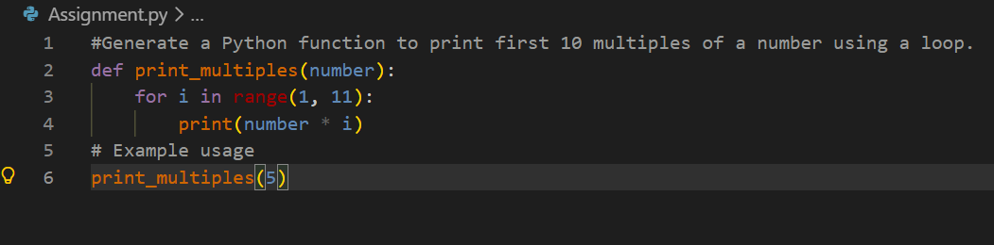
Output:
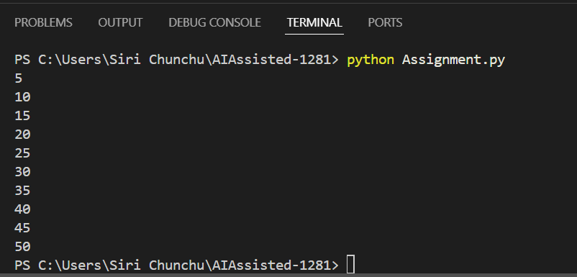

Using while Loop (AI Alternative)
def print_multiples_while(n):
i = 1
while i <= 10:
print(n * i)
i += 1

print_multiples_while(5)
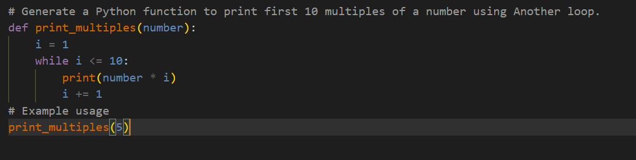
Output:
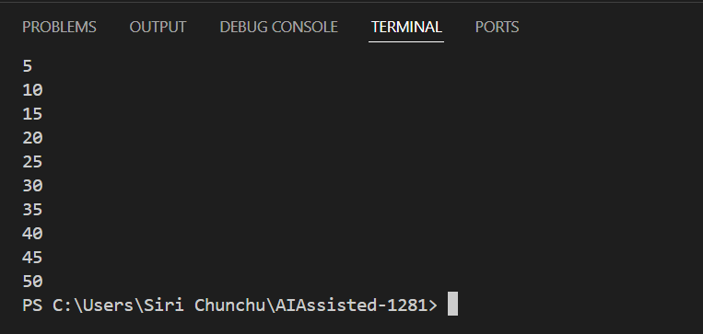
Analysis
Feature | for loop | while loop
Readability | High | Medium
Best Use | Fixed iterations | Condition-based loops
Complexity | Simple | Slightly more logic
->Both implementations are correct.

Task Description #3: Conditional Statements (Age Classification)
Scenario
You are building a basic classification system based on age.
Task
• Ask the AI tool to generate nested if-elif-else conditional statements to classify age groups
(e.g., child, teenager, adult, senior).
• Analyze the generated conditions and logic.
• Ask the AI to generate the same classification using alternative conditional structures (e.g.,
simplified conditions or dictionary-based logic).

AI Prompt
Generate a Python function to print Age Classification (Conditional Statements) Classify age into groups.
AI Generated Code
#Generate a Python function to print Age Classification (Conditional Statements) Classify age into groups.
def classify_age(age):
if age < 0:
return "Invalid age"
elif age <= 12:
return "Child"
elif age <= 19:
return "Teenager"
elif age <= 64:
return "Adult"
else:
return "Senior"
# Example usage
age = 25
print(f"Age: {age}, Classification: {classify_age(age)}")

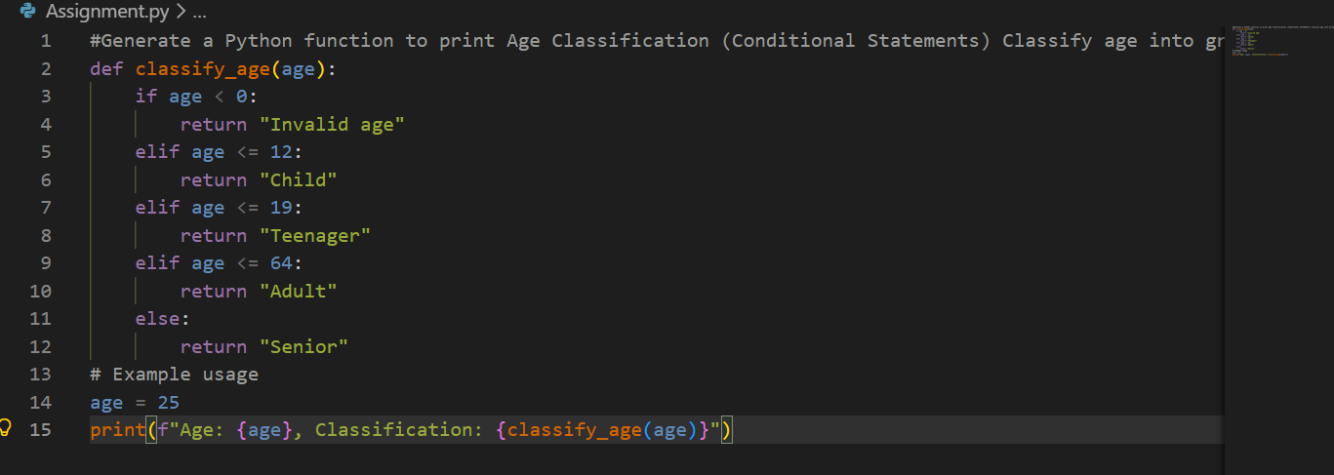
Output:
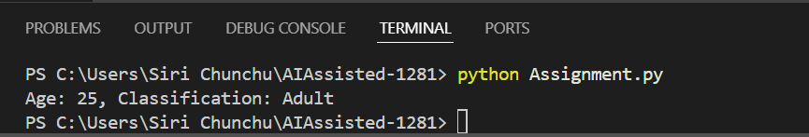
Analysis
- Conditions are logically ordered.
- No overlap between age ranges.
- Easy to modify or extend.
- AI used best practices.
Correct and readable logic.

Task Description #4: For and While Loops (Sum of First n Numbers)
Scenario
You need to calculate the sum of the first n natural numbers.
Task
• Use AI assistance to generate a sum_to_n() function using a for loop.
• Analyze the generated code.
• Ask the AI to suggest an alternative implementation using a while loop or a mathematical
formula.
AI Prompt
Generate a Python function to print Sum of First n Natural Numbers using loops.
AI Generated Code
#Generate a Python function to print Sum of First n Natural Numbers using loops
def sum_of_natural_numbers(n):
total = 0
for i in range(1, n + 1):
total += i
return total
# Example usage
n = 10
print(f"The sum of the first {n} natural numbers is: {sum_of_natural_numbers(n)}")
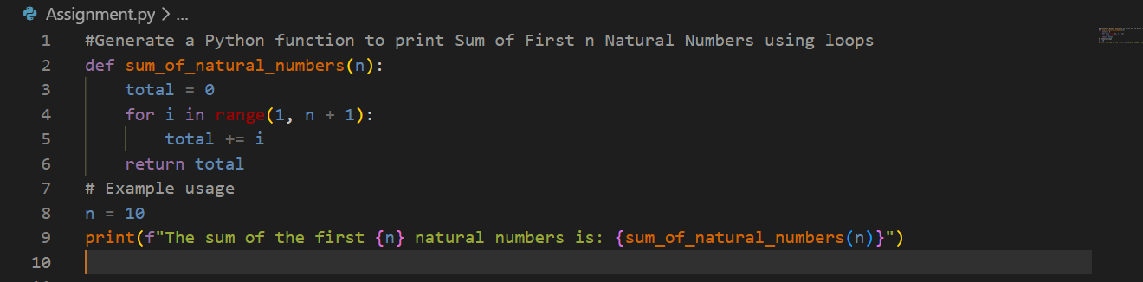
Output

AI Alternative Method:
#Using while loop
def sum_of_natural_numbers_while(n):
total = 0
i = 1
while i <= n:
total += i
i += 1
return total
# Example usage
n = 10
print(f"The sum of the first {n} natural numbers using while loop is: {sum_of_natural_numbers_while(n)}")
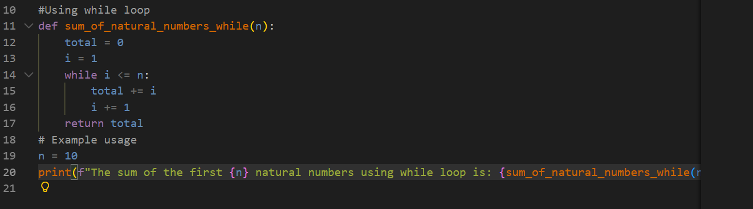
Output:
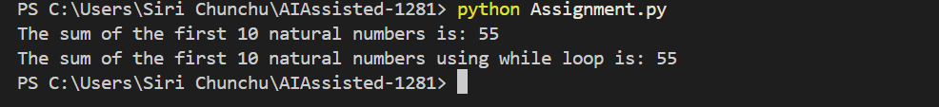
Comparison
Method | Efficiency | Complexity
for loop | Medium | O(n)
while loop | Medium | O(n)
formula | Best | O(1)
AI suggested both logical and optimized approaches.

Task Description #5: Classes (Bank Account Class)
Scenario
You are designing a basic banking application.
Task
• Use AI tools to generate a Bank Account class with methods such as deposit(), withdraw(),
and check_balance().
• Analyze the AI-generated class structure and logic.
• Add meaningful comments and explain the working of the code.

AI Prompt
generate a Bank Account class with methods such as deposit(), withdraw(),and check_balance().
AI Generated Code
#generate a Bank Account class with methods such as deposit(), withdraw(),and check_balance().
class BankAccount:
def __init__(self, account_holder, initial_balance=0):
self.account_holder = account_holder
self.balance = initial_balance

def deposit(self, amount):
if amount > 0:
self.balance += amount
print(f"Deposited: ${amount:.2f}")
else:
print("Deposit amount must be positive.")

def withdraw(self, amount):
if amount > 0:
if amount <= self.balance:
self.balance -= amount
print(f"Withdrew: ${amount:.2f}")
else:
print("Insufficient funds for this withdrawal.")
else:
print("Withdrawal amount must be positive.")

def check_balance(self):
print(f"Current balance: ${self.balance:.2f}")
return self.balance
# Example usage:
if __name__ == "__main__":
account = BankAccount("John Doe", 1000)
account.check_balance()
account.deposit(500)
account.check_balance()
account.withdraw(200)
account.check_balance()
account.withdraw(2000) # Attempt to withdraw more than the balance
account.deposit(-50) # Attempt to deposit a negative amount
# The BankAccount class allows users to create a bank account, deposit and withdraw funds, and check the current balance.
# It includes basic validation to ensure that deposits and withdrawals are positive amounts and that.
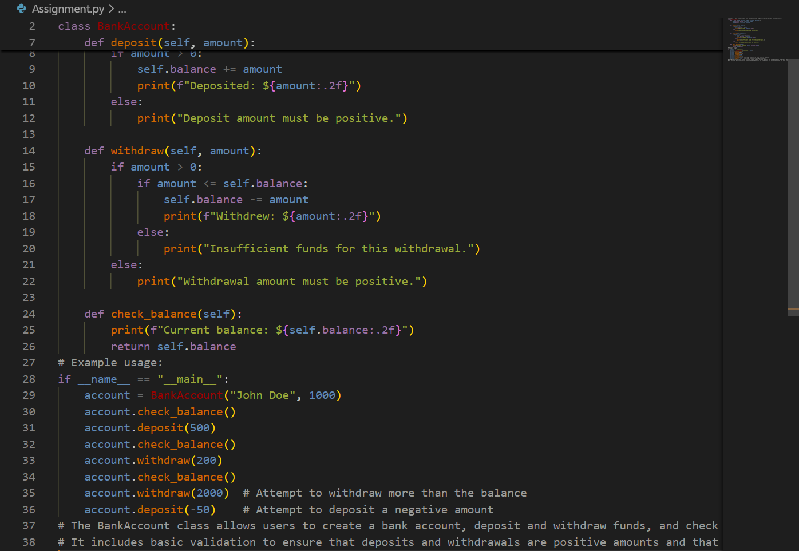
Output
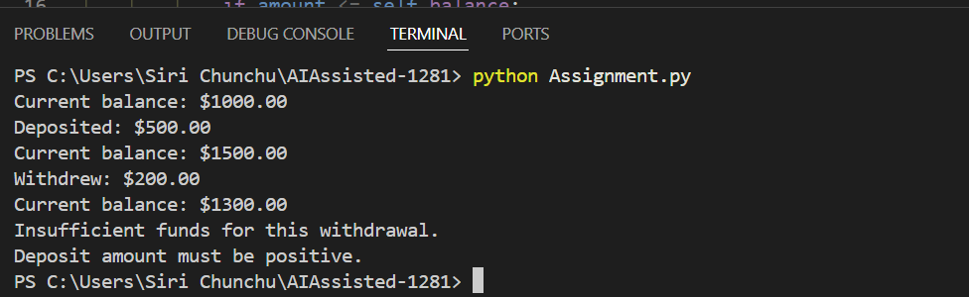
Analysis
- Encapsulation is correctly used.
- Methods are meaningful and readable.
- Error handling for insufficient balance is included.
- Good real-world modeling.
Conclusion
- AI tools effectively generated clean and correct Python code.
- The generated logic was easy to understand and modify.
- AI-assisted coding helps in:
  - Faster development
  - Learning best practices
  - Reducing syntax errors

Manual analysis is still important to ensure correctness and optimization.

