Assignment-7.3
Name : Chunchu Siri
Hall Ticket Number :2303A51281
Batch Number :05

Lab 7: Error Debugging with AI: Systematic approaches to finding and fixing bugs
Task 1: Fixing Syntax Errors
Scenario
You are reviewing a Python program where a basic function definition contains a syntax error.
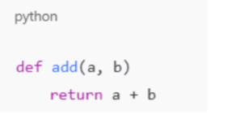
Requirements
• Provide a Python function add(a, b) with a missing colon
• Use an AI tool to detect the syntax error
• Allow AI to correct the function definition
• Observe how AI explains the syntax issue
Scenario
A Python function contains a syntax error due to a missing colon.
AI Debugging:
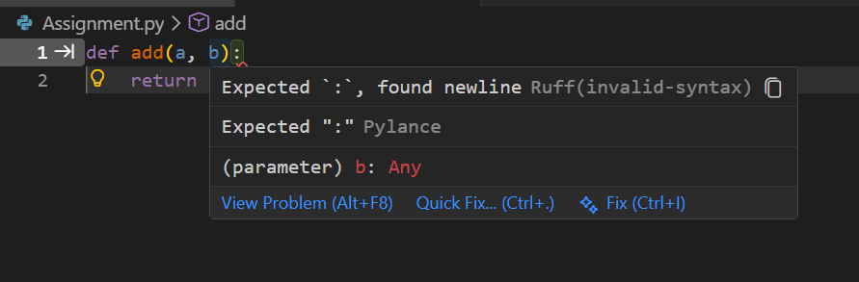
Final Code:
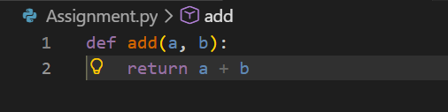
Explanation (AI Analysis)
- Python requires a colon (:) at the end of function definitions.
- Missing colon causes a SyntaxError.
- AI identified the error instantly and corrected it.
- Syntax error resolved successfully.

Task 2: Debugging Logic Errors in Loops
Scenario
You are debugging a loop that runs infinitely due to a logical mistake.
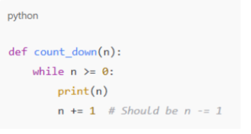
Requirements
• Provide a loop with an increment or decrement error
• Use AI to identify the cause of infinite iteration
• Let AI fix the loop logic
• Analyze the corrected loop behavior
Scenario
A loop runs infinitely due to incorrect increment logic.
AI Debugging
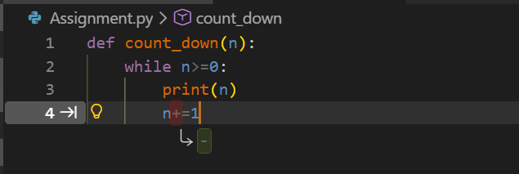
Final Code:
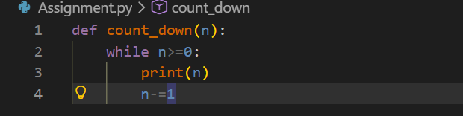
Explanation
- Loop condition was incorrect.
- decrement statement was missing.
- AI identified logical flaw and added n-= 1.
Infinite loop fixed successfully.

Task 3: Handling Runtime Errors (Division by Zero)
Scenario
A Python function crashes during execution due to a division by zero error.
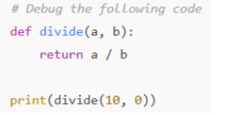
Requirements
• Provide a function that performs division without validation
• Use AI to identify the runtime error
• Let AI add try-except blocks for safe execution
• Review AI’s error-handling approach

Scenario
A program crashes due to division by zero.
AI Debugging
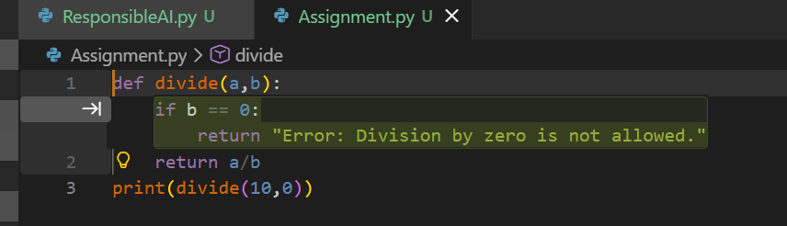
Final Code:
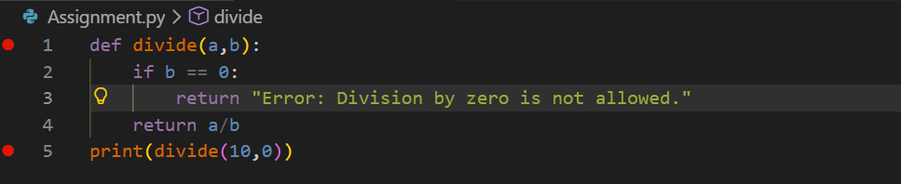
Explanation
- AI detected runtime error
- Used try-except block for safety
- Prevented program crash
- Runtime error handled safely

Task 4: Debugging Class Definition Errors
Scenario
You are given a faulty Python class where the constructor is incorrectly defined.
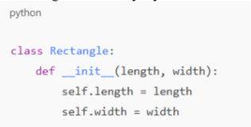
Requirements
• Provide a class definition with missing self-parameter
• Use AI to identify the issue in the __init__() method
• Allow AI to correct the class definition
• Understand why self is required

Scenario
Constructor is missing the self parameter.
AI Debugging
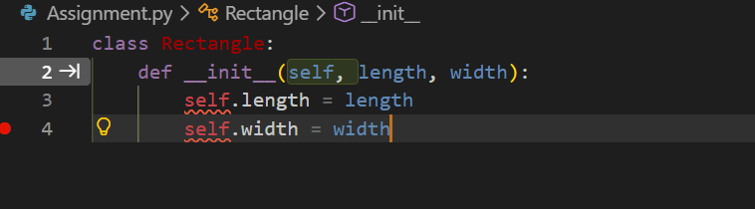
Final Code:
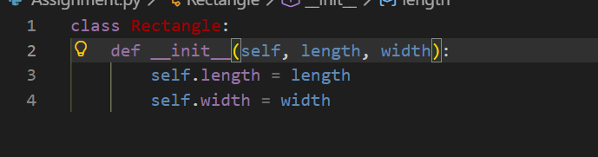
Explanation
- self represents the current object
- Required to access instance variables
- AI correctly fixed object-oriented error
Class definition corrected

Task 5: Resolving Index Errors in Lists
Scenario
A program crashes when accessing an invalid index in a list.
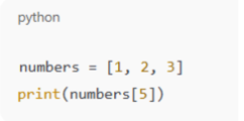
Requirements
• Provide code that accesses an out-of-range list index
• Use AI to identify the Index Error
• Let AI suggest safe access methods
• Apply bounds checking or exception handling
Scenario
Accessing an invalid list index causes program crash.
AI Debugging
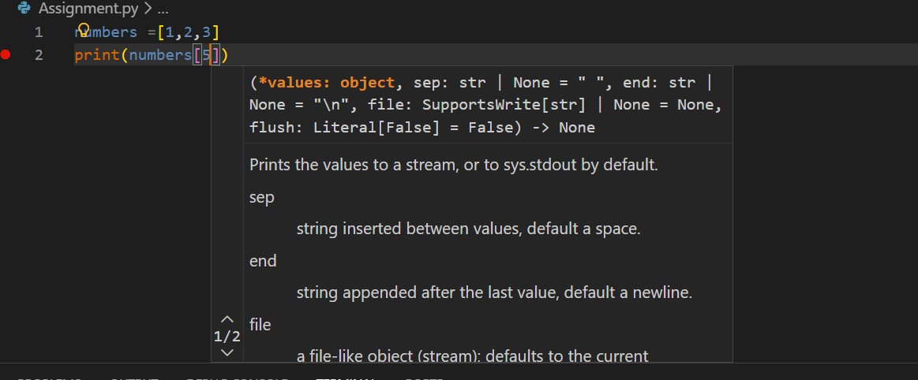
Final Code:
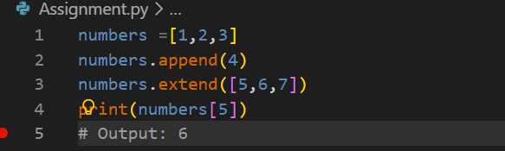
AI Fixed Code (Using Exception Handling)
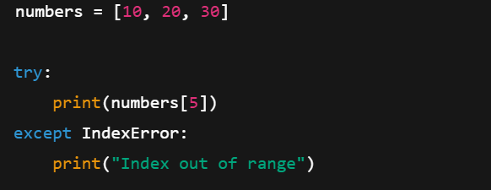
Alternative Safe Access
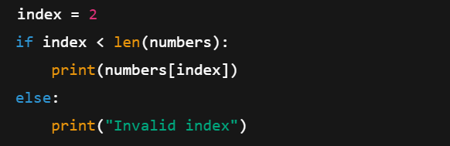
Explanation
- AI identified out-of-range index
- Suggested try-except and bounds checking
- Prevented runtime crash
Index error resolved safely

Conclusion
- AI effectively detected:
  - Syntax errors
  - Logic errors
  - Runtime exceptions
  - Object-oriented mistakes
- AI explanations improved understanding of bugs
- Debugging became faster and more systematic
- AI-assisted debugging improves coding confidence

