Assignment 18.4
AI Assistant Coding
Name : Chunchu Siri
Hall Ticket No.:2303a51281
Batch No.:05

Task 1: Movie Database API Integration
Prompt: Generate a Python script to fetch movie details using OMDB API. The program should accept movie title as input and display title, year, rating, and plot. Include proper error handling for invalid movie names, API errors, and network issues.
Code:
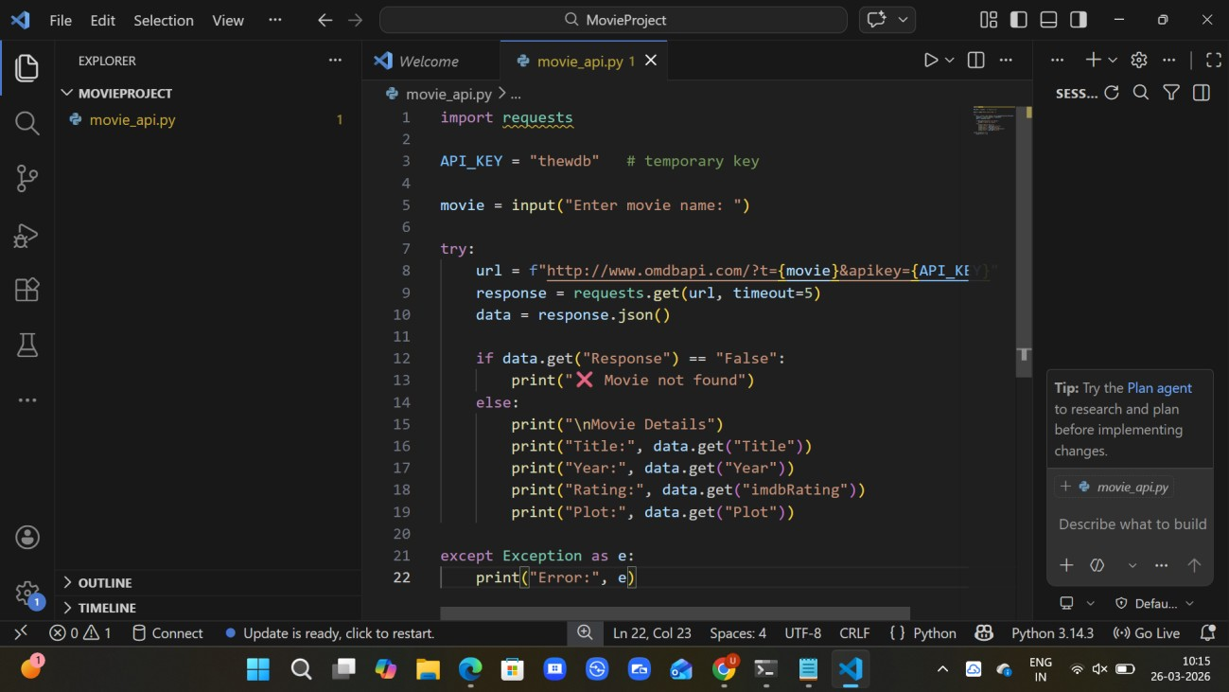
Output:
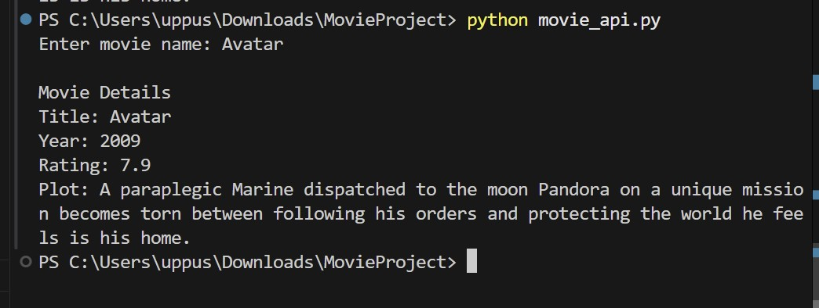
Explanation:
- The program uses requests library to connect to OMDB API.
- It takes movie name as user input.
- The API response is converted into JSON format.
- Required details like title, year, rating, and plot are displayed.
- Error handling is implemented for invalid movie names and network issues.

Task 2: Public Transport Schedule API Integration
Prompt: Generate a Python script to fetch public transport arrival timings using an API.
The program should accept a stop ID as input and display the next 3 arrivals.
Include error handling for invalid stop ID, server issues, and timeout errors.
Also implement retry logic for failed API calls.
Code:
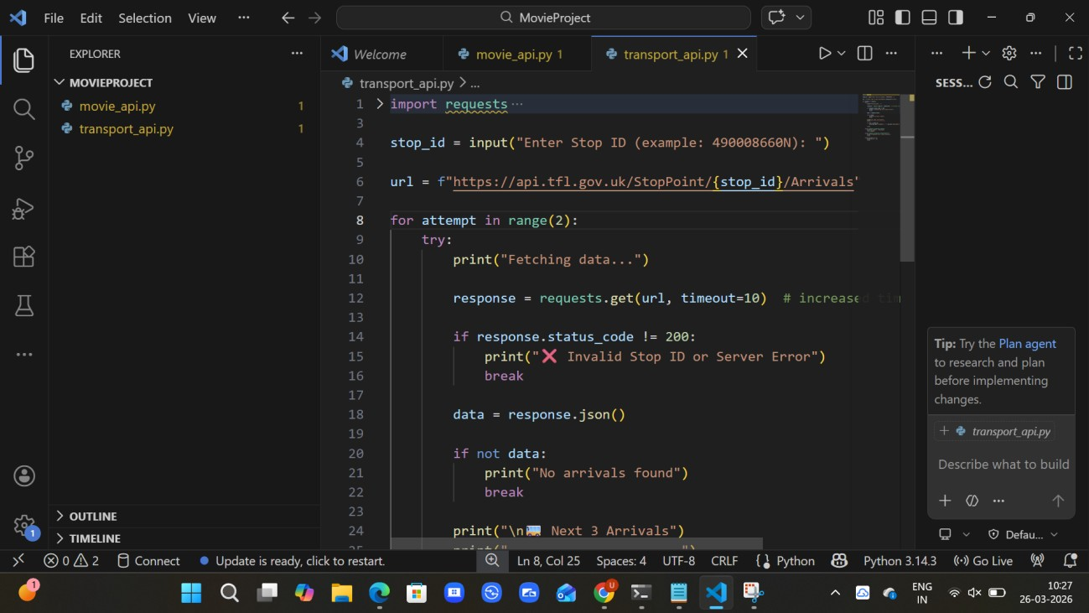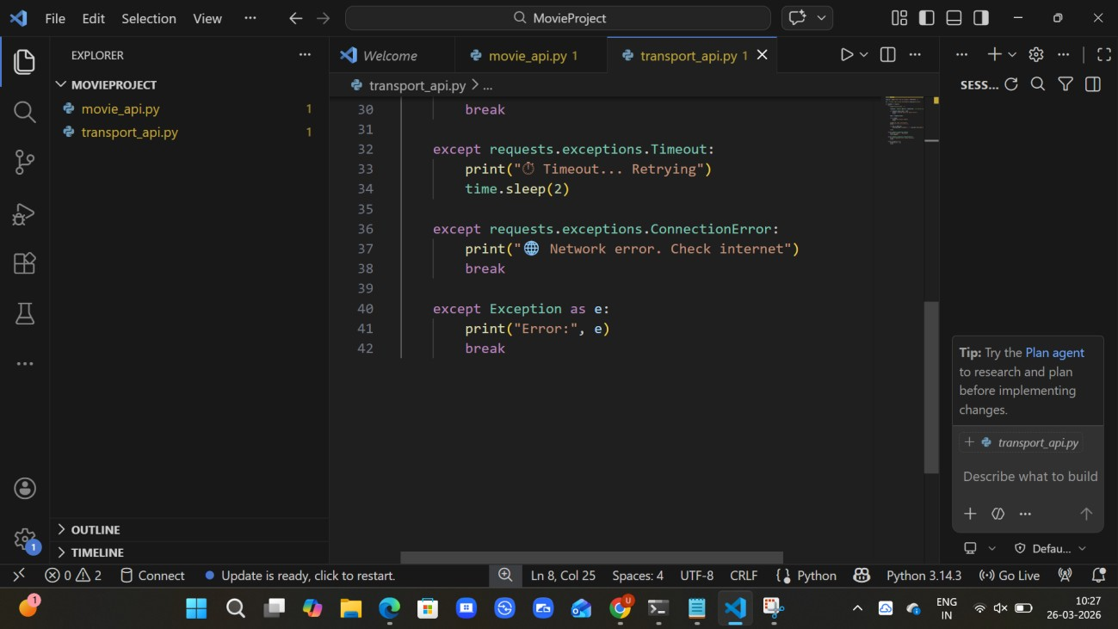
Output:
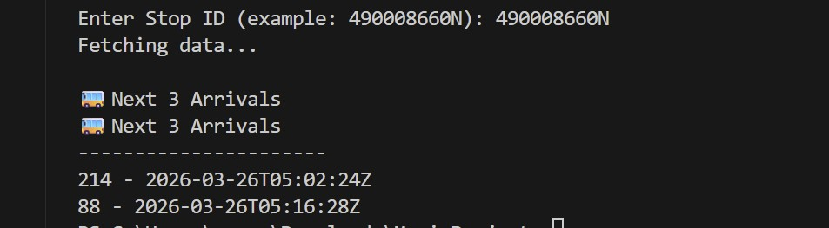
Explanation:
- The program uses the requests library to connect to a transport API and fetch arrival data.
- It takes stop ID as user input to retrieve specific station details.
- The API response is converted into JSON format and processed.
- It displays the next 3 arrival timings in a readable format.

Task 3: Stock Market Data API Integration
Prompt: Generate a Python script to fetch stock market data using a financial API. The program should accept a stock symbol as input and display current price, day high, and day low. Include error handling for invalid symbols, API rate limits, and missing data in the API response.
Code:
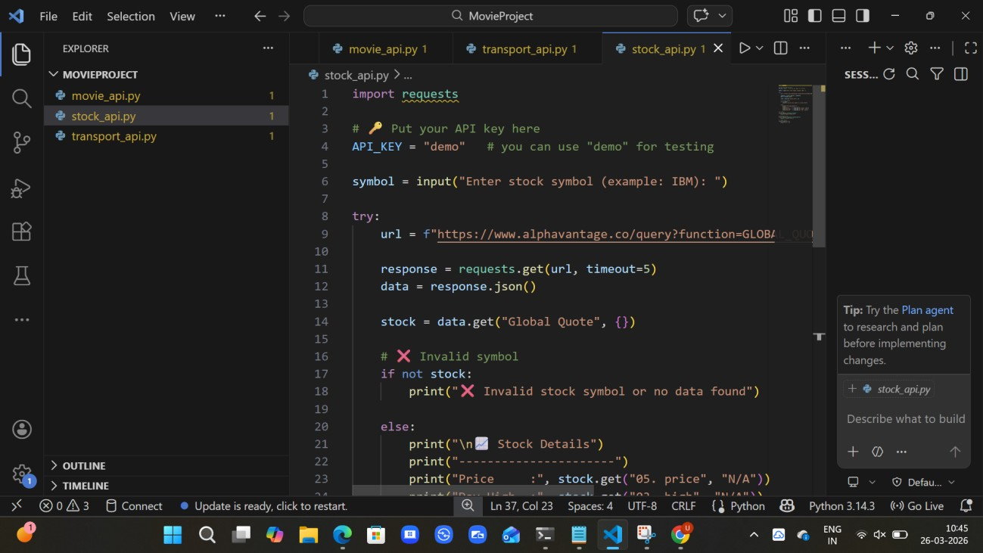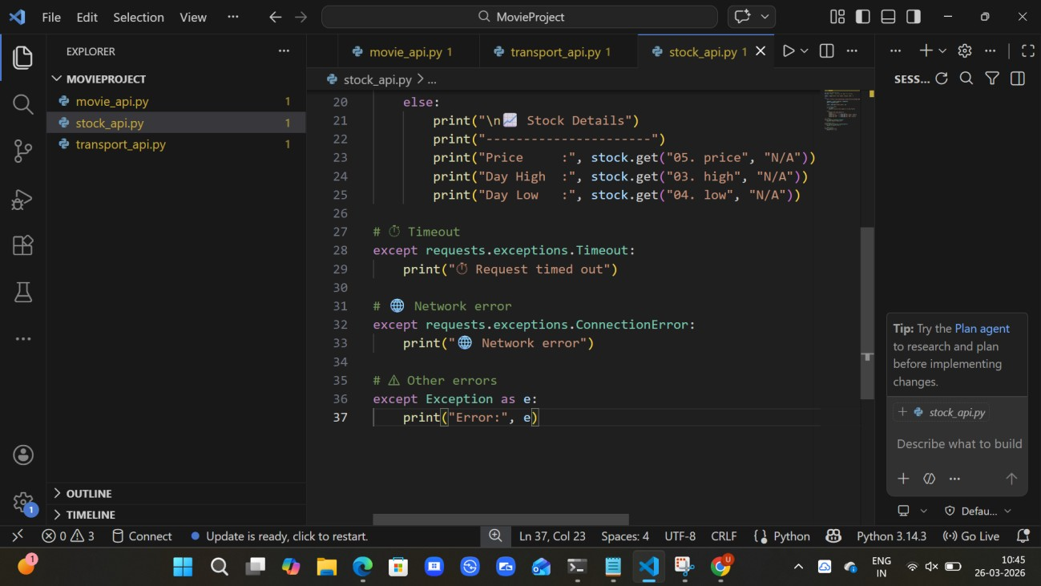
Output:
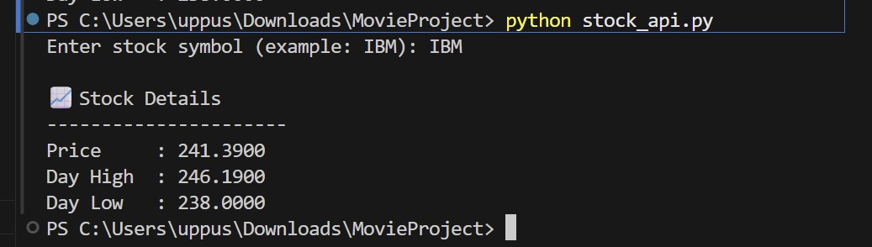
Explanation:
- The program uses the requests library to fetch stock data from a financial API.
- It takes stock symbol as input from the user (e.g., IBM).
- The API response is converted into JSON format and processed safely.
- It displays important details like current price, day high, and day low.
- Error handling is implemented for invalid symbols, network issues, and missing JSON fields.
Task 4: Geolocation API (IP Address Lookup)
Prompt: Generate a Python script to fetch geolocation details using an IP address. The program should accept an IP address as input and display country, city, and ISP. Include validation for IP format and error handling for invalid input, API failure, and JSON decoding errors.
Code:
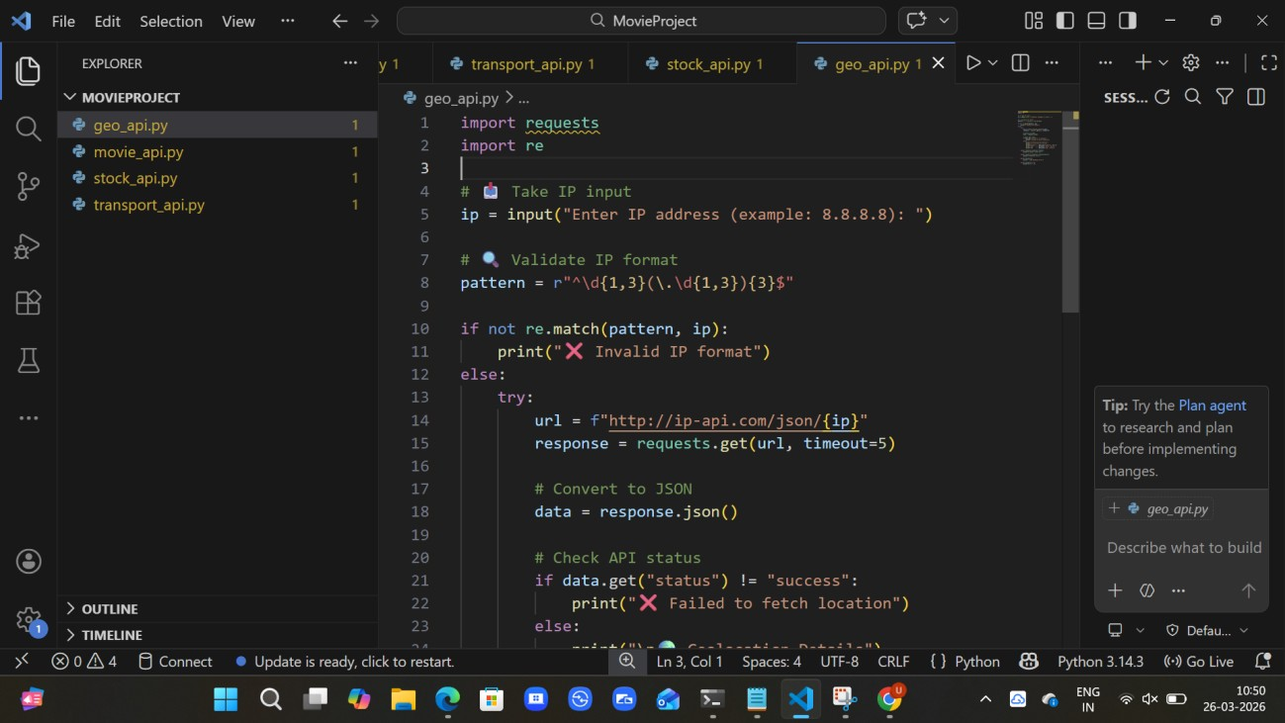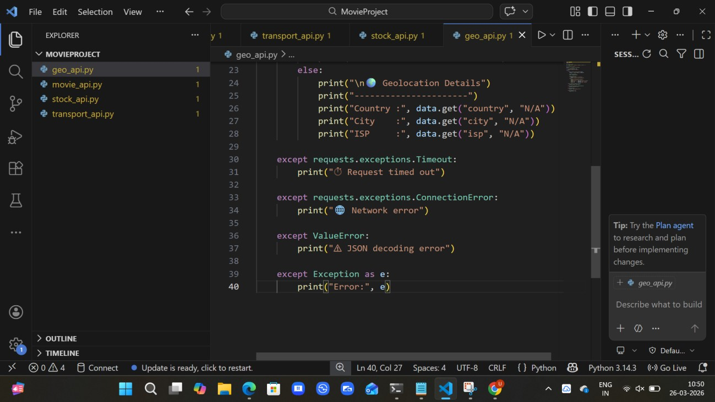
Output:
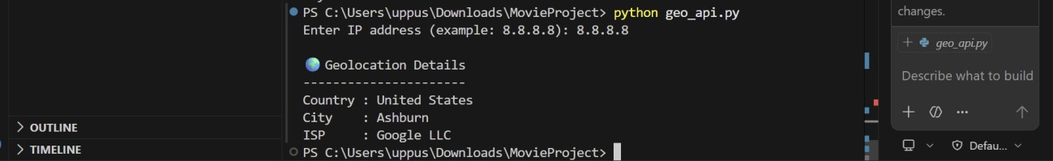
Explanation:
- The program accepts an IP address as user input.
- It validates the IP format using regular expressions (regex).
- It uses the requests library to connect to a geolocation API.
- The API response is converted into JSON format and parsed.
- Error handling is implemented for invalid IP, network issues, API failure, and JSON errors.

Task 5: Real-Time Application – Payment Gateway Simulation API
Prompt: Generate a Python script to simulate payment processing using a sandbox API.
The program should send a POST request with amount, currency, and payment method.
Include input validation and handle errors such as invalid payment details, HTTP status errors (400, 401, 500), and network issues. Also log failed transactions into a file.
Code:
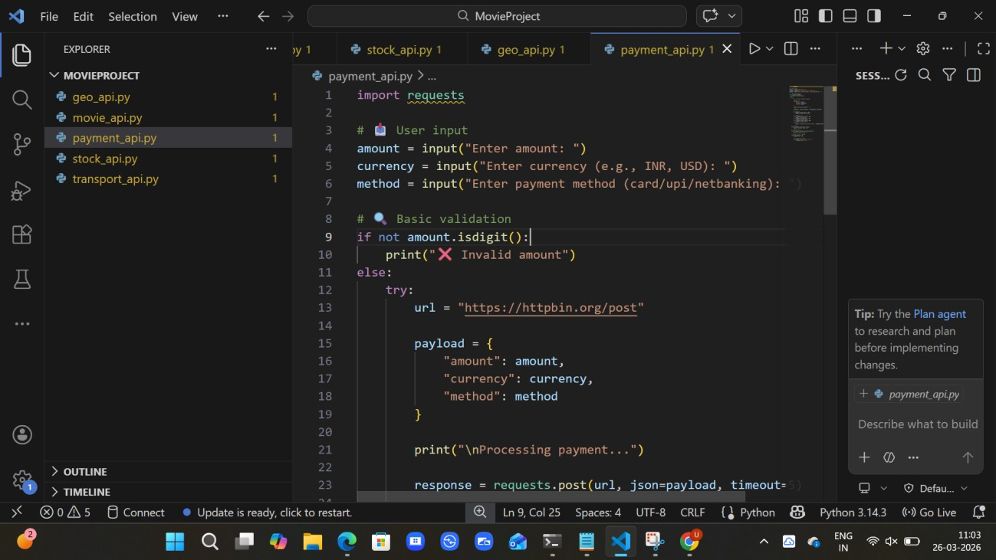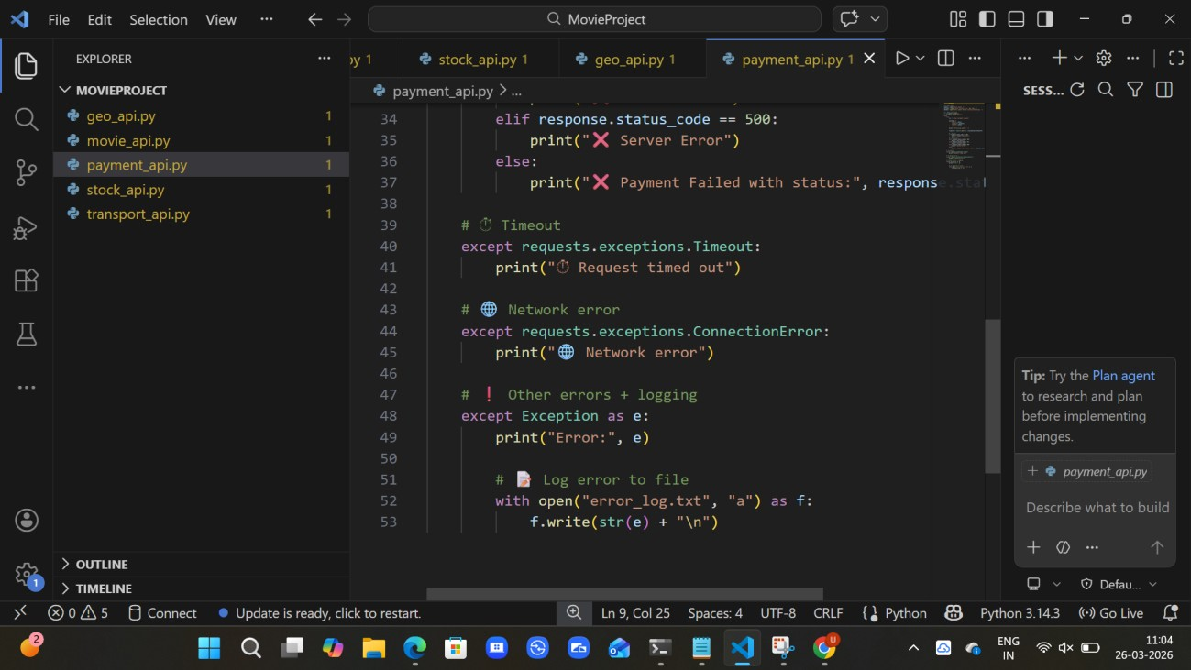
Output:
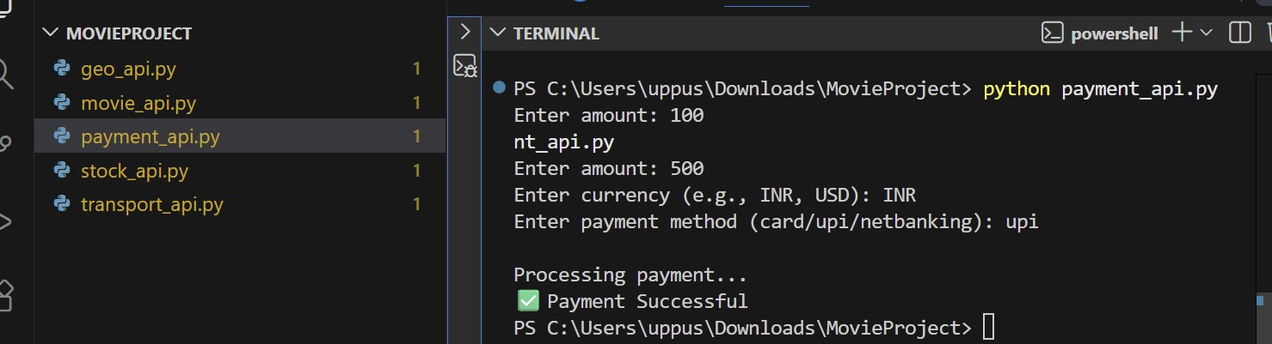
Explanation:
The program collects payment details (amount, currency, method) from the user.
It sends a POST request to a sandbox API to simulate payment processing.
Input validation is performed to ensure the amount is valid before processing.
It handles errors such as HTTP status errors (400, 401, 500), timeout, and network issues.
Failed transactions are logged into a file for future reference and debugging.

