AI Assistant Coding
Assignment – 9.3
Name : Chunchu Siri
Hall Ticket No. : 2303A51281
Batch No. : 05

Task 1: Basic Docstring Generation
Scenario
You are developing a utility function that processes numerical lists and must be properly documented for future maintenance.
Requirements
• Write a Python function to return the sum of even numbers and sum of odd numbers in a given list.
• Manually add a Google Style docstring to the function.
• Use an AI-assisted tool (Copilot / Cursor AI) to generate a function-level docstring.
• Compare the AI-generated docstring with the manually written docstring
• Analyze clarity, correctness, and completeness.

Manually added docstring
#Python function to return the sum of even numbers and sum of odd numbers in a given list.
def sum_even_odd(numbers):
"""
Calculate the sum of even and odd numbers in a list.

Args:
numbers (list of int): A list containing integer values.

Returns:
tuple: A tuple containing two integers:
- sum_even (int): Sum of all even numbers.
- sum_odd (int): Sum of all odd numbers.

Raises:
TypeError: If the input is not a list or contains non-integer elements.
"""
even_sum = 0
odd_sum = 0
for num in numbers:
if num % 2 == 0:
even_sum += num
else:
odd_sum += num
return even_sum, odd_sum

# Example usage:
my_list = [1, 2, 3, 4, 5, 6, 7, 8, 9, 10]
even_total, odd_total = sum_even_odd(my_list)

print(f"Sum of even numbers: {even_total}")
print(f"Sum of odd numbers: {odd_total}")

AI-Generated docstring
def sum_even_odd(numbers):
"""
Returns the sum of even and odd numbers from the given list.

Parameters:
numbers (list): List of numbers to evaluate.

Returns:
tuple: Sum of even numbers and sum of odd numbers.
"""
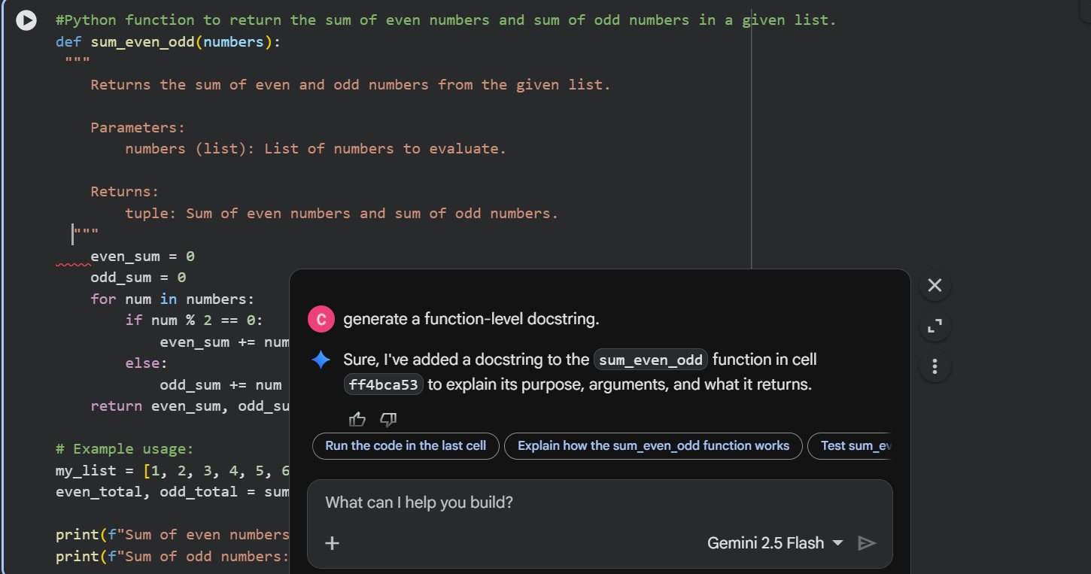
Comparison: Manual vs AI Docstring
Criteria | Manual Docstring | AI-Generated Docstring
Clarity | Very clear — explains structure of return tuple | Clear but slightly vague
Correctness | Fully correct with type expectations | Mostly correct but lacks type precision
Completeness | Includes Args, Returns, Raises | Missing error handling details
Readability | Excellent for team projects | Good for small scripts
Professional Quality | Production-level | Basic / starter-level

Task 2: Automatic Inline Comments
Scenario
You are developing a student management module that must be easy to understand for new
developers.
Requirements
• Write a Python program for an sru_student class with the following:
– Attributes: name, roll_no, hostel_status.
– Methods: fee_update() and display_details().
• Manually write inline comments for each line or logical block.
• Use an AI-assisted tool to automatically add inline comments.
• Compare manual comments with AI-generated comments.
• Identify missing, redundant, or incorrect AI comments.

Manually written inline comments
class sru_student:

def __init__(self, name, roll_no, hostel_status):
# Initialize student attributes
self.name = name # Store student's name
self.roll_no = roll_no # Store student's roll number
self.hostel_status = hostel_status # Store hostel status (True/False)
self.fee_paid = 0 # Track total fee paid by the student

def fee_update(self, amount):
# Validate that the fee amount is positive
if amount <= 0:
print("Invalid fee amount.")
return

# Add the amount to the existing fee
self.fee_paid += amount
print(f"Fee updated successfully. Total fee paid: {self.fee_paid}")

def display_details(self):
# Display student information
print("Student Details:")
print(f"Name: {self.name}") # Print student name
print(f"Roll No: {self.roll_no}") # Print roll number
print(f"Hostel Status: {self.hostel_status}") # Print hostel status
print(f"Fee Paid: {self.fee_paid}") # Print total fee paid

# Create a student object
student1 = sru_student("Rahul", "SRU123", True)

# Update fee
student1.fee_update(50000)

# Display student details
student1.display_details()
AI Generated Inline Coded
class sru_student:
def __init__(self, name, roll_no, hostel_status):
self.name = name
self.roll_no = roll_no
self.hostel_status = hostel_status
# You might want to add a fee attribute here, e.g., self.fees_due = 0

def fee_update(self, amount=0):
# In a real application, this would update a fee attribute
if amount > 0:
print(f"Fee of {amount} updated for {self.name} (Roll No: {self.roll_no}).")
else:
print(f"No fee update specified for {self.name}.")

def display_details(self):
print("\n--- Student Details ---")
print(f"Name: {self.name}")
print(f"Roll No: {self.roll_no}")
print(f"Hostel Status: {self.hostel_status}")

# Example Usage:
# Create a student object
student1 = sru_student("Alice Smith", "SRU1001", "Resident")

# Display initial details
student1.display_details()

# Update fees
student1.fee_update(5000)

# Create another student
student2 = sru_student("Bob Johnson", "SRU1002", "Day Scholar")
student2.display_details()
student2.fee_update()
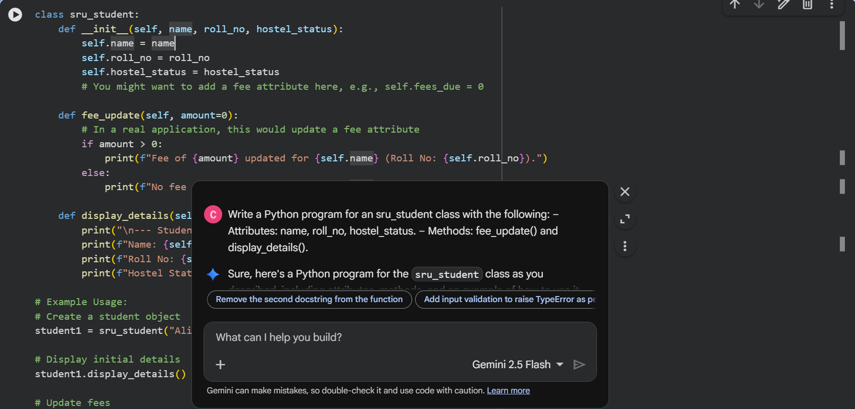
Comparison: Manual vs AI Comments
Criteria | Manual Comments | AI Comments
Clarity | Very descriptive and beginner-friendly | Short but understandable
Coverage | Explains logical blocks and variables | Misses several lines
Redundancy | Minimal | Some comments are too obvious
Correctness | Fully accurate | Mostly correct
Helpfulness for New Developers | Excellent | Moderate

Task 3: Module-Level and Function-Level Documentation
Scenario
You are building a small calculator module that will be shared across multiple projects and
requires structured documentation.
Requirements
• Write a Python script containing 3–4 functions (e.g., add, subtract, multiply, divide)
• Manually write NumPy Style docstrings for each function
• Use AI assistance to generate:
– A module-level docstring.
– Individual function-level docstrings.
• Compare AI-generated docstrings with manually written ones.
• Evaluate documentation structure, accuracy, and readability.

Manually written NumPy Style docstring
"""
calculator.py

A simple calculator module that provides basic arithmetic operations.
"""

def add(a, b):
"""
Add two numbers.

Parameters
----------
a : int or float
The first number.
b : int or float
The second number.

Returns
-------
int or float
The sum of the two numbers.
"""
return a + b

def subtract(a, b):
"""
Subtract the second number from the first number.

Parameters
----------
a : int or float
The number from which another number is subtracted.
b : int or float
The number to subtract.

Returns
-------
int or float
The result of the subtraction.
"""
return a - b

def multiply(a, b):
"""
Multiply two numbers.

Parameters
----------
a : int or float
The first number.
b : int or float
The second number.

Returns
-------
int or float
The product of the two numbers.
"""
return a * b

def divide(a, b):
"""
Divide the first number by the second number.

Parameters
----------
a : int or float
The dividend.
b : int or float
The divisor.

Returns
-------
float
The quotient of the division.

Raises
------
ZeroDivisionError
If the divisor is zero.
"""
if b == 0:
raise ZeroDivisionError("Cannot divide by zero.")
return a / b
AI-Generated Code
"""
This module provides basic arithmetic operations: addition, subtraction, multiplication, and division.
Each function includes a docstring describing its purpose, arguments, and return value.
"""

def add(x, y):
"""
Adds two numbers and returns their sum.

Args:
x (int or float): The first number.
y (int or float): The second number.

Returns:
int or float: The sum of x and y.
"""
return x + y

def subtract(x, y):
"""
Subtracts the second number from the first and returns the result.

Args:
x (int or float): The number from which to subtract.
y (int or float): The number to subtract.

Returns:
int or float: The difference between x and y.
"""
return x - y

def multiply(x, y):
"""
Multiplies two numbers and returns their product.

Args:
x (int or float): The first number.
y (int or float): The second number.

Returns:
int or float: The product of x and y.
"""
return x * y

def divide(x, y):
"""
Divides the first number by the second and returns the quotient.
Handles division by zero to prevent errors.

Args:
x (int or float): The dividend.
y (int or float): The divisor.

Returns:
int or float or str: The quotient of x divided by y, or an error message if y is zero.
"""
if y == 0:
return "Error: Cannot divide by zero!"
return x / y

# Example Usage:
print(f"Addition: 10 + 5 = {add(10, 5)}")
print(f"Subtraction: 10 - 5 = {subtract(10, 5)}")
print(f"Multiplication: 10 * 5 = {multiply(10, 5)}")
print(f"Division: 10 / 5 = {divide(10, 5)}")
print(f"Division by zero: 10 / 0 = {divide(10, 0)}")

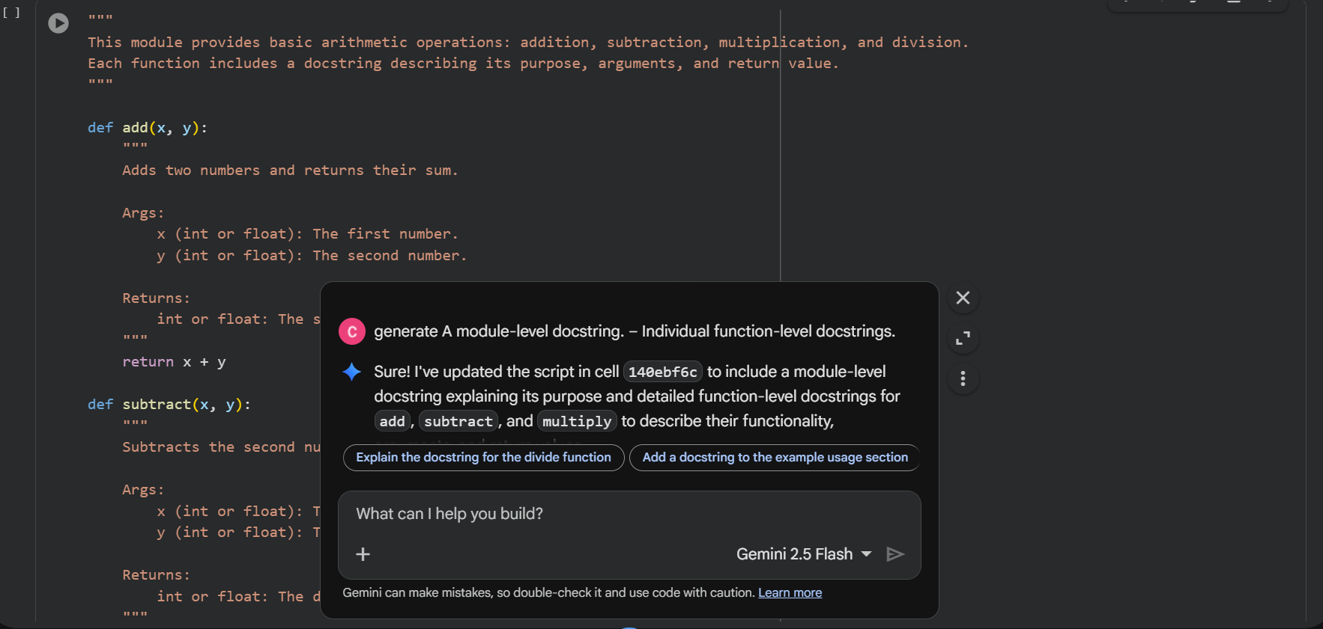
Comparison: Manual vs AI Docstrings
Criteria | Manual NumPy Style | AI Generated
Structure | Strict NumPy format | Often mixed (Google/reStructuredText-like)
Accuracy | Highly precise | Generally correct
Readability | Excellent for technical teams | Very readable but less formal
Completeness | Includes Raises section | Often misses exceptions
Standard Compliance | Fully NumPy-compliant | Not always style-compliant

Documentation Structure
- Manual: Follows NumPy conventions strictly with sections like Parameters, Returns, and Raises.
- AI: Structure is good but inconsistent with NumPy style unless explicitly requested.
Accuracy
Both documentations correctly describe the function behavior.
However, AI frequently:
- Uses vague types like numeric
- Skips error conditions
Readability
- AI docstrings are slightly easier for beginners.
- Manual docstrings are better for professional environments.

