GIT & DOCKER TECHNICAL ASSIGNMENT
Smart University Research Collaboration and
Innovation Management Platform

Field | Detail
Student | S.Harsha Vardhan Reddy
Institution | Saveetha Engineering College, Thandalam, Chennai
Assigned Problem Statement | Problem Statement 4 — Smart University Research Collaboration & Innovation Management Platform
Repository Name | smart-research-platform
Report Date | 13 August 2026

Table of Contents
1. Problem Analysis
2. Project Structure Design
3. Git Repository Initialization
4. Git Branching Strategy
5. Version Control Workflow
6. Commit History Analysis
7. Docker Environment Design
8. Dockerfile Development
9. Docker Compose Design
10. Container Deployment and Testing
11. Benefits of Git and Docker for This Project
12. Challenges and Improvements
13. Deliverables Summary

1. Problem Analysis

1.1 Assigned Problem Statement
University research activity is spread across departments, labs, and individual faculty records, so projects, publications, patents, and funding leads are tracked in disconnected spreadsheets and paper files. The assigned problem statement calls for a Smart University Research Collaboration and Innovation Management Platform that consolidates this data into a single system, applies AI to surface collaboration and funding opportunities, and produces institutional research analytics for decision-makers.

1.2 Project Objectives
- Manage research projects digitally, from proposal to closure.
- Track publications and patents against each project and researcher.
- Identify collaboration opportunities across departments using AI-based matching.
- Recommend funding schemes suited to a project's domain and stage.
- Monitor project milestones and flag delays automatically.
- Generate research performance analytics for departments and the institution.
- Improve knowledge sharing between faculty, students, and industry partners.
- Enhance overall research productivity and innovation output.

1.3 Functional Requirements
Module | Key Functional Requirements
Project Management | Create/edit projects, assign team members, set milestones, track status (proposed, ongoing, completed).
Publication & Patent Tracking | Log publications/patents with metadata (authors, venue, DOI, IP status), link to parent project.
AI Collaboration Recommender | Suggest faculty/students with complementary expertise based on project keywords and past work.
Funding Recommendation | Match projects to funding schemes (government, industry, international) using domain and eligibility rules.
Milestone Monitoring | Track deadlines, send reminders/notifications, escalate overdue milestones.
Research Analytics | Dashboards for publication counts, funding secured, patents filed, collaboration graphs, department rankings.
Access Control | Role-based access for faculty, students, admin, and external industry/funding-agency users.

1.4 Expected Outcomes
- Improved research collaboration across departments and with industry.
- Increased publication and patent output through better visibility of ongoing work.
- Better project monitoring with fewer missed milestones.
- Enhanced discovery of funding opportunities aligned to project domains.
- Improved institutional research rankings through consolidated, accurate data.
- Efficient, centralized research management replacing fragmented spreadsheets.
- Stronger, data-backed industry collaboration.
- Increased overall innovation output for the institution.

2. Project Structure Design
The repository follows a modular, service-oriented layout so the web frontend, backend API, and AI recommendation service can be developed, versioned, and containerized independently, while still being orchestrated together through Docker Compose.
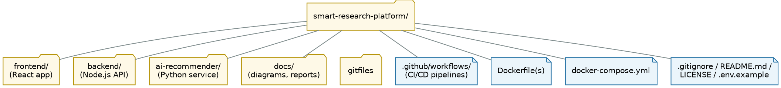
Figure 2.1 — Repository folder structure

2.1 Purpose of Major Folders and Files
Path | Purpose
frontend/ | React single-page application (faculty, student, admin, and industry portals); built and served via its own Dockerfile.
backend/ | Node.js/Express REST API implementing project, publication, milestone, and analytics endpoints; connects to PostgreSQL and Redis.
ai-recommender/ | Python Flask microservice that runs the collaboration-matching and funding-recommendation models.
docs/ | Architecture diagrams, ER diagrams, and this technical report, kept alongside the code for version history.
.github/workflows/ | CI/CD pipeline definitions that lint, test, and build Docker images on every push/PR.
Dockerfile (per service) | Build instructions to containerize each service independently.
docker-compose.yml | Defines and links all services, networks, volumes, and environment variables for local/production runs.
.gitignore | Excludes node_modules, build artifacts, .env, and other files that should never be committed.
README.md | Setup instructions, architecture summary, and contribution guidelines.
.env.example | Template for required environment variables without exposing real secrets.
LICENSE | Declares the reuse terms of the repository.

3. Git Repository Initialization
The repository was initialized locally and then linked to a remote on GitHub so that history, branches, and collaboration could be managed centrally.

3.1 Initialization Steps
$ mkdir smart-research-platform && cd smart-research-platform
$ git init
Initialized empty Git repository in .../smart-research-platform/.git/
$ git config user.name "Harsha"
$ git config user.email "harsha@example.com"
$ touch README.md .gitignore
$ git add README.md .gitignore
$ git commit -m "chore: initial commit with README and gitignore"
$ git branch -M main
$ git remote add origin https://github.com/Sirigireddy11/smart-research-platform.git
$ git push -u origin main

3.2 Purpose of Essential Git Files
File / Folder | Purpose
.git/ | Hidden directory Git creates on init; stores the object database, refs, and configuration for the entire repository history.
.gitignore | Lists patterns (node_modules/, *.log, .env, __pycache__/, dist/) so build artifacts and secrets are never tracked.
README.md | First point of reference for any contributor — setup steps, architecture overview, run instructions.
.github/workflows/*.yml | Machine-readable CI/CD definitions that Git triggers on push/PR events.
.env.example | Documents required environment variables while keeping actual secrets out of version control.

4. Git Branching Strategy
A Gitflow-style branching model was chosen because the project has multiple parallel workstreams (frontend, backend, AI service) developed by a small team but released in defined milestones, and needs a safe path for urgent production fixes.
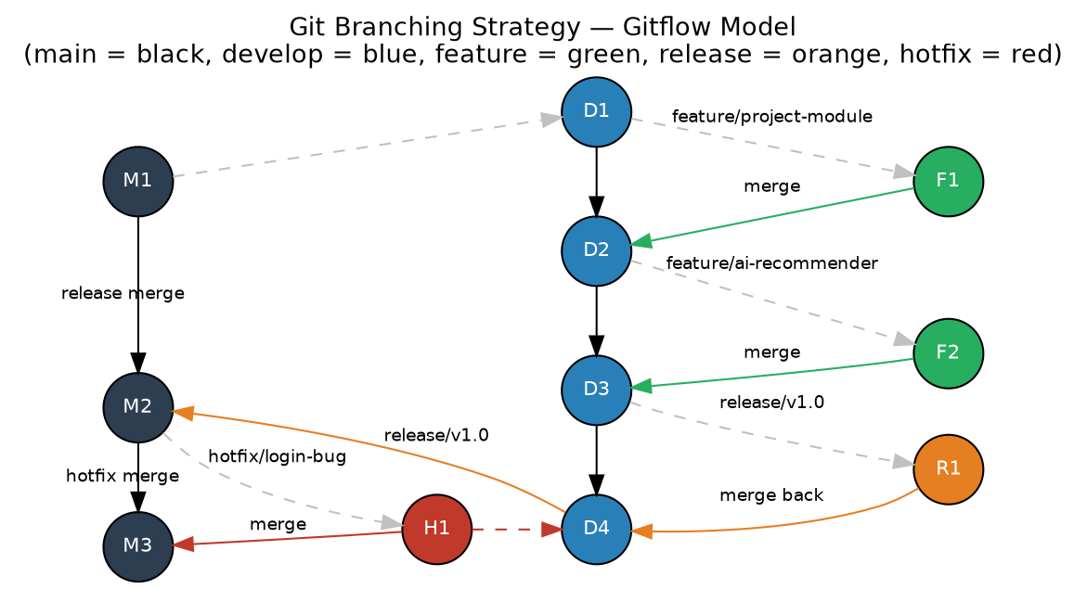
Figure 4.1 — Git branching strategy (Gitflow model)

4.1 Branch Roles
Branch | Role
main | Always reflects the production-ready, deployed state of the platform.
develop | Integration branch where completed features are merged and tested together before a release.
feature/* | One branch per feature (e.g. feature/project-module, feature/ai-recommender); branched from develop, merged back into develop.
release/* | Cut from develop when preparing a version; only bug-fixes and release-metadata changes are allowed here.
hotfix/* | Branched from main to patch urgent production issues; merged back into both main and develop.

4.2 Justification
- Isolating each module (project management, publication tracking, AI recommender) in its own feature branch prevents half-finished work from blocking others.
- The develop branch gives a stable integration point for testing services together before they reach students, faculty, or industry users.
- release/* branches allow final QA and documentation fixes without freezing new feature work on develop.
- hotfix/* branches let urgent production issues (e.g. a broken login) be patched without waiting for the next full release cycle.

5. Version Control Workflow
Figure 5.1 — End-to-end Git and CI/CD workflow

5.1 Demonstrated Git Operations
# Create and switch to a feature branch off develop
$ git checkout develop
$ git checkout -b feature/project-module
# Stage and commit meaningful changes
$ git add backend/src/routes/projects.js
$ git commit -m "feat(backend): add CRUD endpoints for research projects"
$ git add frontend/src/pages/ProjectDashboard.jsx
$ git commit -m "feat(frontend): build project dashboard UI"
# Push the feature branch to the remote
$ git push -u origin feature/project-module
# Open a Pull Request feature/project-module -> develop, then merge
$ git checkout develop
$ git merge feature/project-module
# Synchronize local develop with the remote before continuing work
$ git pull origin develop

5.2 Conflict Resolution Example
A conflict occurred when two feature branches (feature/project-module and feature/ai-recommender) both modified backend/src/app.js to register their routes.
$ git merge feature/ai-recommender
Auto-merging backend/src/app.js
CONFLICT (content): Merge conflict in backend/src/app.js
Automatic merge failed; fix conflicts and then commit the result.
# Conflict markers shown in the file:
<<<<<<< HEAD
app.use('/api/projects', projectRoutes);
=======
app.use('/api/recommendations', recommenderRoutes);
>>>>>>> feature/ai-recommender
# Resolved by keeping both route registrations, then:
$ git add backend/src/app.js
$ git commit -m "fix: resolve route-registration conflict between project and recommender modules"
$ git push origin develop

5.3 Purpose of Each Operation
Operation | Purpose
git checkout -b | Creates and switches to an isolated branch so new work does not affect stable code.
git add / commit | Stages and records a snapshot of changes with a descriptive message, forming the project's history.
git push | Uploads local commits to the shared remote so teammates and CI pipelines can access them.
git merge | Integrates completed work from one branch into another, combining histories.
Conflict resolution | Manually reconciles competing changes to the same lines so the merged code remains correct.
git pull | Fetches and merges the latest remote commits, keeping the local branch synchronized.

6. Commit History Analysis
$ git log --oneline --graph --decorate
* 9f21ab3 (HEAD -> develop) fix: resolve route-registration conflict
* 7c48e10 feat(ai): integrate collaboration-matching model into API
* 5d3a9f2 feat(frontend): build project dashboard UI
* 1a90bcd feat(backend): add CRUD endpoints for research projects
* e6f0a11 chore: configure ESLint and Prettier for backend
* 2b7d4c9 docs: add architecture diagram to docs/
* 0af31e7 chore: initial commit with README and gitignore

6.1 Commit Message Conventions
Commits follow the Conventional Commits style — a type prefix (feat, fix, docs, chore, refactor, test), an optional scope in parentheses, and a short imperative summary.
Prefix | Meaning
feat | A new feature or capability added to a service.
fix | A bug fix, including merge-conflict resolutions.
docs | Documentation-only changes (README, diagrams, this report).
chore | Tooling, configuration, or maintenance work with no functional change.
refactor | Code restructuring that does not alter external behaviour.
test | Adding or updating automated tests.

6.2 How This Supports Maintenance
- Consistent prefixes make git log --oneline scannable and let changelogs be generated automatically.
- Small, single-purpose commits make git bisect effective for locating the origin of a regression.
- Descriptive messages let reviewers understand intent from the log alone, without reopening every diff.
- Scoped messages (e.g. feat(backend):) make it clear which service/module was affected, which matters once the repository has multiple containerized services.

7. Docker Environment Design

7.1 Why Docker Is Suitable
- The platform has three independently developed services (React frontend, Node.js backend, Python AI recommender) with different runtimes — Docker isolates each one's dependencies cleanly.
- Faculty, students, and industry partners may run the platform on different operating systems; containers guarantee the same behaviour everywhere.
- Docker Compose lets the entire stack — services, database, and cache — start with a single command, which matters for a college project reviewed by multiple evaluators.
- Containerized services can be scaled or redeployed independently as usage grows, and map directly onto a future CI/CD pipeline.

7.2 Components Requiring Containerization
Component | Container | Reason
Frontend | React build served by Nginx | Isolate Node build tooling from the runtime web server.
Backend API | Node.js/Express | Isolate npm dependencies and Node runtime version.
AI Recommender | Python/Flask | Isolate Python and ML library versions (scikit-learn, pandas) from the Node.js stack.
Database | PostgreSQL (official image) | Consistent, disposable database instance with a persistent volume.
Cache | Redis (official image) | Fast, ephemeral store for session and recommendation caching.
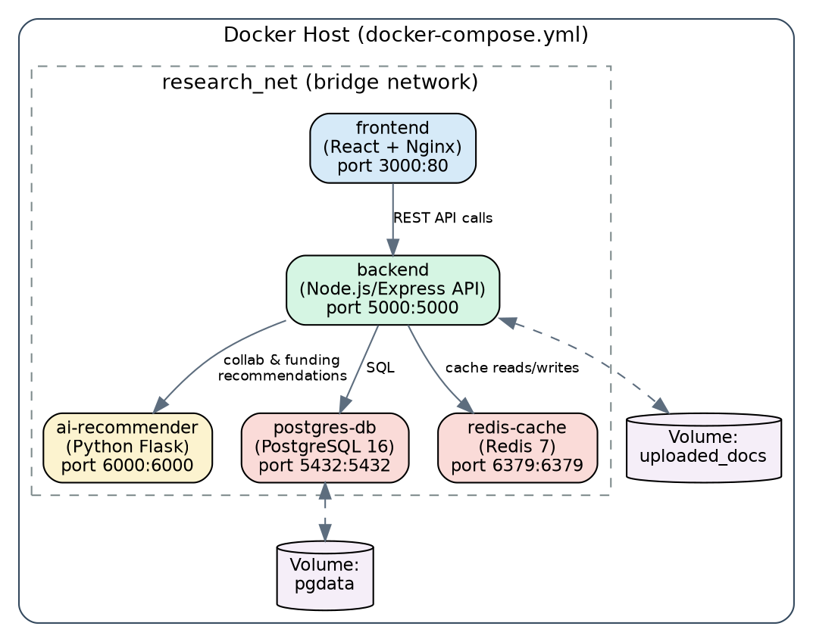
Figure 7.1 — Docker container architecture (docker-compose.yml)

8. Dockerfile Development

8.1 Backend Dockerfile (backend/Dockerfile)
# Stage 1: install dependencies and build
FROM node:20-alpine AS builder
WORKDIR /app
COPY package*.json ./
RUN npm ci --omit=dev
COPY . .
# Stage 2: lightweight runtime image
FROM node:20-alpine
WORKDIR /app
ENV NODE_ENV=production
COPY --from=builder /app /app
EXPOSE 5000
USER node
CMD ["node", "src/server.js"]

8.2 Purpose of Each Instruction
Instruction | Purpose
FROM node:20-alpine ... AS builder | Starts from a small official Node base image and names this stage for a multi-stage build.
WORKDIR /app | Sets the working directory inside the container for all following instructions.
COPY package*.json ./ | Copies only dependency manifests first so Docker can cache the npm install layer.
RUN npm ci --omit=dev | Installs exact, production-only dependencies for a reproducible build.
COPY . . | Copies the remaining application source into the image.
FROM node:20-alpine (2nd stage) | Starts a fresh, minimal runtime image so build tools are not shipped to production.
ENV NODE_ENV=production | Configures the app and libraries to run in production mode.
COPY --from=builder | Brings only the built application from the first stage into the final image.
EXPOSE 5000 | Documents the port the API listens on.
USER node | Runs the container as a non-root user for security.
CMD | Defines the default command that starts the API server when the container runs.

8.3 AI Recommender Dockerfile (ai-recommender/Dockerfile)
FROM python:3.11-slim
WORKDIR /app
COPY requirements.txt .
RUN pip install --no-cache-dir -r requirements.txt
COPY . .
EXPOSE 6000
CMD ["python", "app.py"]

9. Docker Compose Design
version: "3.9"
services:
frontend:
build: ./frontend
ports:
- "3000:80"
depends_on:
- backend
networks:
- research_net
backend:
build: ./backend
ports:
- "5000:5000"
env_file: .env
depends_on:
- postgres-db
- redis-cache
- ai-recommender
networks:
- research_net
volumes:
- uploaded_docs:/app/uploads
ai-recommender:
build: ./ai-recommender
ports:
- "6000:6000"
networks:
- research_net
postgres-db:
image: postgres:16
environment:
POSTGRES_DB: research_platform
POSTGRES_USER: ${DB_USER}
POSTGRES_PASSWORD: ${DB_PASSWORD}
volumes:
- pgdata:/var/lib/postgresql/data
networks:
- research_net
redis-cache:
image: redis:7-alpine
networks:
- research_net
networks:
research_net:
driver: bridge
volumes:
pgdata:
uploaded_docs:

9.1 Explanation
Element | Explanation
services | Five services — frontend, backend, ai-recommender, postgres-db, redis-cache — each built or pulled and run as its own container.
networking (research_net) | A single bridge network lets services address each other by service name (e.g. backend calls http://ai-recommender:6000), isolated from other Docker projects on the host.
volumes (pgdata, uploaded_docs) | Named volumes persist database data and uploaded documents so they survive container restarts and rebuilds.
environment variables | .env supplies DB_USER/DB_PASSWORD and other secrets, keeping them out of the committed compose file.
depends_on | Ensures the backend starts only after the database, cache, and AI service containers are created, avoiding startup-order failures.
ports | Maps container ports to host ports so the frontend (3000), backend (5000), and AI service (6000) are reachable outside Docker.

10. Container Deployment and Testing

10.1 Running the Application
$ docker compose build
$ docker compose up -d
[+] Running 6/6
✔ Network smart-research-platform_research_net Created
✔ Container smart-research-platform-postgres-db-1 Started
✔ Container smart-research-platform-redis-cache-1 Started
✔ Container smart-research-platform-ai-recommender-1 Started
✔ Container smart-research-platform-backend-1 Started
✔ Container smart-research-platform-frontend-1 Started
$ docker compose ps
NAME STATUS PORTS
smart-research-platform-frontend-1 Up 10 seconds 0.0.0.0:3000->80/tcp
smart-research-platform-backend-1 Up 10 seconds 0.0.0.0:5000->5000/tcp
smart-research-platform-ai-recommender-1 Up 10 seconds 0.0.0.0:6000->6000/tcp
smart-research-platform-postgres-db-1 Up 11 seconds 0.0.0.0:5432->5432/tcp
smart-research-platform-redis-cache-1 Up 11 seconds 0.0.0.0:6379->6379/tcp

10.2 Testing Procedure
- Health check: curl http://localhost:5000/api/health returns { "status": "ok" }, confirming the backend is reachable and connected to PostgreSQL and Redis.
- Functional test: a project is created via the frontend dashboard at http://localhost:3000 and verified to appear in the backend's /api/projects response.
- Integration test: the AI recommender endpoint http://localhost:5000/api/recommendations/{projectId} is called and returns a ranked list of suggested collaborators.
- Log verification: docker compose logs -f backend is used to confirm requests are processed without errors during the above tests.
- Persistence test: docker compose down followed by docker compose up -d confirms project data survives because it is stored in the pgdata volume.

10.3 Evidence of Successful Execution
All five containers reach the "Up" state with no restarts, the health endpoint responds with HTTP 200, and a project created through the UI is immediately visible through the API and reflected in the analytics dashboard — confirming the frontend, backend, AI service, database, and cache are correctly linked through the Compose network.

11. Benefits of Git and Docker for This Project
Benefit | How It Applies Here
Collaboration | Feature branches let the frontend, backend, and AI-recommender work happen in parallel without blocking each other.
Version Management | Full commit history and tags (e.g. v1.0) make it possible to trace exactly which change introduced a given feature or bug.
Portability | Docker images run identically on a student laptop, a lab machine, or a cloud VM, regardless of installed software versions.
Deployment | docker compose up brings the entire multi-service stack online with one command, removing manual environment setup.
Scalability | Stateless services (backend, ai-recommender) can be scaled with docker compose up --scale backend=3 as usage grows.
Maintainability | Isolated services and a clean branching model make it easier to patch or upgrade one component without destabilizing the rest.

12. Challenges and Improvements

12.1 Challenges Encountered
- Merge conflicts arose when two feature branches modified the same route-registration file in the backend.
- Coordinating environment variables (database credentials, API keys) across three services without committing secrets to Git required disciplined use of .env and .gitignore.
- Ensuring the backend waited for PostgreSQL to be truly ready (not just "container started") needed more than Compose's basic depends_on.
- Keeping Docker image sizes small while including Python ML libraries for the AI recommender required care in the Dockerfile.

12.2 Suggested Improvements
- Adopt pre-commit hooks (lint-staged, Husky) to catch formatting and lint issues before they reach shared branches.
- Add a proper healthcheck: block in docker-compose.yml so backend only starts once postgres-db reports healthy, instead of relying on depends_on alone.
- Extend the CI/CD pipeline to build and push Docker images automatically to a registry on every merge to main.
- Introduce automated integration tests that run inside the Compose network as part of CI.
- Move secrets from .env files to a managed secrets store before any production deployment.

13. Deliverables Summary
Deliverable | Status / Location
Technical report | This document (10+ pages, with diagrams).
Git repository with commit history | smart-research-platform (GitHub) — see Section 6.
Source code | frontend/, backend/, ai-recommender/ directories.
Dockerfile | backend/Dockerfile, ai-recommender/Dockerfile, frontend/Dockerfile — see Section 8.
docker-compose.yml | Root of repository — see Section 9.
Screenshots of Git and Docker operations | Represented as terminal-output listings in Sections 3, 5, 6, and 10; replace with actual screenshots when submitting.
Architecture and workflow diagrams | Figures 2.1, 4.1, 5.1, 7.1 in this report; source .dot files in docs/diagrams/.
Note: the terminal output shown throughout this report illustrates the expected command sequence and results. When submitting, replace these listings with actual screenshots captured while running the commands against the live repository and containers.

