SMART UNIVERSITY RESEARCH COLLABORATION
AND INNOVATION MANAGEMENT PLATFORM
System Design, Architecture and CI/CD Pipeline Report

Field | Detail
Student | S.Harsha Vardhan Reddy
Institution | Saveetha Engineering College, Thandalam, Chennai
Assigned Problem Statement | Problem Statement 4 — Smart University Research Collaboration & Innovation Management Platform
Repository Name | smart-research-platform
Report Date | 18 August 2026

Declaration
I hereby declare that this report titled “Smart University Research Collaboration and Innovation Management Platform” is prepared for academic purposes. The proposed architecture, modules, workflows, diagrams, and CI/CD process are presented as a system-design exercise based on the supplied problem statement and assessment-oriented design approach.
The report emphasizes practical architecture, automation, security, scalability, continuous integration, continuous delivery, testing, and analytics. It is intended to demonstrate the ability to analyze an industry problem and convert the requirements into an implementable software platform.

Table of Contents
- 1. Introduction and Industry Context
- 2. Problem Statement and Objectives
- 3. Proposed System and Scope
- 4. High-Level Architecture
- 5. Functional Modules
- 6. Data and Database Design
- 7. AI Collaboration and Funding Recommendation
- 8. CI/CD Pipeline Design
- 9. Testing and Quality Assurance
- 10. Security, Privacy and Risk Management
- 11. Deployment, Monitoring and Analytics
- 12. Expected Outcomes
- 13. Future Enhancements
- 14. Conclusion

1. Introduction and Industry Context
Universities increasingly operate as research ecosystems involving faculty members, research scholars, undergraduate and postgraduate students, laboratories, industry partners, government agencies, funding organizations, journals, publishers, and technology-transfer offices. Research information is commonly distributed across spreadsheets, departmental databases, emails, document repositories, publication portals, and separate grant-management systems.
This fragmentation creates operational problems. A researcher may maintain a project plan in one location, publication information in another, patent details in a third system, and collaboration discussions in email. Research administrators may therefore struggle to obtain a current view of project progress, expenditure, outcomes, intellectual property, and funding opportunities.
The proposed Smart University Research Collaboration and Innovation Management Platform integrates these activities into a common digital environment. It combines conventional research management with AI-assisted discovery so that the system can recommend potential collaborators, funding schemes, research domains, and knowledge-sharing opportunities.

Industry Context
- Multidisciplinary projects require researchers from different departments to discover one another.
- Research offices need reliable project, milestone, funding, publication and patent records.
- Industry collaboration requires controlled sharing of expertise and project information.
- Funding schemes have eligibility conditions, deadlines, themes and geographic restrictions that can be difficult to track manually.
- University leadership needs analytics for research productivity, collaboration networks, funding success and innovation outcomes.

Design Principle
The platform follows a modular, API-first and automation-oriented design. Each major function is separated into services so that teams can develop, test and deploy components independently. The CI/CD pipeline provides controlled automation from source-code commit through testing, security validation, staging and production deployment.

2. Problem Statement and Objectives
Research management in universities is often fragmented across multiple departments, making it difficult to track projects, funding opportunities, publications and intellectual property. An intelligent research management platform should automate project monitoring, identify collaboration opportunities using AI, manage research outputs, recommend funding schemes, and generate institutional research performance analytics.

Objectives
- Manage research projects digitally.
- Track publications and patents.
- Identify collaboration opportunities.
- Recommend funding opportunities.
- Monitor project milestones.
- Generate research analytics.
- Improve knowledge sharing.
- Enhance research productivity.

Expected Outcomes
- Improved research collaboration.
- Increased publication output.
- Better project monitoring.
- Enhanced funding opportunities.
- Improved institutional research visibility and rankings.
- Efficient research management.
- Stronger industry collaboration.
- Increased innovation.

Key Stakeholders
- Researchers and faculty
- Students and research scholars
- Research administration office
- Department heads and institutional leadership
- Industry partners
- Funding agencies
- Technology-transfer / IP office
- System administrators

3. Proposed System and Scope
The proposed platform is a centralized research information and innovation-management system. Users access it through a responsive web interface. A secure API layer handles authentication, authorization, business logic, integration and auditing. Research data is stored in a structured database, while documents and research files are stored in secure object storage.

Core Scope
- Researcher profile and expertise management.
- Project creation, approval, milestones, tasks and progress tracking.
- Publication, conference, journal and patent management.
- Funding opportunity catalogue and recommendation engine.
- AI-assisted collaborator discovery.
- Industry collaboration workspace.
- Document and knowledge repository.
- Research KPI dashboards and reports.
- Notifications, reminders and deadline alerts.
- Role-based access control and audit trails.

Non-Functional Requirements
Requirement | Design Target | Reason
Availability | High availability with backups | Research records must remain accessible.
Scalability | Horizontal scaling of services | User and project volumes can grow.
Security | RBAC, encryption, audit logging | Research and IP data can be sensitive.
Performance | Fast API responses for normal queries | Supports daily researcher workflows.
Maintainability | Modular services + CI/CD | Enables frequent safe releases.
Usability | Responsive, role-based interface | Different stakeholders have different needs.

4. High-Level Architecture
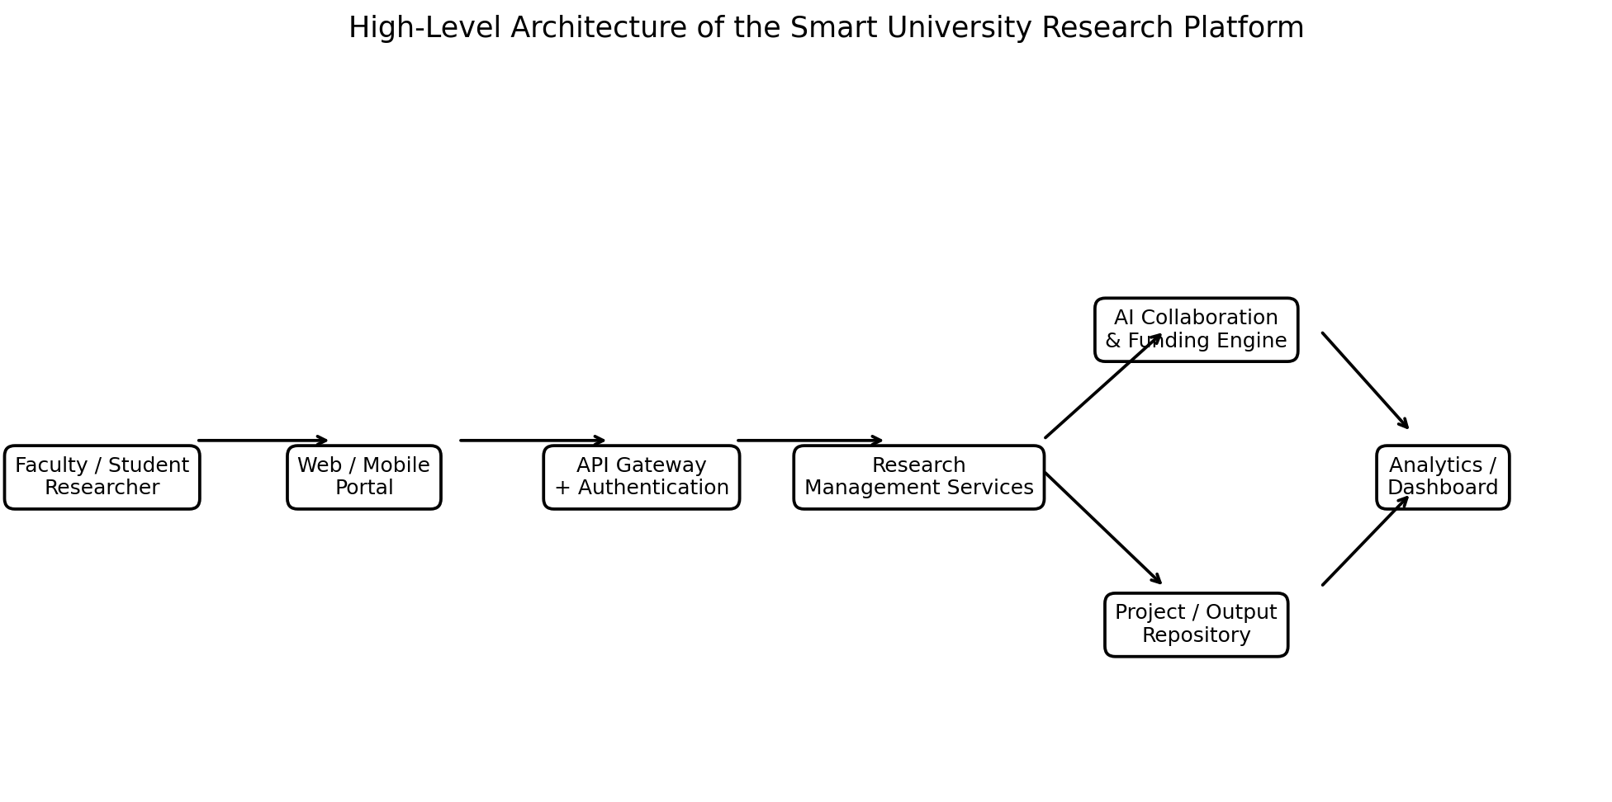
Figure 1. High-level architecture of the proposed platform.
The researcher interacts with the platform through the web or mobile interface. Requests are sent through an API gateway that performs authentication, authorization, rate limiting and routing. Research management services handle projects, publications, patents, funding, notifications and collaboration workflows.
The AI layer processes structured profiles and research metadata to generate recommendations. A project repository stores project and output information, while analytics services transform operational data into dashboards and institutional indicators.

Architecture Layers
- Presentation layer: responsive web interface and dashboards.
- API layer: REST APIs, authentication, authorization, validation and rate limiting.
- Application layer: project, publication, patent, funding, collaboration and notification services.
- AI layer: semantic matching, recommendation and classification services.
- Data layer: relational database, object storage, search index and analytics warehouse.
- Operations layer: logging, monitoring, CI/CD, backup, security and infrastructure automation.

Advantages
- Clear separation of responsibilities
- Independent service scaling
- Easier testing and deployment
- Controlled security boundaries
- Better observability
- Support for future mobile applications and external integrations

5. Functional Modules

5.1 Researcher Profile
Stores department, role, research interests, expertise, keywords, publications, projects and collaboration preferences. Profiles form the basis for AI matching.

5.2 Project Management
Supports project registration, objectives, team members, milestones, deliverables, budgets, risks, documents and progress updates.

5.3 Publication Management
Maintains publication metadata, authorship, DOI, venue, year, citations and links to projects. Duplicate detection can reduce repeated entries.

5.4 Patent and Innovation Management
Tracks invention disclosures, inventors, filing status, patent numbers, ownership, technology-transfer stage and commercialization information.

5.5 Funding Management
Maintains funding schemes, eligibility, research themes, deadlines, funding amounts and application status. Researchers receive ranked recommendations.

5.6 Collaboration Management
Allows users to discover internal and external experts, send collaboration requests, form project teams and maintain collaboration records.

5.7 Knowledge Repository
Provides controlled storage for proposals, reports, datasets, presentations, papers and other research artifacts.

5.8 Notification Service
Generates reminders for milestones, funding deadlines, review dates, project approvals and pending actions.

5.9 Analytics Dashboard
Shows KPIs such as active projects, publications, patents, funding success, collaborations, project completion and department-level trends.

6. Data and Database Design
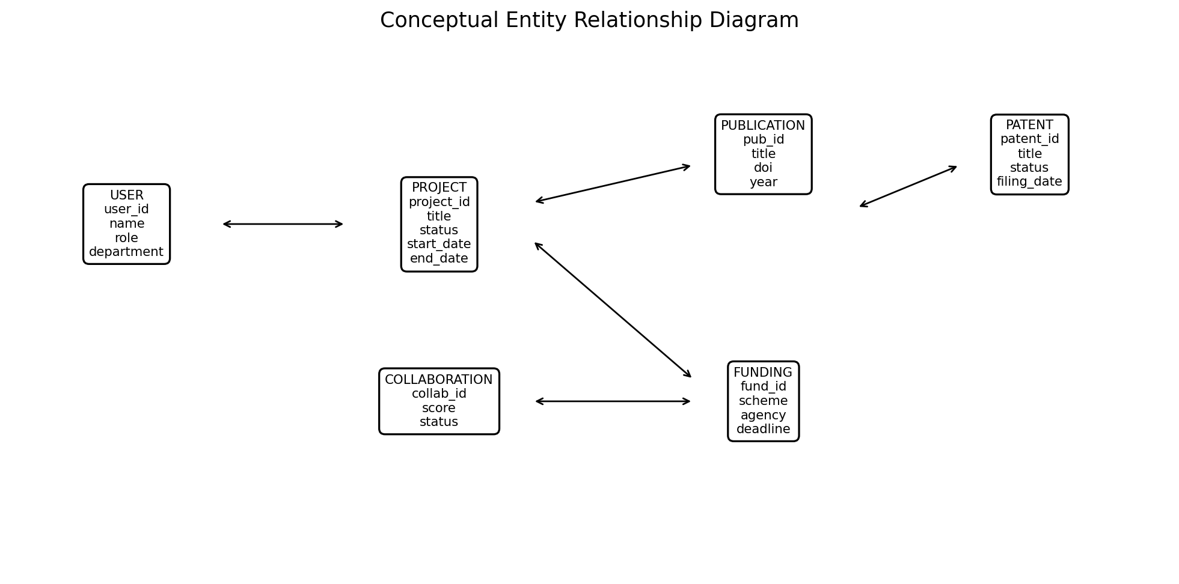
Figure 2. Conceptual entity relationship diagram.
A relational database is suitable for core transactional information because projects, users, milestones, publications, patents and funding applications have well-defined relationships and require consistency. Object storage is used for large files such as reports and proposal documents.

Major Entities
Entity | Important Attributes | Purpose
User | user_id, name, role, department, expertise | Identity and research profile
Project | project_id, title, status, dates, budget | Research project lifecycle
Milestone | milestone_id, project_id, target, status | Progress monitoring
Publication | pub_id, project_id, title, DOI, year | Research output tracking
Patent | patent_id, project_id, title, status | IP management
Funding | fund_id, agency, scheme, deadline, eligibility | Funding catalogue
Collaboration | collab_id, user/project pairs, score, status | Collaboration relationships

Data Quality
- Validation at API boundaries
- Mandatory fields for critical records
- Duplicate checks for publications and funding entries
- Controlled vocabularies for research domains
- Audit history for important updates
- Scheduled backup and recovery testing

7. AI Collaboration and Funding Recommendation
The intelligent layer is designed to reduce the manual effort required to identify experts, partners and funding opportunities. Recommendations should support human decision-making rather than automatically making final research or funding decisions.

7.1 Collaborator Recommendation
Each researcher is represented by a research-interest profile derived from declared keywords, project descriptions, publications and selected expertise categories. A matching service compares profiles using keyword similarity and semantic embeddings. Additional factors such as department diversity, complementary skills and previous collaboration history can be included.
- Input: research profile, project description and required expertise.
- Candidate generation: search across eligible researcher profiles.
- Scoring: semantic similarity + expertise overlap + complementary skills.
- Filtering: role, availability and collaboration rules.
- Output: ranked candidates with reasons for the recommendation.

7.2 Funding Recommendation
Funding opportunities can be represented as structured records containing agency, theme, eligibility, deadline, funding range and required research areas. A recommendation service compares a project profile with these attributes and returns ranked schemes.

7.3 Responsible AI
- Display recommendation reasons.
- Allow users to reject or ignore recommendations.
- Avoid using protected or irrelevant personal characteristics.
- Log model version and recommendation timestamp.
- Periodically evaluate precision and user feedback.
- Keep final approval with authorized human users.

8. CI/CD Pipeline Design
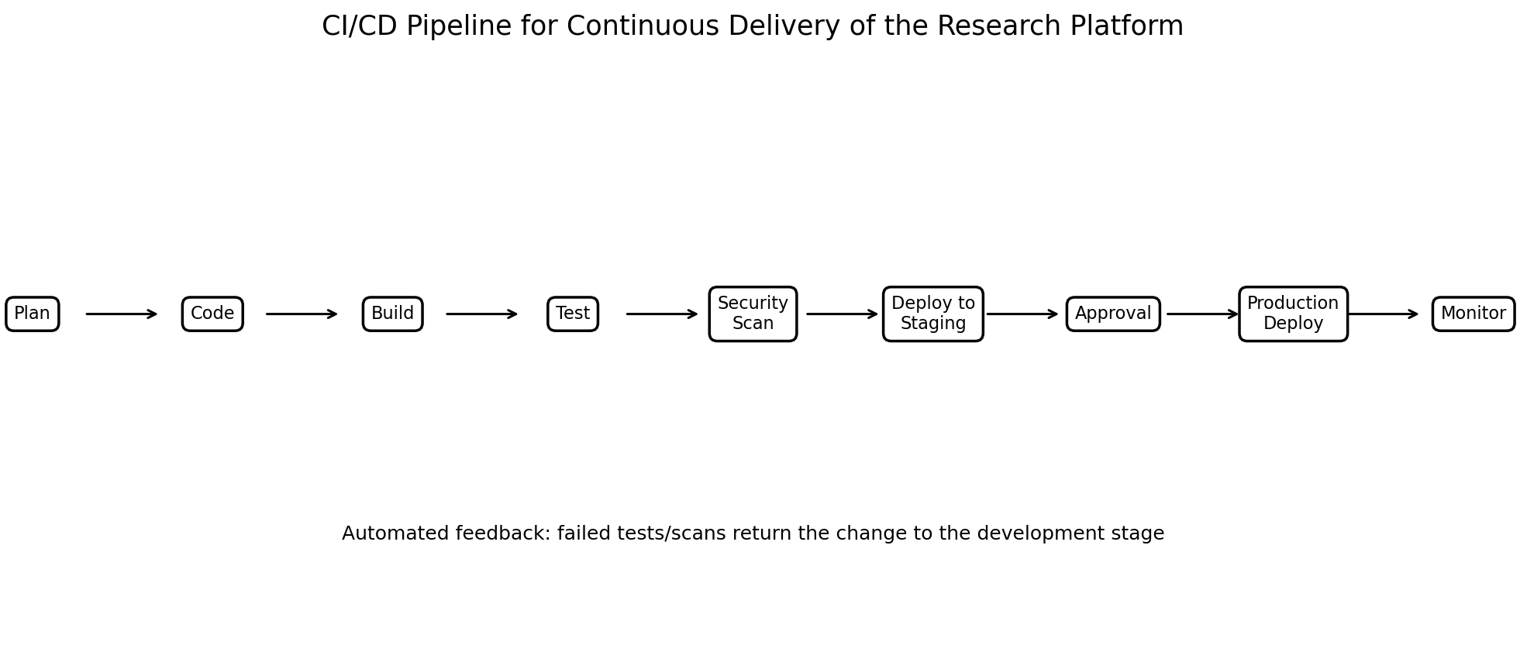
Figure 3. CI/CD pipeline for the research management platform.
The platform should be developed using a continuous integration and continuous delivery process. The process is designed to reduce integration problems, detect defects early and make releases repeatable. Each code change passes through automated checks before it is promoted to production.

Pipeline Stages

Plan
Create user stories, acceptance criteria, technical tasks and release goals.

Code
Develop features in version control using branches and pull requests.

Build
Compile/package the application and create versioned deployment artifacts or containers.

Unit Test
Run automated tests for individual components and business rules.

Integration Test
Verify APIs, database interactions, authentication and service communication.

Security Scan
Check dependencies, secrets, container images and common application vulnerabilities.

Staging Deploy
Deploy the validated artifact to a staging environment.

Approval
Perform review, acceptance checks and controlled promotion.

Production Deploy
Deploy using a repeatable strategy such as rolling, blue-green or canary release.

Monitor
Track availability, errors, latency, resource use and application logs.

CI/CD Quality Gates
- Build must complete successfully.
- Unit-test threshold must be satisfied.
- Critical security findings must block promotion.
- Configuration and secrets must not be hard-coded.
- Staging smoke tests must pass.
- Production deployment must be traceable to a versioned artifact.

9. Testing and Quality Assurance

Testing Strategy
- Unit testing validates individual functions and services.
- Integration testing validates database, API and service interactions.
- System testing validates complete user workflows.
- Security testing checks authentication, authorization, injection risks and exposed secrets.
- Performance testing measures response time and throughput.
- User acceptance testing validates whether the platform satisfies research-office and researcher workflows.
- Regression testing ensures new releases do not break existing features.

Example Test Cases
ID | Scenario | Expected Result | Priority
TC01 | Valid user login | User reaches authorized dashboard | High
TC02 | Unauthorized project access | Access denied and event logged | High
TC03 | Create project | Project stored with valid ID | High
TC04 | Milestone update | Progress and timestamp updated | Medium
TC05 | Funding recommendation | Relevant schemes ranked and explained | Medium
TC06 | Publication duplicate | Potential duplicate flagged | Medium
TC07 | API invalid input | Validation error returned safely | High
TC08 | Production deployment | Versioned release available without data loss | High

Defect Management
Every defect should contain a reproducible description, environment, severity, expected behavior, observed behavior, evidence and resolution status. Critical defects should block production promotion until they are corrected or formally accepted by an authorized owner.

10. Security, Privacy and Risk Management
Research platforms may contain unpublished manuscripts, patent-sensitive information, grant proposals, personal data and industry-confidential material. Security therefore has to be built into the architecture and CI/CD lifecycle.

Security Controls
- Role-Based Access Control for researchers, administrators, reviewers and external partners.
- Multi-factor authentication for privileged accounts.
- TLS for data in transit and encryption for sensitive stored data.
- Secrets stored in a dedicated secret-management service rather than source code.
- Audit logging for authentication, data access and administrative changes.
- API rate limiting and input validation.
- Regular dependency and container vulnerability scanning.
- Backup, disaster-recovery and restoration testing.

Risk Register
Risk | Impact | Mitigation | Owner
Unauthorized data access | High | RBAC, MFA, encryption, audit logs | Security Admin
Incorrect AI recommendation | Medium | Human review, explanation, feedback loop | AI Team
Deployment failure | High | Automated tests, staging, rollback | DevOps Team
Data loss | High | Backups and recovery drills | DB Admin
Service outage | High | Monitoring, redundancy and autoscaling | Operations
Duplicate/inaccurate records | Medium | Validation and data-quality checks | Research Admin

11. Deployment, Monitoring and Analytics

Deployment Model
A cloud deployment is recommended because the platform can scale with university usage and can integrate managed databases, object storage, monitoring and identity services. Services may be containerized and deployed on a managed container platform or Kubernetes-based environment.

Environment Separation
- Development: feature development and developer testing.
- Testing: automated integration and regression validation.
- Staging: production-like environment for acceptance and release verification.
- Production: protected environment with controlled access and automated monitoring.

Monitoring
- Application health and API latency
- Error rate and failed requests
- Database health and connection usage
- CPU/memory/storage utilization
- Authentication failures
- Queue and background-job status
- Deployment success/failure
- AI recommendation quality metrics

Research Analytics
The analytics layer can provide institutional indicators such as active projects by department, publications per year, patent pipeline, external funding applications, funding success rate, collaboration network density, milestone completion, industry projects and emerging research themes.

Dashboard Example
KPI | Description | Use
Active Projects | Projects currently in progress | Operational monitoring
Funding Success Rate | Successful applications / total applications | Funding strategy
Publication Growth | Year-over-year publication change | Research performance
Patent Pipeline | Disclosures, filings and granted patents | Innovation management
Industry Collaboration | Active external collaborations | Industry engagement

12. Use Cases and Interaction Flow
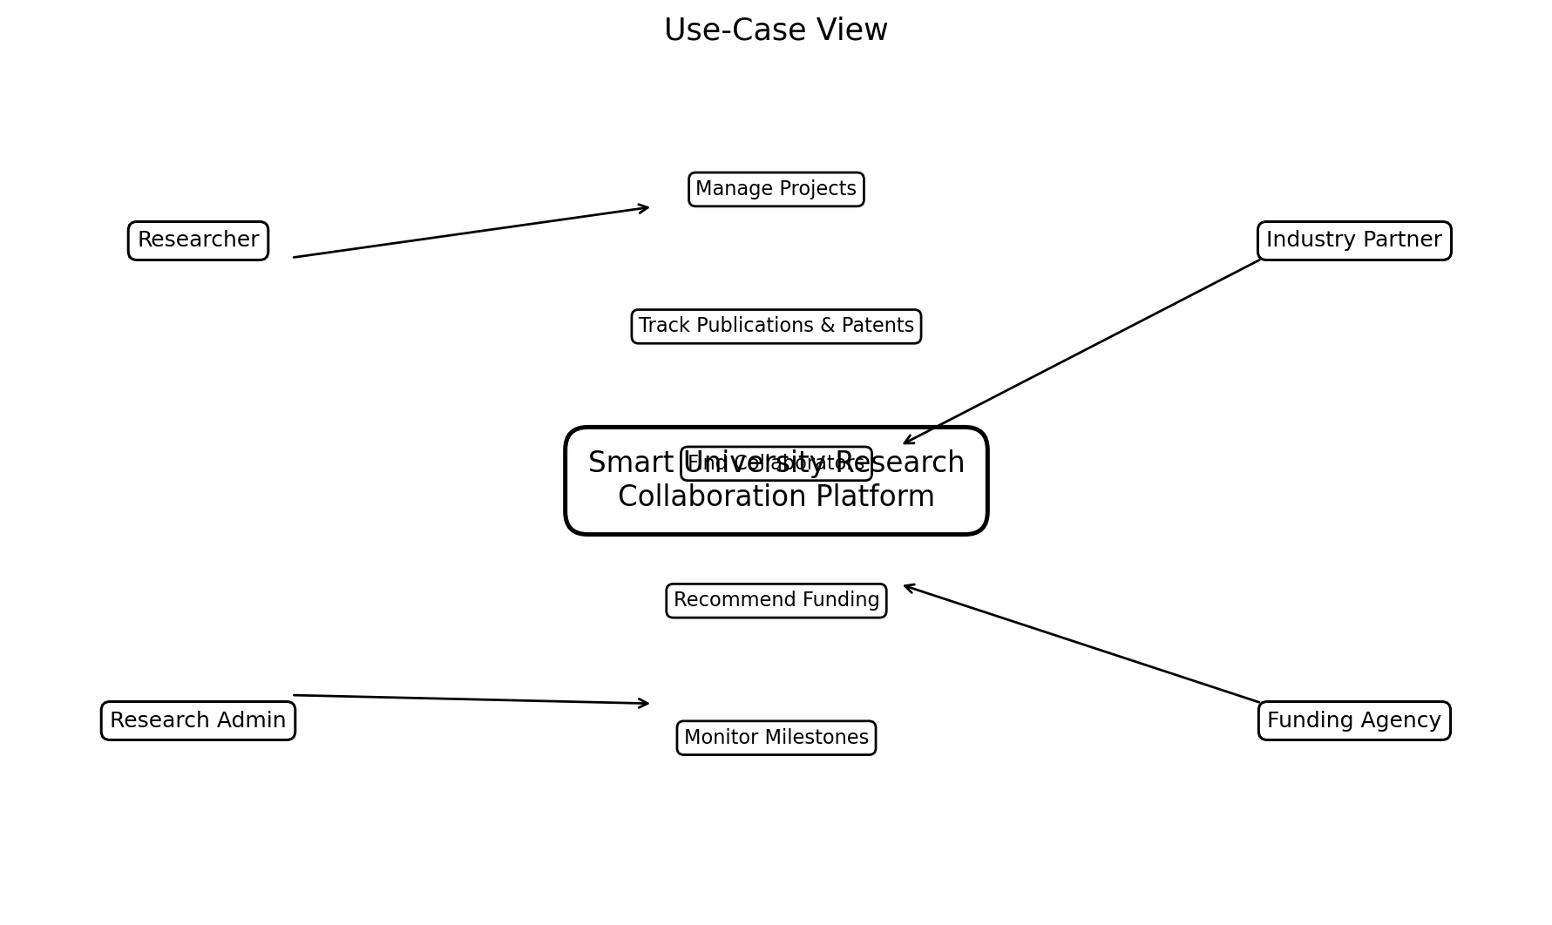
Figure 4. Major actors and use cases.

Primary Use Cases
- Researcher creates or updates a research profile.
- Researcher registers a new project and adds team members.
- Research office reviews and approves the project.
- System tracks milestones and sends reminders.
- Researcher adds publications and patents.
- AI engine recommends collaborators and funding opportunities.
- Industry partner receives authorized collaboration information.
- Leadership views research-performance analytics.

Sequence Flow
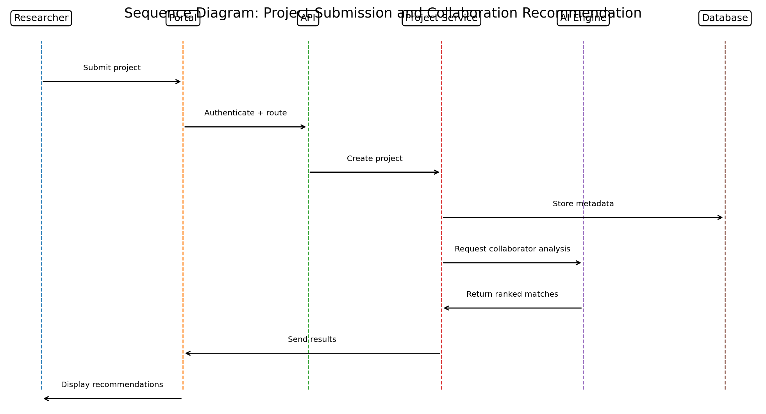
Figure 5. Sequence diagram for project submission and collaborator recommendation.
The sequence begins with a researcher submitting a project through the portal. The API gateway authenticates the request and forwards it to the project service. Project metadata is stored in the database. The AI engine can then analyze the project description and return ranked collaborator suggestions. The portal displays the results with explanations so that the researcher can make the final selection.

13. Future Enhancements
- Natural-language research assistant for project and proposal support.
- Integration with scholarly metadata services and institutional repositories.
- Advanced graph analytics for research collaboration networks.
- Automated extraction of publication and patent metadata.
- Research-data catalog with dataset lineage and access policies.
- Mobile application for milestone updates and notifications.
- Predictive analytics for project delay and funding success risk.
- Multilingual interface for broader university adoption.
- Federated collaboration across multiple universities.
- Advanced MLOps pipeline for model evaluation, versioning and monitoring.

Implementation Roadmap
Phase | Duration | Main Deliverables | Success Measure
Phase 1 | Weeks 1–4 | Requirements, UX, architecture | Approved design
Phase 2 | Weeks 5–10 | Users, projects, milestones | Core workflow works
Phase 3 | Weeks 11–15 | Publications, patents, funding | Research outputs tracked
Phase 4 | Weeks 16–20 | AI recommendations | Useful ranked results
Phase 5 | Weeks 21–24 | Analytics, security, CI/CD | Release-ready platform

14. Conclusion
The Smart University Research Collaboration and Innovation Management Platform provides an integrated approach to fragmented research administration. By combining project management, publications, patents, funding, collaboration, knowledge sharing and analytics in one platform, the university can obtain a more complete and timely view of its research ecosystem.
The proposed architecture is modular and scalable. A secure API layer protects access to application services, structured storage maintains transactional consistency, object storage supports research documents, and an analytics layer provides institutional insight. The AI layer adds value by identifying potential collaborators and funding opportunities while keeping human users responsible for final decisions.
The CI/CD pipeline is a critical part of the design because a research platform is expected to evolve continuously. Automated builds, tests, security checks, staging validation and controlled deployment reduce operational risk and improve release speed. Monitoring and rollback capabilities further strengthen reliability.
Overall, the proposed system can improve research collaboration, project visibility, funding discovery, innovation management and institutional decision-making. It provides a practical foundation that can be expanded into a production-grade university research and innovation ecosystem.

Final Summary
- Centralizes research information and workflows.
- Improves project and milestone visibility.
- Tracks publications, patents and innovation outputs.
- Uses AI to support collaboration and funding discovery.
- Provides institutional research analytics.
- Embeds security and quality into the software lifecycle.
- Uses CI/CD to enable repeatable and reliable releases.
- Supports future integration with external research and industry systems.

References / Design Basis
1. Supplied problem statement: Smart University Research Collaboration and Innovation Management Platform.
2. Supplied assessment context: CI/CD Pipeline Design Exercise and assessment-oriented software/cloud design process.
3. Standard software engineering practices for requirements analysis, modular architecture, automated testing, CI/CD, security and monitoring.
Note: The diagrams in this report are original conceptual diagrams created for the proposed system and are intended for academic system-design documentation.

