Issue 1: Scenario: While trying to enter Aim description to create experiment.

The element frame Id is Alphanumeric.

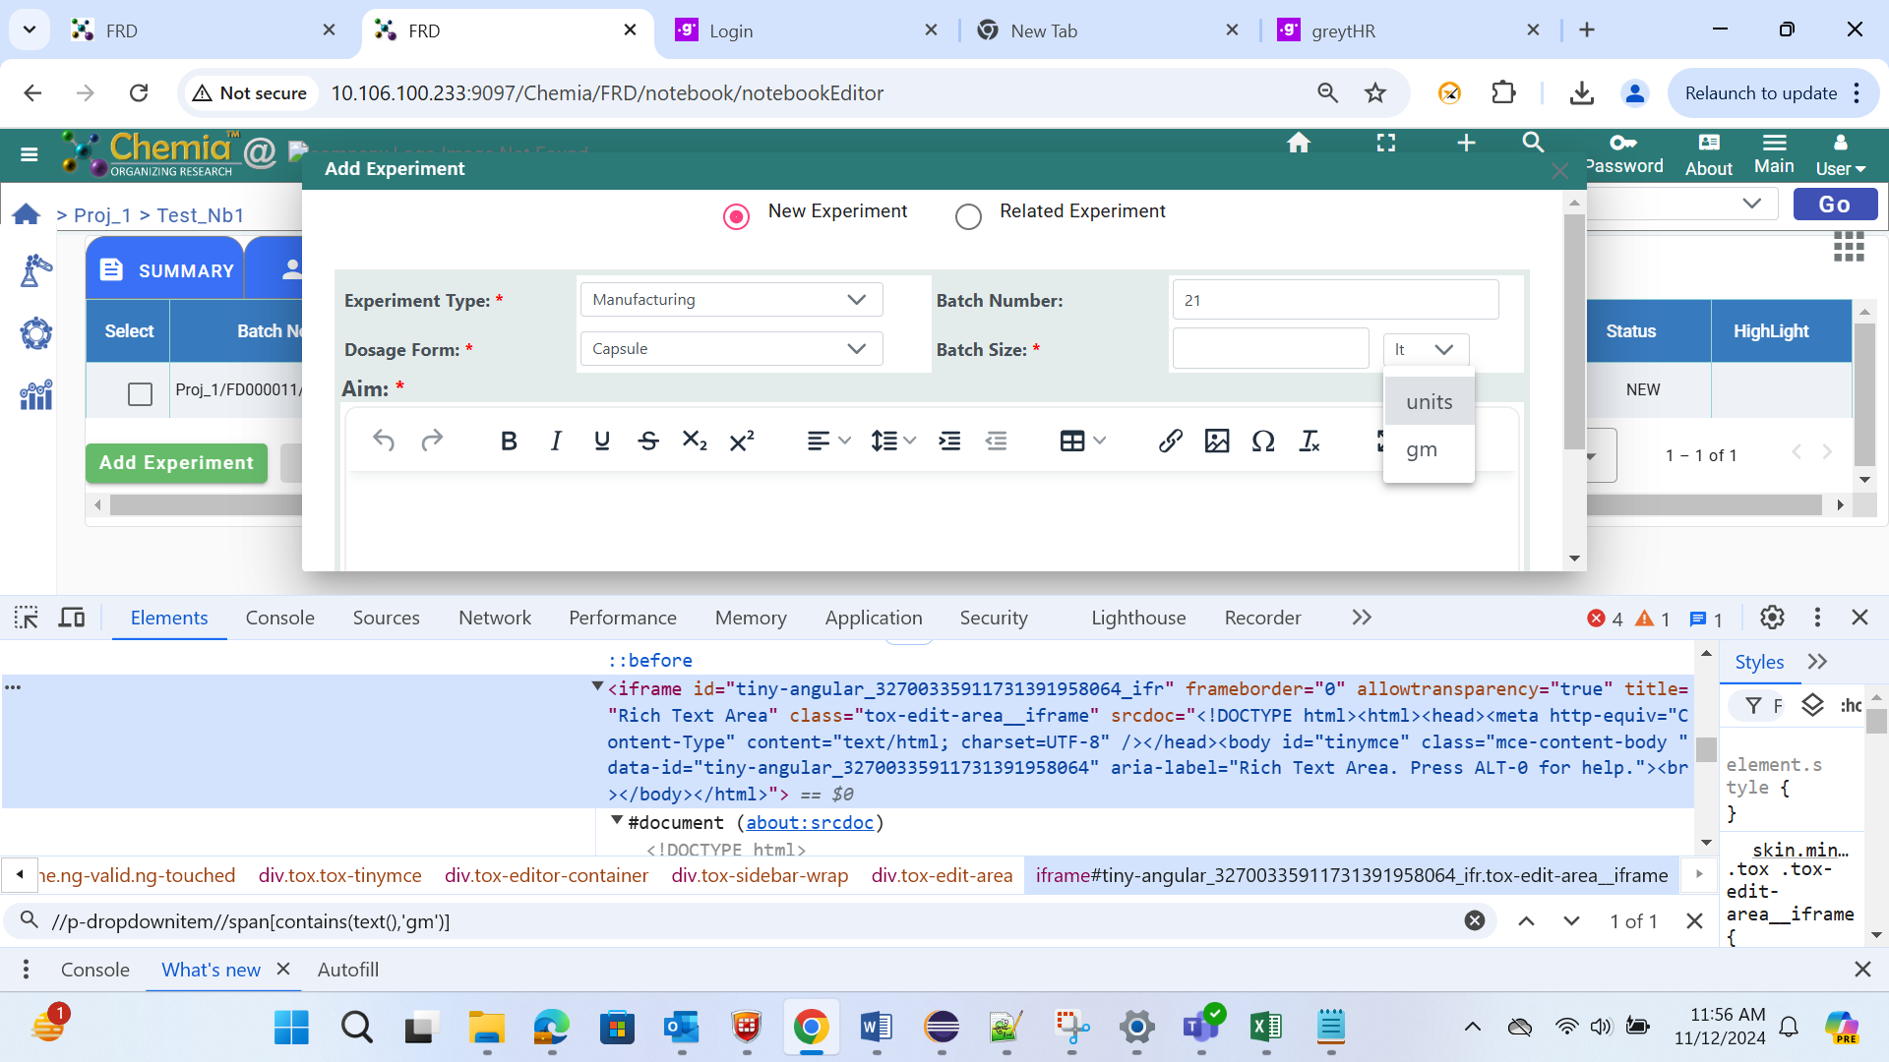

Issue 2: Scenario: While trying to enter Aim description to edit experiment.

The element frame Id is Alphanumeric.

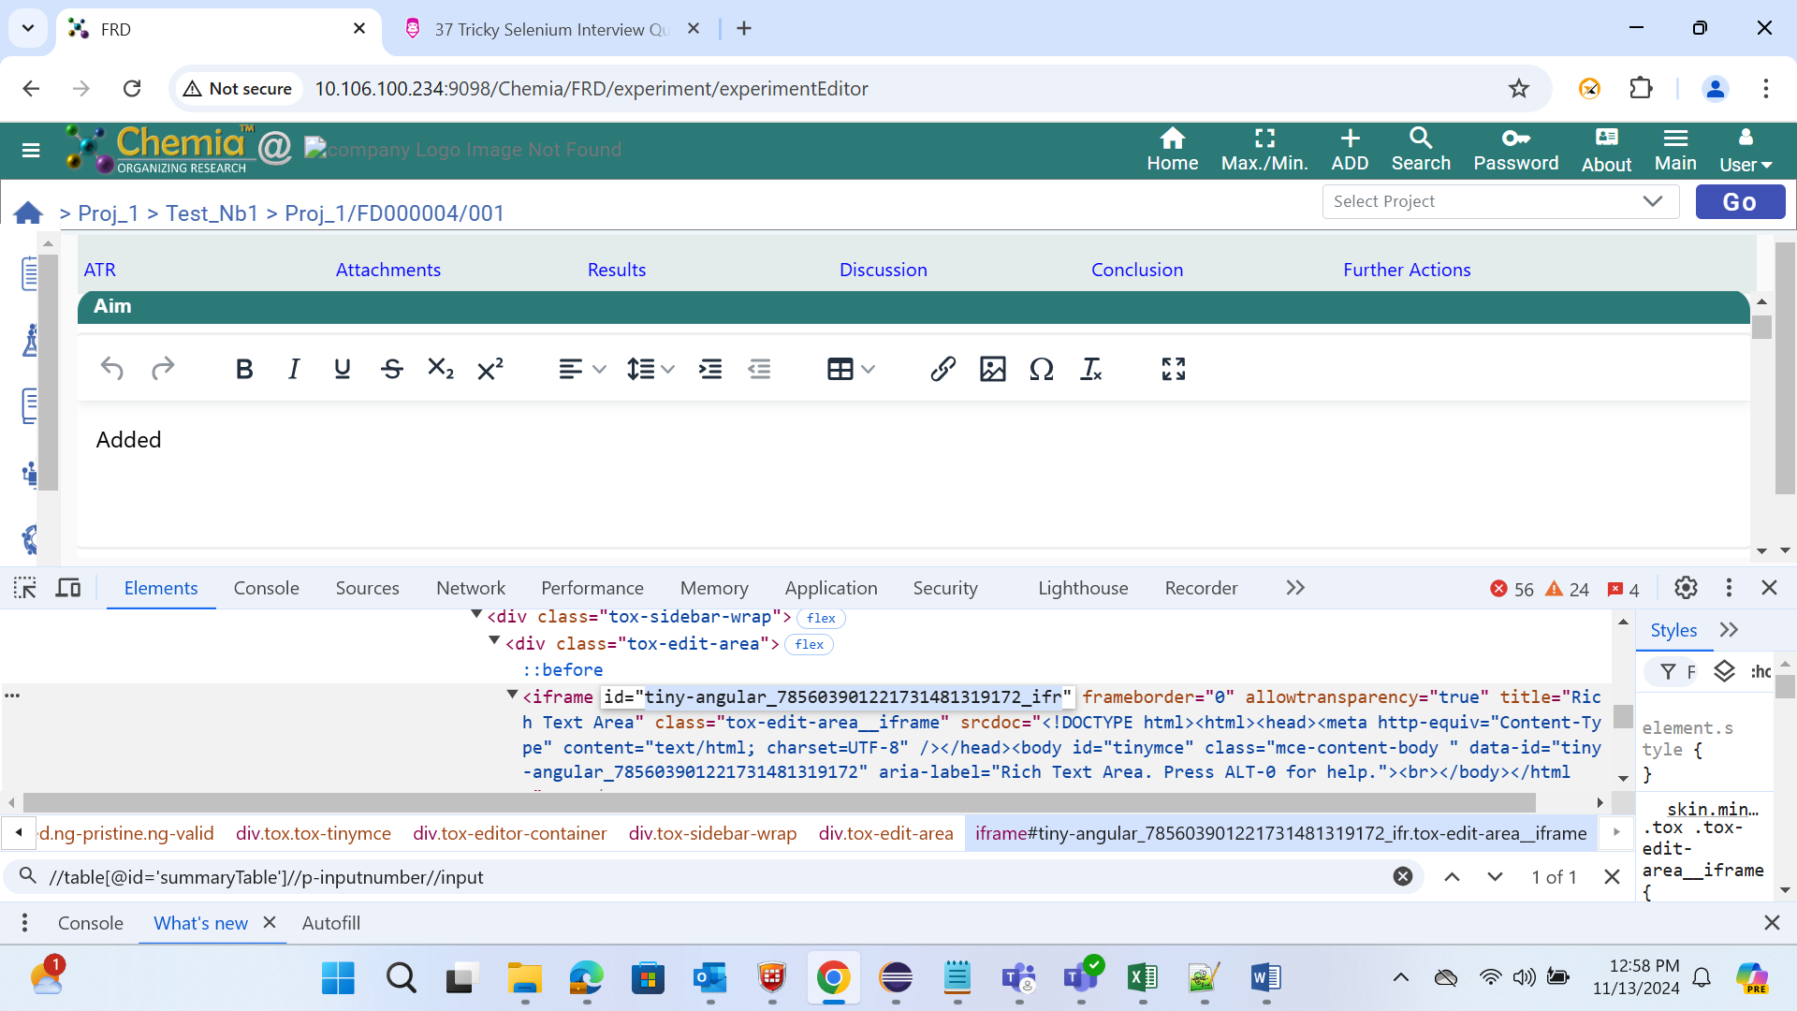

Issue 3: Scenario: While trying to enter Discussion description to edit experiment.

The element frame Id is Alphanumeric.

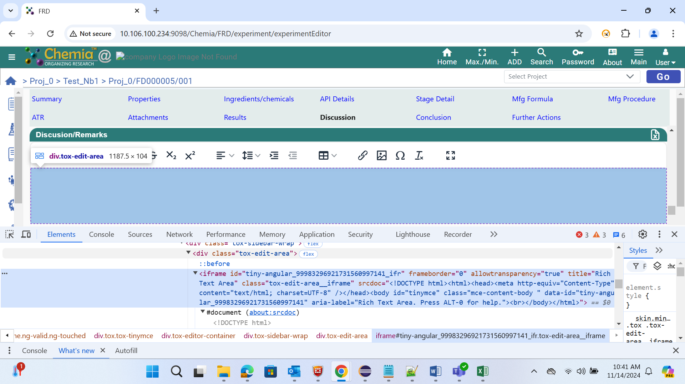

Issue 4: Scenario: While trying to enter Conclusion description to edit experiment.

The element frame Id is Alphanumeric.

