COMPTE RENDU DE TP(1:c++) by :

**SIRINE DHIB GROUPE C : TD : 9 :TP:17**

Ex 1:

Output:

Ex2:

Output:

Ex3:

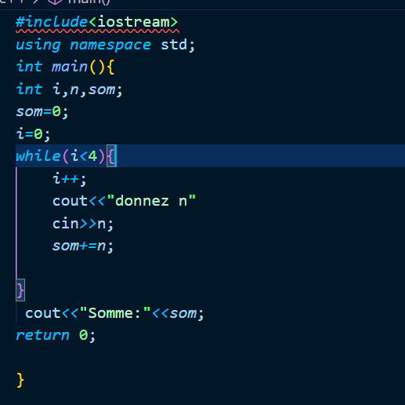

Output:

2/

Output:

Ex3:

Output:  
  
Ex4:

1/

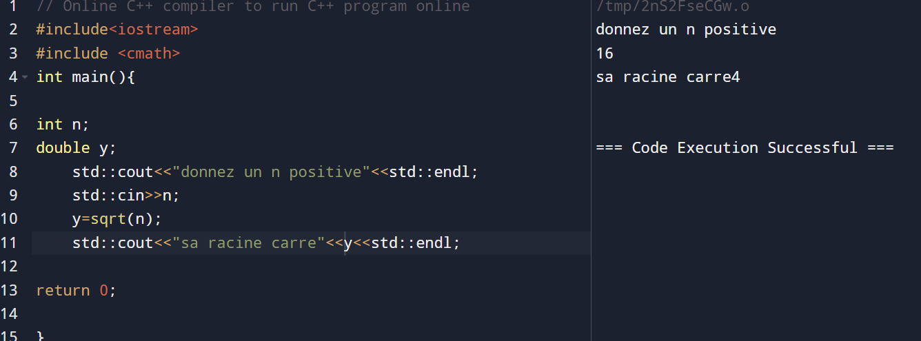

2/

