LatexEditor
Release Report
TITAN IV
Sirinian Aram Emmanouil
Emmanouil Bachlitzanakis

Versions History
Date | Version | Description | Author
18/4/2019 | 1.0 | In this version no code have been written. Team introduced to each other and the project and the plan of acting have been discussed. | Emmanouil Bachlitzanakis

Date | Version | Description | Author
21/5/2019 | 2.0 | In this version all user stories have been completed as well as the minimum amount of JUnit tests. | Sirinian Aram Emmanouil

Introduction
This document provides information concerning the V2.0 release of the project.

Purpose
Latex is a well known high quality document preparation markup language. It provides a large variety of styles and commands that enable advanced document formatting. Typically, a Latex document is compiled with a tool like MikTex, Lyx, etc. to produce a respective formatted document in pdf, ps, etc. Formatting documents with Latex is a programming like process as it involves the proper usage of Latex commands which are embedded in the document contents. The objective of this project is to develop a simple Latex editor for inexperienced Latex users. The goal of the editor is to facilitate the usage of Latex commands for the preparation of Latex documents. One of the prominent features that distinguishes the LatexEditor from other similar applications is its multi-strategy version tracking functionalities that enable undo and redo actions.

Document Structure
The rest of this document is structured as follows. Section 2 specifies the acceptance tests that have been employed for this release of the project. Section 3 specifies the main design concepts for this release of the project.

Tests

Tests for User Story <US1>
Test ID | T001US1
User Story | US1
Test Class | GivenArticleTypeWhenCreatingNewDocumentThenDocumentContentsContainTheRightTemplate
Description | The purpose of this test is to make sure that CreateNewDocumentCommand works right for Latex document with article template. Given a LatexEditorController object set to create a new document with article template. When enact LatexEditorController with “CreateNewDocument” as parameter. Then the contents of the newly created document with the expected contents of the selected template are the same.

Test ID | T002US1
User Story | US1
Test Class | GivenBlankTypeWhenCreatingNewDocumentThenDocumentContentsContainTheRightTemplate
Description | The purpose of this test is to make sure that CreateNewDocumentCommand works right for Latex document with no template (blank). Given a LatexEditorController object set to create a new document with no template (blank). When enact LatexEditorController with “CreateNewDocument” as parameter. Then the contents of the newly created document with the expected contents of the selected template are the same.

Test ID | T003US1
User Story | US1
Test Class | GivenBookTypeWhenCreatingNewDocumentThenDocumentContentsContainTheRightTemplate
Description | The purpose of this test is to make sure that CreateNewDocumentCommand works right for Latex document with book template. Given a LatexEditorController object set to create a new document with book template. When enact LatexEditorController with “CreateNewDocument” as parameter. Then the contents of the newly created document with the expected contents of the selected template are the same.

Test ID | T004US1
User Story | US1
Test Class | GivenLetterTypeWhenCreatingNewDocumentThenDocumentContentsContainTheRightTemplate
Description | The purpose of this test is to make sure that CreateNewDocumentCommand works right for Latex document with letter template. Given a LatexEditorController object set to create a new document with letter template. When enact LatexEditorController with “CreateNewDocument” as parameter. Then the contents of the newly created document with the expected contents of the selected template are the same.

Test ID | T005US1
User Story | US1
Test Class | GivenReportTypeWhenCreatingNewDocumentThenDocumentContentsContainTheRightTemplate
Description | The purpose of this test is to make sure that CreateNewDocumentCommand works right for Latex document with report template. Given a LatexEditorController object set to create a new document with report template. When enact LatexEditorController with “CreateNewDocument” as parameter. Then the contents of the newly created document with the expected contents of the selected template are the same.

Tests for User Story <US2>

Test ID | T001US2
User Story | US2
Test Class | GivenAnyDocumentWhenEditingDocumentContentsThenDocumentContainTheRightContents
Description | The purpose of this test is to make sure that EditDocumentCommand works right. Given a LatexEditorController object set to add some new contents. After creating new Latex document (of any type but for this test, article have been used). When enact LatexEditorController with “EditDocument” parameter. Then the expected contents and the actual contents of Latex document are the same.

Tests for User Story <US3>

Test ID | T001US3
User Story | US3
Test Class | GivenArticleDocumentWhenAddingLatexCommandAddChapterThenDocumentContainTheRightContents
Description | The purpose of this test is to make sure that AddLatexCommand works right when it adds new “Chapter Latex command” to Latex document with article template. Given a LatexEditorController object set to add “Chapter Latex command”. After creating new Latex document with article template. When enact LatexEditorController with “AddLatex” parameter. Then the expected contents and the actual contents of Latex document are the same.

Test ID | T002US3
User Story | US3
Test Class | GivenArticleDocumentWhenAddingLatexCommandAddEnumerationListEnumerate  ThenDocumentContainTheRightContents
Description | The purpose of this test is to make sure that AddLatexCommand works right when it adds new “Enumeration List Enumerate Latex command” to Latex document with article template. Given a LatexEditorController object set to add “Enumeration List Enumerate Latex command”. After creating new Latex document with article template. When enact LatexEditorController with “AddLatex” parameter. Then the expected contents and the actual contents of Latex document are the same.

Test ID | T003US3
User Story | US3
Test Class | GivenArticleDocumentWhenAddingLatexCommandAddEnumerationListItemize  ThenDocumentContainTheRightContents
Description | The purpose of this test is to make sure that AddLatexCommand works right when it adds new “Enumeration List Itemize Latex command” to Latex document with article template. Given a LatexEditorController object set to add “Enumeration List Itemize Latex command”. After creating new Latex document with article template. When enact LatexEditorController with “AddLatex” parameter. Then the expected contents and the actual contents of Latex document are the same.

Test ID | T004US3
User Story | US3
Test Class | GivenArticleDocumentWhenAddingLatexCommandAddFigureThenDocumentContainTheRightContents
Description | The purpose of this test is to make sure that AddLatexCommand works right when it adds new “Figure Latex command” to Latex document with article template. Given a LatexEditorController object set to add “Figure Latex command”. After creating new Latex document with article template. When enact LatexEditorController with “AddLatex” parameter. Then the expected contents and the actual contents of Latex document are the same.

Test ID | T005US3
User Story | US3
Test Class | GivenArticleDocumentWhenAddingLatexCommandAddSectionThenDocumentContainTheRightContents
Description | The purpose of this test is to make sure that AddLatexCommand works right when it adds new “Section Latex command” to Latex document with article template. Given a LatexEditorController object set to add “Section Latex command”. After creating new Latex document with article template. When enact LatexEditorController with “AddLatex” parameter. Then the expected contents and the actual contents of Latex document are the same.

Test ID | T006US3
User Story | US3
Test Class | GivenArticleDocumentWhenAddingLatexCommandAddSubsectionThenDocumentContain  TheRightContents
Description | The purpose of this test is to make sure that AddLatexCommand works right when it adds new “Subsection Latex command” to Latex document with article template. Given a LatexEditorController object set to add “Subsection Latex command”. After creating new Latex document with article template. When enact LatexEditorController with “AddLatex” parameter. Then the expected contents and the actual contents of Latex document are the same.

Test ID | T007US3
User Story | US3
Test Class | GivenArticleDocumentWhenAddingLatexCommandAddSubsubsectionThenDocumentContain  TheRightContents
Description | The purpose of this test is to make sure that AddLatexCommand works right when it adds new “Subsubsection Latex command” to Latex document with article template. Given a LatexEditorController object set to add “Subsubsection Latex command”. After creating new Latex document with article template. When enact LatexEditorController with “AddLatex” parameter. Then the expected contents and the actual contents of Latex document are the same.

Test ID | T008US3
User Story | US3
Test Class | GivenArticleDocumentWhenAddingLatexCommandAddTableThenDocumentContainTheRightContents
Description | The purpose of this test is to make sure that AddLatexCommand works right when it adds new “Table Latex command” to Latex document with article template. Given a LatexEditorController object set to add “Table Latex command”. After creating new Latex document with article template. When enact LatexEditorController with “AddLatex” parameter. Then the expected contents and the actual contents of Latex document are the same.

Test ID | T009US3
User Story | US3
Test Class | GivenBookDocumentWhenAddingLatexCommandAddChapterThenDocumentContainTheRightContents
Description | The purpose of this test is to make sure that AddLatexCommand works right when it adds new “Chapter Latex command” to Latex document with book template. Given a LatexEditorController object set to add “Chapter Latex command”. After creating new Latex document with book template. When enact LatexEditorController with “AddLatex” parameter. Then the expected contents and the actual contents of Latex document are the same.

Test ID | T010US3
User Story | US3
Test Class | GivenBookDocumentWhenAddingLatexCommandAddEnumerationListEnumerate  ThenDocumentContainTheRightContents
Description | The purpose of this test is to make sure that AddLatexCommand works right when it adds new “Enumeration List Enumerate Latex command” to Latex document with book template. Given a LatexEditorController object set to add “Enumeration List Enumerate Latex command”. After creating new Latex document with book template. When enact LatexEditorController with “AddLatex” parameter. Then the expected contents and the actual contents of Latex document are the same.

Test ID | T011US3
User Story | US3
Test Class | GivenBookDocumentWhenAddingLatexCommandAddEnumerationListItemize  ThenDocumentContainTheRightContents
Description | The purpose of this test is to make sure that AddLatexCommand works right when it adds new “Enumeration List Itemize Latex command” to Latex document with book template. Given a LatexEditorController object set to add “Enumeration List Itemize Latex command”. After creating new Latex document with book template. When enact LatexEditorController with “AddLatex” parameter. Then the expected contents and the actual contents of Latex document are the same.

Test ID | T012US3
User Story | US3
Test Class | GivenBookDocumentWhenAddingLatexCommandAddFigureThenDocumentContainTheRightContents
Description | The purpose of this test is to make sure that AddLatexCommand works right when it adds new “Figure Latex command” to Latex document with book template. Given a LatexEditorController object set to add “Figure Latex command”. After creating new Latex document with book template. When enact LatexEditorController with “AddLatex” parameter. Then the expected contents and the actual contents of Latex document are the same.

Test ID | T013US3
User Story | US3
Test Class | GivenBookDocumentWhenAddingLatexCommandAddSectionThenDocumentContainTheRightContents
Description | The purpose of this test is to make sure that AddLatexCommand works right when it adds new “Section Latex command” to Latex document with book template. Given a LatexEditorController object set to add “Section Latex command”. After creating new Latex document with book template. When enact LatexEditorController with “AddLatex” parameter. Then the expected contents and the actual contents of Latex document are the same.

Test ID | T014US3
User Story | US3
Test Class | GivenBookDocumentWhenAddingLatexCommandAddSubsectionThenDocumentContain  TheRightContents
Description | The purpose of this test is to make sure that AddLatexCommand works right when it adds new “Subsection Latex command” to Latex document with book template. Given a LatexEditorController object set to add “Subsection Latex command”. After creating new Latex document with book template. When enact LatexEditorController with “AddLatex” parameter. Then the expected contents and the actual contents of Latex document are the same.

Test ID | T015US3
User Story | US3
Test Class | GivenBookDocumentWhenAddingLatexCommandAddSubsubsectionThenDocumentContain  TheRightContents
Description | The purpose of this test is to make sure that AddLatexCommand works right when it adds new “Subsubsection Latex command” to Latex document with book template. Given a LatexEditorController object set to add “Subsubsection Latex command”. After creating new Latex document with book template. When enact LatexEditorController with “AddLatex” parameter. Then the expected contents and the actual contents of Latex document are the same.

Test ID | T016US3
User Story | US3
Test Class | GivenBookDocumentWhenAddingLatexCommandAddTableThenDocumentContainTheRightContents
Description | The purpose of this test is to make sure that AddLatexCommand works right when it adds new “Table Latex command” to Latex document with book template. Given a LatexEditorController object set to add “Table Latex command”. After creating new Latex document with book template. When enact LatexEditorController with “AddLatex” parameter. Then the expected contents and the actual contents of Latex document are the same.

Test ID | T017US3
User Story | US3
Test Class | GivenLetterDocumentWhenAddingLatexCommandAddChapterThenDocumentContainTheRightContents
Description | The purpose of this test is to make sure that AddLatexCommand works right when it adds new “Chapter Latex command” to Latex document with letter template. Given a LatexEditorController object set to add “Chapter Latex command”. After creating new Latex document with letter template. When enact LatexEditorController with “AddLatex” parameter. Then the expected contents and the actual contents of Latex document are the same.

Test ID | T018US3
User Story | US3
Test Class | GivenLetterDocumentWhenAddingLatexCommandAddEnumerationListEnumerate  ThenDocumentContainTheRightContents
Description | The purpose of this test is to make sure that AddLatexCommand works right when it adds new “Enumeration List Enumerate Latex command” to Latex document with letter template. Given a LatexEditorController object set to add “Enumeration List Enumerate Latex command”. After creating new Latex document with letter template. When enact LatexEditorController with “AddLatex” parameter. Then the expected contents and the actual contents of Latex document are the same.

Test ID | T019US3
User Story | US3
Test Class | GivenLetterDocumentWhenAddingLatexCommandAddEnumerationListItemize  ThenDocumentContainTheRightContents
Description | The purpose of this test is to make sure that AddLatexCommand works right when it adds new “Enumeration List Itemize Latex command” to Latex document with letter template. Given a LatexEditorController object set to add “Enumeration List Itemize Latex command”. After creating new Latex document with letter template. When enact LatexEditorController with “AddLatex” parameter. Then the expected contents and the actual contents of Latex document are the same.

Test ID | T020US3
User Story | US3
Test Class | GivenLetterDocumentWhenAddingLatexCommandAddFigureThenDocumentContainTheRightContents
Description | The purpose of this test is to make sure that AddLatexCommand works right when it adds new “Figure Latex command” to Latex document with letter template. Given a LatexEditorController object set to add “Figure Latex command”. After creating new Latex document with letter template. When enact LatexEditorController with “AddLatex” parameter. Then the expected contents and the actual contents of Latex document are the same.

Test ID | T021US3
User Story | US3
Test Class | GivenLetterDocumentWhenAddingLatexCommandAddSectionThenDocumentContainTheRightContents
Description | The purpose of this test is to make sure that AddLatexCommand works right when it adds new “Section Latex command” to Latex document with letter template. Given a LatexEditorController object set to add “Section Latex command”. After creating new Latex document with letter template. When enact LatexEditorController with “AddLatex” parameter. Then the expected contents and the actual contents of Latex document are the same.

Test ID | T022US3
User Story | US3
Test Class | GivenLetterDocumentWhenAddingLatexCommandAddSubsectionThenDocumentContain  TheRightContents
Description | The purpose of this test is to make sure that AddLatexCommand works right when it adds new “Subsection Latex command” to Latex document with letter template. Given a LatexEditorController object set to add “Subsection Latex command”. After creating new Latex document with letter template. When enact LatexEditorController with “AddLatex” parameter. Then the expected contents and the actual contents of Latex document are the same.

Test ID | T023US3
User Story | US3
Test Class | GivenLetterDocumentWhenAddingLatexCommandAddSubsubsectionThenDocumentContain  TheRightContents
Description | The purpose of this test is to make sure that AddLatexCommand works right when it adds new “Subsubsection Latex command” to Latex document with letter template. Given a LatexEditorController object set to add “Subsubsection Latex command”. After creating new Latex document with letter template. When enact LatexEditorController with “AddLatex” parameter. Then the expected contents and the actual contents of Latex document are the same.

Test ID | T024US3
User Story | US3
Test Class | GivenLetterDocumentWhenAddingLatexCommandAddTableThenDocumentContainTheRightContents
Description | The purpose of this test is to make sure that AddLatexCommand works right when it adds new “Table Latex command” to Latex document with letter template. Given a LatexEditorController object set to add “Table Latex command”. After creating new Latex document with letter template. When enact LatexEditorController with “AddLatex” parameter. Then the expected contents and the actual contents of Latex document are the same.

Test ID | T025US3
User Story | US3
Test Class | GivenReportDocumentWhenAddingLatexCommandAddChapterThenDocumentContainTheRightContents
Description | The purpose of this test is to make sure that AddLatexCommand works right when it adds new “Chapter Latex command” to Latex document with report template. Given a LatexEditorController object set to add “Chapter Latex command”. After creating new Latex document with report template. When enact LatexEditorController with “AddLatex” parameter. Then the expected contents and the actual contents of Latex document are the same.

Test ID | T026US3
User Story | US3
Test Class | GivenReportDocumentWhenAddingLatexCommandAddEnumerationListEnumerate  ThenDocumentContainTheRightContents
Description | The purpose of this test is to make sure that AddLatexCommand works right when it adds new “Enumeration List Enumerate Latex command” to Latex document with report template. Given a LatexEditorController object set to add “Enumeration List Enumerate Latex command”. After creating new Latex document with report template. When enact LatexEditorController with “AddLatex” parameter. Then the expected contents and the actual contents of Latex document are the same.

Test ID | T027US3
User Story | US3
Test Class | GivenReportDocumentWhenAddingLatexCommandAddEnumerationListItemize  ThenDocumentContainTheRightContents
Description | The purpose of this test is to make sure that AddLatexCommand works right when it adds new “Enumeration List Itemize Latex command” to Latex document with report template. Given a LatexEditorController object set to add “Enumeration List Itemize Latex command”. After creating new Latex document with report template. When enact LatexEditorController with “AddLatex” parameter. Then the expected contents and the actual contents of Latex document are the same.

Test ID | T028US3
User Story | US3
Test Class | GivenReportDocumentWhenAddingLatexCommandAddFigureThenDocumentContainTheRightContents
Description | The purpose of this test is to make sure that AddLatexCommand works right when it adds new “Figure Latex command” to Latex document with report template. Given a LatexEditorController object set to add “Figure Latex command”. After creating new Latex document with report template. When enact LatexEditorController with “AddLatex” parameter. Then the expected contents and the actual contents of Latex document are the same.

Test ID | T029US3
User Story | US3
Test Class | GivenReportDocumentWhenAddingLatexCommandAddSectionThenDocumentContainTheRightContents
Description | The purpose of this test is to make sure that AddLatexCommand works right when it adds new “Section Latex command” to Latex document with report template. Given a LatexEditorController object set to add “Section Latex command”. After creating new Latex document with report template. When enact LatexEditorController with “AddLatex” parameter. Then the expected contents and the actual contents of Latex document are the same.

Test ID | T030US3
User Story | US3
Test Class | GivenReportDocumentWhenAddingLatexCommandAddSubsectionThenDocumentContain  TheRightContents
Description | The purpose of this test is to make sure that AddLatexCommand works right when it adds new “Subsection Latex command” to Latex document with report template. Given a LatexEditorController object set to add “Subsection Latex command”. After creating new Latex document with report template. When enact LatexEditorController with “AddLatex” parameter. Then the expected contents and the actual contents of Latex document are the same.

Test ID | T031US3
User Story | US3
Test Class | GivenReportDocumentWhenAddingLatexCommandAddSubsubsectionThenDocumentContain  TheRightContents
Description | The purpose of this test is to make sure that AddLatexCommand works right when it adds new “Subsubsection Latex command” to Latex document with report template. Given a LatexEditorController object set to add “Subsubsection Latex command”. After creating new Latex document with report template. When enact LatexEditorController with “AddLatex” parameter. Then the expected contents and the actual contents of Latex document are the same.

Test ID | T032US3
User Story | US3
Test Class | GivenReportDocumentWhenAddingLatexCommandAddTableThenDocumentContainTheRightContents
Description | The purpose of this test is to make sure that AddLatexCommand works right when it adds new “Table Latex command” to Latex document with report template. Given a LatexEditorController object set to add “Table Latex command”. After creating new Latex document with report template. When enact LatexEditorController with “AddLatex” parameter. Then the expected contents and the actual contents of Latex document are the same.

Tests for User Story <US4>
Test ID | T001US4
User Story | US4
Test Class | GivenStableStrategyIsEnabledWhenRollbackToPreviouseVersions  ThenDocumentContentsChangeRight
Description | The purpose of this test is to make sure that the StableStrategy works right. Given a LatexEditorController object and some new contents to be added one after the other. After creating new Latex document (of any type but for this test book have been used). When enact LatexEditorController with “EnableVersionsManagement” and “SetStableStrategy”. Continue by enacting multiple times the LatexEditorController with “EditDocument” first and after that with “RollbackToPreviousVersion”. Then the contents of the versions that have been brought back are the ones that are expected to be.

Test ID | T002US4
User Story | US4
Test Class | GivenVolatileStrategyIsEnabledWhenRollbackToPreviouseVersions  ThenDocumentContentsChangeRight
Description | The purpose of this test is to make sure that the VolatileStrategy works right. Given a LatexEditorController object and some new contents to be added one after the other. After creating new Latex document (of any type but for this test book have been used). When enact LatexEditorController with “EnableVersionsManagement” and “SetVolatileStrategy”. Continue by enacting multiple times the LatexEditorController with “EditDocument” first and after that with “RollbackToPreviousVersion”. Then the contents of the versions that have been brought back are the ones that are expected to be.

Tests for User Story <US5>
Test ID | T001US5
User Story | US5
Test Class | GivenStableStrategyInVersionsManagerWhenSetVolatileStrategy  ThenStrategyInVersionsManagerChangeRight
Description | The purpose of this test is to make sure that the SetVolatileStrategyCommand works right. After creating new document (of any type but for this test book have been used). When enact LatexEditorController with “EnableVersionsManagement” and then with “SetVolatileStrategy” as parameters. Then the actual Strategy instance created is the expected one.

Test ID | T002US5
User Story | US5
Test Class | GivenVolatileStrategyInVersionsManagerWhenSetStableStrategy  ThenStrategyInVersionsManagerChangeRight
Description | The purpose of this test is to make sure that the SetStableStrategyCommand works right. After creating new document (of any type but for this test book have been used). When enact LatexEditorController with “EnableVersionsManagement” and then with “SetStableStrategy” as parameters. Then the actual Strategy instance created is the expected one.

Tests for User Story <US6>
Test ID | T001US6
User Story | US6
Test Class | GivenVersionsManagerWhenDisableVersionsManager  ThenVersionsHistoryRemainsUnchanged
Description | The purpose of this test is to make sure that the DisableVersionsManagerCommand works right. Given a LatexEditorController object and multiple new contents to be used to edit the Latex document. After creating new document (of any type but for this test book have been used). When enact LatexEditorController with “EnableVersionsManagement” and “SetVolatileStrategy” and then with “DisableVersionsManagement”. Then the VersionsManager is disabled as expected. After that when enact multiple times LatexEditorController with “EditDocument” as parameter for every new content. Then no matter of how many rollbacks the actual contents are the ones that are expected. The same procedures and tests are made for StableStrategy.

Tests for User Story <US7>
Test ID | T001US7
User Story | US7
Test Class | GivenBunchOfVersionsWhenRollbackToPreviousVersionThenDocumentContentsChangeRight
Description | The purpose of this test is to make sure that the RollbackToPreviousVersionCommand works right. Given a LatexEditorController object and multiple new contents to be used to edit the Latex document. After creating new document (of any type but for this test book have been used). When enact multiple edits to document contents and enact multiple rollbacks. Then the expected contents are the actual contents.

Tests for User Story <US8>
Test ID | T001US8
User Story | US8
Test Class | GivenContentsOfAnyDocumentWhenSaveDocument  ThenContentsInDocumentAndInFileAreTheSame
Description | The purpose of this test is to make sure that the SaveDocumentCommand works right. Given a LatexEditorController object. After creating new document (of any type but for this test book have been used). When enact LatexEditorController with “SaveDocument” as parameter. Then the contents in selected file and the contents in Latex document are the same.

Tests for User Story <US9>
Test ID | T001US9
User Story | US9
Test Class | GivenContentsOfAnyDocumentWhenLoadDocument  ThenContentsInDocumentAndInFileAreTheSame
Description | The purpose of this test is to make sure that the LoadDocumentCommand works right. Given a LatexEditorController object. After creating new document (of any type but for this test book have been used) and save its contents in some file by enacting LatexEditorController with “SaveDocument” as parameter. When enact LatexEditorController with “LoadDocument” as parameter. Then the contents in selected file and the contents in Latex document are the same.

Design

Architecture
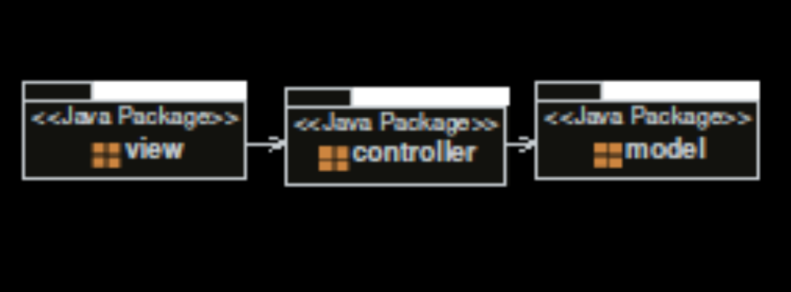

Design
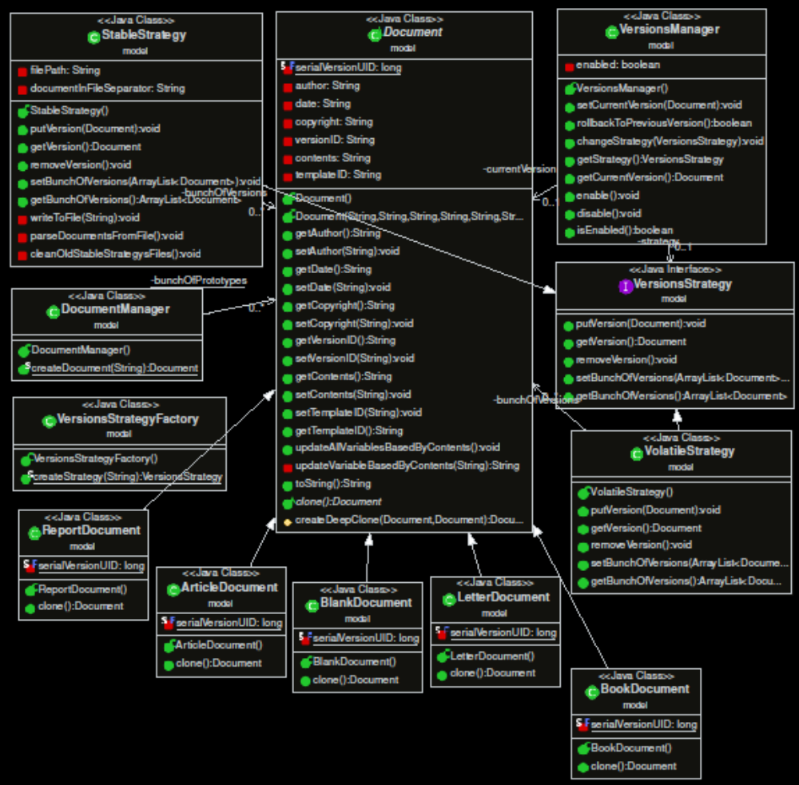
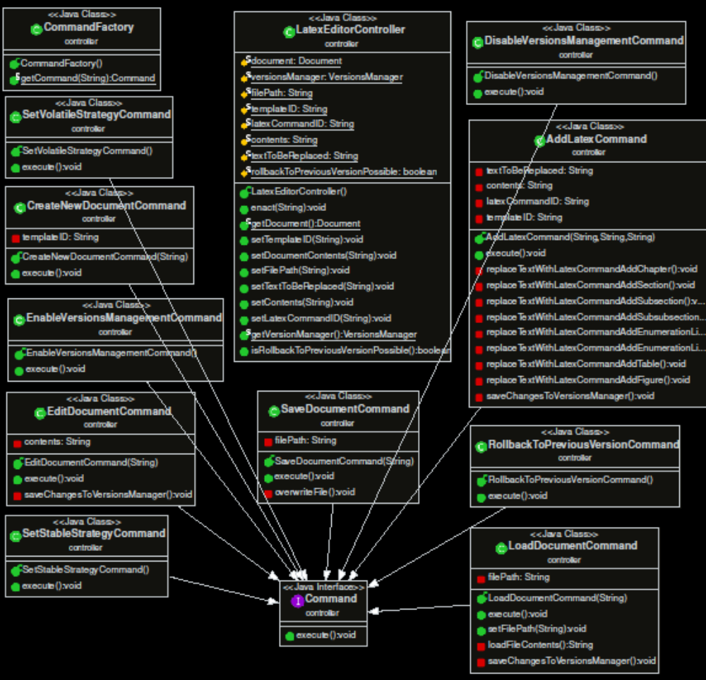

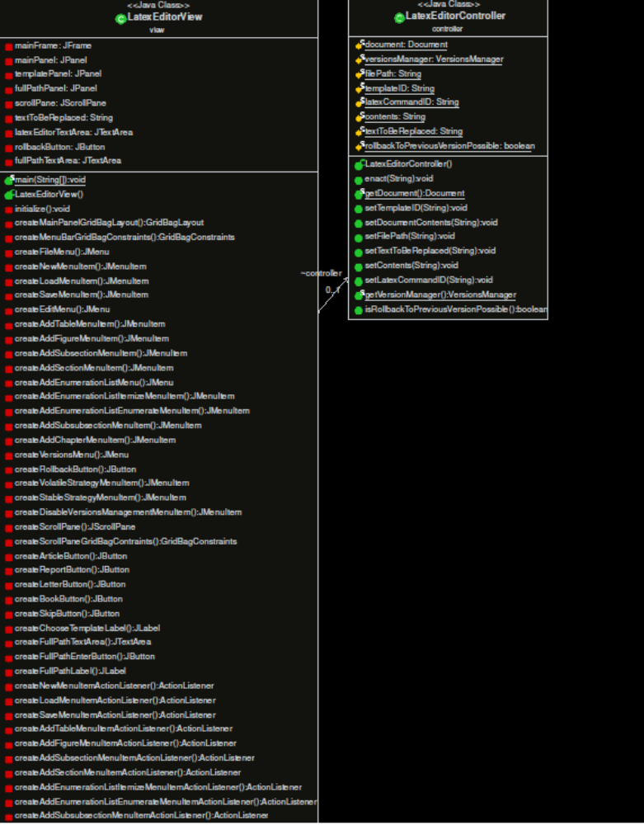

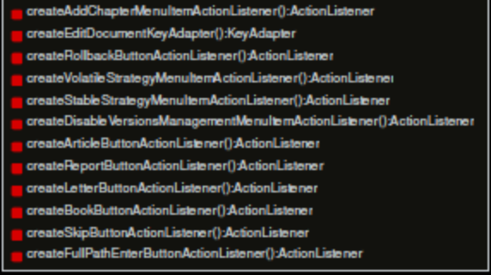

Class Name: model.ArticleDocument
Responsibilities:  - Constructing the skeleton of an article template. | Collaborations:

Class Name: model.BlankDocument
Responsibilities:  - Constructing the skeleton of an empty template. | Collaborations:

Class Name: model.BookDocument
Responsibilities:  - Constructing the skeleton of a Book template. | Collaborations:

Class Name: model.Document
Responsibilities:  - Creating deep clones of any Document  - Updating its variables based by its contents. | Collaborations:

Class Name: model.DocumentManager
Responsibilities:  - Managing the creation of all Document object kinds. | Collaborations:

Class Name: model.LetterDocument
Responsibilities:  - Constructing the skeleton of a Letter template. | Collaborations:

Class Name: model.ReportDocument
Responsibilities:  - Constructing the skeleton of a Report template. | Collaborations:

Class Name: model.StableStrategy
Responsibilities:  - Keeps all the versions created by rollback command when stable strategy is selected.  - Put, get and remove document versions from a file in secondary memory. | Collaborations:

Class Name: model.VersionsManager
Responsibilities:  - Keeps the latest document version.  - Keeps the information of being or not being enabled.  - Keeps the selected strategy.  - Managing the latest document version.  - Managing if VersionsManager is enabled or not.  - Manages the selected strategy.  - Provide the rollback method. | Collaborations:

Class Name: model.VersionsStrategy
Responsibilities:  - Provides an interface for all kinds of strategies to build on. | Collaborations:

Class Name: model.VersionsStrategyFactory
Responsibilities:  - Creates and returns a strategy based of some ID from its input. | Collaborations:

Class Name: model.VolatileStrategy
Responsibilities:  - Keeps all the versions created by rollback command when volatile strategy is selected.  - Put, get and remove versions from a file in primary memory. | Collaborations:

Class Name: controller.AddLatexCommand
Responsibilities:  - Once executed creating and inserting Latex commands inside specific position of Document contents. After the change it is saves to VersionManager. The position which is given through input in form of text to be replaced. | Collaborations:

Class Name: controller.Command
Responsibilities:  - Interface for all commands to build on. | Collaborations:

Class Name: controller.CommandFactory
Responsibilities:  - Creates and returns a command based of some ID from its input. | Collaborations:

Class Name: controller.CreateNewDocumentCommand
Responsibilities:  - Once executed creates a new document through DocumentManager. The type is given though input. | Collaborations:

Class Name: controller.DisableVersionsManagementCommand
Responsibilities:  - Once executed disables VersionsManager. | Collaborations:

Class Name: controller.EditDocumentCommand
Responsibilities:  - Once executed it edits document contents with new ones which it takes as input. After the change it is saves to VersionManager. | Collaborations:

Class Name: controller.EnableVersionsManagementCommand
Responsibilities:  - Once executed enables VersionsManager. | Collaborations:

Class Name: controller.LatexEditorController
Responsibilities:  - It is the link that connects GUI with the commands that it can execute. It takes as input a special ID to create a command though CommandFactory and the execute it.  - Holds all the variables which are needed to pass to commands and provide the necessary methods to handle them. | Collaborations:

Class Name: controller.LoadDocumentCommand
Responsibilities:  - Once executed it loads document contents from a selected file and sets accordingly the current document contents. After the change it is saves to VersionManager. It takes the file path as input. | Collaborations:

Class Name: controller.RollbackToPreviousVersionCommand
Responsibilities:  - Once executed it enact rollback method of VersionsManager. If it is not possible it updated a corresponding variable. | Collaborations:

Class Name: controller.SaveDocumentCommand
Responsibilities:  - Once executed it overwrites the contents of a selected file with contents of the current document. It takes the file path as input. | Collaborations:

Class Name: controller.SetStableStrategyCommand
Responsibilities:  - Once executed it changes the strategy of VersionsManager to stable strategy. | Collaborations:

Class Name: controller.SetVolatileStrategyCommand
Responsibilities:  - Once executed it changes the strategy of VersionsManager to volatile strategy. | Collaborations:

Class Name: view.LatexEditorView
Responsibilities:  - Provide user with a graphical user interface to edit his Latex documents and be help by executing the LatexEditor’s commands without need to know anything about it. | Collaborations:

