CHAPTER 1
INTRODUCTION

1.1 OVERVIEW
Employees have always been valuable assets to any company. They might be referred to as an organization's life-blood because of their crucial nature. Knowing where you are now and where you want to go next is one of the most significant aspects of the job search. A job seeker's perspective is similar to that of a product manager, who is looking for the best product and market fit. However, because technology requires human resources to operate, this circumstance does not diminish the worth of employees in a business. In most industries, competition is growing increasingly fierce as a result of factors such as globalisation. This condition has an impact on the job market since organisations need more human resources to stay competitive in their respective industries. As a result of this research, it examines the following topics:
- Company Culture/Philosophy;
- Leadership Style;
- A system for motivating and rewarding employees;
- The Influence of Cultural Demographics;
- HRM's role and HPWS's application tool
Overall, there is a great degree of uncertainty about the best strategy to restore and maintain employee engagement. Employers who are astute understand the value of retaining top talent. In the Indian context, retaining talent has never been more vital; however, things have altered in recent years. There is no shortage of chances for the finest in the business, or even for the second or third best, in India's major cities. Companies have never placed a greater emphasis on retaining key personnel and addressing attrition issues. There are a number of factors that contribute to their departure from the company. The following are some of the most common reasons:
- Job isn't what the employee expected: Job obligations don't always turn out to be what the candidates expected. Job unhappiness is caused by unexpected job responsibilities.
- Misalignment of work and personality: A candidate may be qualified for a specific sort of employment that matches his personality. If he is assigned a job that does not fit his nature, he will struggle to perform successfully and will look for reasons to leave.
- No or limited learning and growth possibilities: A candidate's employment and career will become stagnant if there are no or limited learning and growth chances in their current position.
- Workplace stress and work-life balance: Workplace stress can lead to work-life balance, which can lead to employees quitting the company.
- Salary: Other organisations may offer better compensation packages, which may entice people to work for them.
Various tools have been developed by various firms to improve customer retention; similarly, tools for employee retention have been produced, and the case study demonstrates how machine learning can aid in employee retention by employing the Employee turnover prediction and classification approach. Employee retention is described as "an employer's endeavour to retain desirable employees in order to fulfil business objectives" by keeping the appropriate individuals in the right jobs.
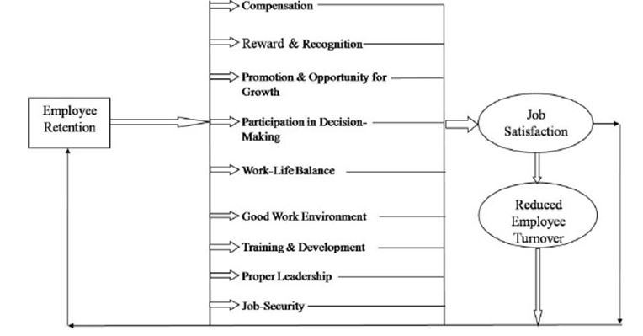
Figure 1: Employee Confinement

  - EMPLOYEE CONFINEMENT :THE THREE R'S
You must execute each of the three pillars of Employee Retention: respect, recognition, and rewards, in order to keep staff and maintain high levels of satisfaction. RESPECT is a term that refers to a person's esteem, special regard, or unique treatment. Respect is the cornerstone of keeping your employees, as the pyramid illustrates. If you don't appreciate your employees, RECOGNITION and REWARDS will have minimal impact. Rewards are the extra goodies you provide in addition to the essentials of respect and recognition that motivate employees to work hard, care, and go above and beyond.
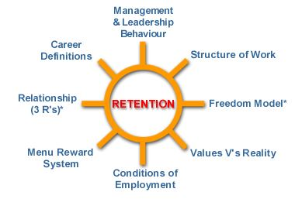
Figure 2: Terms for Employee Retention
Employers competing for employees in a free labour market must offer desirable working conditions in order to attract and keep them. A competitive remuneration package is one such example. When it comes to the impact of state laws, a company's Conditions of Employment must adhere to federal and state regulations in areas like worker safety, healthcare access, and non-discrimination rules. An employment contract is a written agreement between an employer and an employee that spells out each party's rights and responsibilities. Before the law will recognise an employment contract, it must meet specific standards, just like any other contract.
  - OBJECTIVES OF THE STUDY
Our predictive approach differs from many others since it is not constrained by sample numbers. Rather, it forecasts salaries based on over 600,000 variables connected to job titles, locations, and talents, as well as patterns and values for the elements that go into your individual wage forecast. Our salary ranges are shown in our public salary estimates. Log in to your Dice account or create a free account today to get a more specific, customized salary figure. You may fully edit your list of abilities; add your education level, and more within your profile.
- Determine the organization's level of motivation.
- To figure out how stressed the company's personnel are.
- To have a better understanding of the numerous elements that influences an employee's decision to stay and work with the company.
- To determine the most important factors influencing employee retention in IT firms.
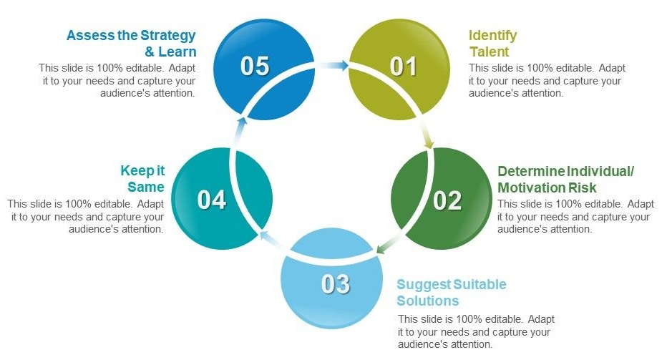
Figure 3: Steps to follow for better performance
Learning is an essential component of our lives. It becomes a tough process in a classroom. It necessitates active involvement on both sides. To achieve good results, this ongoing commitment is required. At regular periods, the entire learning process must be checked. It will enable us to achieve positive outcomes. These verifications also help us to improve and update the procedure. As a result, desirable outcomes are possible. This verification is carried out using a variety of assessment methods. Assessment Strategies are what they're termed.
1.4 SCOPE OF THE STUDY
This will assist management in understanding their employees' attitudes toward their jobs. The study's recommendations and suggestions can be applied to similar projects. It will be beneficial for management to recognise employee needs in order to keep them in the company. This project can be used by students who are working on a project in a related field, as well as organisations looking to improve their retention techniques.
You can keep your top performers and build a loyal, engaged, and goal-oriented team by employing the appropriate strategies. Various data mining methods can be used to create the predictive model. Statistical modelling and data mining approaches can help with this. One study used SVM and Random Forest models to predict staff attrition, while another used the KNN method to predict employee attrition and retention for accurate results.

CHAPTER 2
LITERATURE REVIEW

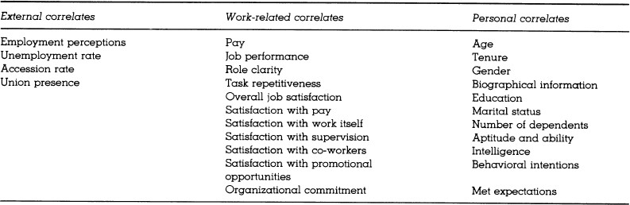
Using Machine Learning technique, more specifically Predictive Analytics, we can predict the employee attrition. Another study of Indian IT organisations found the following reasons to be responsible for attrition: Low incentives, a pay that falls short of expectations Relationships between superiors, subordinates, and co-workers knowledge of the job and skill recognition.

Table 1: Factors responsible for the Employee Attrition
2.1 FEASIBILITY STUDY
In this phase, the project's likelihood is assessed, and a structure scheme is developed. While the suggested structure isn't a weight in any study, some understanding of the framework's true inevitabilities is essential. Answers to a variety of questions, including: Does the framework add to the proposed framework's general destinations? Can the framework be applied utilizing current innovation? And, given the cost and timeframe restrictions, can the framework be broken down with already-existing frameworks? The following are six major criteria to consider while assessing achievability:
- Operational Feasibility
- Technical Feasibility
- Social Feasibility
- Schedule Feasibility
- Economic Feasibility
- Implementation Feasibility
2.1.1 OPERATIONAL FEASIBILITY:
Proposals are only valuable if they can be transformed into knowledge systems. That may be sufficient to meet the needs of the organization. The project's operational feasibility components might be considered an important feature of model implementation. This strategy is expected to address the above-mentioned difficulties. Management challenges and consumer preferences have been factored into the design. There is yet no issue of public opposition, which could limit the program's future benefits. The well-planned infrastructure will ensure that machine resources are optimally utilized and that performance levels are improved.
2.1.2 TECHNICALFEASIBILITY:
The most recent developed solution is theoretically plausible. It also provides users with easy access. The goal of a database is to build, construct, and maintain workflow between many organizations so that all users of varied capacities can benefit. Permission will be provided to users based on defined places. As a result, it provides a technological guarantee of precision, dependability, and safety. The purpose of this study is to determine the technical feasibility, or if the System's technical requirements can be met. There is a significant demand for technical resources that are now available due to the use of technology resources. 4GB RAM and a 500GB hard drive are among the technical requirements.
To develop the proposed model, JUPYTER NOTEBOOK Integrated Development Environment (IDE) is needed. The technical requirements include 4GB RAM.
2.1.3 SOCIALFEASIBILITY:
The purpose of this part of the study is to see how well the system recognizes people. This incorporates how the customer will be trained to use the platform effectively. The client should not be intimidated by the system, but rather accept it as a need. The methods used to educate the consumer and make him happy with the system are fully dependent on the tactics used to educate the client about the system and make him pleased with it.
2.1.4 SCHEDULEFEASIBILITY:
Ventures are begun with a certain deadline in mind. We must decide whether the deadlines are necessary or desirable. Time is one of the most important factors in the development of any framework, although this level of believability does not exist in any framework. It is now possible to construct a framework over a predetermined period of time.
2.1.5 ECONOMICALFEASIBILITY:
If a powerful project for the firm still needs to be designed, a computer should be designed and used. The cost of installation for the infrastructure design is weighed against the net benefit generated by the updated technology in terms of economic feasibility. The financial gains must be equal to or greater than the losses.
2.1.6 IMPLEMENTATIONFEASIBILITY:
Under the investigation of usability achievability, we must draw the finger to check specific issues, such as is it possible to introduce the product in the given condition, will client support be available for the product's installation, and will the proposed framework cause any harm to the client's framework's activities. The structure of encouraging and hastening the effective execution of a territorial vitality design by determining whether the current arrangement is monetarily, mechanically, legally, politically, officially, socially, and morally attainable is known as usage achievability.
2.2 LITERATURE SURVEY
We show in this study that there is a tremendous quantity of data available in the medical business to acquire knowledge from big volumes of data using an analytical method. Incomplete values, higher dimension values, and interference, among other issues, are common in real-time data sets and are ineffective for the full classification. We show in this study that there is a tremendous quantity of data available in the medical business to acquire knowledge from big volumes of data using an analytical method. Incomplete values, higher dimension values, and interference, among other issues, are common in real-time data sets and are ineffective for the full classification. As a result, categorization is a supplementary data analytics strategy. The major goal of this study is to create a one-of-a-kind Random Forest methodology. The experimental findings reveal that the method achieves excellent results on the dataset and provides a better solution to the real-world situation.
[1] Mita, M., Aarti K. and Ravneeta, D et.al tells that it examine the findings of various authors' research articles in order to determine the elements that influence employee commitment and retention in the workplace. Existing studies, while some did, did not place enough attention on the type of employee, the sector of the economy, or the sort of firm that is most affected by one element or another. More research is needed to better provide organisations with the knowledge they need to improve their retention capability.
[2] Kumar, Sanath & Devadas, Udaya & Dhammika, Kas et.al explains the purpose of this paper was to propose a conceptual framework that explains the mediating role of employee brand equity and the moderating role of demographic characteristics in the link between employee value proposition and intention. The findings point to the need for more empirical study to explain why higher-level employees leave and to discover effective remedies.
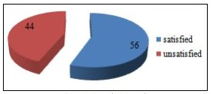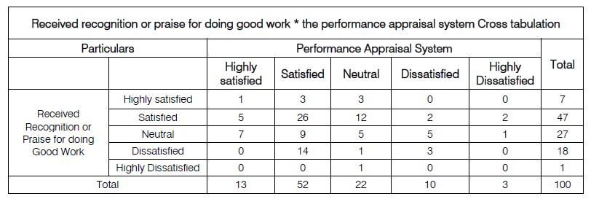
Table 2: Satisfaction Level Towards of Two Variables (Analysis of Correlation)
[3] Reddy Asi, Dr Vasudeva et.al this focuses mostly on employee compensation, which is a crucial factor for any firm to address in order to keep its most valuable asset, its personnel. Employee loyalty and retention will improve if they are fairly compensated for their contributions to the organisation. Also, it sheds light on how to adequately recompense an employee's performance, ensuring that the employee stays with the company for the long haul.
[4] Gorde, Sangita et.al demonstrate how important staff retention is in this day and age, and what the consequences will be if employers are not aware of the situation and do not take immediate action to that end, and how they will influence the organisation and the industry. The first literature theme depicts a study of the elements that influence employee attrition, as well as the results of an HR survey conducted to investigate these aspects. Organizations invest a lot of money in hiring, induction, training, development, and retention of employees, thus losing one is a major loss for them. As a result, managers must limit employee turnover in order to reduce turnover loss.
[5] Silva, Melissa & Carvalho, Joao & Dias, Álvaro et.al to determine which criteria are significant in keeping employees in firms and, as a result, not only avoiding turnover but also retaining the top individuals. To that purpose, we looked into 8 employee-related aspects and 13 company-related factors, using a conceptual model as a guide.
2.3 LITERATURE CONCLUSION
As can be seen, different theoretical and technical research and studies have been conducted to date in order to determine attrition prediction. However, no significant study or research has been conducted on the development of a tool that can make automatic judgements about which personnel are useful and which are not. Furthermore, there is no application that displays the final dashboard that displays the retention elements that HR Managers must consider when retaining a valuable employee, allowing the Human Resource Management budget to be greatly lowered if retention rates are increased.

CHAPTER 3
SYSTEM ARCHITECTURE

This section tells about the Software Development Life Cycle (SDLC) methodology used, Functional and Non-Functional Requirements, System Design including System Diagram, Sequence Diagram, Use- case diagram along with various use case scenarios, Development and Testing processes performed. I have chosen the agile methodology for the development of an application. I have chosen this method for development to complete the work in given timelines. I completed the work in sprints.
The functional requirements are divided into four categories. The following are some of them:
- Forecast Attrition — based on existing employee attrition data, the user must be able to predict future employee attrition.
- Decide on Valuable Employees — allows the user to classify employees as valuable or average.
- Identify and identify the factors that influence retention decisions - Display the retention factors on a dashboard to improve valued staff retention.
- Data Exploration and Data Visualization - User Interactive Attribute Selection for Plotting Graphs against Attrition
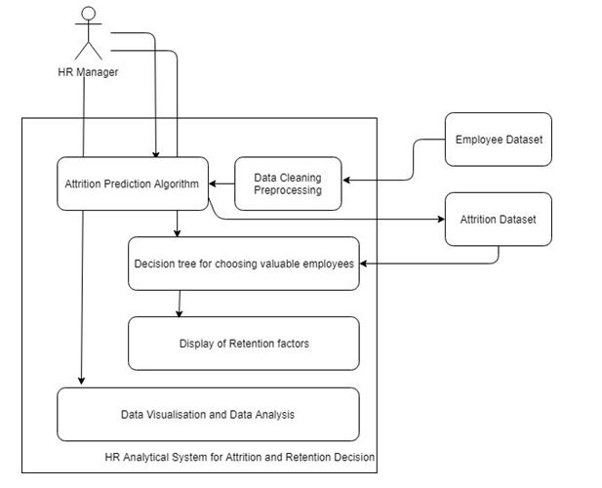
Figure 4: System Architecture

3.1 USE-CASE DIAGRAM:
Use case design is as follows which shows how the user (HR Manager) can interact with the application and take decisions with regards to valuable employees. The actors in the process are represented by stick figures, and the actor's engagement in the system is modelled by a line connecting the actor and the use case. Draw a box around the use case to represent the system boundary.
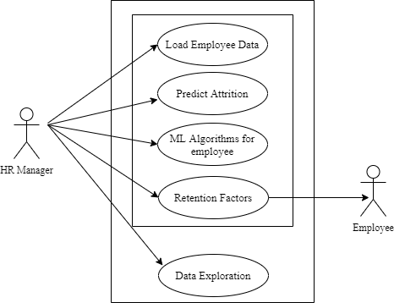
Figure 5: Use-Case Diagram
Use Case Scenario 1: The data is perfectly entered into the system, and attrition is accurately forecasted. Using a decision tree, employees who are about to depart from the company are divided into valuable and average employees. The dashboard then displays the most successful retention elements for valuable personnel.
Use Case Scenario 2 (Exception): The data is precisely entered into the system, but the attrition prediction fails to meet expectations. The user can manually undertake data analysis with the help of the application's user interactive data visualization tab.

3.2 SEQUENCE DIAGRAM:
A sequence diagram depicts the sequence of events that occur during the execution of an application. Software engineers and business experts use these diagrams to understand the requirements for a new system or to describe an existing process.
Businesses and other organisations can use sequence diagrams as a guide. Consider making a flowchart to:
- Represent a UML use case's details.
- Create a model of the logic of a complex procedure, function, or operation.
- Examine how items and components work together to execute a task.
- Plan out and comprehend the specific functionality of a current or future scenario.
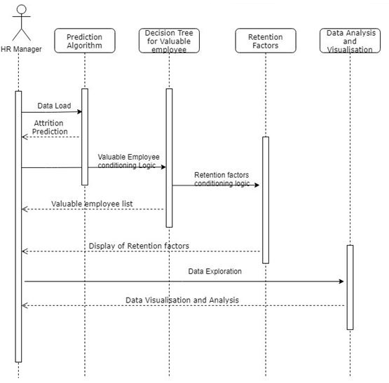
Figure 6: Sequence Diagram

CHAPTER 4
METHODOLOGY

Employers are fully aware that certain qualities, such as a strong work ethic, critical thinking, excellent communication, and teamwork, are desired by undergraduate students. This project will assist you in becoming that smart product manager by advising you on what attributes and top abilities the market seeks, as well as assisting you in navigating pay negotiations and making the best decision possible. It also incorporates data analysis, which encompasses both qualitative and quantitative elements of the research. Finally, it emphasises the research findings in the same way that they would be presented to a user. This also contains how the methodological assumptions were applied to the study and development of the final working analytical application. However, it performs the two primary types of analysis – predictive and prescriptive analysis – with the help of an analytical application. Predictive analytics forecasts employee turnover, whereas prescriptive analysis assists HR managers in identifying valuable people and determining the variables that are most effective in maintaining them.
Proposed method for Projection of Salary
Step 1: Employee retention information was extracted from the dataset.
Step 2: In the graph, the points corresponding to an individual's performance data have been plotted. Using the dataset, we plotted the points on the graph according to number or input, resulting in the true dataset.
Step 3: We then create lines between the sites using linear regression.
Step 4: We use polynomial regression to curve the points if they are not in a linear order. We may create a smooth and curved path using the clustering points.
Step 5: We can then anticipate salary using the linear/polynomial graph on the x-y axis.
Step 6: We also forecast a person's future salary position based on the graph. Take a specific person's position, and then use the graph to calculate the prediction response.
We examine multiple models to discover the classifier that best describes the data in a job recruitment situation characterised by high levels of noise, high dimensionality, and a restricted quantity of samples after phrasing the prediction issue as a classification challenge. Our main focus is on pay range prediction, as this might lead to improved categorization of job postings and hence easier navigation for end-users.

4.1 DATASET:
This dataset contains various features to define how the employee performance is measured for future benefits. This helps organizations to use data to assess the effectiveness of a strategy and gathering data allows you to see how effectively your solution is working and whether it needs to be altered in the long run.
For this project:
- The dataset has 14249 observations for past/present employees.
- The observations span 12 different departments.
- Each observation includes the employee’s current employment status.
Target variable: 'status' – Current employment status (Employed / Left)
This information is classified into 3 categories which are given as follows:
Administrative information
- 'department' – Department employees belong(ed) to
- 'salary' – Salary level relative to rest of their department
- 'tenure' – Number of years at the company
- 'recently_promoted' – Was the employee promoted in the last 3 years?
Workload information
- 'n_projects' – Number of projects employee is staffed on
- 'avg_monthly_hrs' – Average number of hours worked per month
Mutual evaluation information
- 'satisfaction' – Score for employee’s satisfaction with the company (higher is better)
- 'last_evaluation' – Score for most recent evaluation of employee (higher is better)
- 'filed_complaint' – Has the employee filed a formal complaint in the last 3 years?
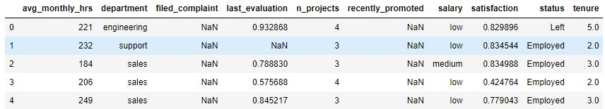
Figure 7: Dataset for Employee’s Analysis on Performance
Below are some important features with % contribution towards attrition.
- Satisfaction level : 34.77%
- Time spend in the company : 28.24%
- Average monthly hours : 12.05%
- Latest Evaluation : 11.46%
- Number of projects : 10.77
These are the driving factors which leads an employee to leave the company.
4.2 DATA PRE-PROCESSING:
Missing values are supplemented, outliers are identified and removed, and self-contradiction is resolved via data pre-processing. Because the sample code number has no bearing on illnesses, it has been removed from the dataset. In the dataset, there are 16 trait values that are missing. The class's missing traits are replaced by the mean. In addition, the dataset uses random selection to ensure that the data is circulated properly.
An outlier is a statistician's term for an observation point that stands out from the others. Anomalies are observations that are regarded unusual in a given situation. When a data point's value differs greatly from the rest of the data points in the same context, it's called a contextual outlier. Note that if the same value occurs in a different environment, it may not be deemed an outlier. Because time series data are records of a given quantity across time, the "context" is virtually always temporal if we confine our discussion to time series data.

4.3 DATA VISUALIZATION:
The graphical depiction of information and data is known as data visualisation. Data visualisation tools make it easy to examine and comprehend trends, outliers, and patterns in data by employing visual elements like charts, graphs, and maps. Almost every profession requires data visualisation. It is also crucial in large-scale data efforts. It's also part of the larger data presentation architecture discipline, which strives to find, package, and convey data in the most efficient way possible.
A Box Plot is used to show a summary of a group of data values that have qualities such as minimum, first quartile, median, third quartile, and maximum. A box is drawn from the first quartile to the third quartile in the box plot, and a vertical line runs through the box at the median. The data to be plotted is represented by the x-axis, while the frequency distribution is represented by the y-axis. The matplotlib.pyplot module of the matplotlib library has a boxplot () method that can be used to make box plots.
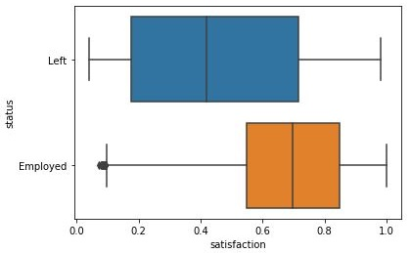
Figure 8: Boxplot for Status VS Satisfaction fields
A histogram is a useful tool for quickly examining a probability distribution that practically anybody can understand. Python provides a variety of tools for creating and plotting histograms.
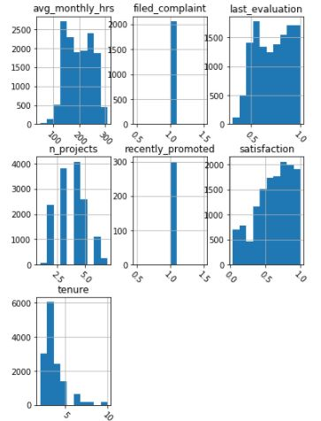
Figure 9: Histogram Grid for the dataset
4.4 TRAINING AND TESTING PHASE:
Adequate training necessitates the algorithm seeing the training data several times, which means that if the model is run over the same data set, it will be exposed to the same patterns. To avoid this, you'll need a new set of data to aid your algorithm's recognition of diverse patterns. However, because you require your testing data set for other purposes, you don't want to involve it before the training is completed. The training data sets can be obtained from a variety of sources, and the one you choose is determined by your goals, the requirements of your machine learning project, as well as your money, time, and manpower constraints. The training step extracts the dataset's features, whereas the testing phase determines how the appropriate model performs in terms of prediction. This is the stage of training and testing. K fold cross-validation shows that a single fold is used for testing and k 1 folds are used in a circular fashion for training.
4.5 MODEL SELECTION:
Applying Machine Learning to any dataset is at its most interesting stage. For forecasting the best results, it's also known as Algorithm selection. When dealing with huge data sets, Data Scientists typically employ a variety of Machine Learning algorithms. The term "supervised learning" refers to a system in which both the input and the desired output data are provided. To offer a learning framework for future data processing, input and output data are labelled for classification.
The most prevalent approaches for supervised learning are regression and classification. Categorical Features are typically expressed as 'strings' or 'categories,' and have a finite amount of entries. This table describes the values for 3 fields as department, salary and status of the employees. Categorical data must be encoded as part of the feature engineering process. It's more vital to know the coding scheme to utilize, taking into account the dataset and model we'll be using.
The following are the ML algorithms that were investigated: “Decision trees are trees that classify occurrences by arranging them based on feature values,” according to Wikipedia. The following is a diagram of a decision tree:
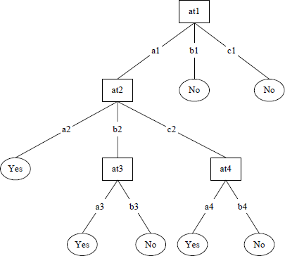
Figure 12: Decision Tree
The C5 decision tree technique is used in another investigation. Another sort of Decision Tree Algorithm is Bagging. Various considerations were considered for selecting the valuable employee, necessitating the use of a more advanced decision tree. The ID3 algorithm is a recursive approach in which each subset is evaluated and a decision node is constructed based on a metric called Information Gain. Entropy and Information Gain are two fundamental ideas used in ID3. "In information theory, entropy is a measure of the impurity of a randomly collected set of things."It is now required in HRM (Human Resource Management) to make fast and correct decisions, for which Intelligent HR Decision Making Systems have been developed, one of which is the Decision Support System DSS, which assists HR in making decisions in a shorter amount of time. Extraction of knowledge for HRM is accomplished via DSS (Decision Support System), KDD (Knowledge Discovery in Databases), and Data Mining.
Various considerations were considered for selecting the valuable employee, necessitating the use of a more advanced decision tree. The improved ID3 algorithm, which is an updated version of the ID3 Decision tree method, was discovered in one of the investigations. The ID3 algorithm is a recursive approach in which each subset is evaluated and a decision node is constructed based on a metric called Information Gain. Entropy and Information Gain are two fundamental ideas used in ID3. "In information theory, entropy is a measure of the impurity of a randomly collected set of things."
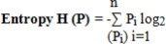
For set S, being pi the probability of S belonging to class I, formulation is
Information Gain = I (S1,S2,S3,…, Sm)- E(A) Algorithm for generating a decision tree according to a given data sets.
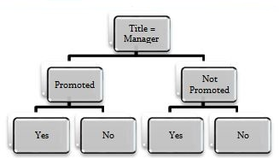
The ID3 has a flaw in that only one attribute is checked at a time, which can lead to overfitting or classification. Improved ID3 is utilized to solve this problem. Improved ID3 algorithm reduces complexity and saves time. The same gain that is calculated initially in basic ID3 is used in Improved ID3, but it is adjusted every time the dataset is modified as the tree grows.

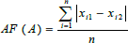
Association factor | Normalized Form | Gain – Decision Node
Table 3: Important Formulas for Decision Tree
Support Vector Mechanisms (SVMs) find a division point for categorizing on a hyper plane in a high-dimensional space to perform a class division. The hyper plane does a good job at partitioning because it keeps the separation between the different groups as large as feasible. The larger the edge, the smaller the classifier's error and inaccuracy. SVM is capable of solving both linear and nonlinear binary classification problems. Maximum margin classifiers are another name for SVMs.
K-Nearest Neighbor (KNN), also known as Neighbors-based order, is a type of instance-based learning. A fundamental larger part vote of each point's k closest neighbors is used to characterize it. "The two stages of KNN classification are determining neighboring data points and then deciding the class based on the neighbors’ classifications." "Because the algorithm stores all of its training data in memory, maybe transformed as a ball tree or a KD tree, KNN is a non-generalizing technique."
Random Forest (RF) - Random Forests (RFs) are created by combining different tree classifiers. For the training dataset, RF offers the ability to rectify decision tree over-fitting. Random forests differ from standard trees in that each node is divided according to the optimal category split across all variables. "In a random forest, each node is split using the best predictors from a subset of predictors picked at random."
Logistic Regression – Logistic Regression is a machine learning calculation for characterization. In this calculation, the probabilities portraying the possible results of a separate trial are displayed utilizing a Logistic Regression. Logistic regression is a statistical model that uses a logistic function to represent a binary dependent variable in its most basic form, though there are many more advanced variants. Logistic regression is a type of regression analysis that involves estimating the parameters of a logistic model (a form of binary regression). A binary logistic model mathematically has a dependent variable with two possible values, such as pass/fail, which is represented by an indicator variable, with the two values labelled "0" and "1." The logit, or logistic unit, is the unit of measurement for the log-odds scale, hence the alternative names.
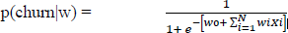
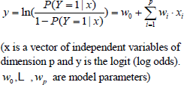
Logistic regression is a regression model that fits the values to the logistic function. It is useful when the dependent variable is categorical. The general form of the model is
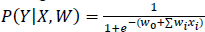
.
Random forest is a decision tree-based methodology for modelling predictions and behavior analysis. It contains a number of decision trees, each of which represents a unique classification of data fed into the random forest. They aim to maximize whatever assessment criteria you're using and they might take shortcuts to do so. The model would have a high accuracy rating, but it wouldn't be able to help you find examples of the smaller class.

Algorithm | Cross-Validation | Accuracy
Logistic Regression | 0.90 | 90%
SVM | 0.98 | 97%
Random Forest | 0.99 | 99%
KNN | 0.97 | 95%
Decision Tree | 0.98 | 97%
Table 4: Accuracy for different Machine Algorithms

CHAPTER 5
IMPLEMENTATION

5.1 TECHNOLOGIES USED
5.1.1 Machine Learning:
Machine Learning (ML) is the subset of Artificial Intelligence. In healthcare it is becoming more popular, and it is assisting patients in various ways. The most common machine learning applications in healthcare are medical billing automation, clinical decision support, and the development of clinical care guidelines. It analyses and discovers patterns in large datasets in order to make decisions. The algorithms are designed to learn the data on their own, without the need for human intervention. By analysing huge number of health records and other patient data, ML algorithms can detect patterns associated with disease and health condition.
5.1.2 Python:
Python is a popular object-oriented, interpreted programming language similar to PERL because of its simple syntax and readability. Python is said to be simple to learn and portable, which means that its statements may be read in a variety of operating systems, such as UNIX-based systems, Mac OS, MS-DOS, OS/2, and various versions of Microsoft Windows 98. Guido van Rossum, a former Dutch citizen with Monty Python's Flying Circus as his favourite comedy group at the time, developed Python. The source code is available to the public and can be changed and reused.
Python has a huge number of users. The indenting of source statements in Python is a significant feature that makes the code simpler to read. Python includes a variety of dynamic data types, ready- made classes, and interfaces for variety of system functions and libraries. The C or C++ programming languages can be used to expand it. Python is a language which is extremely comprehensible. So instead, it generally uses English words and less syntactic constructions than in other languages.

5.1.3 Libraries used in the system:
- Numpy
- Pandas
- Matplotlib
- seaborn
- Scikit –learn

5.1.4 Performance Evaluation Criteria:
To check the performance of our machine learning model we use different metrics:
1. Confusion Matrix
2. Accuracy
3. Precision
4. Recall
5. F1-Score
In terms of a binary classification problem where let’s say we’ll have to a patient is having an attack (positive) or is found healthy (negative). Some common terms to be known:
- True positives (TP): Predicted positive and are actually positive.
- False positives (FP): Predicted positive and are actually negative.
- True negatives (TN): Predicted negative and are actually negative.
- False negatives (FN): Predicted negative and are actually positive.
Confusion matrix: It’s just a representation of the above parameters in a matrix format. Better visualization is always good.
Accuracy: The most commonly used metric to judge a model and is actually not a clear indicator of the performance. The worse happens when classes are imbalanced.
Precision: Percentage of positive instances out of the total predicted positive instances. Here denominator is the model prediction done as positive from the whole given dataset. Take it as to find out ‘how much the model is right when it says it is right’.
Recall: Percentage of positive instances out of the total actual positive instances. Therefore denominator (TP + FN) here is the actual number of positive instances present in the dataset. Take it as to find out ‘how much extra right ones, the model missed when it showed the right ones’.
F1 Score: It is the harmonic mean of precision and recall. This takes the contribution of both, so higher the F1 score, the better. See that due to the product in the numerator if one goes low, the final F1 score goes down significantly. So a model does well in F1 score if the positive predicted are actually positives (precision) and doesn't miss out on positives and predicts them negative (recall). One drawback is that both precision and recall are given equal importance due to which according to our application we may need one higher than the other and F1 score may not be the exact metric for it.
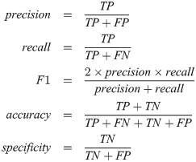
Figure 10: Performance metrics of Machine Learning
5.2 SYSTEM REQUIREMENTS
A Software Requirements Specification (SRS) – It's a software system's requirements definition. It's a comprehensive description of a system's behavior while it's being created. It provides a collection of use cases that explain all of the software's interactions with users. The SRS also covers non-functional requirements in addition to use cases. Non-functional requirements are those that place restrictions on the design or execution of a system (such as performance quality standards, design constraints, engineering requirements).
System Requirements Specification: An organized collection of data that encapsulates a system's needs. A business analyst, also known as a system analyst, is in charge of analyzing their customers' and stakeholders' business demands in order to discover problems and provide solutions. Typically works as a liaison function between the business side of a company and the information technology department or third-party service providers within the systems development life cycle domain. Product and process needs are closely interrelated. Process requirements are frequently used to specify the actions the measures to be taken to meet a product requirement. A maximum development cost requirement (a process requirement) may be imposed to aid in the achievement of a maximum sales price requirement (a product requirement); a requirement that the product be maintainable (a Product requirement) is frequently addressed by imposing requirements to follow specific development styles.
5.2.1 Functional Requirements:
User:
- Load data
- Data pre-processing
- Data Analysis
- Data Model building
- Prediction
5.2.2 Non Functional Requirements:
- Secure access to private data (user information). SSL can be utilized.
- Better component design for improved peak performance.
- For future extension, flexible service based architecture will be highly desirable.
5.3 SOFTWARE REQUIREMENTS
- Operating System : Windows
- Language : Python
- IDE : Jupyter Notebook / pycharm
5.4 HARDWARE REQUIREMENTS
- RAM : 4GB and Higher
- Processor : Intel i3 and above
- Good Internet

5.5 IMPLEMENTATION CODE

Importing Libraries
# for numerical computing
import numpy as np
# for dataframes
import pandas as pd
# for easier visualization
import seaborn as sns
# for visualization and to display plots
from matplotlib import pyplot as plt
%matplotlib inline
# import color maps
from matplotlib.colors import ListedColormap
# to split train and test set
from sklearn.model_selection import train_test_split
# to perform hyperparameter tuning
from sklearn.model_selection import GridSearchCV
from sklearn.model_selection import RandomizedSearchCV
# Machine Learning Models
from sklearn.linear_model import LogisticRegression
from sklearn.ensemble import RandomForestClassifier
from sklearn.tree import DecisionTreeClassifier
from sklearn.svm import SVC
from sklearn.metrics import roc_curve, auc, roc_auc_score, confusion_matrix
from sklearn.preprocessing import StandardScaler
from sklearn.neighbors import KNeighborsClassifier
from matplotlib.colors import ListedColormap
from sklearn.metrics import accuracy_score
#import xgboost
import os
# To save the final model on disk
from sklearn.externals import joblib
np.set_printoptions(precision=2, suppress=True)
df = pd.read_csv("D:/Pandas/employee_data.csv")
# Dataframe dimensions
df.shape
# Columns of the dataframe
df.columns
df.head()
df.describe()
Data Visualization
## We can also use bar plots instead
plt.figure(figsize=(6,4))
sns.countplot(y='department', data=df)
# Plot histogram grid
df.hist(figsize=(6,9), xrot=-45)
## status vs satisfaction
sns.boxplot(y='status', x='satisfaction', data=df)
## status vs last_evaluation
sns.boxplot(y='status', x='last_evaluation', data=df)
Correlations
df.corr()
plt.figure(figsize=(5,6))
sns.heatmap(df.corr())
# Drop duplicates
df = df.drop_duplicates()
print(df.shape)
# Drop temporary workers
df = df[df.department != 'temp']
print(df.shape)
Fix structural errors
# Print unique values of 'filed_complaint'
print( df.filed_complaint.unique() )
# Print unique values of 'recently_promoted'
print( df.recently_promoted.unique() )
# Missing filed_complaint values should be 0
df['filed_complaint'] = df.filed_complaint.fillna(0)
# Missing recently_promoted values should be 0
df['recently_promoted'] = df.recently_promoted.fillna(0)
# Print unique values of 'filed_complaint'
print( df.filed_complaint.unique() )
# Print unique values of 'recently_promoted'
print( df.recently_promoted.unique() )
# Plot class distributions for 'department'
sns.countplot(y='department', data=df)
Outliers
# Display number of missing values by feature
df.isnull().sum()
#Fill missing values in department with 'Missing'
# Display number of missing values by feature
df.isnull().sum()
One hot encoding
# Create new dataframe with dummy features
df = pd.get_dummies(df, columns=['department', 'salary'])
# Display first 10 rows
df.head(10)
# Save analytical base table
df.to_csv('D:/Pandas/analytical_base_table.csv', index=None)
# Create separate object for target variable
y = df.status
# Create separate object for input features
X = df.drop('status', axis=1)
# Split X and y into train and test sets
X_train, X_test, y_train, y_test = train_test_split(X, y,
test_size=0.2,
random_state=1234,
stratify=df.status)
# Print number of observations in X_train, X_test, y_train, and y_test
print(X_train.shape, X_test.shape, y_train.shape, y_test.shape)
X_train = (X_train - train_mean) / train_std
## Check for mean and std dev.
X_train.describe()
## Note: We use train_mean and train_std_dev to standardize test data set
X_test = (X_test - train_mean) / train_std
## Check for mean and std dev. - not exactly 0 and 1
X_test.describe()
Logistic Regression Code:
X_test.fillna(X_train.mean(), inplace=True)
tuned_params = {'C': [0.0001, 0.001, 0.01, 0.1, 1, 10, 100, 1000, 10000], 'penalty': ['l1', 'l2']}
model = GridSearchCV(LogisticRegression(), tuned_params, scoring = 'roc_auc', n_jobs=-1)
model.fit(X_train, y_train)
model.best_estimator_
## Predict Train set results
y_train_pred = model.predict(X_train)
## Predict Test set results
y_pred = model.predict(X_test)
# Get just the prediction for the positive class (1)
y_pred_proba = model.predict_proba(X_test)[:,1]
# Display first 10 predictions
y_pred_proba[:10]
i=113 ## Change the value of i to get the details of any point (56, 213, etc.)
print('For test point {}, actual class = {}, precited class = {}, predicted probability = {}'.
format(i, y_test.iloc[i], y_pred[i], y_pred_proba[i]))
confusion_matrix(y_test, y_pred).T
# Plot the ROC curve
fig = plt.figure(figsize=(5,5))
plt.title('Receiver Operating Characteristic')
# Calculate AUC for Train set
print(roc_auc_score(y_train, y_train_pred))
## Building the model again with the best hyperparameters
model = LogisticRegression(C=1000, penalty = 'l1')
model.fit(X_train, y_train)
indices = np.argsort(-abs(model.coef_[0,:]))
print("The features in order of importance are:")
print(50*'-')
for feature in X.columns[indices]:
print(feature)
# Calculate AUC for Test set
print(auc(fpr, tpr))
Random Forest Code:
tuned_params = {'n_estimators': [100, 200, 300, 400, 500], 'min_samples_split': [2, 5, 10], 'min_samples_leaf': [1, 2, 4]}
model = RandomizedSearchCV(RandomForestClassifier(), tuned_params, n_iter=15, scoring = 'roc_auc', n_jobs=-1)
model.fit(X_train, y_train)
model.best_estimator_
y_train_pred = model.predict(X_train)
y_pred = model.predict(X_test)
confusion_matrix(y_test, y_pred).T
# Calculate AUC for Train set
roc_auc_score(y_train, y_train_pred)
# Calculate AUC for Test set
print(auc(fpr, tpr))
## Building the model again with the best hyperparameters
model = RandomForestClassifier(n_estimators=200, min_samples_split=2, min_samples_leaf=1)
model.fit(X_train, y_train)
indices = np.argsort(-model.feature_importances_)
print("The features in order of importance are:")
print(50*'-')
for feature in X.columns[indices]:
print(feature)
K-Nearest Neighbour Code:
from sklearn.model_selection import cross_val_score
from sklearn.model_selection import train_test_split
# creating odd list of K for KNN
neighbors = list(range(1,20,2))
# empty list that will hold cv scores
cv_scores = []
# 10-fold cross validation , 9 datapoints will be considered for training and 1 for cross validation (turn by turn) to determine value of k
# determining best k
optimal_k = neighbors[MSE.index(min(MSE))]
print('\nThe optimal number of neighbors is %d.' % optimal_k)
y_pred = classifier.predict(X_test)
y_train_pred = classifier.predict(X_train)
acc = accuracy_score(y_test, y_pred, normalize=True) * float(100) ## get the accuracy on testing data
acc
cnf=confusion_matrix(y_test,y_pred).T
cnf
# Get just the prediction for the positive class (1)
y_pred_proba = classifier.predict_proba(X_test)[:,1]
# Display first 10 predictions
y_pred_proba[:10]
# Calculate AUC for Train
roc_auc_score(y_train, y_train_pred)
# Calculate AUC for Test
print(auc(fpr, tpr))
Decision Tree Code:
tuned_params = {'min_samples_split': [2, 3, 4, 5, 7], 'min_samples_leaf': [1, 2, 3, 4, 6], 'max_depth': [2, 3, 4, 5, 6, 7]}
model = RandomizedSearchCV(DecisionTreeClassifier(), tuned_params, n_iter=15, scoring = 'roc_auc', n_jobs=-1)
model.fit(X_train, y_train)
model.best_estimator_
y_train_pred = model.predict(X_train)
y_pred = model.predict(X_test)
y_pred_proba = model.predict_proba(X_test)[:,1]
y_pred_proba[:10]
confusion_matrix(y_test, y_pred).T
# Calculate AUC for Train
roc_auc_score(y_train, y_train_pred)
print(auc(fpr, tpr))
Support Vector Machine Code:
from sklearn import svm
def svc_param_selection(X, y, nfolds):
Cs = [0.001, 0.01, 0.1, 1, 10]
gammas = [0.001, 0.01, 0.1, 1]
param_grid = {'C': Cs, 'gamma' : gammas}
grid_search = GridSearchCV(svm.SVC(kernel='rbf'), param_grid, cv=nfolds)
grid_search.fit(X_train, y_train)
grid_search.best_params_
return grid_search.best_params_
svClassifier=SVC(kernel='rbf',probability=True)
svClassifier.fit(X_train,y_train)
## Building the model again with the best hyperparameters
model = SVC(C=10, gamma=1)
model.fit(X_train, y_train)
## Predict Train results
y_train_pred = model.predict(X_train)
## Predict Test results
y_pred = model.predict(X_test)
confusion_matrix(y_test, y_pred).T
# Calculate AUC for Train
roc_auc_score(y_train, y_train_pred)
print(auc(fpr, tpr))
5.3 SCREENSHOTS AND RESULTS
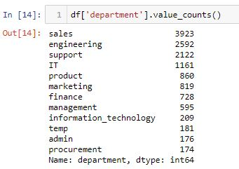
Screenshot 1: Summarize Categorical Values
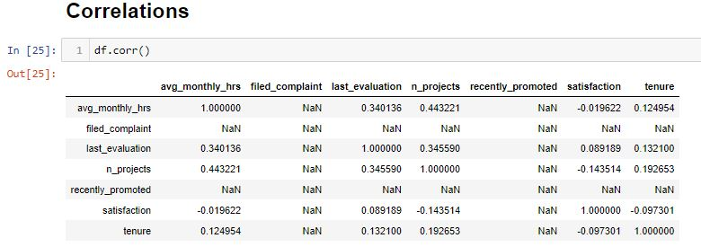
Screenshot 2: Correlation for the model
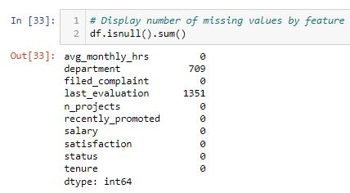
Screenshot 3: Outliers and missing values
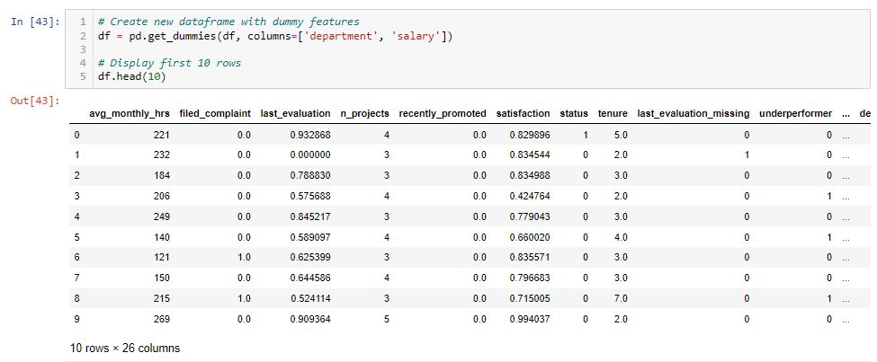
Screenshot 4: One-Hot Encoding for Categorical Values
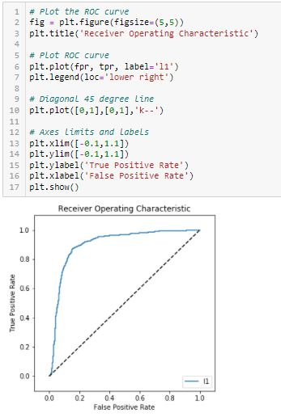
Screenshot 5: Plotting ROC Curve

CHAPTER 6
RECOMMENDATIONS & THOUGHTS

The following ideas are based on the findings: employees are dissatisfied with the organization's recognition and performance appraisal. As a result, they should place considerable emphasis on it. Employees must be properly compensated in order for the company to retain them for a lengthy period of time. Employees are feeling overworked as a result of the workload. As a result, the company should concentrate on ensuring a smooth workload in order to reduce employee stress. Employees and management must enhance their relationship. The following are the main guidelines to keep in mind when developing employee retention strategies:
- First and foremost, hire the appropriate individuals.
- Employees should be empowered. Give your personnel the authority to complete tasks.
- Make employees realise that they are the company's most valuable asset.
- Have faith in them, respect them, and trust them.
- Provide them with knowledge and facts.
- Continue to give them comments on how they're doing.
- Recognize and congratulate them on their accomplishments.
- Maintain a positive attitude among them.
- Create an environment in which employees desire to work while also having a good time.
People want to enjoy their work, therefore make it enjoyable for them. Recognize that employees need to balance their personal and professional lives, thus provide flexible start times and core hours. To encourage open communication, provide 360-degree feedback surveys and other questionnaires. Allow anonymous questionnaires on occasion so that staff can be more open and honest about their thoughts. Provide opportunities for career advancement and cross-training inside the organisation.

CHAPTER 7
CONCLUSION

It is self-evident that industries will not be able to survive in the long run unless they have predictive analytics skills in human resource management. The relationship between excellent HRM practises and their impact on employees and organisations provides an effective means for corporate sector employees and HR practitioners to develop desirable employee attitudes and behaviours, which in turn contribute to improved organisational performance over time. Existing studies, while some did, did not place enough attention on the type of employee, the sector of the economy, or the sort of firm that is most affected by one element or another. To reduce attrition, the study finds that businesses should use new creative technologies and effective training programmes to provide possibilities for employees to progress within the corporation. More research is needed to better provide organisations with the knowledge they need to improve their retention capability. In comparison to Logistic Regression and Support Vector Machine, the results showed that Random Forest Regression produces the best results. Instead, by identifying at-risk employees, analytics may be utilised to prevent this from happening in the first place. Predictive analytics can identify who is most likely to leave the company by analysing criteria such as compensation, promotions, corporate culture, and relationships with managers.

REFERENCES
- Mita, M., Aarti K. and Ravneeta, D. (2014) Study on Employee Retention and Commitment. International Journal of Advance Research in Computer Science and Management Studies, 2, 154-164.
- Kumar, Sanath & Devadas, Udaya & Dhammika, Kas. (2021). Impact of Employee Value Proposition on Employee Retention: A conceptual paper. 10.5281/zenodo.5513384.
- Reddy Asi, Dr Vasudeva. (2021). Compensation System: Influence on Employee Retention.
- Gorde, Sangita. (2019). A Study of Employee Retention.
- Silva, Melissa & Carvalho, Joao & Dias, Álvaro. (2019). Determinants of Employee Retention. 10.4018/978-1-5225-7888-8.ch004.

