Solve Advanced Query by using the Two Tables:

1.

Write the query to display productionid, production name with total number movies produced by each.

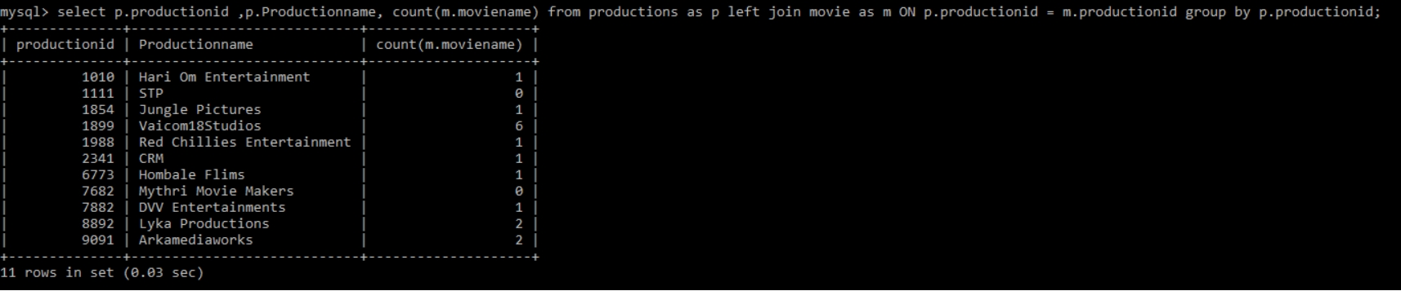

2.

Write the query to display production name, owner name have produced more than 2 movies.

SELECT productions.productionname,productions.ownername,COUNT(\*)

FROM productions

INNER JOIN movie ON movie.productionid = productions.productionid

group by productionname

HAVING COUNT(\*)>2;

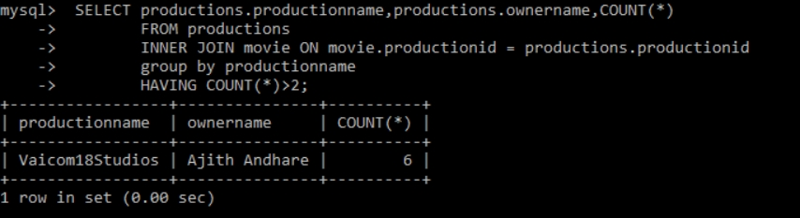

3.

Write the query to display production name, owner name have produced maximum movies

SELECT productions.productionname,productions.ownername

FROM productions

INNER JOIN movie ON movie.productionid = productions.productionid

group by productionname

ORDER BY COUNT(\*) DESC

LIMIT 1;

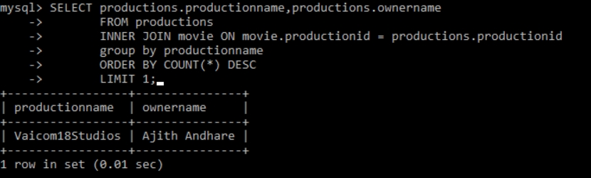

4.

Write the query to display the moviename, heroname and productionname acted in the producer name= ’Subaskaran’.

SELECT movie.moviename,movie.HeroName,productions.productionname

FROM productions

INNER JOIN movie ON movie.productionid = productions.productionid

WHERE ownername='Subaskaran';

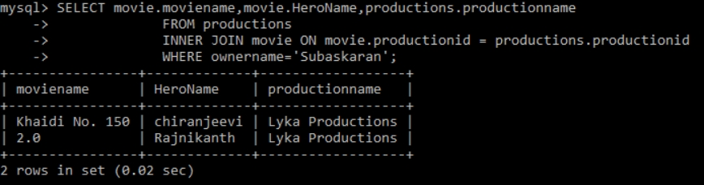

5.

Write the query to display the moviename, heroname whose productionid ends with 82.

SELECT movie.moviename,movie.HeroName FROM productions

INNER JOIN movie ON movie.productionid = productions.productionid

WHERE

movie.productionid LIKE '%82';

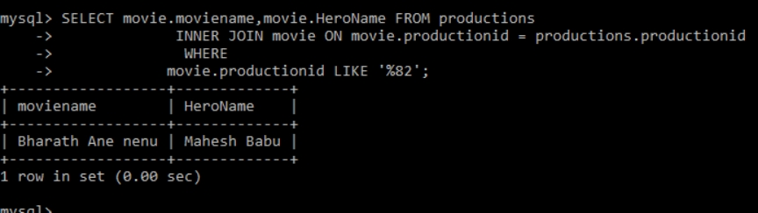

6.

Write the query to display the productionname, ownername who has not produced the movie.

SELECT productions.productionname,productions.ownername FROM productions

LEFT JOIN movie ON movie.productionid = productions.productionid

WHERE moviename IS NULL;

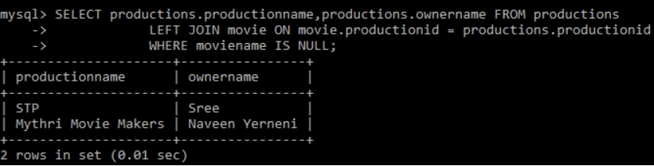

7.

Write the query to display the productionname, ownername who has not produced the ‘hindi’ movie.

select p.Productionname,p.Ownername from productions p left join movie m on m.Productionid=p.productionid and m.language="Hindi" where

m.Language is null;

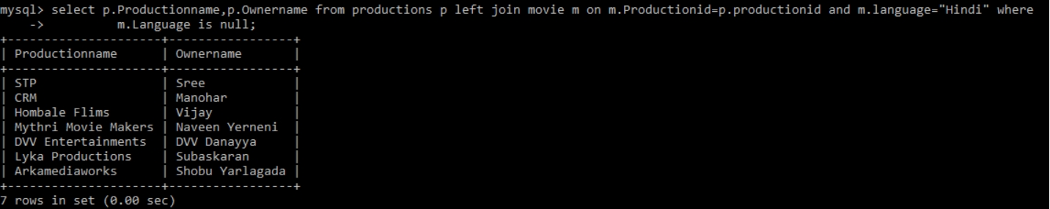

8.

Write the query name to display the heroinename who acted in the different productions but not in same production id.

CREATE TABLE basic(heroine VARCHAR(30));

mysql> INSERT INTO basic

SELECT movie.Heroine FROM movie

INNER JOIN productions ON productions.productionid=movie.productionid

GROUP BY(ownername);

select heroine from basic

-> GROUP BY heroine

-> HAVING COUNT(heroine)>1;



Ans:AMY

9.

Write the query to display the heroname who acted in maximum languages.

Ans: select distinct Heroname ,Language , count(Heroname) as result from movie group by(Language) order by (result) desc limit 1;

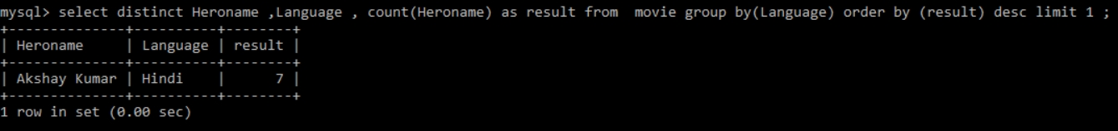

10.

Write the query to display the production name, owner name who has produced movie for more languages.

Ans:

select Distinct p.Productionname,p.Ownername ,count(p.Productionname) as counter from movie as m right join productions as p ON m.productionid =p.productionid group by(m.language) order by(counter) desc limit 1;



11.

Write the query to display the productionname, producername who has not produced any movie.

Ans: select p.Ownername ,p.Productionname from movie as m right join productions as p ON m.productionid =p.productionid where m.moviename is null ;

