Solve the SQL fundamentals Query:

1.Display the name of movies, movie type is starts with Drama.

ANS: select moviename from movie where Movietype like "Drama%";

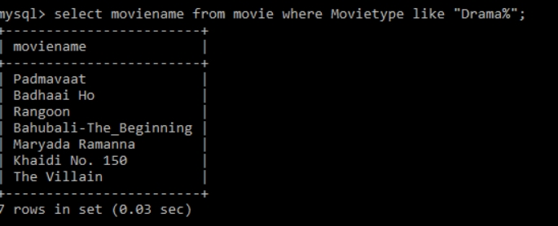

2.Display the movies acted by actor Ayushmann.

Ans: select Moviename from movie where Heroname like "Ayushmann";

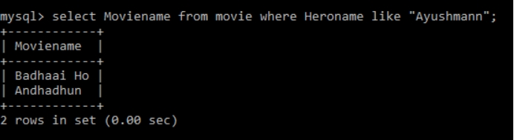

3.Display the count of movies, having length above 18.

Ans:select count(Moviename) from movie where Length>18;

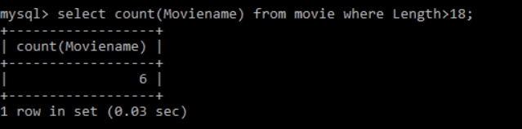

4.Display the movie having minimum length.

Ans: select Moviename from movie where Length=(select min(Length) from movie);

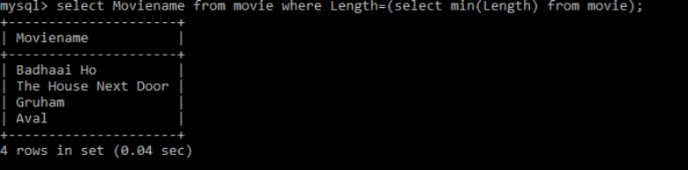

5.Display all the details of movie, the language that first name starts with ‘T’

Ans: select \*from movie where Language like 'T%';

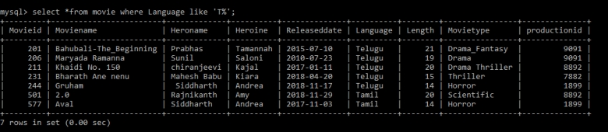

Display the movie name, hero name, heroine name whose having maximum length.

Ans:select Moviename,Heroname,Heroine from movie where Length=(select max(Length)from movie);

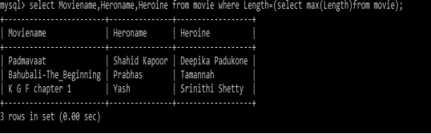

7.Display the movie name, hero name, heroine name the movie released after 15 march 2018.

Ans:select Moviename,Heroname,Heroine from movie where Releaseddate>'2018-03-15';

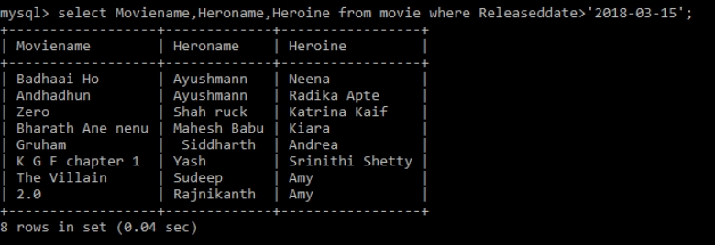

8.Display the count of thriller movies.

Ans:select count(Moviename) from movie where movietype like '%Thriller';

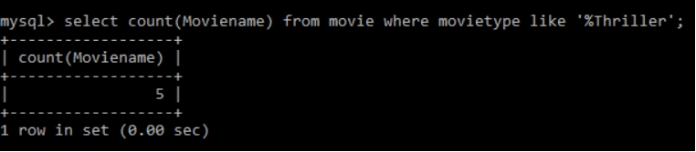

9Display the count of movies whose released before 15 march 2018.

Ans: select count(Moviename) from movie where Releaseddate<'2018-03-15';

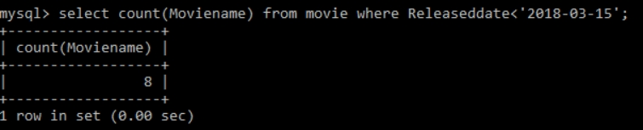

1. Display the release date of the movie name ‘Zero’.

Ans:select Releaseddate from movie where Moviename='Zero';

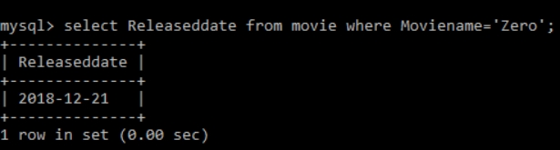

11.Display the actor name that acted with ‘Amy’.

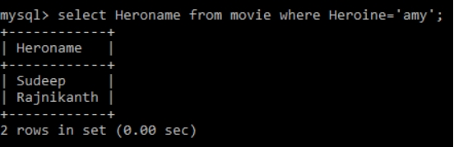

12.Display the Count of maximum movies released in a month of October.

select Hero name from movie where Heroine='amy';

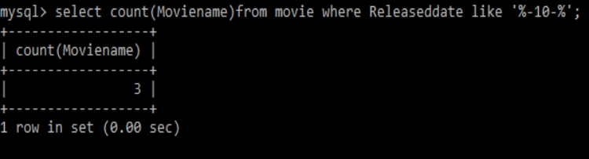

13.Display the movie names whose production id for different languages.

Ans: select moviename,Productionid from movie ;

