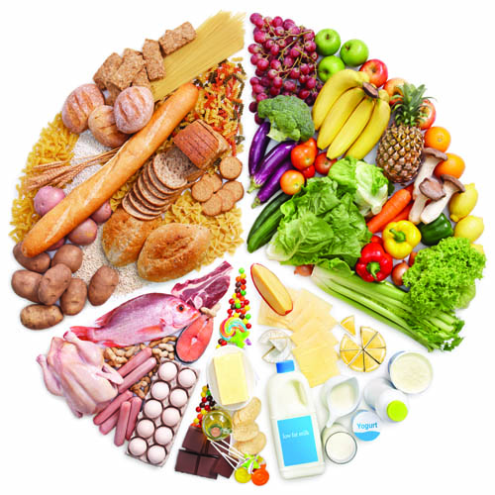

**CS551 Advance Software Engineering**

**FOURTH INCREMENT REPORT**

**Project Diet Planner**

**Group# 3**

**Group Members:**

BhuLakshmi Makkena

Lakshmi Sirisha Devineni

Jyoshna Bollineni

Faisal Hakami

**Contents**

1. Introduction
2. Objectives/Features
3. Import Existing Services/API
4. Report all existing services, widget, API or source code you used in your project.
5. Detail Design of Services (using tools)
6. WireFrames and Mockups
7. Architecture diagram/Sequence diagram/Class diagram
8. Write User Stories /Use Case/Service description
9. Testing (using tools)
10. Unit testing
11. Performance testing
12. A/B testing
13. Implementation (using Ionic framework/Angular.js/Bootstrap/MongoDB/Bluemix)
14. Server Side Implementation: REST services & Database
15. Mobile Client Implementation: Implementation of Mobile Apps
16. Deployment
17. Include your project management site link to the report
18. Post your mobile web app and services to your project cloud site (IBM Bluemix) and include the URLs to the report
19. Deploy your mobile app to smartphones and describe it including the screenshots
20. Post your second increment report and source code to your GitHub site and include the URL to the report and the google spreadsheet.
21. https://docs.google.com/spreadsheets/d/1vBMJ4gp22y1JzebvTcwkDS1r9Aals 2H7H-ml_wznHSg/edit#gid=411568252
22. Submit your report to the blackboard project second increment submission site.
23. Project Management
24. Implementation status report
25. Work completed:
26. Description
27. Responsibility (Task, Person)
28. Time taken (#hours)
29. Contributions (members/percentage)
30. Work to be completed
31. Description
32. Responsibility (Task, Person)
33. Time to be taken (estimated #hours)

III.Issues/Concerns

Bibliography

**Introduction**

Nutrition is essential to cells that are important to support life. Health diet is important

to prevent many health problems. Malnutrition is caused due to nutritional imbalances or excessive consumption. For proper health it is important for everyone to know what the food that we are eating is composed off, and to what extent it is meeting the daily requirement .Deficiencies in nutritional values results in long-term problems to individual. Hence, calculating BMI (Body Mass Index) will help people to know their health conditions and ensure they are in good health conditions.

The Diet Planner web application is to develop an application which contains database

Comprising of nutritional value, calorific value, protein value, fat content, fiber content, vitamins

Present in particular food item which user can input the food in terms of text/audio/image. It allows users to plan their daily calorie and nutrient intake based on the Body Mass Index (BMI). It also allows users to view nutritional chart, which contains information about the nutritional values of various food items for user to have an idea about the nutritional values present in various food items.

**Goal and Objectives**

* Diet Planner is an ionic application. Its main Goal is to take the information about the food items consumed as an input (Text, Image, Voice signals) and compare it with the available standard per day intake of different type of nutrients.
* The information comprises of nutritional value, calorific value of the particular item.
* For every input both the calorie reading and daily required nutrients will be changing.
* The system also suggests the nutrient rich foods for the user based on the input provided.
* The system also calculates the Body Mass Index of the user by taking Height and weight as input.
* A detailed chart about different types of food items available along with the nutrient contents are displayed as nutrition chart in the diet planner.

**Framework Specification:**

Initially we have used Java script and SQL to implement the application in the form of a Native web application. Now we have used ionic framework and implemented the functionalities in angular js and MongoDB. We have used bootstrap for the User Interface and used API’s to call few functionalities. We are creating a Hybrid application which can be run on Web and Mobile simultaneously.

**Import Existing Services/API**

* API to show the nutrition contents of the typed food Item. Here we have used nutritionix API to display the nutrition contents of the required food items.
  + <https://developer.nutritionix.com/demos>
* API to display all the calorie and nutrient information of the variety of foods recipes available. For this we have used edamam API.
  + <https://developer.edamam.com/diet_api_documentation>
* MongoDB API to validate the user information. We have created an collection and new Users in MongoDB and used it to validate the users information.

[**https://mongolab.com/connections/assgnment7/collections/users**](https://mongolab.com/connections/assgnment7/collections/users)

**Detail design or services:**

**Architecture diagram:**

The architecture diagram describes about the entire application how actually the system is working. The user access the application over a phone using the ionic software and Angular Js. The database used is mongo dB, the user information data about the application is stored in database. We are using API rest services like nutritionix, Edamam to call the basic functionalities and use them in our application.

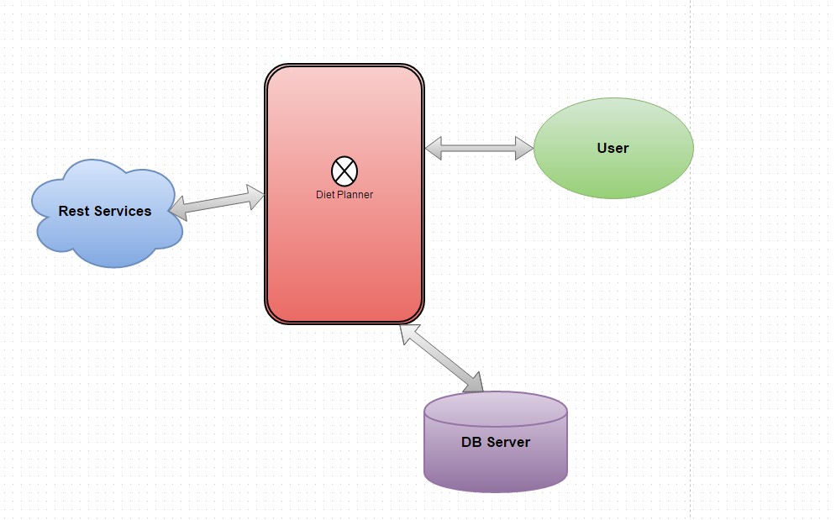

**ACTIVITY DIAGRAM:**

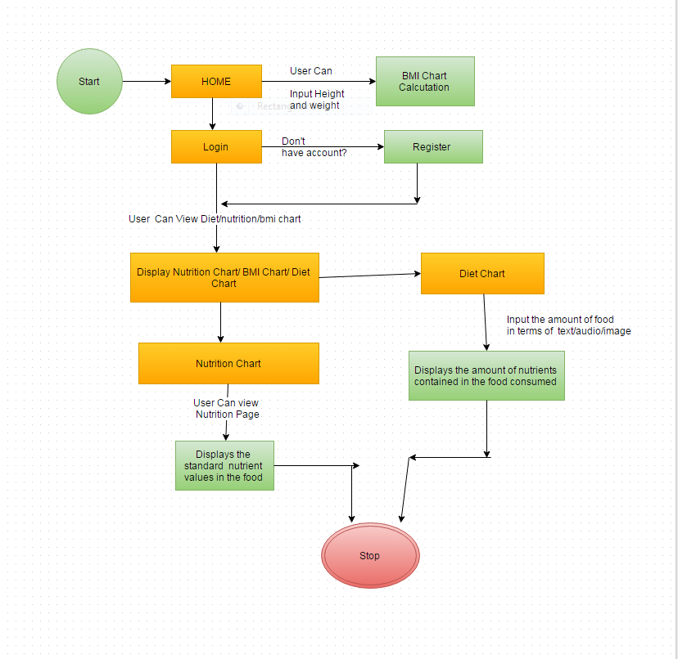

* When user open the application, he must be able to access BMI without any user access.
* The user creates an account in the registration page.
* A registered user will have access to nutrition, Diet chart.
* Nutrition Chart is a dynamic chart that displays the information about the various food items about their nutrional values.
* Diet chart displays about the nutrional values present in the food consumed by the user.

**CLASS DIAGRAM:**



The above figure shows the class diagram for Diet Planner. The explanation is as follows

The Diet Planner consists of Home page and it consists of Login, View BMI, Register, Logout options.

We have Association from Home page to Anonymous User, BMI, Login User, and Registration. Anonymous

User entering in to the Home Page can View BMI and View Nutrition Chart by entering the Login Details or New User the User has to go for Registration. The user can enter the details in the Register Page which consists of Attributes Email id, Name, Password, Address, Phone number, Date of Birth, Gender, City. The methods are Enter Details, Submit, Reset, and Update.

If the old user enters in to the Home page the user can enter the Login Details by giving Email id, Password which are available as Attributes and the methods are Login, Logout. The user gets directed to the Diet Planner Home page and can go either for Diet Chart, BMI chart, Nutrition Chart based on user’s desire. We have Login dependent on Registration

The BMI Chart is dynamic and takes Height and Weight from the User which are available as attributes and the methods are Submit and View BMI. It takes input from user and gives the BMI Index and state of the user. That is, Whether Normal or Obese or Weak.

In the Diet Chart the user can enter Food Item and get the amount of calories, fat, proteins, Vitamins content in the food. The user can enter the food item in either Text or Voice or Image format. The Voice, Image and Text are generalized on Diet Chart. The user is given Suggestions based on the food taken by User based on users BMI. The Diet Chart connects to Online Database and retrieves information about the food.

The Nutrition Chart is dynamic and the user on entering the food item gets the Amount of Calories, Fat, Proteins, and Vitamins available for that food. The Nutrition is in Inheritance with Login User.

**SEQUENCE DIAGRAM:**

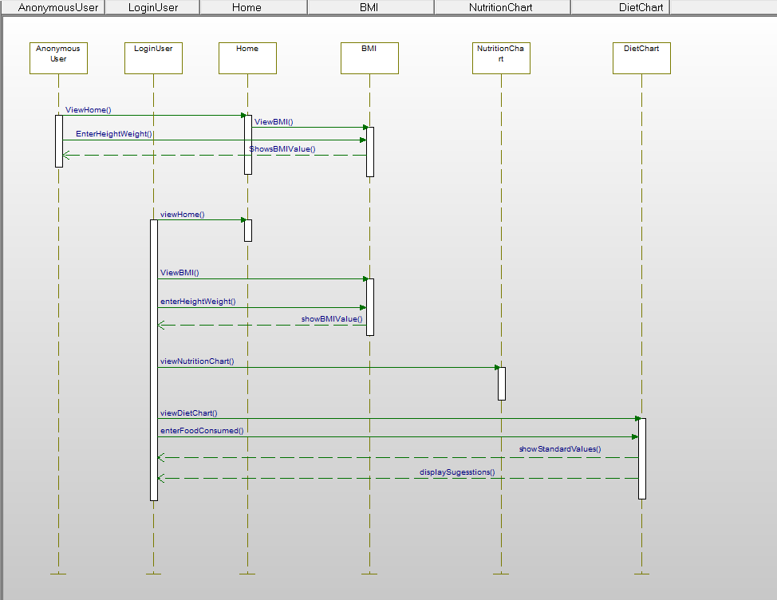

The above figure shows the Sequence Diagram and explanation as follows

Anonymous User entering in to the Home Page can enter Height and weight as inputs and get the BMI Index value as output and state of user without login in to the application.

The user after getting login to the site Can View Nutrition Chart and gets the amount of calories, Proteins, Fats, Vitamins for the particular food entered in the search button

The user after getting login can view Diet Chart and give the input as food item in different types as text, image, and voice. The comparison is done with the Standard values available and suggestions are given to the user based on the food taken. By this, the user can maintain good health following the suggestions.

**User stories:**

* As a user, I must login to account to access the application.
* As a system, I must allow the user to login only if the credentials are correct.
* As a system, I must be able to access the database which shows the details of standard per day intake of Calories, Proteins, Fiber Content, Vitamins and Fats.
* As a system, I must analyze the input message provided in diet chart and give suggestions accordingly.
* As a system, I must give the output as suggestions for diet by comparing the standards with the amount consumed.
* As a system, I must calculate the BMI based on the input provided by user.
* As a user, I must be able to view the nutrition chart which displays the Calories, Proteins, Fiber Contents, Vitamins and fats.
* As a user, I must be able to give message in the type of text, image or audio for diet chart.
* As a system, I must be able to detect the input message given in diet chart and process it.
* As a system, I must be able to analyze the height and weight and calculate the BMI.

**Use Case Diagram:**

USE CASE FOR ANONYMOUS USER:

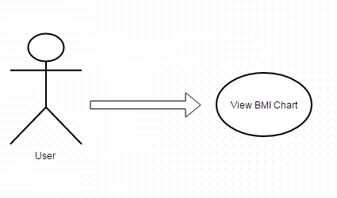

USE CASE FOR AUTHORISED USER:



**WIRE FRAMES & MOCKUPS:**

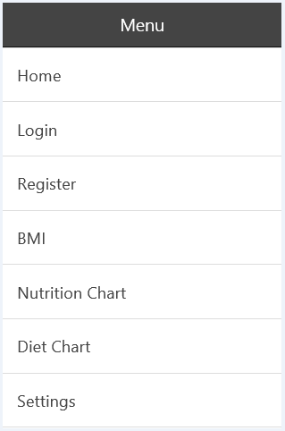

The Menu Bar displays all the pages of the application namely:

* Home Page
* Login Page
* Register Page
* BMI Page
* Nutrition Chart
* Diet Chart
* Settings

**Login Page:**

The User can login to the application in this page.

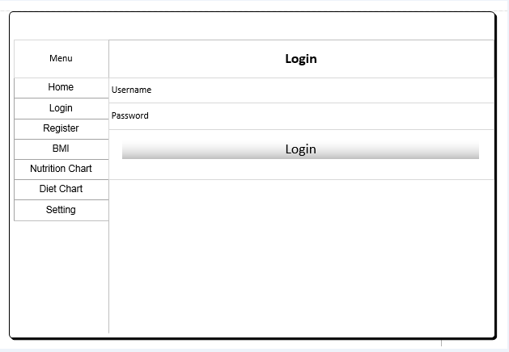

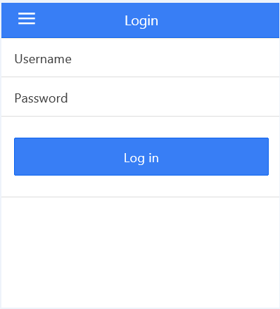

Using Mondo DB database in login page to retrieve the user details..

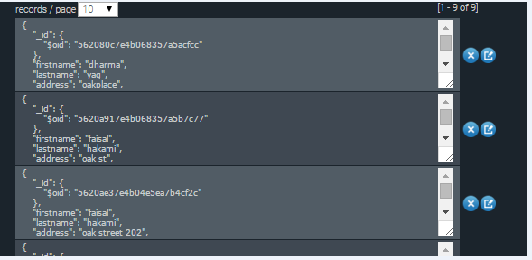

**Registration Page:**

The user can create account in the register page by entering the below details:

* First Name
* Last Name
* Address
* Age
* Username
* Password

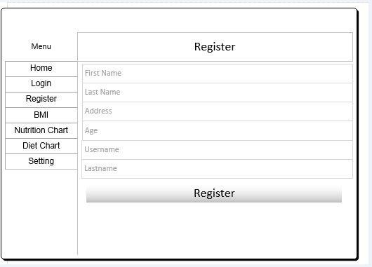

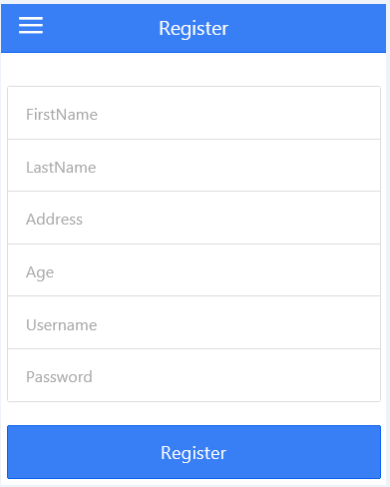

Using Mongo DB in registration page to store the user details….



**CAMERA PLUGIN using Cordova:**

The camera plugin captures the picture of the food that is given by the user.

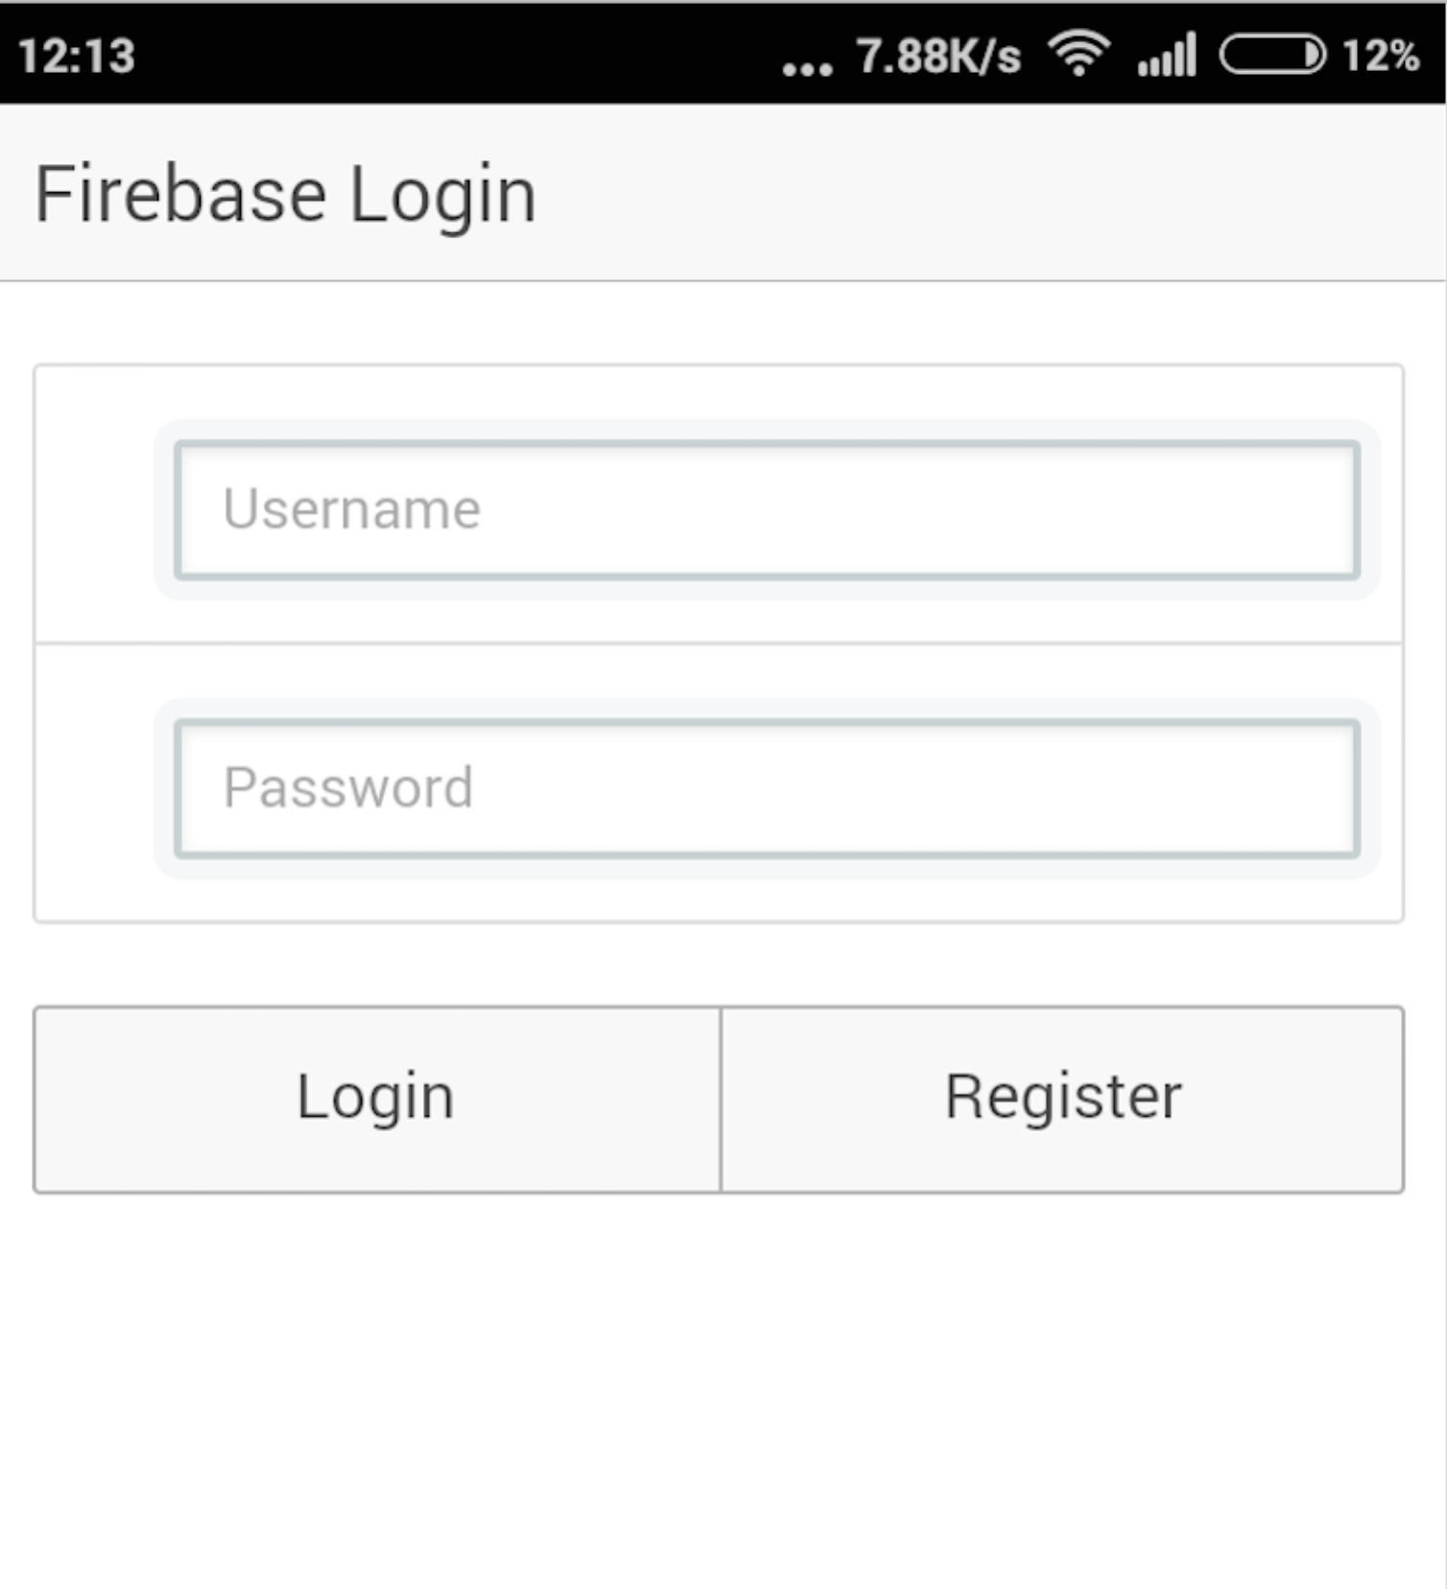

**BMI Chart:**

In the BMI chart, User gives his height and weight in the form of lbs or kg and gets the resultant BMI value.

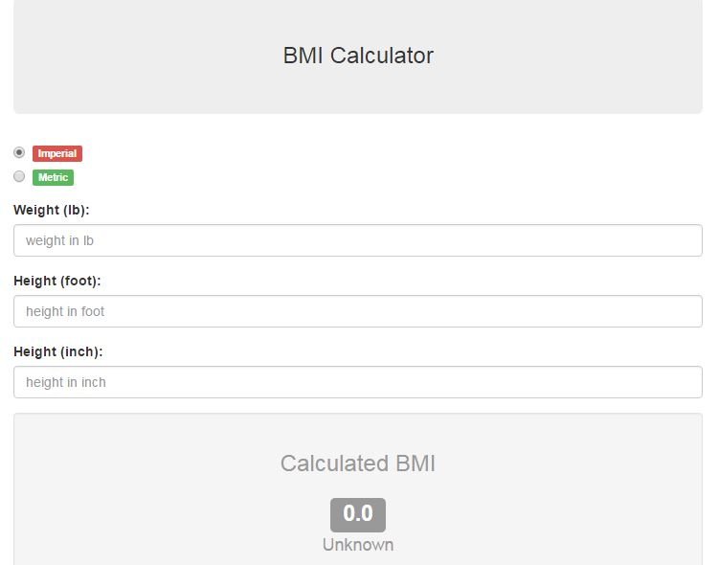

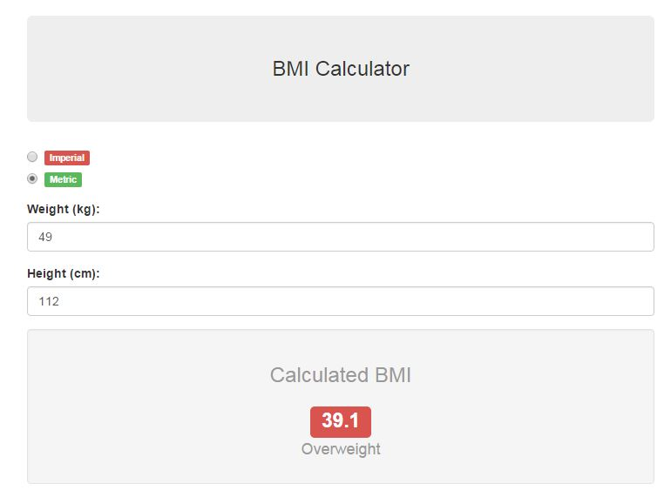

**Diet Chart:**

The user gives the information about the food intake. The user can add the food item in this page.

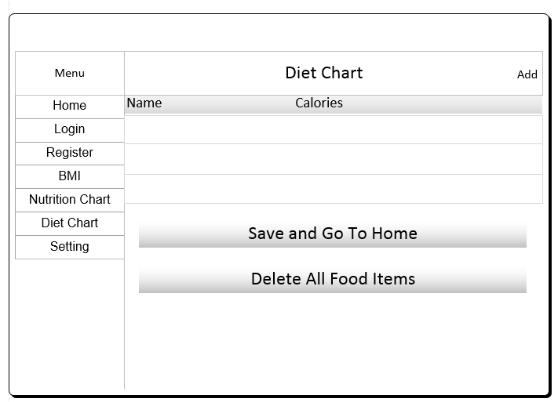

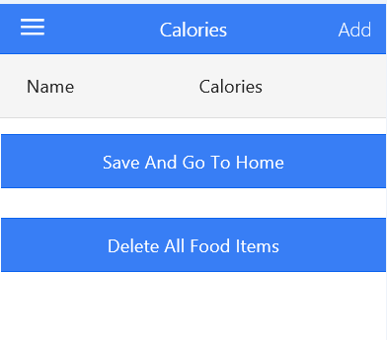

The application reports the amount of calories in taken. The amount of calories needed more for the day.

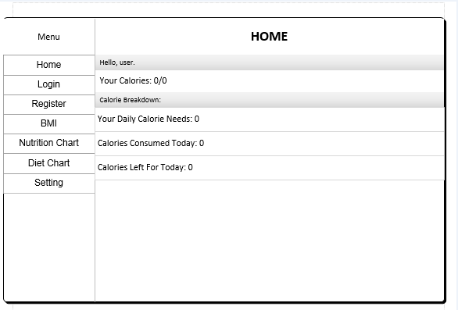

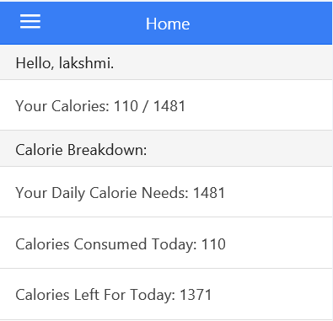

**Nutrition Chart:**

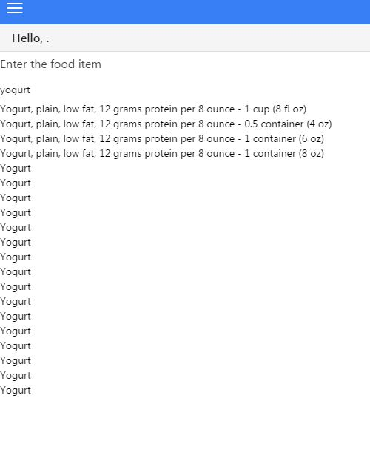

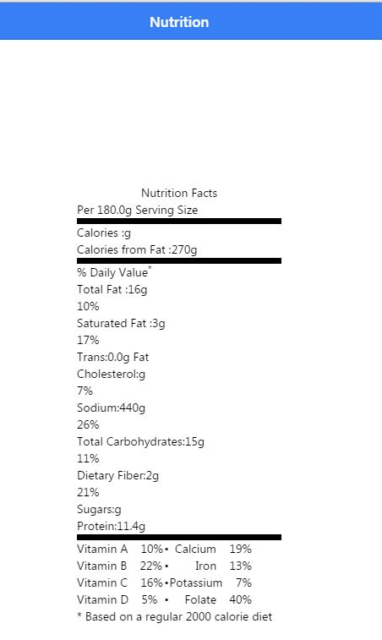

**Settings Page:**

The user can do profile settings in this page

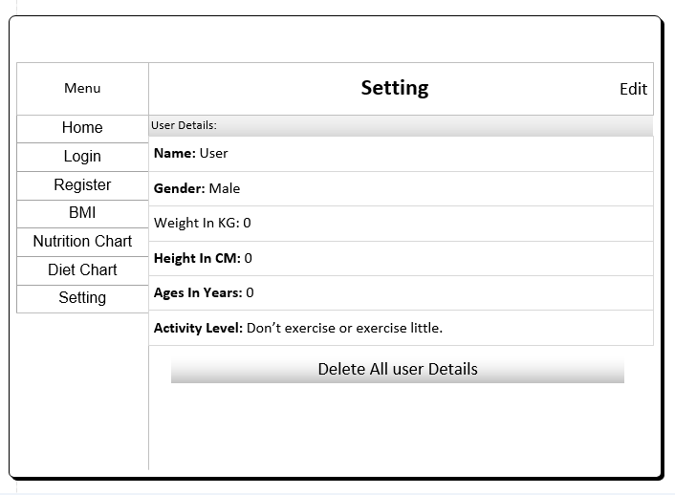

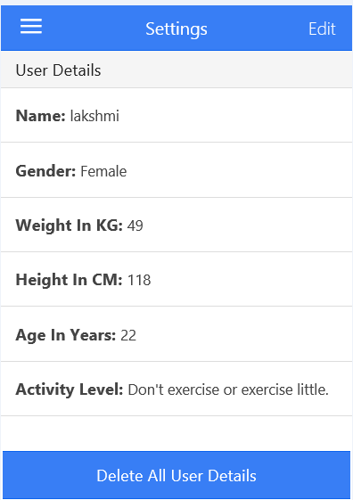

**TESTING**

**UNIT TESTING:**

We use angular js in ionic framework along with tools like Karma and jasmine to do the unit testing. Karma as an environment for running the tests and Jasmine for actual test cases and framework for JavaScript code

The application is broken in to small logics and each logic is called chunk or unit and checking whether each unit works as desired unit. The test case is written for Login, Registration, Diet Chart, BMI chart, Nutrition chart. The output is checked whether all the test cases are executed successfully and if they are satisfied then the application can be deployed

**PERFOMANCE TESTING:**

Performance testing determines the loopholes of application from server side in terms of response times, throughput, CPU Utilization, Memory Utilization of application under different load.

The performance testing is done using Y Slow tool

Y Slow which is a Firebug extension used for grading the application in real time. It analyzes the webpages and suggests performance has to be improved. It grades the application and consists of Home, Grade, Components, and Statistics. It consists of Rulesets based on that the grade is given.

In the below figure, the webpage is kept in the Y Slow tool and the grade is given by tool based on Rule Sets. Here the Grade is given as B by the tool.

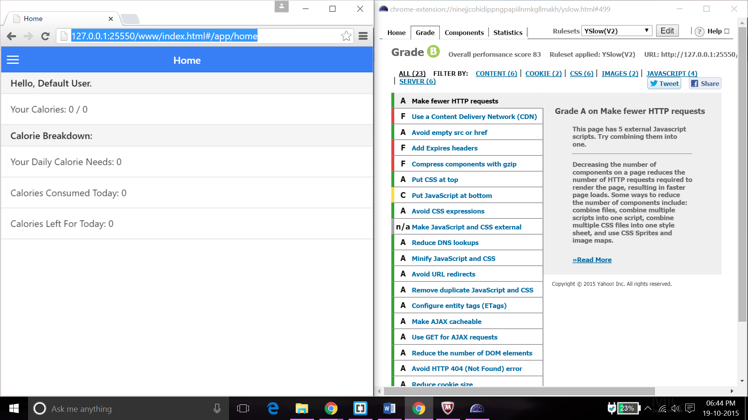

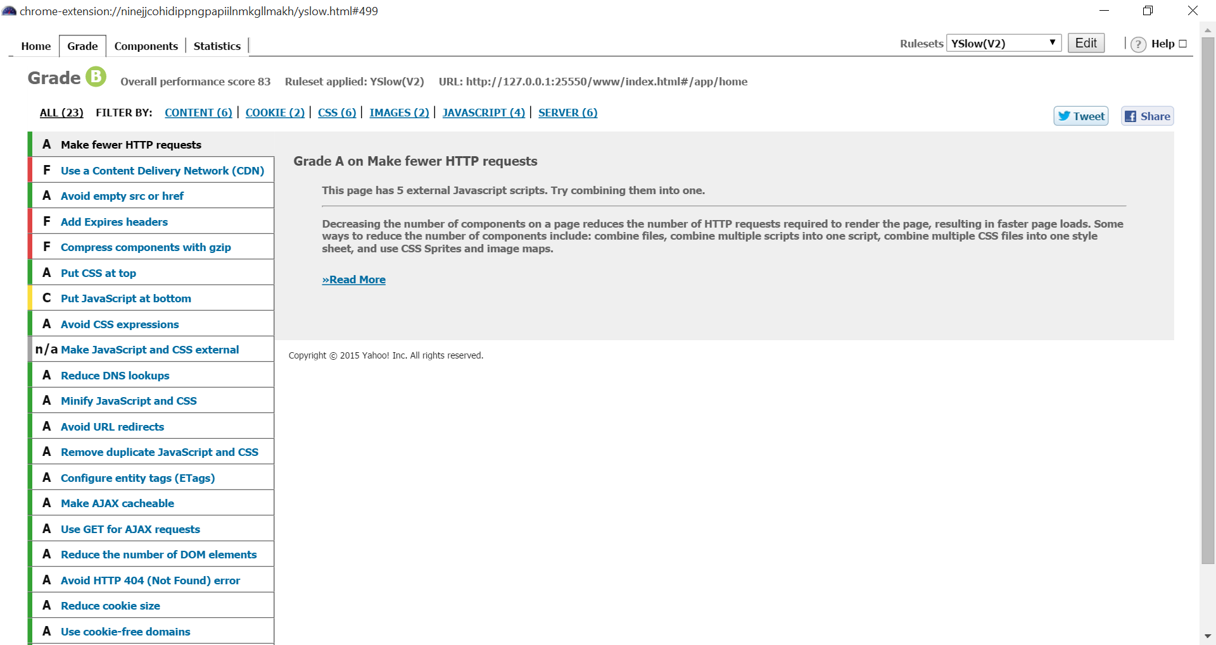

The above figure shows the webpage put in Y Slow tool and the grade B is given. The overall performance score 83 is given by the tool as the Rule Set is applied. It says to improve the Grade and gives suggestions for improving the grade

**A/B TESTING:**

This testing is used for comparing two different versions of same webpage. This evaluates which webpage is better for implementation. For instance, takes A as one web page with one version and B as other webpage with different version and compares A and B webpages. This checks which better user interface is. The evaluation is done by site visitors and they determine which webpage is the winner. This is useful and optimization is performed. Because of this the webpage authority gets benefited as many users visit the page leading to increase of revenue.

**IMPLEMENTAION(using the ionic framework/Angular.js/Boostrap**

**/MongoDB)**

Server side implementation: We have used three API’s and implemented the whole application in ionic framework. The source code has be written in angular js and used boostrap to implement GUI of our application.

We have used firebase server to login into the system and for the nutrition chart we used Nutritionix API. For Diet chart to calculate the calories of the recipe we use Edamam API.

The database is maintained by MongoDB.

Ionic framework is a hybrid application which allows application to be both web and Mobile. i.e cross platform application.

**Mobile client implementation:**

Mobile client applications enable users to access the application or site on their smartphones unlike web applications which need PC’s to access the application.

We are implementing our project in mobile client using ionic framework .

**Deployment:**

**Project management:**

We have divided the whole application into four modules and divided among our team members.

Each of us has implemented one each module. We have divided the application in terms of functionalities. Modules are whole GUI, Login, Register pages, BMI functionality, Diet Chart and Nutrition chart.

We have coordinated our project using Kanban tool. The updated project Management site url is given below.

<http://jyoshna.kanbantool.com/boards/175412>

**Implementation status report**

**Work completed:** We have completed 98% of the application and working towards the completion of the project.

• **Description:** AS a part of second incrementation, WE have completed the BMI chart, Nutrition chart and have completed the User interface part of Diet chart.

• **Responsibility** (Task, Person)

GUI, Login, Register- Faisal Hakami

Nutrition Chart-Sirisha

BMI-Jyoshna

Diet Chart-Lakshmi

* **Time taken** (#hours): Each of the team member has taken 20 hrs. to complete the project.

• **Contributions** (members/percentage)

GUI, Login, Register- Faisal Hakami

Nutrition Chart-Sirisha

BMI-Jyoshna

Diet Chart-Lakshmi

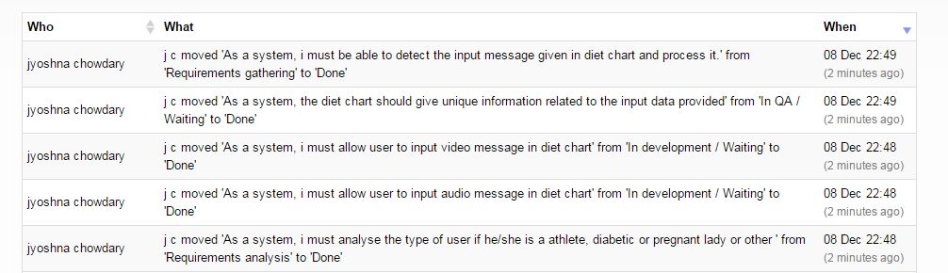

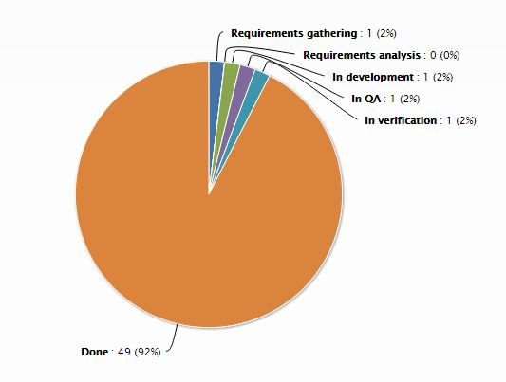

**Work to be completed:** There is more 2% of work to be completed to implement the full project as proposed earlier.

• Description: There is some API calls that have to be implemented in diet chart to process the user input in terms of voice commands and Image uploading. This feature needs to be implemented in the Third increment and we are working towards it.

• Time to be taken (estimated #hours): The estimated hours to complete the rest of the application is expected to be 70 more hours.

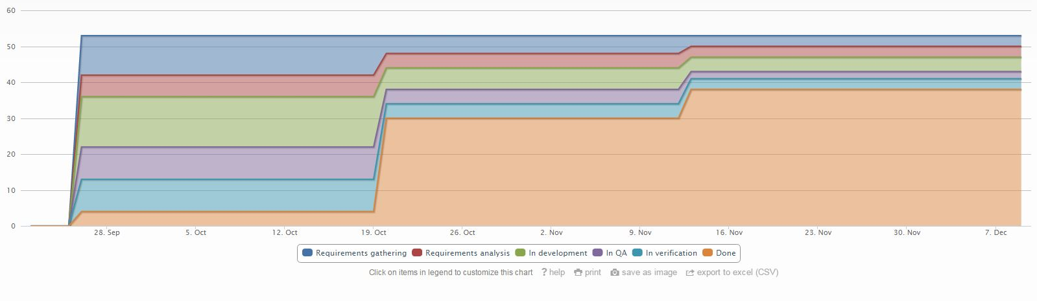

**Issues/Concerns:**

* Finding the online database which has more than ten thousand food items with all the calorific information is a concern.

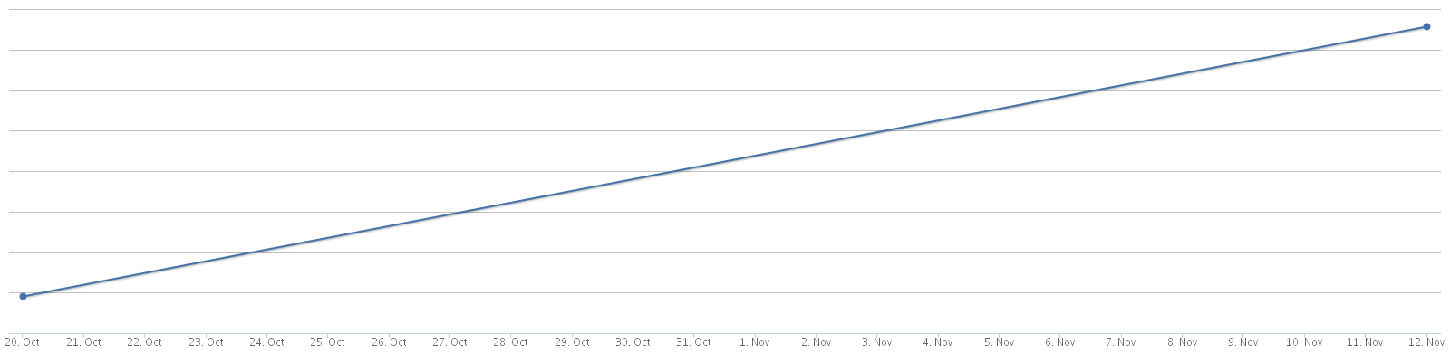

**BIBLIOGRAPHY**

**• http://www.iibt.in/**

**• http://www.who.int/en/**