Documentation for pushing the code / Applications to git hub.

1. First need to create the github account by clicking on “Sign Up” button.



1. After that sign with the credentials.

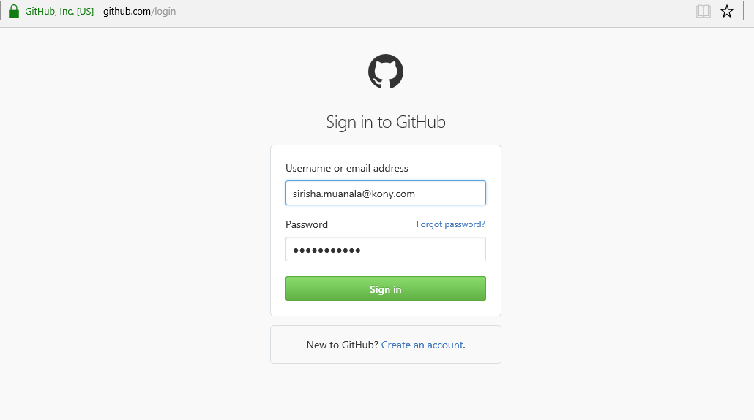

1. Invite the user to particular repository (eg: Kony-CSE)
2. Once we got the access please login to the <https://github.com/Kony-CSE> URL.

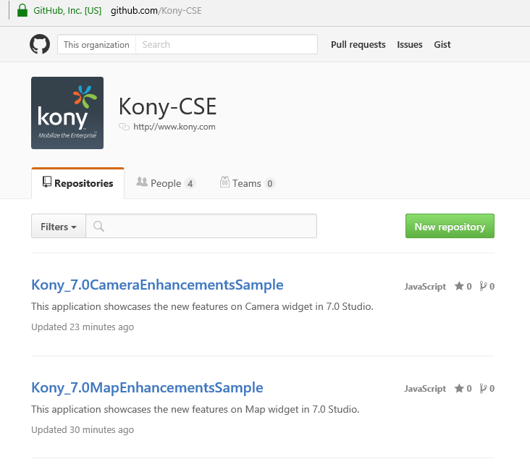

1. After login, please click on New Repository button.
2. Add the new repository name and click Create Repository button.

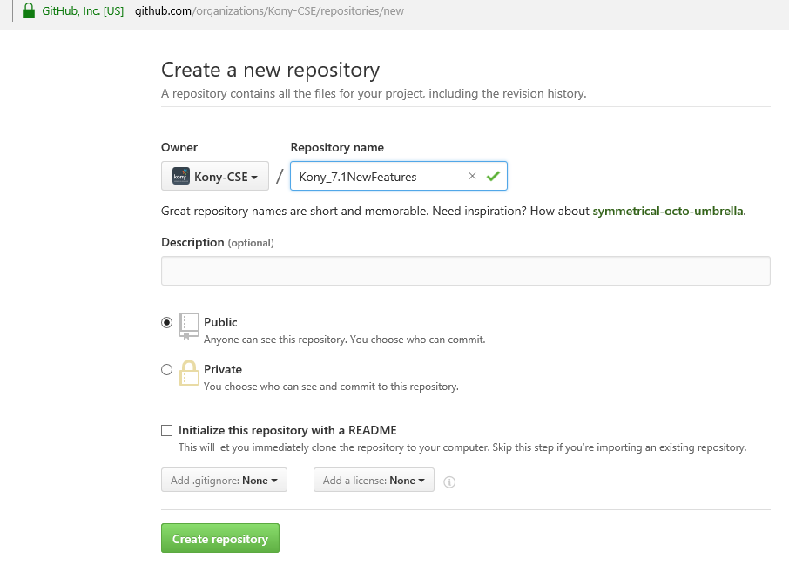

1. Install the Github on your machine by downloading the installer from the

<http://github-for-windows.en.softonic.com/> link.

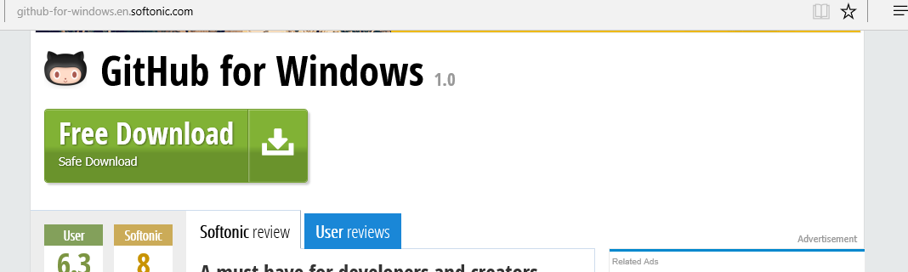

1. The installer will be installed to “C:\Program Files\Git” location by default.
2. To start the Git, please click on git-bash from the git installation location (eg: C:\Program Files\Git).

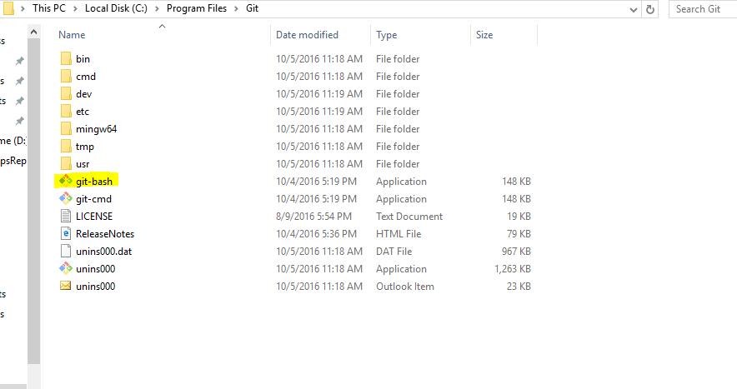

1. To push the applications to Github, first create one folder (sample 1) and copy the sample application into that folder.
2. From the Git-bash, Navigate to the above created folder location. (eg: cd d:\SampleApplications)

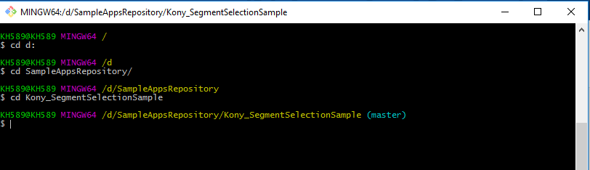

1. To initialize the git, please execute the below command.

**Git init**

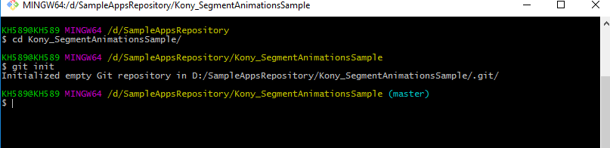

1. To add the code to Git repository, please use the below command.

**git add .**

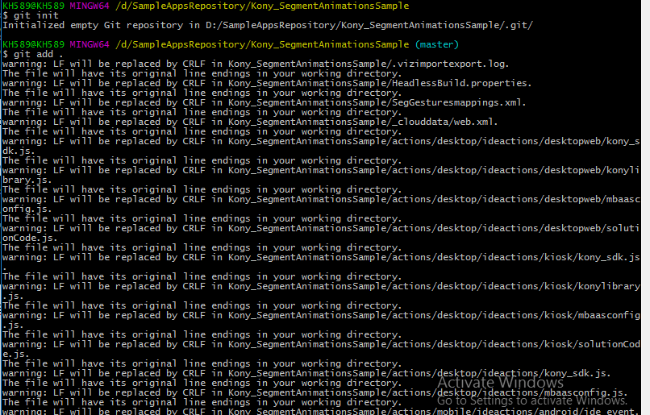

1. To add the code to created github link, please use the execute the below link.

**git remote add origin** [**https://github.com/Kony-CSE/Kony_SegmentAnimationsSample.git**](https://github.com/Kony-CSE/Kony_SegmentAnimationsSample.git)



1. To commit the changes please execute the below command.

**git commit -a -m "Commit for Segment Animation Sample application"**

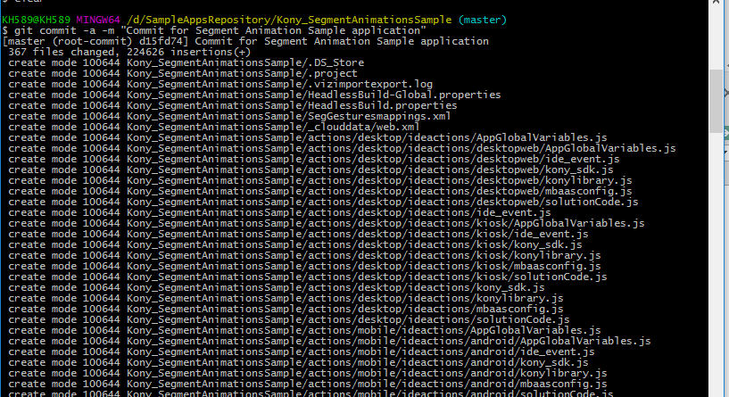

1. To push the complete changes to github, please execute the below command.

**git push -u origin master**

1. It is asking for the username and password for authentication. Please provide the same.

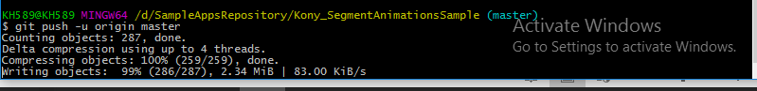

1. Go to <https://github.com/Kony-CSE/Kony_SegmentAnimationsSample> URL and check for the above added code.

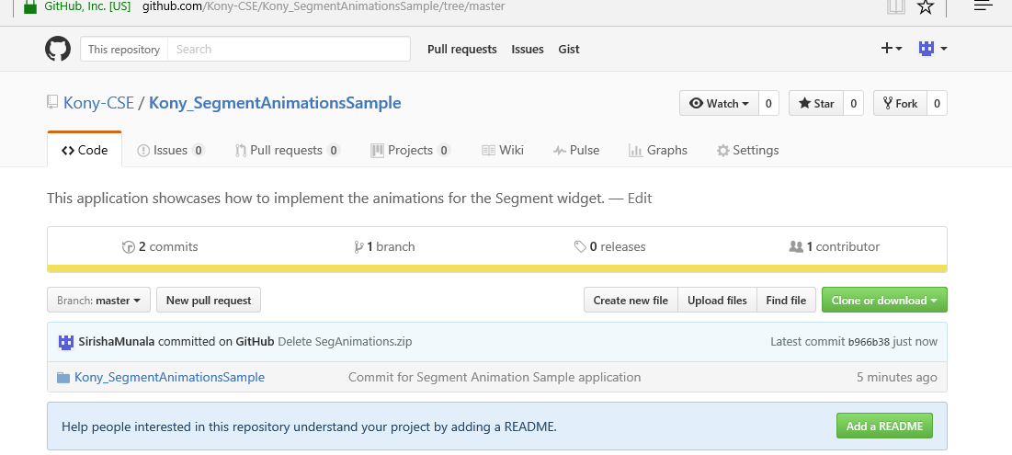

1. For the instructions to add regarding the sample application, please click on Add a README button.

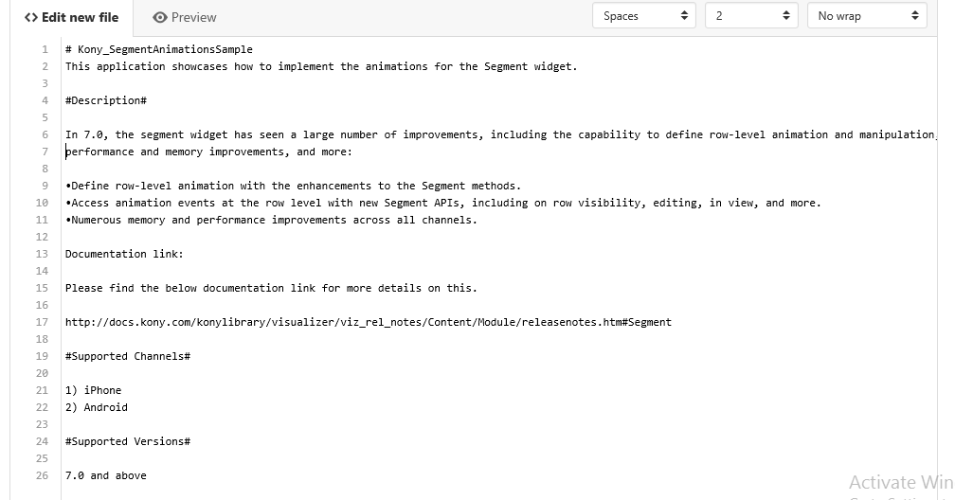

1. The README.md file needs to have the below instructions.

* Title of the application name
* Purpose of the application.
* Prerequisites in any.
* Supported Channels.
* Supported Versions.

Please check the below example link for reference,

<https://github.com/Kony-CSE/Kony_DragDropSample>

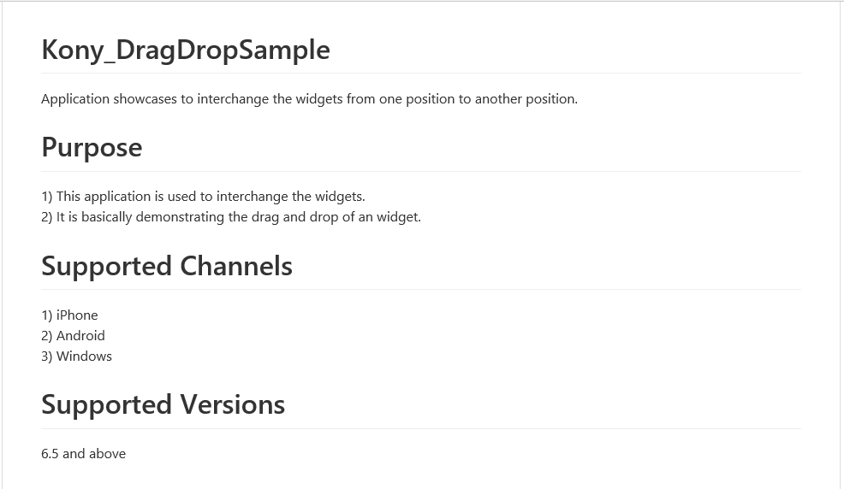

1. Click on Commit New File button.

