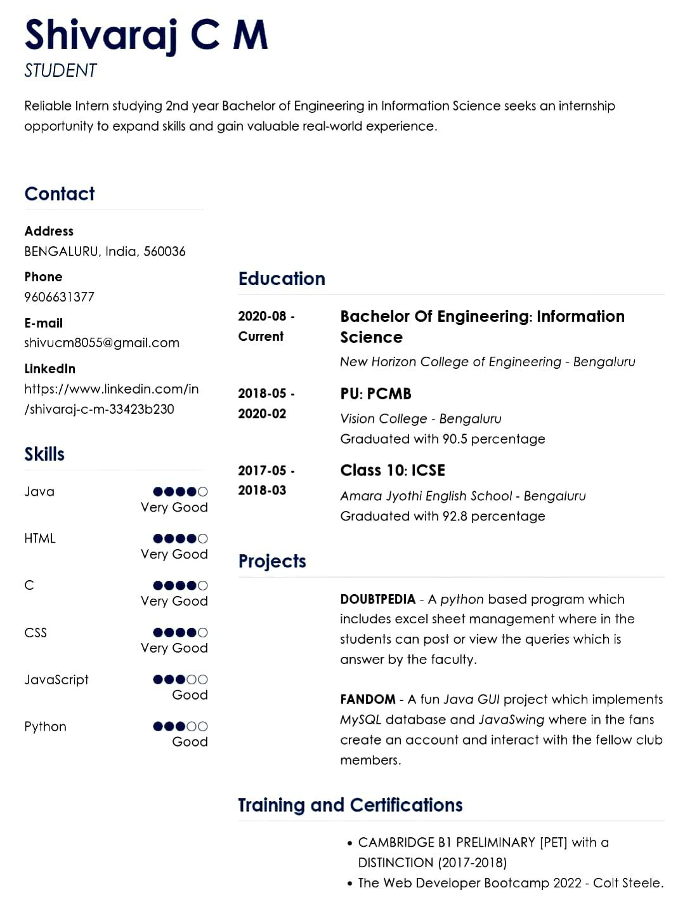Shivaraj CM

STUDENT

Reliable Intern studying 2nd year Bachelor of Engineering in Information Science seeks an internship opportunity to expand skills and gain valuable real-world experience.

Contact

Address

BENGALURU, India, 560036

Phone

9606631377

E-mail

shivucm8055@gmail.com

Linkedln

https://www.linkedin.com/in

/shivaraj-c-m-33423b230

Skills

Java

Very Good

HTML

Very Goood

Very Good

CSS

Very Good

Education

|  |  |
| --- | --- |
| 2020-08- | Bachelor of Engineering: Information |
| Current | Science |
|  | New Horizon College of Engineering Bengaluru |
| 2018-05 | PU: PCMB |
| 2020-02 | Vision College - Bengaluru |
|  | Graduated with 90.5 percentage |
| 2017-05 | Class 10: 1cSE |
| 2018-03 | Amara Jyothi English School - Bengaluru |
|  | Graduated with 92.8 percentage |

Projects

DOUBTPEDIA A python based program which includes excel sheet management where in the students can post or view ihe queries which is answer by the faculty.

Javascript

|  |  |  |
| --- | --- | --- |
| Good | FANDOM- A fun Java GUl project which implements |  |
|  |  |

|  |  |  |
| --- | --- | --- |
| Python | MysQL database and JavaSwing where in the fans |  |
| create an account and interact with the fellow club |  |
| Good |  |
|  | members. |  |

Training and Certifications

CAMBRIDGE B1 PRELIMINARY .PET] with a

DISTINCTION (2017-2018)

.The Web Developer Bootcamp 2022- Colt Steele.