**How to create a Repository and Folders/Files in GitHub?**

1. 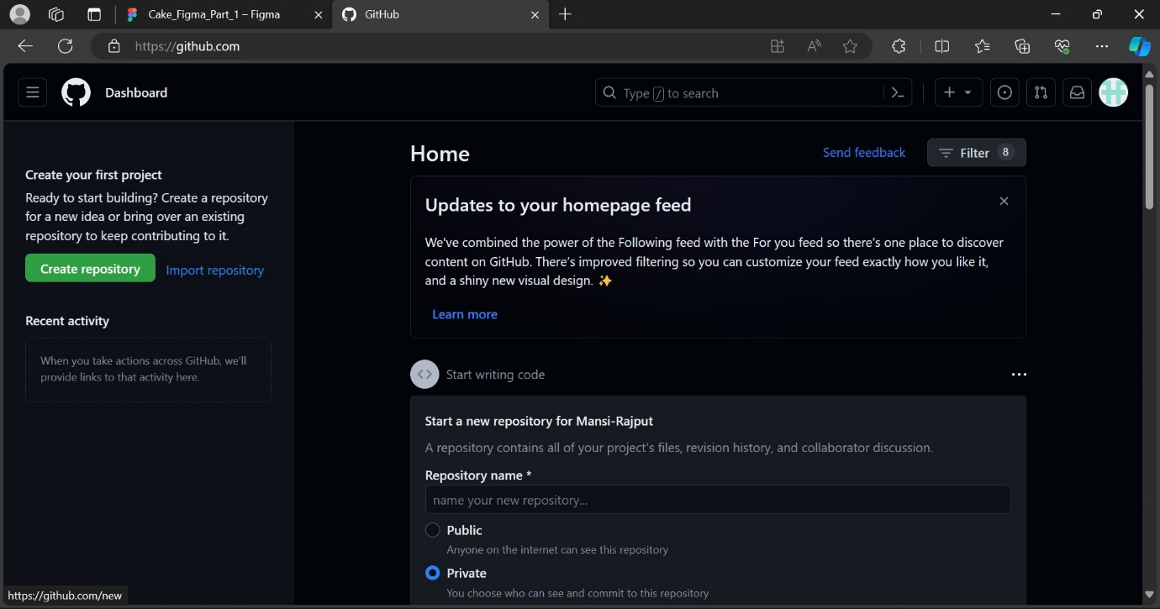To create a repository, log into your GitHub account and click on ***Create Repository***.
2. Next, enter your ***Repository Name***, select the type of repository according to your needs and click on create repository.

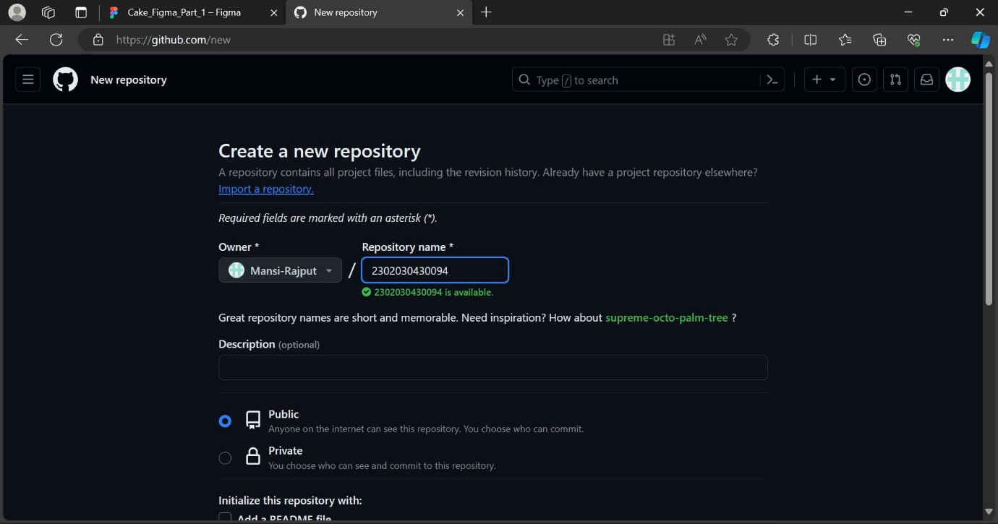

1. To create a folder, click on **creating a new file** or **uploading an existing file** from the quick setup section.

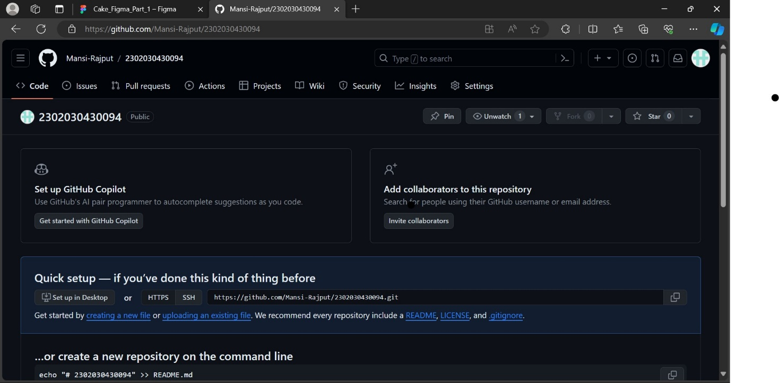

1. After clicking on it, Enter your ***File/Folder name*** beside your repository name.

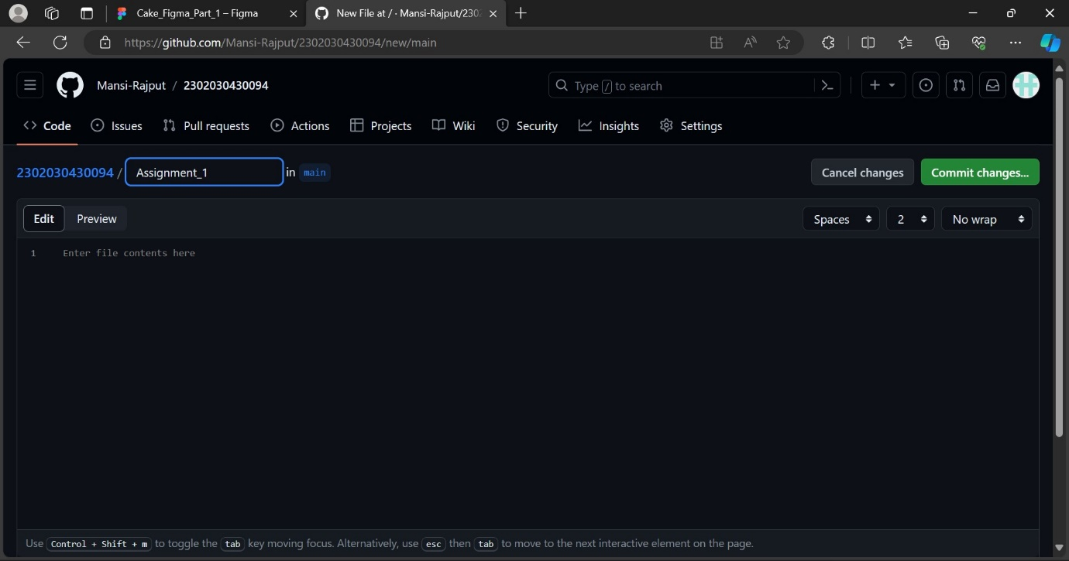

1. 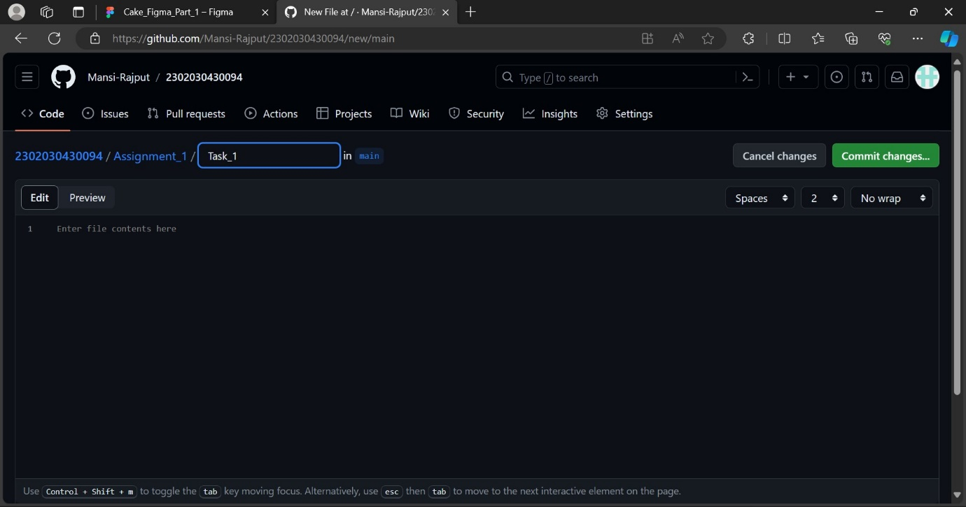After entering your folder name, type **‘/’** to create a file inside your folder and now enter the **new file name** inside the new text box and then click on **commit changes** button on the top-right corner.
2. 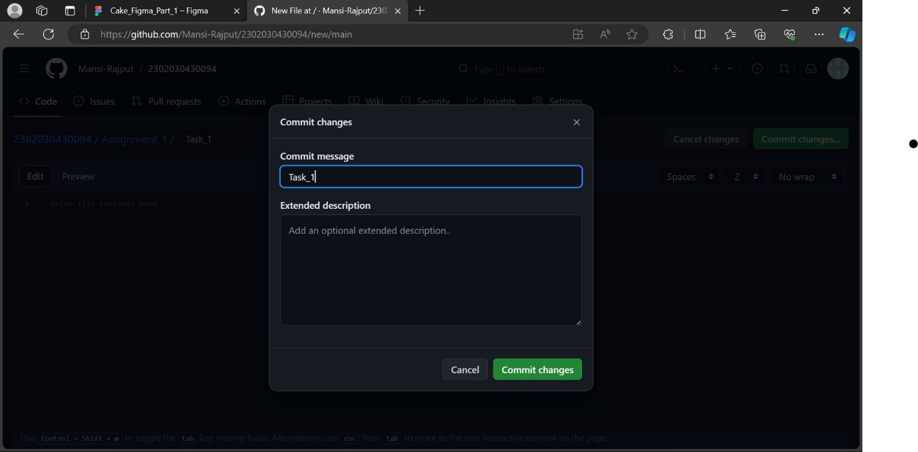After clicking on commit changes, a new window will open, in which you can enter the ***commit message*** and ***description(optional)*** according to your preference then click on ***commit changes*** button again and your file will be created. You can access your folders and files inside your repository.