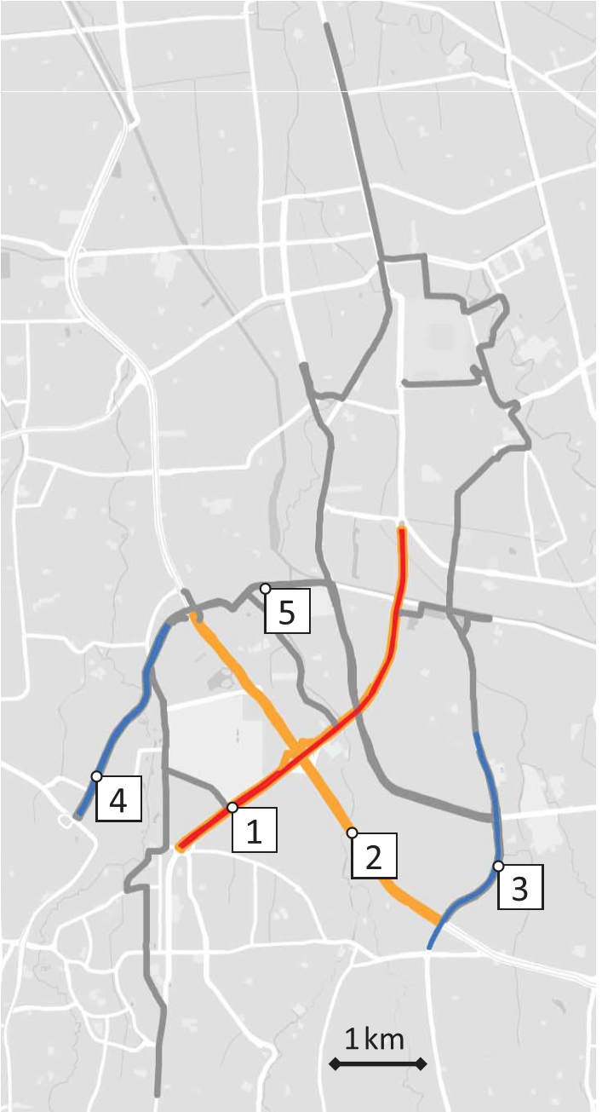We collected data in two phases. Starting on 31 March at 4:40 p.m. local time, about 48 hours after the announcement but 2.5 “weekday” days before the three-in-one policy was lifted, we began collecting traffic data in both directions on three main roads (seeFig.1)—Jalan Sudirman, Jakarta’s main artery and a road subject to the HOV policy, and two alternate roads that run parallel to parts of Jalan Sudirman that were never subject to the HOV policy :Jalan Rasuna Said (another main CBD road with many office towers) and Jalan Tentara Pelajar(an artery leading into the CBD from the southwest). Thus, we have data from both before and after the policy was lifted, as well as the predicted speeds described above. Starting on 28 April 2016, we expanded our dataset to include an additional previously HOV road, Jalan Gatot Subroto, as well as eight alternate routes that had never been subject to HOV restrictions that were suggested to us by the Jakarta Department of Transportation. As with the earlier roads, we also queried the “predicted” business-as-usual data for comparison. More details on the data can be found in the supplementary materials (14).

The preperiod data also contains suggestive evidence that the HOV policy was effective in reducing traffic at the restricted times of the day. Specifically, on Jalan Sudirman, the delay was lower during the morning and evening peaks, relative to the midday off-peak and the hour after the evening peak, respectively. On the two nonrestricted roads, the opposite pattern holds. In fact, Jalan Sudirman traffic was abruptly worse right after the end of the two restricted time periods (fig. S1). We begin our analysis of the lifting of the policy by comparing traffic right before and after the policy. In Fig. 2, we graph the average delay in minutes per kilometer on the weekdays for the former HOV road Jalan Sudirman(Fig.2A), as well an alternate road, Jalan Rasuna Said (Fig. 2B); results for an additional alternate road, Jalan Tentara Pelajar, are in fig. S2. We average delay over both road directions (north and south) because there are strong traffic flows in both directions at both times (disaggregated results are in fig. S3). The dashed line denotes the preperiod days of 31 March (from 4:40 p.m. onward), 1 April, and 4 April, whereas the solid line denotes the postperiod from 5 April to 4 May. We started by examining only what occurred during the first month after the policy change so that our postperiod would be as comparable as possible to the preperiod. The concern is that factors—e.g., citywide changes in school schedules, income, and weather—may eventually change over time. We lift this restriction below to explore what happens over time. Bootstrapped 95% confidence bands, bootstrapped pointwise, and clustered by date and direction, are shown shaded. For convenience, vertical lines mark the morning and evening peak-hour intervals during which the three-in-one policy was in effect during the preperiod. Traffic clearly increased after the HOV policy was lifted. On the former HOV road(Fig.2A), we observed traffic increasing in both the morning and evening peak. This could be due to one of two factors:(i) after the abolition of the three-in-one policy, the number of cartrips increased and there are more cars on the road (e.g., people stopped car pooling, stopped using bus transit, or increased their likelihood of travel to and from the CBD) or (ii)the number of carson the road is the same, but people changed the times of day when they travel or their routes. Figure 2 shows that(ii) is unlikely to play a large role. If anything, we observe an increase in traffic on the former HOV road during non peak hours (Fig.2A), especially after7:00p.m., when HOV restrictions were never in place. Moreover, we do not observe any changes in traffic on the alternate routes in the morning peak hours and actually observe an increase in traffic on the alternate routes in the evening rush hour. This implies that individuals are not just changing their travel time or routes but rather that there is more traffic overall throughout the city.